Largoward Primary School

School Improvement Plan
2021 - 2022

Identifying Priorities For Improvement:

When identifying our priorities for improvement in Lawhead Primary School and Nursery we have taken into
consideration national, regional and local guidance and information.
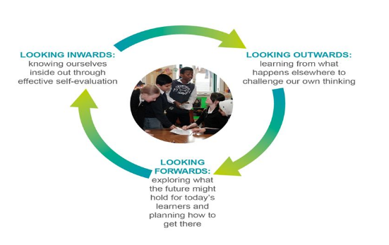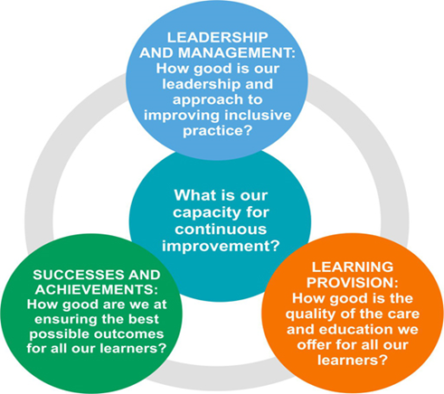

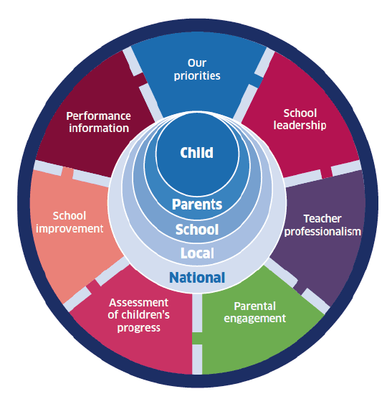

- HGIOS4/HGIOELC
- National Improvement Framework
- Fife Children’s Services Plan
- Pupil Equity Funding
- Cluster Plan
- Learning Partnership
- On-going self-evaluation
- Evidence from staff, pupils, parents and partners

How We Triangulate Our Evidence:

Parents:

- Focus groups
- Parental questionnaires
- Parents evenings
- Groupcall
- Facebook page
- Parent council and PTA
Pupils:

- Focus groups
- Pupil surveys
- Pupil council
- PLJ’s
- Microsoft Teams/GLOW
- Observations
- Assessment information

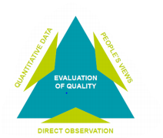
Staff:

- Staff meetings – teachers, PSA’s and nursery
- Staff wise survey
- PRD’s
- Classroom visits
- Excellence and equity meetings
- Moderation activities
- Assessment information
Partners In Education:

- Planning with partner agencies – family support team, active schools, educational psychologist, SALT, EAL, social work.
- Planning with community groups – rotary club, sports groups and clubs, etc

National Improvement Framework Priority:
● Improve attainment, particularly in Literacy and Numeracy
● Close the attainment gap between the most and least disadvantaged children
● Improve children and young people’s health and well-being
● Improve employability skills and sustained, positive destinations for all young people (DYW 3 to 18)
Focused Priority 1: Development of our curriculum rationale in partnership with stakeholders
QI (HGIOS4):  1.2 Leadership of learning  2.2 Curriculum |  |  | QI (HGIOELC):  1.2 Leadership of learning  2.2 Curriculum
Expected Impact | Strategic Actions Planned | Responsibilities |  | Measure of Success  (Triangulation of Evidence) | Timescales
Almost all pupils, staff and parents will understand what a curriculum rationale is and why we have it. | Staff – Inset days used to engage with whole staff team to input on rationale design.  Pupils and parents – planned sessions to engage with pupils and parents to gather views and inputs to curriculum rationale.  Identify key staff and stakeholders to take the lead on different aspects of our curriculum rationale | SLT, all staff  SLT and pupil council  CT’s to be identified |  | That we would have an evolving curriculum rationale for our school.  Staff, parents and learners can articulate a shared understanding of our curriculum and uniqueness of our setting (focus groups, questionnaires) | Aug 21 – June 22  (use of inset days to engage with entire staff team)
Ongoing Evaluation:

National Improvement Framework Priority:
● Improve attainment, particularly in Literacy and Numeracy
● Close the attainment gap between the most and least disadvantaged children
Focused Priority 2: Raise attainment in writing across P1-7 from 66.7% to 75% by developing pedagogical approaches to learning, teaching and assessment.

QI (HGIOS4):  1.2 Leadership of learning  2.3 Learning, teaching and assessment |  |  | QI (HGIOELC):  1.2 Leadership of learning  2.3 Learning, teaching and assessment
Expected Impact | Strategic Actions Planned | Responsibilities |  | Measure of Success  (Triangulation of Evidence) | Timescales
Increased attainment in writing in P1-7 from 66.7% to 75%.  High standard of learning, teaching and assessment of writing across the school. | Identify pupils who are off track in writing – ensure all appropriate universal and additional supports are in place. Track during E&E meetings and SfL liaison. Additional monitoring of identified pupils.  Collegiate sessions planned with different writing focus throughout the session including the 6 chapters from ‘Teaching Backwards’ and use of ‘Pedagogy Premieres’  Upskilling PSA’s to support writing.  Upskill on digital tools that support writing support and teaching staff.  Moderation stage groups facilitated through a whole school PLC Team. Moderation of every stage of the assessment cycle.  Introduction of 4-part lesson model for all writing lessons (then expand to other curricular areas)  Class weekly/daily plans to evolve with dedicated time to act on feedback and high-quality opportunities for writing across the curriculum.  Whole school genre focus each term.  Start and end of session assessment ‘cold’ piece of writing. | SLT, CT and SfL  SLT, CT and SfL  PSA’s, SfL and SLT  SfL (KE) and WG  CT’s  SLT, CT’s and PSA’s  CT’s  CT’s  CT’s |  | Improved tracking data on TRAMS, improved SNSA and BASE data. Early identification of pupils requiring additional support in writing.  Improved quality of writing lessons delivered across genres with work of increased length and quality. Pupils clear on strengths and areas for improvement.  Increase in PSA skill and confidence to support learners.  Digital technology used effectively across the school to improve quality of pupils writing.  Assessment cycle implemented consistently across the school.  All writing lessons will follow the 4-part lesson model with pupils understanding each of the 4 stages.  Children writing on a daily basis for a range of purposes in a variety of styles/genres  All pupils will be able to identify and write in a range of styles within different genres.  Assessment data to measure pupil gains. | Termly  Term 1 and 2  Term 1 and 2  Term 1 and 2 for Clicker and Term 3 and 4 for iPads  Termly moderation sessions  Term 1 and 2  Termly
Ongoing Evaluation:

National Improvement Framework Priority:
● Improve attainment, particularly in Literacy and Numeracy
● Close the attainment gap between the most and least disadvantaged children
● Improve children and young people’s health and well-being
● Improve employability skills and sustained, positive destinations for all young people (DYW 3 to 18)
Focused Priority 3: Develop progressive learning pathways from P1 to P7 for learning outdoors and outdoor education

QI (HGIOS4):  1.2 Leadership of learning  1.3 Leadership of change  2.2 Curriculum  2.3 Learning, teaching and assessment |  |  | QI (HGIOELC):  1.2 Leadership of learning  1.3 Leadership of change  2.2 Curriculum  2.3 Learning, teaching and assessment
Expected Impact | Strategic Actions Planned | Responsibilities |  | Measure of Success  (Triangulation of Evidence) | Timescales
Clear distinction between learning outside and outdoor education which is understood by all staff and almost all pupils and families.  All pupils are given a progressive outdoor experience building on prior knowledge and skills.  Almost all staff confident to deliver lessons outside and outdoor education. | Information shared with parents in a range of ways to define the difference between learning outside and outdoor education.  Continue to develop our outdoor learning areas including the bumpy outdoor classroom, P1 area and school garden.  Establish two working parties – one for taking learning outside and the other for outdoor education – to develop learning pathways.  Planned professional learning opportunities and reading for support and teaching staff.  Develop wider community links e.g. Botanic Gardens, Ranger Service | SLT, CT’s, pupil council and grounds keepers  SLT, CT’s, pupil council and grounds keepers  JS (Lawhead) and another staff member to be identified  SLT, CT’s and PSA’s  Working party |  | All stakeholders will understand the distinction between learning outside and outdoor education  Outdoor areas are used with increased frequency and pupil ownership for their upkeep.  Pupils will experience a wide range of high quality, challenging and progressive outdoor experiences.  Increased staff confidence  Improved community links to support delivery. | Jan/Feb 22  Term 1 and 2  Term 3 to plan and term 4 to trial  Term 3  Term 4
Ongoing Evaluation:

