FALKLAND PRIMARY
AND NURSERY SCHOOL

School and Nursery
Improvement Plan
2021-22

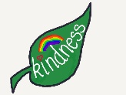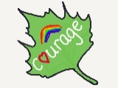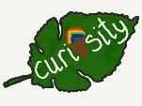

Vision Statement

We aspire to be a nurturing, learning community where attainment is excellent, achievements are planned for and celebrated and where we are all involved in supporting a love of learning.

All learning together.

Declaration/Aims

We are kind to ourselves, each other, our school, our community and our world.
We have courage through ambition, risk-taking, challenge and self-reflection.
We show curiosity by having enquiring mind, being motivated and by developing a love of learning.

Our Values

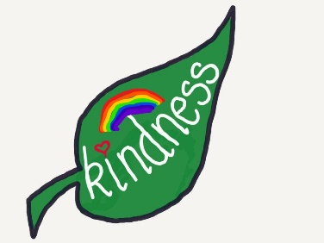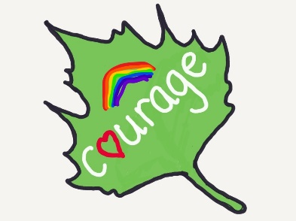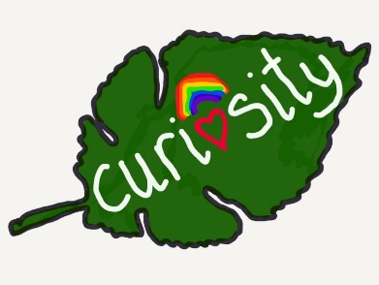

Our school book “The Boy, the Mole, the Fox, and the Horse” by Charlie Mackesy directly relates to our school values whilst underpinning growth mindsets, resilience and challenge.

Context

Falkland Primary School was built in 1967. It is the only primary school in Falkland and also serves the village of Newton of Falkland and the surrounding area. The main school building houses 4 classrooms, assembly hall, dining area, staffroom and office accommodation. Two huts in the school grounds house the Nursery class and Primary 1. We have a tarmac playground, Zen Garden and a large playing field. We also have access to the beautiful surroundings of Falkland Estate and local countryside. We have 6 mainstream classes this session: P1, P2, P3/4, P4/5, P6, P6/7 and our Nursery supports full day places for three and four year olds.

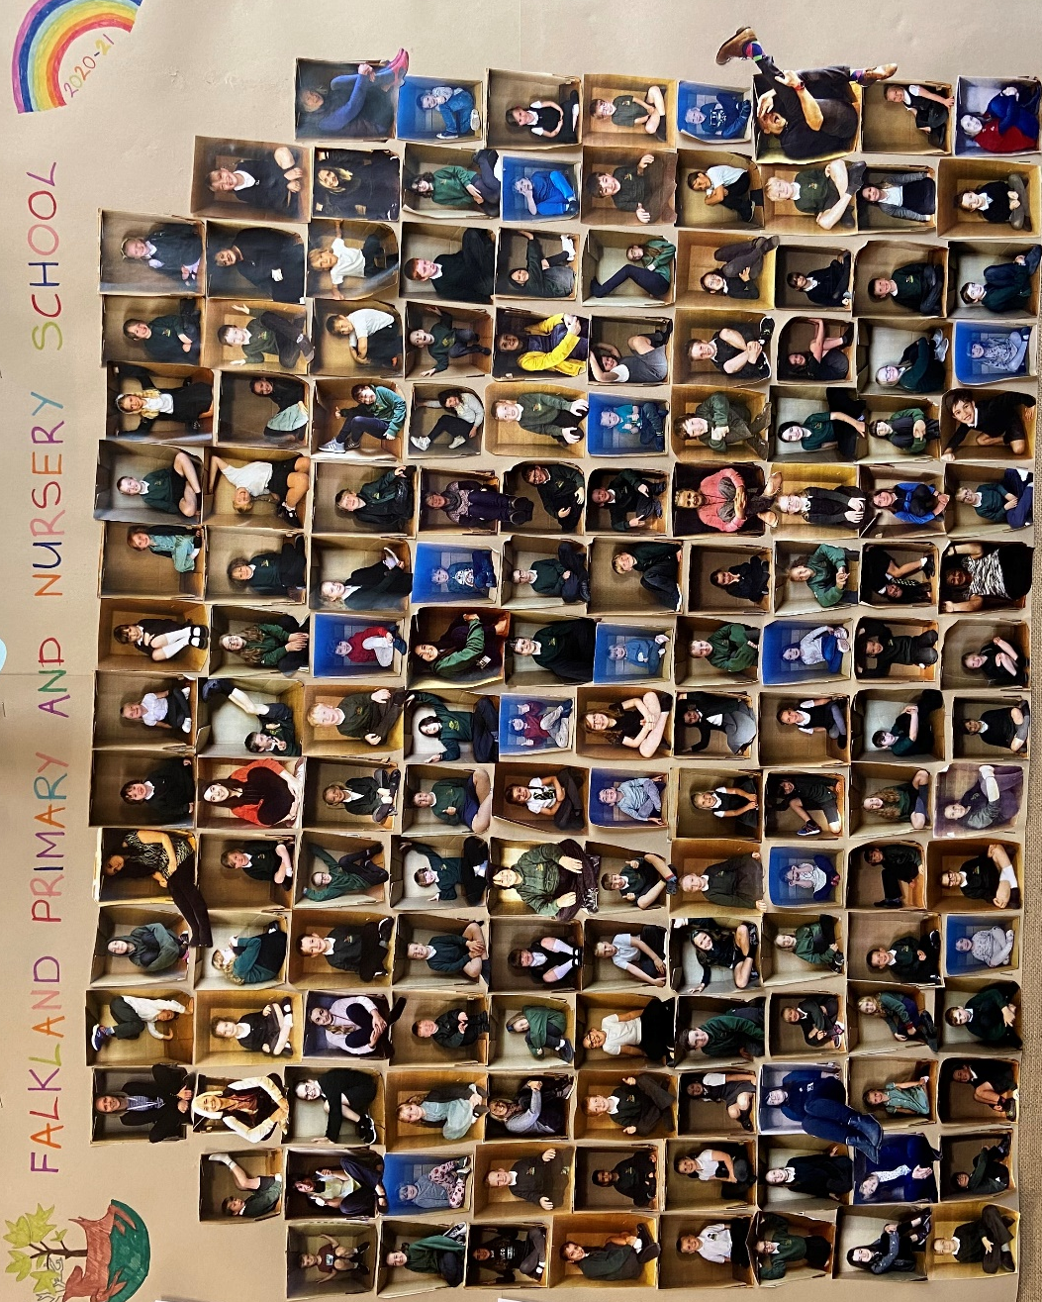

Falkland is situated in a unique location, rural, spacious and rich in diversity, commerce, heritage and creativity. We use local talents to enhance our curriculum, focusing on literacy, numeracy and health and well-being. We use our natural connections to transfer our skills, to and from the classroom and the outdoor environment, creating real and relevant links between our lives, other’s lives and our future lives.

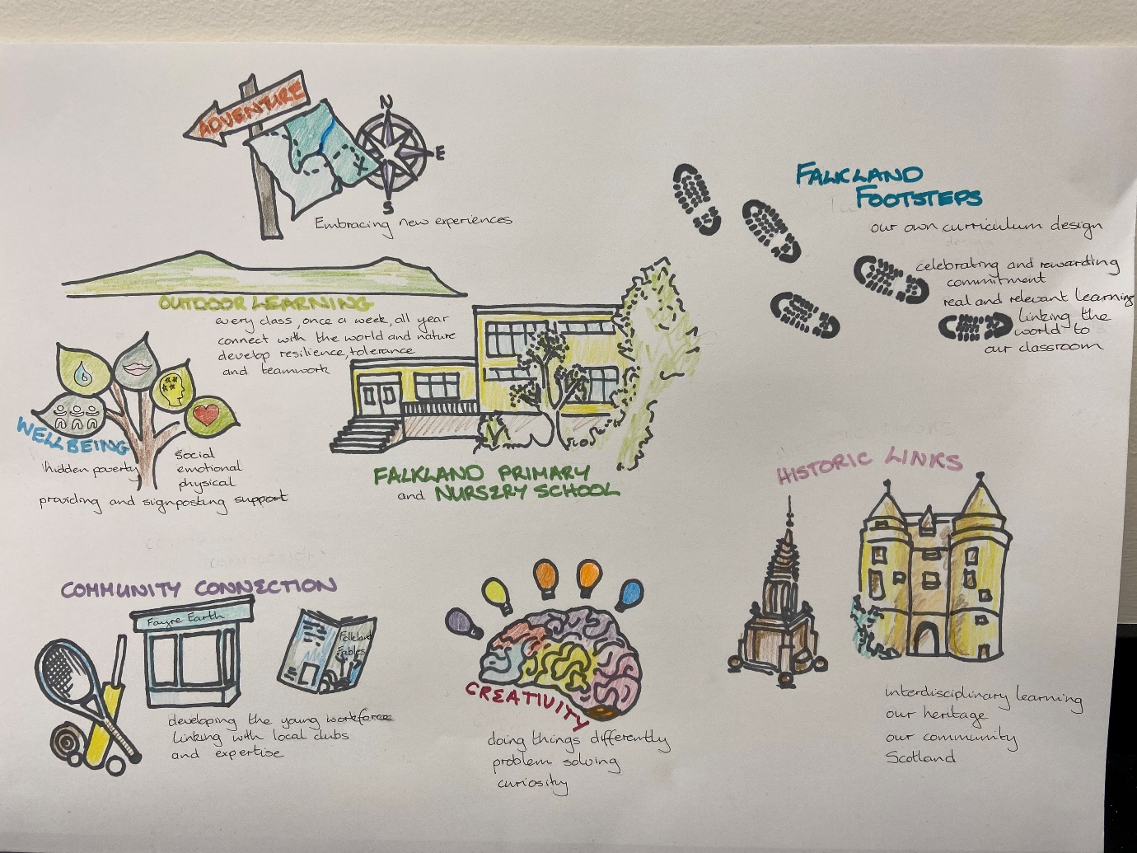
Our School Learning Approach

We creatively link skills across the curriculum using rich opportunities including digital literacy. We motivate, support and challenge ourselves within a culture of continual improvement that makes a positive difference.
We minimise the cost of the school day by ensuring equity across all experiences for all learners, supporting parents with affordable uniform options and £zero expectation for pupil resources and trips. Our fundraising focuses on one school fundraiser, one local, one national and one international event each year.
We use our school Seesaw app., enhancing the communication that we provide to link the children’s learning to their families, stimulating questions by using open questions on each post, by explaining the what and the why, and by encouraging parents to comment on their child’s post.

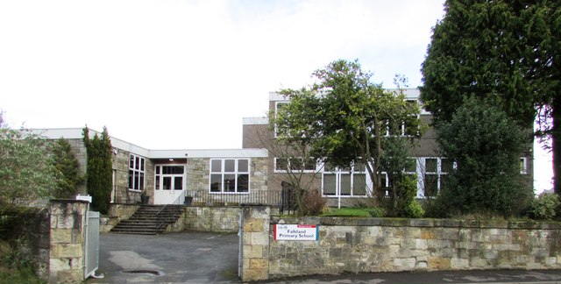

Setting/School Roll | School 123 Nursery 13
SIMD | 7
FME | 11%
Attendance 95.24 | Authorised 2.65 | Unauthorised 2.11
Exclusion | 0%
Placing Requests | 35%
Pupils with Support for Learning | 40%
Flexi-schooling Agreements | 4%
Attainment Scotland Fund Allocation (current session) | £33,080.00

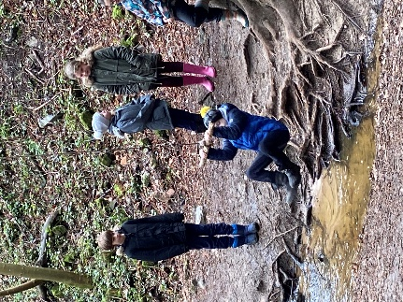

Priority 1: All staff, pupils with ASN and their parents have a clear understanding and of the child’s needs and support plans are in place to ensure continued engagement and progression in their learning across all aspects of the curriculum.
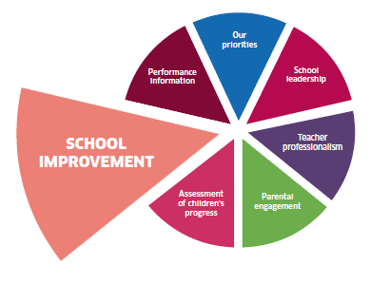  NIF Drivers  Improvement in attainment, particularly in literacy and numeracy  Improvement in children and young people’s health and wellbeing | HGIOELC/HGIOS4  2.4 Personalised support  3.1 Ensuring wellbeing, equality and inclusion | UN Convention—the right to:  Article 12 – be heard  Article 13 – be curious  Article 17 – wellbeing information  Article 19 – be protected in body and mind  Article 28 – good education | Article 29 – develop every child’s personality, talent and abilities to the full  Article 31 – to play and rest

Expected Impact | Strategic Actions Planned | Responsibilities | Measure of Success | Timescales
All staff have increased awareness and understanding of autism, ADHD, ADD, DLD, Dyscalculia, SALT and ACE’s.  All staff have greater confidence and have strategies to support pupil emotional wellbeing.  20% improvement in the participation, engagement and achievement of learners who have additional support needs.  All staff, pupils and parents support and promote the development of Inclusive Classrooms as best practice in our school and nursery.  All staff and pupils further develop creative and inclusive approaches to learning ensuring that the child’s personality, talent and abilities are developed  P6 pupils increase their capacity of resilience, conflict resolution and leading change. | Programme of staff continued professional development throughout the academic calendar, linking with Educational Psychology Service, SALT, ASIST, PT Learning Support , Emotion Works.  All staff participate, engage and enhance their classroom practise, and out with the classroom, through the implementation of Emotion Works.  Engage as a whole staff with the Circles Framework and link with cluster schools to share approaches, resources and best practice.  Termly reviews using the CICS to evidence colleagues learning spaces.  Monthly discussions and feedback sessions to highlight positives and areas for development.  Engage with “Our creative Journey” and share ideas and developments at whole school opportunities.  School staff engage with creativity benchmarks, Education Scotland resources and professional reading – “When the change happens” Paul Dix  Nursery and P1, P2 to develop Purposeful Play pedagogy as best practice to support the development of learning through purposeful play led activities, linking with other schools/nurseries/practitioners  P6 pupils engage in Peer Mediation Training, then use Train the Trainer model to cascade their knowledge and experience to P5s and P6s liaise with S3/4 BBHS pupils to support development of leadership skills. | Laura Munro  Whole staff  Whole staff  All stakeholders  Teaching staff /EYOs  Nursery staff  School staff  Nursery, P1 and P2, PSA staff  Scottish Peer Mediation  P6 pupils  P6 Class Teacher | Engagement/Leuven Scale, observations, withdrawal data, staff survey  Emotion Works self evaluation – reflective conversations, Leuvan Scale/or alternative  CIRCLE Participation Scale (CPS), attainment data, observations  The CIRCLE Inclusive Classroom Scale (CICS), observations, colleague observations, pupil focus group  Self-evaluation, classroom/outdoor observations, pupil focus groups  Professional discussion/debate, observation of school culture, pupil feedback, attainment data  Observations, audit of resources, audit of pupils’ purposeful play in specific areas, attainment data  Participation data, data on playground and classroom conflict/resolution, pupil feedback, observations | May 2022  October 2021  Jan 2022, May 2022  Jan 2022, May 2022  Jan2022  Nov, Jan, May  October21 – May 22
Ongoing Evaluation

Priority 2: Increase the attainment of P5 in writing so that 90% have attained the achievement of First Level by March 2022.
NIF Drivers  Improvement in attainment, particularly in literacy and numeracy | HGIOELC/HGIOS4  2.4 Personalised support  3.1 Ensuring wellbeing, equality and inclusion | UN Convention—the right to:  Article 28 – good education

Expected Impact | Strategic Actions Planned | Responsibilities | Measure of Success | Timescales
Increase the children and staff’s understanding of the criteria for achieving a level.  All pupils can state what their successes are and what their next steps are.  More sophisticated language (up levelling) used by pupils within written assignments.  Improved spelling within written assignments.  All pupils able to produce increased length of written work. | Implement the use of target sheets for each genre for  use across all levels.  Target sheets to be used as a tool for self-assessment, peer assessment and teacher assessment in all classes.  P2-7 children to be taught how to self-assess/peer assess and identify next steps.  All classes to have a word wall, use wordbanks.  P3-7 make regular use of SRA to support the exposure to a wide variety of genre and language used.  Spelling to be taught using the cluster progression twice weekly (homework?)  Lexia to be used a minimum of three times a week (40 mins) by identified pupils with dyslexia or literacy difficulty.  Implementation of Cursive Handwriting P2-7.  P5/6 to use fountain pens as a test of change. | All teachers  Teachers/pupils  Teachers/PSAs  Teachers/PSA  Teachers/PSA  Teachers/Parents  Fiona Liu – to monitor  Teachers/PSAs  P5/6 Teacher | Data, observation, feedback  Data, observation, feedback  Focus groups, data, observations  Written assignments, observed behaviours in class, SfL data  Engagement data, focus group, feedback  Planning/tracking data, observations, questionnaire  Lexia data, attainment data, focus group  Written data, feedback, test of change | Nov 2021  Nov 2021  Jan 2022  Jan 2022  Nov 2022  Oct 2021  Oct 2021  May 2022
Ongoing Evaluation

