Economy, Planning & Employability Services

Blue-Green Algae and Water
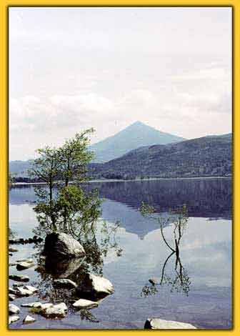

What are blue-green algae?

Blue-green algae are minute organisms which occur naturally in lochs, ponds, reservoirs, rivers and in the sea. They tend to clump together to form large masses or scums. Blue-green algae commonly occur during periods of prolonged hot weather in waters which have been polluted by agricultural, domestic or industrial discharges.

In still waters the algae can multiply during the summer months to such an extent that they discolour the water which then appears green, blue-green or greenish brown. Sometimes a scum may form on the surface. This scum can appear in different places at different times but is most commonly found at the water’s edge or shoreline.

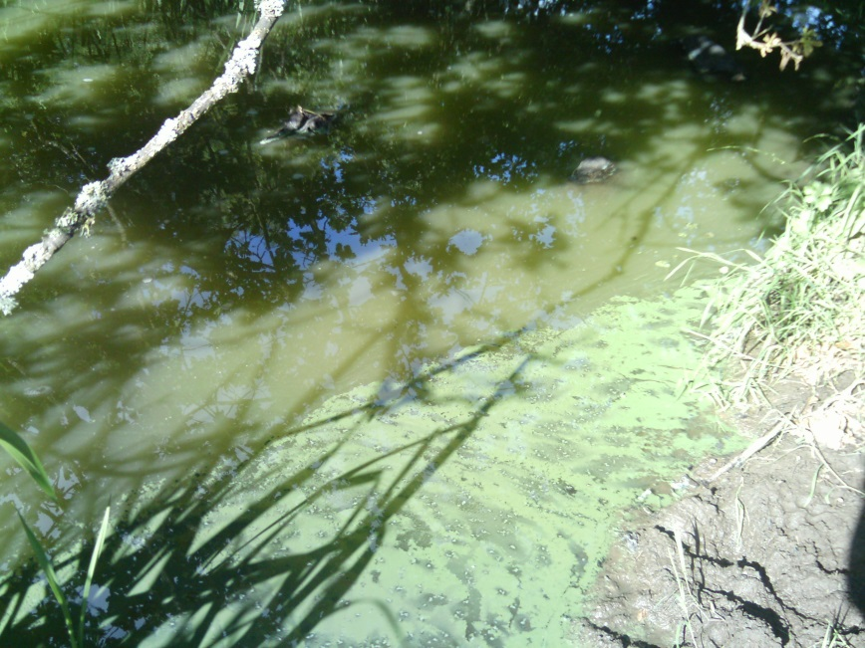

How do blue-green algae affect humans and animals?

Some, but not all, the blue-green algae release poisons into the water. It is not possible to tell which algae do or do not produce poisons without detailed examination in a laboratory; therefore it is advisable to regard all algal scums as poisonous.

The toxins of blue-green algae can cause death to animals either through drinking contaminated water or swallowing quantities of the scum. Dogs have died after going into the water at the shores of affected lochs.

Canoeists, wind surfers and swimmers who have either swum through algal scum or swallowed it have suffered from skin rashes, eye irritation, vomiting, diarrhoea and pains in muscles and joints. There have been no reports of long-term illness or death in human beings. However, illnesses were sometimes severe.

Drinking water supplies are treated to prevent any harmful effects to health from blue-green algae.

What should I do about blue-green algae?

Avoid all contact with affected or suspect water and ensure that children and pets are kept away. Farmers should ensure that their animals do not have access to contaminated water. This may require fencing around the suspect waters. If any member of the public find areas of water affected with blue-green algae they should inform Economy, Planning & Employability Services (see below for details). Action may then be taken to ensure that notices are posted around the affected water to let local residents, visitors or patrons know what the position is. A typical warning notice which may be used is shown below:

WARNING

BLUE-GREEN ALGAL BLOOMS

Algal scum may be harmful: it is sensible precaution for you and your animals to avoid contact with scum and the water close to it.

What about eating fish from affected waters?

Current guidance states that fish caught in waters affected by blue-green algae should not be consumed.

You should not feed the liver from fish caught in waters affected with blue-green algae to pets.

Further information or advice is available from Fife Council, Economy, Planning and Employability Services, Fife House, North Street, Glenrothes, KY7 5LT on 03451 55 00 22.

Revised 03 March 2020

