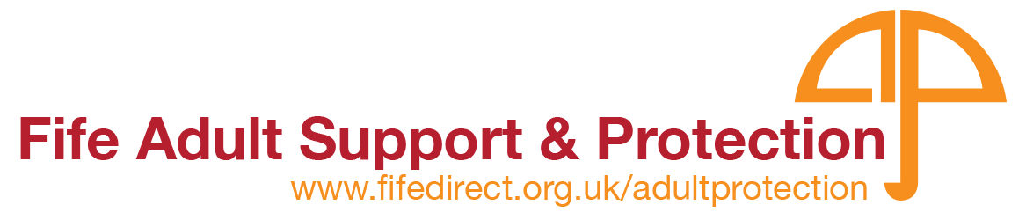
Inter-agency Report of Harm Referral Form

Copies of this form can be located at: www.fifedirect.org.uk/adultprotection on the ‘Staff Information and Training’ page.

Is the adult in immediate danger
or
In need of immediate medical attention?

Call 999 immediately and complete form later

If the adult is NOT in immediate danger:
Call Adult Protection on 01383 602200
AND
Complete and email this form to:

sw.contactctr@fife.gov.uk

This form should be completed by anyone wishing to refer an adult at risk of harm

- Complete as much as you know
- Do not delay reporting harm, even if you do not have access to all information
- The field boxes will expand as required

The Adult Support and Protection (Scotland) Act 2007 defines “adults at risk” as individuals, aged 16 years or over, who:

- Are unable to safeguard their own well-being, property, rights or other interests, and
- Are at risk of harm; and
- Because they are affected by disability, mental disorder, illness or physical or mental infirmity;

... are more vulnerable to being harmed than others who are not so affected.

REFERRED BY
Name and job title: (including any relevant reference no.)
Agency/Dept:
Contact details
Address:
Tel. No:
E-mail address:
Where relevant, date line manager notified:
Date referred to Social Work:

Details of Adult at Risk [Complete as much as you know]
Name & Address | Tel. No. | D.o.B. | Gender | Ethnicity | Known  Disability | Religion | Language

Do you believe the adult at risk is capable of understanding what has happened to them? (select appropriate answer) [You may need to use your own judgement to answer this]
YES/NO/UNSURE

Have you (or any other person) told the adult at risk that this information will be shared with other relevant agencies? (select appropriate answer) [You should tell the adult that you are making a referral and explain why. If this is not possible, make the referral anyway]
YES/NO

Details of Nearest Relative/Next of Kin [Complete as much as you know]
Name & Address | Tel. No. | D.o.B. | Gender | Relationship to adult at risk

Name and contact details of any other persons involved (where known) [Complete as much as you know]
GP |  |  | Community Nurse
Social Worker |  |  | Housing Support Worker
Residential Care Worker |  |  | Police
Welfare Attorney/Guardian |  |  | Other
Details of why you are making this referral [What are your concerns? Make clear what is first-hand information and what you have been told by others. Identify the source of the information.]

Provide details of the situation where the adult is/was considered to be at risk.
Include TIME, DATE, LOCATION, plus own observations and information from witnesses. Detail the nature of your report of harm.

Type of harm you are concerned about [tick relevant box(es)]
Financial |  | Self-injury
Neglect |  | Self-neglect
Physical |  | Self-poisoning (including overdose)
Psychological/emotional |  | Sexual
Extremism/radicalisation

Details of other adults/children in the setting [There may be others at risk so supply as much information as you can. If you have concerns about others, this will require reporting/action too, e.g. ‘Fife Child Concern Notification Form (Multi-Agency)
Full name | Address | D.o.B. | Gender | Ethnicity | Relationship to adult at risk

Details of person(s) alleged to be causing harm (where known) [Supply as much information as you can]
Name | Address | Tel. No. | D.O.B. | Gender | Ethnicity | Nature of relationship to adult

What action, other than this referral, have you taken to ensure the adult at risk is now safe? [Indicate what you have done to reduce the risk and to safeguard the adult]

Additional information and comments (include any known risks and identified warning markers for information of Partner Agencies etc.) [This is information/intelligence that may be important for Social Work Services to be aware of prior to visit/assessment]

Next steps

You can get further advice about how and when to complete this form from your line manager or on our website at www.fifedirect.org.uk/adultprotection on the ‘Staff Information and Training’ page.

Acknowledgement will be sent to the referring agency within 5 days of receipt of this form.

The Local Authority (Fife Council) will decide whether an investigation under the Adult Support and Protection (Scotland) Act 2007 is required.

