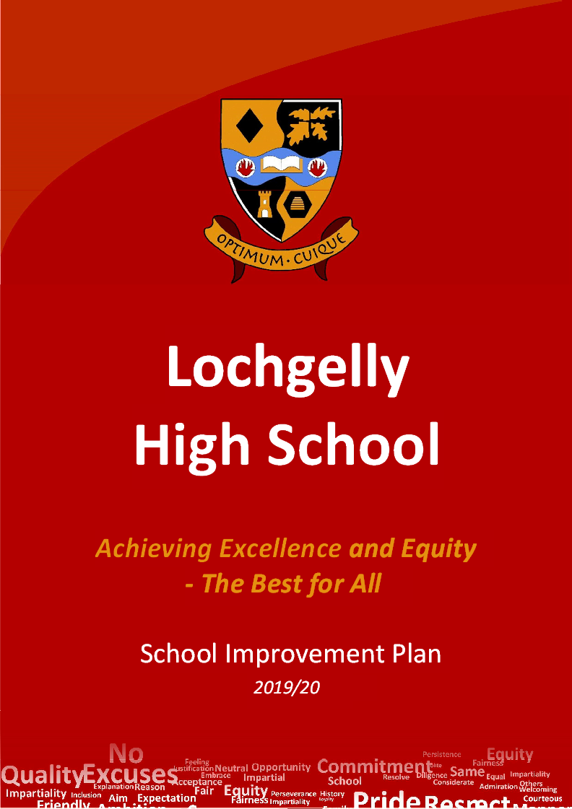
Standards and Quality Report 2020-21
Introduction by The Rector 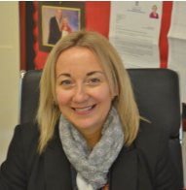
I am delighted to be able to introduce this year’s Standards and Quality Report, which provides a snapshot of life at
Lochgelly High School and features the successes and achievements of our pupils and staff. As you know Sessions 2020 and 2021 have provided very different challenges to our work in schools, across all areas of business and life in general across The World at large. From January to March 2021 we had the second Lockdown in Britain which resulted in a period of remote learning for almost all of the learners in our school. There were a group of our most vulnerable young people who continued with face to face learning and this included around 40 young people in DAS and 50 others in school. Towards the end of this period groups of Senior Phase Learners were scheduled into school to complete practical work that could not be achieved at home. Due to the cancellations of this year’s SQA examinations and their replacement with the Alternative Certification Model this has involved all teaching staff in a great deal of work on developing and designing assessments, ensuring that the learners in Lochgelly High School were given a fair and equitable chance to achieve their very best outcomes through moderation of the Standard and then marking and feedback.
The results for the Senior Phase attainment, again reflect a strong overall performance and in some areas our young people achieved the best outcomes of the last five years, albeit in different circumstances. However, there are many reasons for our improving attainment trends and very rarely in schools can we pin success down to one single action. However, what is certain is that the achievements of our young people were down to their effort, their abilities and their ambition.
We must recognise the contribution and commitment of everyone working in school and here I stress the hard work not just of teachers but also support assistants, clerical staff, janitorial staff, our catering and cleaning teams and all the external partners who work together to ensure the best experiences for every young person in Lochgelly High School. I believe that through everyone’s hard work we genuinely do meet our school motto of “Optimum Cuique” the best for everyone. Nevertheless, we are constantly evaluating our work with pupils, staff and parent/carers and
focusing on the areas where we know we need to improve. We have worked hard over the last year in unprecedented circumstances and have had focus on a number of different areas - as detailed in this report - and you can be confident that we will continue to do so again as we hopefully return to a bit more normality in 2021/22. This document sets out what we will be working on and trying to improve. We are a strong school community and through this strength we will continue to reflect on our work to ensure the best outcomes for all of our pupils.
I hope you find this report useful and informative. If you have any comments on the report, or on aspects of our development, please do not hesitate to get in touch.

Debbie Aitken, Rector
Lochgelly High School

Standards and Quality Report
Achieving Excellence and Equity

Context
Setting/School Roll (including ELC/ASC) | 737
FME | 30.74
Attendance (%) 88.24 | Authorised | 4.8 | Unauthorised | 6.91
Exclusion (%) | 0.05
Attainment Scotland Fund Allocation (PEF and SAC) | £230,000
Lochgelly High School is a six year, non-denominational school in Fife opened in August 1987 that serves the Benarty, Cardenden, Lochgelly and surrounding areas. We work closely with our five Cluster Primary Schools, Lochgelly South, Lochgelly West, Benarty, Cardenden and Denend.
We are a busy community-use school and have a relatively large fully integrated Department of Additional Support. Free school meals is currently 30% and has been one of the highest in Fife for the last 5 years. 78% of our learners live in the most deprived Scottish Index of Multiple Deprivation deciles 1 -3 and 28% are categorised as children (under 16) in poverty, which is 10% above Fife average. Four-fifths of our young people live in the poorest SIMD areas, therefore the core purpose of our work is to close the poverty-related attainment gap and
build on ensuring equity and excellence for all learners.
The continuation of PEF funding has provided us with the opportunity to extend our targeted approaches within the themes of learning and teaching, nurture and family and community engagement, with impact on outcomes universally but also specifically on groups of learners in relation to literacy, numeracy and health and wellbeing.
Our context drives a strong focus on inclusion and improving the mental, emotional and physical wellbeing of our learners. Through this we are provided with exciting opportunities to work closely with elected members, partners and the wider community, including partnerships with approximately 60 employers, Police Scotland and Career Ready mentors.
We have worked hard on consulting with our school community over the last sessions to develop our three school values- Our 3 Rs, Respect, Responsibility and Resilience where “every minute counts and our the distilled vision: We are Lochgelly High School a proud and ambitious learning community where everyone strives to achieve the best for all.
The Cowdenbeath Locality priorities were developed to focus on Anti-poverty, Raising Aspiration and Resilience/ Mental Health and match in well with the Fife Education and Childrens’ Services vision of Improving Life Chances for all.
• Educational Outcomes– raising attainment, literacy, numeracy levels etc.
• Employability Skills– raising overall achievement, including skills for work and life in the community.
• Equality and Equity– reducing inequalities and seeking to break the cycle of social disadvantage. Our interventions need to be as early as possible and then sustained.
• Enhancing opportunities for our most vulnerable groups and individuals - protecting our most vulnerable children, families, and service users but also enhancing opportunities to improve their whole life outcomes and seek to secure positive outcomes and destinations for learners.
We are strongly committed to developing young people who are well equipped to move into positive destinations at the end of their school career and to support this our Work and Wellbeing Academy which continues to be developed with Pupil Voice and is integrated into the curriculum from S1 – S6. Our programme has been developed around building resilience in our learners and incorporates a skills progression framework which develops the skills embedded within Education Scotland’s Careers Standards as well as Personal and Social Education.
Utilising our quantitative data analysis, stakeholder views and direct observation both via our internal processes and via-our most recent January 2019 Education Scotland Curriculum Empowerment Review, March 2019 Extended Learning Partnership Review and March 2016 Fife Authority Follow-up Review of the 2015 RIF, there is strong evidence of ongoing progress and a clear capacity for continuing improvement. The last two sessions have presented their own challenges in terms of Covid-19 Lockdowns and Agile Action Recovery work This is taken cognisance of in the following report.

Improvement for Recovery Priority Work
Session 2020 - 2021
NIF Priority:  Closing the attainment gap in terms of the most and least disadvantaged young people  Improvement in attainment, particularly Literacy and Numeracy  NIF Driver: Leadership, CPD | HGIOS 4 Quality Indicators  2.3 Learning and Teaching  How do we adapt our approaches to Learning and Teaching in the classroom and how we interact with young people around the school to progress learning?  How do we ensure that our contingency plans will prepare us to be ready in each subject area for blended or virtual learning if needed?
Progress:
Learning and Teaching
Detailed under section on Remote Learning
Impact:
Detailed under section on Remote Learning
Next Steps:

Review of Curriculum Rationale and Senior Phase offerings taking into consideration OECD report 2021

Continue with Learning Links discussions with greater emphasis on opportunities to discuss research and practice.

Improvement for Recovery Priority Work
Session 2020 - 2021
NIF Priority:  Closing the attainment gap in terms of the most and least disadvantaged young people  Improvement in Young People’s Health and Wellbeing  Improvement in attainment, particularly Literacy and Numeracy  NIF Driver: Leadership, CPD | 3.1 Wellbeing and Relationships  How do we in our individual roles and as a school community, support staff and young people’s wellbeing in the reconnect and recovery back to school?
Progress:
Wellbeing
- Pivotal services were employed to review the current behaviour policy and practice in Lochgelly High School- we are in the process of developing positive relationships approaches and consistent adult behaviours leading to policy. All stakeholders have been consulted around this and Pivotal delivered a CPD session at November INSET to all staff.
- DAPL- counsellor in school 2 days a week to provide counselling services to both self-referred and learners referred through pupil support
- Trauma Informed Practice CLPL delivered to all staff during August 2020 INSET days to help raise awareness of trauma and how staff can help.
- Wellbeing indicators were used as a basis for feedback from learners and parent/ carers during Lockdown
- Our school website has been updated to enable easier access and reconnection- initial feedback from Parent Council and other stakeholders has been very positive in terms of accessibility, information and layout.
- We have appointed a voluntary Wellbeing Ambassador in school (the current PTC Health and Wellbeing). Following feedback she has created a wellbeing dropbox and presented various challenges and activities to support physical and mental wellbeing during Lockdown.
- In session 2020-2021 we have focussed on broadening our flexible curriculum offering to help support pupils to achieve more broadly. Our new curriculum focuses more on self-regulation and social skills, which should then to applicable to other areas of learners’ lives. The PTC Support, Pupil Support teacher, PSO/PSAs, School Engagement Officer, CLD, Scottish Sports Futures and Active Schools have all been involved in the delivery of our flexible curriculum this session.
- Alternative programme offered by Pupil Support and Guidance Staff in the week prior to the Christmas and Summer breaks. This programme supports the wellbeing of learners who might struggle during the holidays due to lack of supports and structure available in school. Excellent uptake by those identified.
- Partner engagement sessions (Blue light Summer Safety pilot) were delivered in May and June with S3 and S2 pupils to introduce Summer activity programme planned by School Engagement officer
- Online courses have been completed by PSAs and Guidance Team on Mental Health First Aid, Seasons for Growth.
- Due to the impact of Covid-19 The work on Rights Respecting Schools- Silver Award is delayed until next session.
Impact:
- Exclusion data (3 year)
2018-19- 42 exclusions for 83 days, 2019-20- 24 exclusions for 50.5 days, 2020-21, 30 exclusions for 58 days, downward trend and alternatives being developed and implemented. Presentation to all learners around values and new rules delivered in April 2021.
- All staff in school were involved in CLPL with Pivotal around classroom management and relationships during the INSET sessions in November. This is impacting on the way that staff are managing behaviour and leading to de-escalation strategies being used in all classes around a system with merits and demerits. We are continuing with the development of consistency in application through discussion at INSET in August and implementation of policy and launch of guidance in 2021/22. Consistent adult behaviours agreed by all staff and shared for implementation term 4 2020-21, toolkit developed to support staff in managing classroom behaviour and issued to all staff. Moved away from “Stages” to using SEEMiS merits/ demerits/ referrals between 12/4/21 and 11/6/21 staff recorded:
Merits- 57,028, Demerits- 2961 and Referrals- 2180. Therefore, there have been over 10 times more positive rewards recorded compared to combined negative recorded behaviours. Praise postcards were also issued and this was commented upon as being positive from learners and parent/carers.
- Pivotal- Positive Relationships Policy- All staff were consulted around policy and all S1-3 learners in English classes were sampled for their opinion around merits and demerits (rewards and consequences) to input into the Positive Relationships Policy that we are developing. This has not yet had enough time to evaluate in terms of impact on lowering the number of exclusions or improvements to working relationships. We are starting to notice that staff are relating behaviour more to our school rules/ values. We will be continuing with restorative practice training next term.

- DAPL Counsellor- in school 2 days per week and continues to work in school and offer face to face and remote sessions. There have been a total of 33 referrals to DAPL (22 through OMM provision and 11 through substance misuse). OMM- 14 girls and 8 boys. Main reasons for referral were anxiety (17.5%), stress at home (21.1%) and low mood (14%). Core score improvement was a reduction from 20 (moderate to sever) to 12 (mild). Substance abuse- 8 girls and 3 boys. Reasons for referral were “affected by other’s substance misuse (64%) and drug and alcohol misuse (36%).
- Well being indicator survey- Lockdown 2
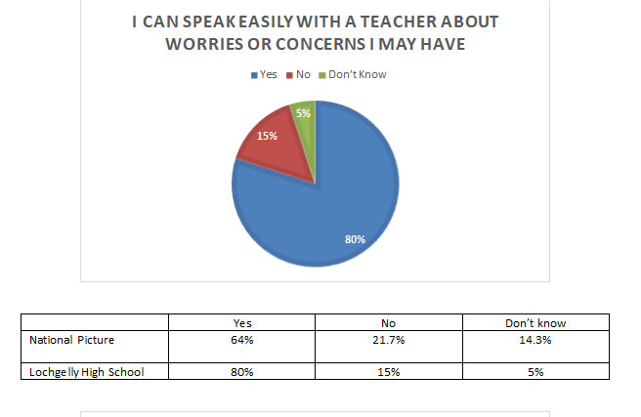

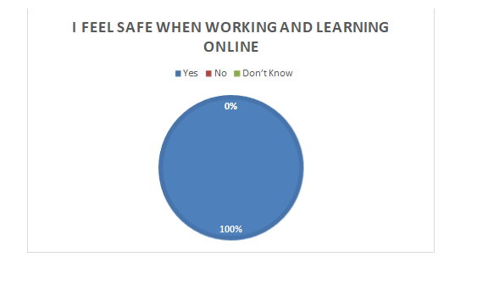
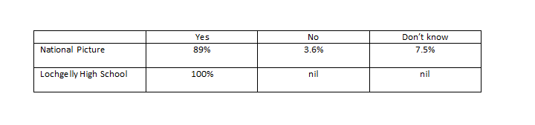
- Flexible Curriculum- 70 S1-3 young people involved in this programme. Almost all have fed back that this impacts positively on their attendance and engagement in school. Most pupils asked felt that Pupil Support had improved their attainment and achievement. All pupils indicated how Pupil Support had helped them with their wider achievement. Pupils highlighted how they were now able to use their assistive technology appropriately, work in teams, speak in front of others, engage with reading, be able to regulate their own behaviour in other contexts etc. as wider achievements associated with the department.
Impact statement from Pupil Support:
- Almost all pupils highlighted the positive impact that the Pupil Support team had on them over the lockdown. Pupils expressed how the staff enabled them to ‘come into the hub’ to engage with learning, whilst another highlighted that was the only thing that ‘kept me working’. Staff were described as being ‘brilliant’ and that their wellbeing was supported as staff ‘phoned a lot’ to give them a daily boost. These interventions were described as being highly ‘supportive’. Most pupils rate their relationships with Pupil Support Assistants as ‘good’ or better.
Most pupils rate their relationships with Pupil Support Officers as ‘good’ or better. Most pupils rate their relationships with Pupil Support Teachers as ‘good’ or better. The majority of pupils believe that the work that takes place in the department supports them with other relationships (peers, family, other staff).
Impact statement from Modern Languages:
- This session, our focus was on positive relationships with pupils, ensuring school and in particular the languages department was a safe space for all pupils. When there was a breakdown in relationships, restorative conversations were held to help improve the situation. Almost all of these conversations had a positive impact in the classroom with less disruptions and better learning.
Impact statement from Social Subjects:
- The reconnect and recovery to support wellbeing has been demonstrated in the introduction of a new Pivotal behaviour system that the department have been working on aspects of throughout the year. All staff have tried to “praise the positive” and give first recognition to the behaviours that we would like to see. This has resulted in almost all pupils receiving merits. Staff also tried to use this approach to support pupil wellbeing during online learning by sending home praise postcards and using the “praise” function in Teams to recognise the hard work of pupils. The department also contributed to the celebrating success newsletter and shared examples of pupil work on Twitter each week.
- The consideration of pupil wellbeing during reconnect phase and online learning has impacted the departmental uptake in S3 and Senior Phase. There has been an increase in the uptake for Geography and Modern Studies in S3, an increase in uptake for RMPS in S4 and for S5/6 History and Geography.
Impact statement from Expressive Arts:
- To address any anxiety from learners we have focussed on basic skills reminders/ opportunities within our units of work, particularly at the start when learners may feel most at sea. Most learners have responded well to this which can be seen in an increased engagement with work, the ability of the majority of learners to confidently evaluate their successes and next steps in learning and a rise in attainment for almost all learners.

Impact statement from Science:
Within the senior phase we returned to mindfulness activities prior to assessments to reduce any stress or anxiety. We also continued our open door policy for learners so they had a safe space and the opportunity to speak to a member of staff whenever they needed. Through our actions all learners were within a calm, purposeful learning environment, conducive to learning and progress. The reconnect of positive relationships meant that the number of referrals decreased very quickly after our return. Through our mindfulness techniques most learners stated that they were more focussed prior to assessments.

Next Steps:
- Continue to develop our Positive Relationships Policy and ensure that the learning environment, including our approaches to learning and teaching, are inclusive.
- Continued focus on outdoor learning (flexible curriculum) and supports for Mental Wellbeing.
- Use of collegiate time as opposed to SIG focus this on development of staff understanding of effective differentiation and the importance of planning around learner needs.
- Staff and Pupil Wellbeing will continue to be a focus for next term- including pupil attendance in school. We will use the Cluster approach to “Our Minds Matter” to survey S1 learners and stage interventions based on this information. We will also utilise the information supplied for new P7 to support with transition. PSAs are undergoing training to support this

Improvement for Recovery Priority Work
Session 2020 - 2021
NIF Priority:  Closing the attainment gap in terms of the most and least disadvantaged young people  Improvement in Young People’s Health and Wellbeing  Improvement in attainment, particularly Literacy and Numeracy  NIF Driver: Leadership, CPD | 3.2 Attainment and achievement  How do we bridge the Covid-19 gap with a particular focus on identified groups of learners in BGE and SP?  How do we plan for the next year ahead in terms of gathering evidence for SQA if exams were not to go ahead or for the best outcomes this session if they do?
Progress:
SQA attainment and gathering evidence
- Fife Guidance was used to develop an LHS Assessment, Moderation and Quality Assurance Policy- all departments consulted and input into this policy
- Alternative Certification Model Calendar was designed which included initial Stage 1 meetings with all PTs in small groups then individual PT meetings with HT and DHT for Stage 2 and Stage 3. Feedback from this was that all staff felt supported and more confident in use of data and able to support learners in gathering the evidence
- During the INSET in February feedback from almost all staff included improvements in confidence around gathering evidence and producing provisional grades.
- SQA Academy- all teaching staff took part in SQA Academies 1 and 2
- Involvement in Fife moderation groups- Five LHS PTs have led these groups. This has provided very strong feedback on the direction of the ACM that was discussed at PTs meetings. All PTs have been involved in moderation groups which supported approaches to internal moderation in school and cross school moderation across Fife.
- Our DHT attainment was involved in Fife SLWG. This improved our knowledge of what was required and helped to shape our policy and approaches.
- Whole School Learning Links and SIG time were completely devoted to moderation this session.
- HT was involved in National sessions with Gayle Gorman and John Swinney as well as Education Scotland coaching program.
- As part of approach to quality assuring our ACM feedback was gathered from a few Learners around information sharing and Pupil log books for profiling evidence (focus groups) as well as Pupil Log book sampling.
- Another part of the quality assurance approach included gathering feedback from Parents/ Carers (Parent Council and focus groups)
- AAA- meeting with educational psychologist- overview of different groupings and sampling
- Weekly PTs meetings included discussion on ACM and approaches to assessment, moderation and LHS expectations around this to meet the needs of our community.

Example of use of strategies to support Literacy and Numeracy:
“The Computing Department has been using a range of strategies to improve literacy and numeracy across the curriculum: - Key words are displayed alongside the learning intentions for each year group on the board. Reference is made to these regularly. For SP courses the key words relate directly to key words in the specific course specification documents. Staff in the Department discuss the meaning of command words regularly with pupils. Staff in the Department have had a focus of correcting spelling and grammar in class work and in homework. - We have made a conscious effort to highlight any links to numeracy in the learning intentions. - We have spent additional time looking at problem solving and calculations, particularly in S3 Computing Science.”

Computing Science:
Our Computing Department adapted their course to be more in line with remote learning including a focus on numeracy and examination command words. They then focussed their inputs upon return to the more practical elements of the course. They have noted an improvement in most of the learners approach to problem solving in assessments. This is good preparation for those moving from S3 into S4 Computing but will also have benefits in other areas of the curriculum.
Modern Languages:
Following the return to school in August, all S2 French classes were divided into smaller classes in order to support their learning of French and pupil’s wellbeing as the class teachers were able to spend more time with each individual pupil.

Due to the period of remote working (March – June and January-April) Senior Phase pupils had missed out on listening and speaking practice. In order to help them catch up all pupils received one to one time prior to their Talking exams this has been a benefit to almost pupils.

Music:
During virtual lessons during lockdown, Music teachers used a programme called Mentimeter to support Learning and Teaching. The teachers started and finished lessons with a variety of slides to measure emotional wellbeing. This fun approach often allowed open engagement with learners around how they were feeling. Senior learners in Music were messaged by their teachers with a motivational GIF prior to their video lesson each morning. The S5/6 class in particular left appreciative messages on Teams around this each lesson. Motivational postcards were posted out to senior along with packets of resources to support their learning. All of the Music class seniors spoke of how important they felt it was to engage with their teacher in virtual lessons through Lockdown.

Impact:
- Extra supports for S4/5/6 literacy and numeracy to ensure that once again we optimise these outcomes for our leavers to ensure best Life chance. This is evidenced in the attainment data for S4 Literacy and Numeracy outcomes.
- S3 intervention to bridge gap in numeracy for move into S4- see PT1 Numeracy PEF feedback
- 209 Senior Phase learners week 1 and 190 Senior Phase learners week 2 were provided with supports for Practical Subjects in return to school in March and 160 young people attended Study Support over the 4 day input over Easter with an additional 39 learners being provided with study support virtually.
- Tutoring- SEIC there have been seven N5 Maths learners who have been engaged and reported back that they benefited from this input. St Andrews University (Fife tutoring initiative) have tutored three Higher Chemistry, three Higher Physics and three Higher Maths students. Almost all reported that this improved their confidence and outcomes.
- Qualifications Group time ensuring best outcomes with 13 learners getting supported- additional Computing qualification. Almost all young people have attained National 4 Literacy and Numeracy, also ensuring that they attain a minimum of 5 qualifications in S4. There has been Qualification Group input and support around those most at risk of not attaining. 52 learners across different groups have been targeted including lowest attendance in school and engagement in remote learning, Young Carers, Care Experienced, Most able and pupils with ASN . This has been particularly challenging this session and involved a lot of outreach work by PSAs and DHT attainment.
- Impact statement from Modern Languages:
The majority of Senior Phase pupils achieved better than predicted grades in their Talking Assessments due to the one to one time they received. Attainment in National 5 and Higher Spanish is very good this year with the majority (60%) of pupils meeting or exceeding their aspirational grade. Due to the individualised support received this year, a minority of our pupils this year achieved better results at Higher than at National 5 last year. Almost all BGE pupils using the vocabulary and support folders have engaged really well with them and have participated more in class as a result. All staff participated in various training events and moderation days to ensure they were fully equipped to assess pupils fairly.
- Impact statement from Computing: “YP in the Computing department are more confident in writing full examination style answers using the appropriate command words. This was evident in the answers provided by the majority of YP in the recent ACM written assessments. In general, answers provided by the young people were more detailed and less marks were lost needlessly as a result of poor quality answers. YP in the department have demonstrated that they are more confident in using number which allows them to solve problems, analyse information and make informed decisions based on calculations. The vast majority of YP in S3 and SP performed well in questions relating to number and calculations.”
- Covid Teacher impact in the Scottish Government additional funding section
- PSO impact in the PEF section to follow
Next Steps:
A more strategic approach to ACM spread across the whole session with opportunities for moderation and gathering evidence embedded into the calendar. Consideration of on track reporting to support this.

More strategic approach to identification and ongoing support for achievement for the most vulnerable group of learners – those most at risk of not achieving from the beginning of S1 and a particular focus in S3.

Use of SNSA information to have specific detail around gaps in literacy and numeracy interventions- DHT and PT Numeracy to go on SNSA training

Outcomes for Young People
Positive Destinations:
 | Positive Destinations | 5 year change | 1 year change | Comparison with virtual comparator
 | 2015/16 2016/17 2017/18 2018/19 2019/20
Lochgelly High School | 91.6 93.4 92.3 96.1 90.2 | -1.4 | -5.9 | -0.1
Attainment overview:
S3 CfE
Stage S3 | Reading | Writing | Listening and Talking | Numeracy
2016 | 76.56 | 74.22 | 80.47 | 78.91
2017 | 76.74 | 65.12 | 65.12 | 49.21
2018 | 70.08 | 55.91 | 68.55 | 70.31
2019 | 83.46 | 71.65 | 79.20 | 69.05
2020 | 73.7 | 61.7 | 70.0 | 51.9
2021 | 77% (69.0% inc DAS) | 74% (66.0% inc DAS) | 82% (74.0% inc DAS) | 59% (52.0% inc DAS)

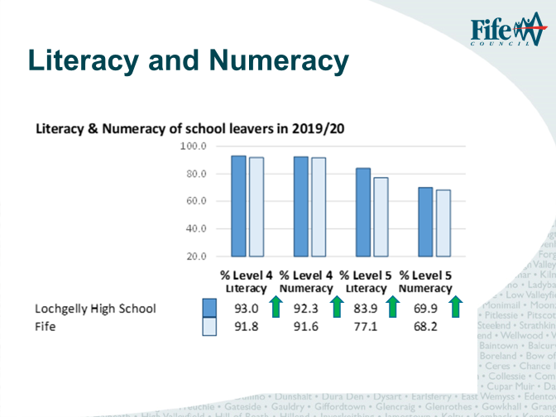
S4
Year | % Level 4 Literacy | % Level 5 Literacy
2015 | 85.71 | 48.87
2016 | 86.92 | 58.46
2017 | 87.94 | 56.74
2018 | 87.77 | 63.31
2019 | 88.37 | 75.19
2020 | 93.01 | 66.23

Year | % Level 4 Numeracy | % Level 5 Numeracy
2015 | 67.67 | 36.84
2016 | 64.62 | 29.23
2017 | 85.82 | 39.01
2018 | 82.73 | 35.97
2019 | 89.92 | 63.57
2020 | 83.85 | 56.15
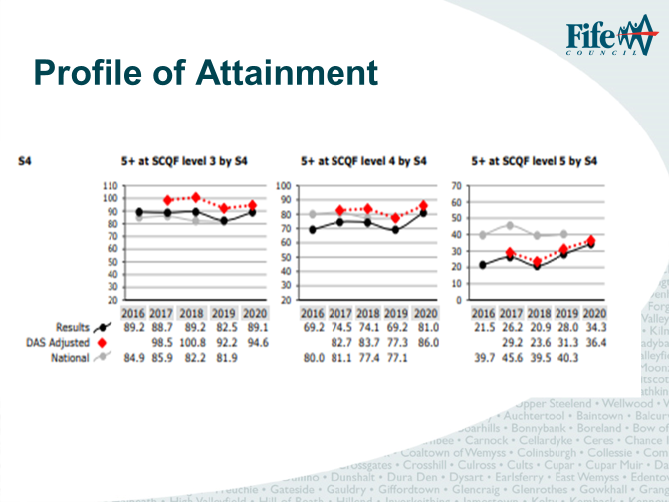
S4 Attainment:

Year | % 5+ Level 3 | % 5+ Level 4 | % 5+ Level 5
2016 | 89.2 | 69.2 | 21.5
2017 | 88.7 | 74.5 | 26.2
2018 | 89.2 | 74.1 | 20.9
2019 | 82.5 | 69.2 | 28.0
2020 | 89.1 | 81.0 | 34.3
2021 | 89.47 | 79.7 | 28.57

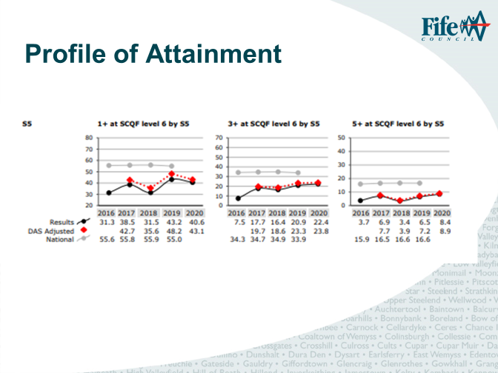

S5 attainment:
Year | % 1+ SCQF Level 6 | % 3+ SCQF Level 6 | % 5+ SCQF Level 6
2016 | 31.3 | 7.5 | 3.7
2017 | 38.5 | 17.7 | 6.9
2018 | 31.5 | 16.4 | 3.4
2019 | 43,2 | 20.9 | 6.5
2020 | 40.6 | 22.4 | 8.4
2021 | 48.9 | 28.5 | 10.2

Attainment:
In terms of school attainment, the outcomes for N3/4/5 in S4 show a pleasing upward trend. The S5 1@L6 showed an expected slight decrease as in 2019/20 the outcome for 1 Higher was the best result ever, however this has been exceeded in 2021. For 3 and 5@L6 the ongoing increasing trend is pleasing. S4 results show a slight decrease on 2020. This was as predicted as was a slightly less able year group overall.

We were exceptionally proud of the outcomes for Literacy and Numeracy which continued to show an upward trend for S4/5/6 leavers.
We are concerned around the attainment of S3 BGE, in particular in numeracy, and this continues to be an area of development for our cluster. We are aware that there was a lack of engagement with certain year groups with Maths during Lockdown 2 and various strategies were employed to encourage engagement including use of Interdisciplinary Learning, small mathematical challenges and contact with home.

Positive Destinations outcomes dipped by 5.9% in 2020/21. We know that a large percentage of schools in Fife also experiences a dip in destinations, particularly those in low SIMD profiles. This was exceptionally disappointing to us as we are a school that takes great pride in our Positive Destinations outcomes for every individual young person and have worked hard to secure our best ever outcome in 2019/20 at 96.1%. This included interventions with CR Smith Handpicked Academy and Enable. We did have a change in SDS workers in school and this has shown that systems and processes- including communication need to be revisited and clearly delineated including a clear calendar for intervention. We are reengaging Enable to work with our DAS learners and also MCR to work with Care Experienced young people. In addition to our DYW work and a focus on Career Management skills we will improve our Positive Destinations next session back up to where we were. Our target is always 100% and we will be aiming for this.

Evidence of significant wider achievements
- 156 hours completed for Duke of Edinburgh volunteering. This improves skills such as communication, teamwork and build confidence.
- Kingdom FM nomination for Best School Award- one of last three finalists- Listening school, this evidences impact of and listening to pupil voice
- Chamber of Commerce awards- Best Business Partnership with CR Smith in terms of our Handpicked Academy work- support for CV writing and Positive Destinations evidence of support for development of the majority of young people in S3-6 in terms of Skills for Work
- Recognising/ Bronze level of the “We Care” Award.
- SOHK caps- resilience and responsibility two of our S3 learners were the second and third in Scotland to be awarded these caps
- Rotary Community award- Respect for and working with our community DAS Rotary Bulb garden- Respect for our environment
- SOHK John O’Groats to Lands End Staff Cycling challenge- Health and Wellbeing of staff, Second in UK- Mental and Physical wellbeing
- PC Passport for 13 learners in S4 as an additional L4 qualification
- Links with Higher Education bodies for Business Education- 10 pupils are involved in a Work Experience with Ernst Young “Smart Futures” this Summer. Pupils will be working on live financial projects and gaining extra employability qualifications. The impact of this is that pupils will feel more self-confident when they are in The World of Work. One pupil in S6 was successful in being selected to do a podcast. This again developed her positive mindset. A Director from RBS spoke to AH Business classes about opportunities in finance.
- We have 13 learners achieving a Level 6 NPA Business with Information Technology and 5 learners Level 5. This is because they have studied Administration & IT and Business Management and have passed the Outcome Assessments. By pupils studying N5/H Administration & IT and N5/H Business Management and passing they also get the NPA so walk away with three qualification for only doing two subjects within the department.
- Five of our current S5 pupils have been part of the Lift Off Learning programme. They attended live sessions using MS Teams and breakout groups with other pupils from Secondary Schools across Fife and Tayside. This improved their teamwork and communication skills and introduced them to the world of Higher Education as a possible pathway.
- The majority of S4 pupils achieved The SQA Employability Award- skills for work
- The LHS ICT Ambassadors planned a series of internet safety and digital well-being events for Safer Internet week in February 2021. Unfortunately these were unable to proceed due to the school closures. They planned separate lessons for YP in BGE and SP to be used in WAWA classes. The ambassadors were able to share Internet Safety messages on Teams and created information for Parents to access Teams. We are aiming for achieving the European Digital Schools Award next session.
- Our Music Department plays a crucial role in the wider life of the school. This session they were challenged with thinking outside of the box to enhance family and community engagement. For example the Virtual Christmas Concert included almost all of the instrumentalists in the Pipe and Wind Bands. They also utilised virtual instrumental tuition, local authority virtual orchestras, solo competitions for Pipers etc. Almost all of the LHS instrumentalists featured in the Virtual Local Authority Showcase Ensemble in June 2021.
- Expressive Arts: one S5 and an S6 pupil successfully achieve entrance to Duncan and Jordanstoun College of Art’s Foundation course and Strathclyde Universities architecture course respectively. In the BGE, several S2 pupils engaged with Edinburgh Universities’ ‘Power of Public Art’ online project gaining an ‘Artsmark’ award and a few S3 pupils will be participating in Fife Contemporary Arts’ Digital Summer School.

What have been the success and challenges of school/setting closure period (school/class/playroom isolation, remote learning between January – March 2021)
Expectations for remote learning:
Challenges:
- Whole School Remote learning was a really challenging period for pupils and staff alike in Lochgelly High School. Overall engagement across the school was reasonable with the majority engaging at some point during the nine weeks of complete Remote learning. It was higher in some year groups than in others. Engagement in S1 and S3 was better than in other year groups where most young people engaged in some of the weeks. Overall, engagement during lockdown 2 was higher than during lockdown 1. Our Guidance Team were in contact where learners were not engaging to find out if any supports were needed and provide devices. On the back of these conversations a few young people were then encouraged to attend the Inschool Learning Provision.
- During Lockdown 2 (Jan- Mar 21), in school learning provision was implemented and offered to learners of key workers (S1-3) and 37 vulnerable learners. Our 57 DAS learners who require additional support, nurture and face to face contact were also supported in school. The sessions followed the normal school day and learners were supported by all teaching staff on a rota and had the daily support of DHT Support, guidance teachers and support staff. A few additional learners were offered days in the In School Learning Provision due to various factors including mental health. These sessions were offered on an individual basis.
- During and post the school closure period, the Pupil Support team were involved in a number of activities to support the reconnect and recovery phase of Education. These activities included, but were not limited to:
- Wellbeing visits to households
- Organisation of equity and welfare packs accessible in local community hubs
- Supporting the delivery of Education for the in-school provision for vulnerable learners
- Daily phone calls to learners with ASN and their families to support wellbeing, learning and engagement
- Organisation and delivery of paper-based resources for learners with ASN and barriers to accessing learning through
Glow Teams
- Delivery of ICT to learners without digital access
- Information was collated from all stakeholders (parents/carers, pupils and staff) to arrange appropriate
Interventions from Pupil Support Team

Learner descriptors were shared with YP / parents and carers on a weekly basis via the school website. Work details were also shared on the LHS App and tweeted using Twitter. This allowed parents to keep abreast of the learning programmes being offered by the various subjects. Departments / Faculties posted work on a rolling basis through Microsoft Teams to try and avoid overburdening pupils.
All teachers facilitiated at least one live check in with learners each week
Almost all subjects had at least one live lesson per year group per week and almost all Senior Phase lessons in the majority of subjects were delivered by live interaction.
Feedback on learning was gauged as a priority to progress learning and several PTs meetings and DMs had this as an item on the agenda as part of our approach to CLPL.
Data for engagement levels (January – March 2021):
Average engagement levels over period = 63.2%
S1 = 67.7%
S2 = 62%
S3 = 67.8%
S4 = 61.5%
S5/6 = 57.5%
This shows that the majority of learners engaged with learning over Lockdown 2. There were follow up phone calls from Guidance Teachers and PTCs subject to encourage the young people to take part.
Feedback from Learners:

Question | Percentage of Learners in LHS  (agree or no opinion) who responded | National percentage of learners
“I am clear what I am to learn each day” | 69% | 70%
“Information is easy to access on line” | 78% | 80%
“The amount of work I have to do is too much or about right” | 92% | 88%
“I have opportunity for feedback from my teachers” | 71% | 71%
“I can speak easily with a teacher about any worries or concerns” | 80% | 64%
Feedback from Parent/ Carers
Question | Percentage of Parent/ Carers in LHS (agree or no opinion) who responded | National Percentage of Parent/ Carers
“My child has regular contact with their teachers” | 78% | 75%
“We have the appropriate resources and equipment” | 91% | 89%
“I am satisfied with the quality of remote learning” | 79% | 71%
“I am satisfied with support for learning over lockdown” | 79% | 70%
Some successes of Remote Learning :
Business Department statement:
I feel if we didn’t offer live lessons the engagement levels would have been low and our pupils would have fallen behind. Pupils enjoyed being part of the live lessons. I know this because they stayed on at the end of lessons to informally chat – they enjoyed still having the contact with us – I feel this helped their mental wellbeing.
Learning from Lockdown to take forward:
Continue with having resources on TEAMS, homework should be handed in via teams and pupils become more and more confident using ICT as they will need to when they look to apply for jobs – this is a vital skill. Teachers should continue to have up to date resources so that pupils can access when working from home. Use the framework from Education Scotland on ‘Building Back Better’ to further develop pupils skills in the classroom and at home.

Expressive Arts:
Most BGE pupils have shown progression in assessed folio work and practical performance. The majority of pupils engaged in online learning during the second lockdown which was a significant improvement on the first period of remote learning. Within the SP most pupils have shown positive progression within tracking assessments and almost all pupils engaged in online learning during the most recent period of remote learning. Improved attainment was partly due to the extended amount of time spent on the written element of the course during both home learning periods.

DET:
Our senior phase engagement has been a particular success across all of the DET subjects. Almost all S5/S6s have engaged with learning throughout lockdown, above 90%. Across the BGE cohort our best engagement came from project-based learning so we are looking to incorporate this style into our existing BGE programme.

English:
The Department discovered new approaches to Teaching and Learning as a result of remote learning – ones which made more effective use of a range of multi-media tools e.g. the creation of revision videos for Senior Pupils. This will continue to be a feature of our teaching strategies as we move forward as we could see the benefit of creating these and the feedback from the pupils was very positive about them.

Science:
During the most recent period of remote learning some staff began to use class notebook, specifically within the senior phase. Almost all pupils were happy with the move and felt that it was easier to complete and hand in work set. The use of class notebook as a classroom learning tool will be further investigated for the 2021-2022 session.

Impact of Local/National resources to support recovery within your setting (digital devices, additionality of staffing)
Number of devices provided to support learning at home | 80 (plus a further 120)
Additionality in staffing | 2 FTE
Devices to support learning at home:
Feedback from learners and parents/ carers around the supply of chrome books where young people did not have a device has been that this has been an invaluable support in allowing them to keep up with their online learning.
Of the 80 Chromebooks issued engagement figures improved for all pupils issued with a device. Almost all subject areas commented that there had been an improvement in those learners’ engagement who had devices supplied.

In terms of specific feedback the following comments were provided by learners whose opinion was sampled:
JS S3
- The Chromebook (CB) allowed me to access the work on Teams much easier and this allowed me to keep up with the work a lot better.
- I completed no work in lockdown 1 because I was only using my iPad but from when I received the CB I managed to complete nearly all of my work.
- Having access to Word and PPT made completing the work much easier.
AL S3
- CB was really easy to use as it logs in as soon as you open it.
- Much better than only using my phone.
- I completed very little work in lockdown 1as accessing Teams was difficult but as soon as I got the CB I managed to complete nearly all my assigned work.

EB S4
- I didn't have to share a device with my brother and this helped me work when I wanted, and I could save all my work on the one device.
- I had to share a laptop during lockdown 1. Not having to share allowed me to complete more of the work assigned to me.
- I still used my phone for some of the live lessons but when I did use the CB it helped me to see the other members of the class better.
JO'D S4
- I received a CB between me and my brother and although I could use it some of the time I was still using my phone most of the time to access Teams.
- I completed more work during lockdown 2 but could have completed more if I didn't have to share the CB.
HS S4
- I was able to get more work done as it was easier to get logged in to Teams and to see all of the work in one place.
- Having access to Word made it easier to type up any work. Doing this on my phone during lockdown 1 was a nightmare.
HK S4
- It was much easier to use than my phone.
- I didn't have any issues with connecting to Wi-Fi when using the CB but my phone would struggle for signal sometimes.
GA S6
- Not having to share a device with my brother and sister was a massive help as it allowed me to work when it suited me most.
- The access to the live lessons was much better as I could see all the materials my teaches were sharing on a bigger screen. This helped me to get a better understanding of the assigned tasks.
- I was fully engaged with my learning in both lockdowns but having the CB made accessing Teams and staying on track with my assignments much easier
- I have continued to use my CB every day since returning to school
Feedback from Computing: A few of our YP in Computing – S3, S4, were able to start engaging with the work set on Ms Teams as a result of acquiring a home working device.
Feedback from Business: In lockdown 2 the department felt that engagement was a lot better. Having the capacity to contact parents directly and ask what the barriers are and how we could support the learners made a massive difference. Pupils have learned vital communication skills in the way that they engaged with us during lock down which enhances their employability skills.
Additionality in staffing: The two “Covid teaching” FTE staff were utilised in different ways. Both were used in proactive and reactive means. In terms of reactive this was to support with cover where staff were self-isolating or having to be at home to support their own children who were self-isolating. Almost all of the 80 learners who were given a chromebook had good engagement with their learning.
In terms of the proactive work one of the Covid Teachers was involved in “bridging the gap” and supporting with improvements to attainment particularly for those learners most at risk of not achieving known as our “Qualifications Group”. The other Covid Teacher had a focus on nurture and building resilience through meetings and interventions one to one and small groups. She also had inputs with a Prince’s Trust class where she led work with the local care home and two pupils achieve a bronze award from National Archaeology Trust. All learners involved in the nurture supports fed back that this improved their attitude to school and had it also had a positive impact on their attendance pre lockdown 2: Health and Wellbeing for quizzes. Positive mental health and wellbeing outside the school day. Proactive support for young people offered by Covid support teachers:
- Bronze IDEA award for 4 S4 pupils
- Prince’s Trust and work with Mossview Care Home for class of 12 learners
- School refuser group- supply delivery of resources, scheduled 1 to 1 meetings with 5 S1-4 young people around encouraging attendance to school- social anxiety
- Leadership class- 15 S6 learners
- Reconnect Group S3 boys and literacy skills
- Outdoor learning with History class- also virtual visit from St Andrews Historian
- Walk and Talk sessions to support mental health- S3 boys
- Girls group

Attainment Scotland Fund Evaluation (PEF)
Progress:

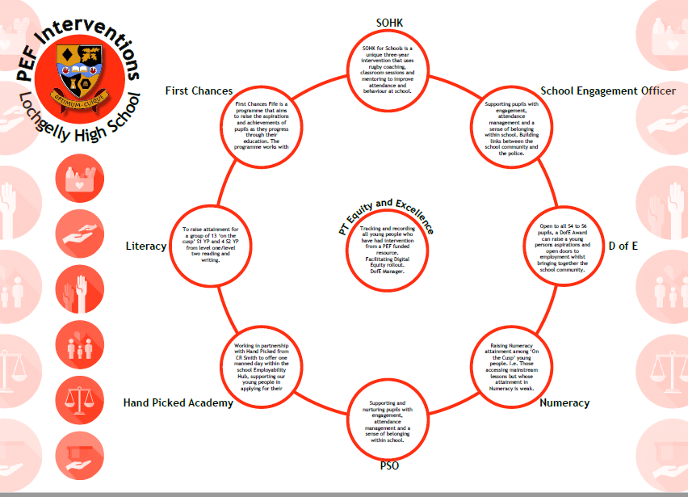

Impact:
SOHK:
Prior to the easter break we adapted our practice and came to the school 3-4 days a week to give our participants 1:1’s focusing on the ones we did not have any contact with over lockdown. With a focus on their overall wellbeing.

-Personal Development:
After the easter we resumed to our normal timetable and we have delivered 7 personal development sessions to each group these were: Sugary drinks, nutrition, sleep, digital health, mob mentality and growth mindset.
-Mentoring:
Over the course of the year, we have developed positive working relationships with all participants where they feel comfortable discussing aspects of their lives. We discuss strategies to help them overcome these and build up resilience, we also use target setting as a way of allowing the participant to take some ownership and feel a sense of achievement when they accomplish it. Please see attached case studies.
We have also been approached by some education staff at the school asking for support on how to work with some of the participants we have. We have offered advice and strategies to assist them.
-Attendance at SoHK sessions:
S2 – 80%
S3 – 80%
-Monitoring & Evaluation
We have completed our final feedback form, and these are the findings from the start of the year to now:
S2
50% increase in overall happiness.
10% are happier in their peer group.
16% are happier at home.
4% increase in enjoying their school.
27% reported that they are feeling good about themselves.
24% reported an increase in their confidence.
S3
13% increase in their happiness at school.
16% are happier within their peer groups.
23% are happier at home.
24% increase in enjoying their schoolwork.
23% reported that they are sleeping better.
18% reported that they are feeling better about themselves.
31% reported increase in their confidence.
86% increase in overall happiness.
-School Stats:
S2 – 61% improved their overall attendance at school (with one YP improving by over 16%)
Over 44% improved their punctuality.
83% received more positive behaviour points
50% are now receiving less referrals.
S3 – 66% improved/maintained their overall attendance at school (with one YP improving by 21%)
80% improved/maintained their punctuality.
Over 86% received more positive behaviour points.
80% are now receiving less referrals
We are working with 20 S2 and 17 S3 pupils.
Computing Department:
“A number of our S2 pupils attend the School of Hard Knocks. As a Department, we were recently asked to complete an evaluation form for some of these YP to indicate if we had observed any changes in their behaviour, levels of engagement etc. I can confirm that we have observed improvements in a number of our YP”
Modern Languages:
“All pupils who engaged in school of hard knocks and Spanish are now much more engaged in Spanish.”
DET impact statement:
Significant impact on behaviour and engagement with pupils involved. Specifically, 3rd yr pupils – increase in attendance

PSOs Nurture and Family Engagement
- Online Courses on Mental Health First Aid and Seasons for Growth completed by Guidance and PSOs. This has provided skills in Guidance staff to support mental wellbeing of learners and will lead to Seasons for Growth Programme being offered for groups of 10 students next session who meet the criteria.
- During session 2020-21 Pupil Support also offered a range of nurture groups including; S1 Movers group (supporting transitions) 14 learners, Nurture/ resilience groups 28 learners, Going into the weekend group (weekly check in), 4 learners, Direct Support to individuals on a weekly basis, 6 learners and Learners identified as requiring alternatives to Duty Rector (Enhanced Protocol), 25 learners. Total of 77 learners included in nurture groups.
- Feedback from learners included:
“I feel calm and not anxious when I am in the group”, “I feel like a stronger and more positive person”, “I have made new friends in the group”, “I always feel safe and can talk openly about anything worrying me because everyone has the same kind of feelings so no one will judge”, “I learn from others’ coping mechanisms”, “We can relate to each others’ feelings”, “I never feel alone when I am in the group”, “I know that all the others will let me lean on them and open up” and “I am a lot more outgoing inside school and outside”.
- Groups have been running again since the Easter holidays. Pupils in the groups have taken a while to settle in and a lot have experience anxieties Mrs Collie and Mrs Martin are now seasons for growth companions and will be delivering sessions every Thursday P5 & P6.
- PSOsI have been delivering 1-1 BGE support with 3 pupils, one who has previously been excluded and we are working towards more in school attendance and 2 who have disengaged from their timetabled classes, one due to anxieties and one due to anger management issues.

PSO – Nurture
- All pupils asked highlighted the positive impact of the interventions run by the PSO. Highlights of their feedback include how these interventions are the ‘main reason I come to school’, helping them to have increased ‘confidence’, being ‘less panicky’ and having a ‘better attitude’.
- Almost all pupils indicated the interventions improved their confidence, made them feel better about themselves
- The majority of pupils highlighted how the interventions supported their wider relationships with peers and staff and helped them to make new friends more readily

PSO – Learning and Engagement
- All pupils asked described their experience in the learning hub as positive. Highlights of their feedback included comments around how the hub had improved their behaviour, allowing them to ‘focus more in class’. Another pupil indicated how they were no longer ‘scared of people as much’, whilst another stated that they felt ‘better about coming to school’. Improved confidence was a recurring theme in pupil feedback.
- Almost all pupils indicated that the learning hub had supported them to have
- The majority of pupils highlighted how the learning hub interventions had improved their confidence and how they felt about themselves

Feeling valued and included
“We all support each other in the group which I think is really nice, makes me feel good”
“We can always be ourselves”
“We have chats about feelings and we can always be open and honest and don’t feel judged at all”
“We all have at least one thing in common and it’s good to hear other people feel like I do, we know how each other feels because we all have our own problems every day like being anxious”
“This is my last year at school but I feel I have made friends that I will keep when I leave”
“I always feel really relaxed when I leave the group and ready for the next period”
“I feel like the pressures of exams are a lot to cope with but the group feels like an escape, it is nice to be in the quiet safe space”.
“Mrs Collie’s always listens”
Impact statement from DET:
One learner in particular in S1 has seen a significant change in behaviour for the positive and now fully engages with every lesson

PT Literacy and PT Numeracy
PT Literacy
Class have made good progress. Progression in reading skills achieved by most learners (70%) of those who regularly attended.
Students were identified through analysis of SNSA data and current Reading and Writing levels. Nine S2 pupils regularly attended the class once per week and of the nine, four made very positive progress through both their reading and writing levels. RO moved from 2G to 3S in Reading and 2S to 3S in writing. TD moved from 2G to 3B in Reading and 2G to 3B in Writing. OH’s Reading level didn’t change but progressed from 2S to 3B in Writing. DK progressed from 2G to 3B in Reading and from 2S to 3S in Writing. Awaiting SNSA data from S3 to assess further progression. All other pupils who attended the class made no positive change in Reading or Writing levels.
Literacy mats have been produced but still experiencing issues with production post-Covid.
Lexia trial was postponed and is scheduled to begin in August due to Covid restrictions.
Leadership class have been trained and the groups have met twice.
Literacy pack developed. To be shared with identified YP and families in August.
Lexia intervention and Literacy packs to be shared with these YP. Readworks.org tasks to be set to increase family engagement.

PT Numeracy
Group of 15 young people identified to work with. Pupils identified through a combination of primary tracking data and teacher observation/ assessment score from September.
Pupils withdrawn from one period per week (Thursday period 4) to work on Numeracy with PT Numeracy. Focus on core numeracy topics including structure of number, place value, multiplication, division etc.
Pupils assessed at beginning of intervention. Progress planned to be assessed at S1 tracking periods (December and two further occasions in the year). S1 currently have the majority of pupils (65% of the cohort) achieving Level 3 (B/S/G) with in their last Maths assessment, compared to last year only 49% of pupils achieved Level 3 (B/S/G) in the same assessment. The change to our approach to the BGE lessons has shown improvement
Group changed in April from S1 ‘On the Cusp’ learners to Prospective National 5 S3 learners who missed content during lockdown. Group meeting Monday period 7 (learners withdrawn from WAWA until summer).
Focus on catching up topics which learners missed during lockdown to enable them to continue to access their own classes and to continue to work towards National 5 in S4. The extra revision class run by Mr Murphy for the S3 classes 3B1 and 3B2 was gauged to have been very effective in impacting positively on their CfE outcomes.
Observed increased confidence in class and ability to access new material.
See CfE data for Numeracy for S3- now inline with last year due to Numeracy intervention.

Handpicked Academy
New fulltime employee Megan McKay working every Wednesday since February
In that time Megan has worked with 22 pupils
9 males vs 13 females
Covering:
CV Support/Building (for all 22); Cover Letter Support; Skills Tests for college; Interview Prep; Apprenticeship Applications; Job Search; Interviews from job search x 1; Accepted into college/Uni x 4; College Applications Completed x 4; Apprenticeship Applications completed x 6
S4 x 4 learners
S5 x 9 learners
S6 x 9 learners
CW has successfully gained a trail with a metal manufacturing plant in Glenrothes
CR Smith printed full colour handbooks for all classes – delivered to LB who distributed to class teachers to be used as classroom material
Due to 2nd Lockdown and work placements not going ahead this year no progress made.
2nd Lockdown and then PMcG off on maternity.
The Handpick hub has worked closely with individuals to support in applying for part-time work, college and apprenticeships post lockdown.
First Chances Fife
Due to Covid-19 all in person delivery has been suspended since March 2020. All elements of the First Chances Fife programme have been converted to online delivery. First Chances Principal teachers have supported pupils, through phone calls and emails. In 2020 – 2021, First Chances Fife increased the number of online support sessions for pupils and increased this session. Pupils have been offered a greater range of activities throughout the year including involvement in British Science and Brain week.
Breakdown of learners involved in the LHS cluster:
Benarty: 7 Cardenden: 9 Denend: 8 Lochgelly South: 7 Lochgelly West: 8
Learners completed a writing piece in P7 which was submitted. Each fully completed piece was printed, framed and delivered to LHS for distribution.
Pupils were asked for their feedback on the events that have taken place so. The majority of answers have been positive about the activities. The pupils have felt they have learned new things, gained new experiences and have said this will help them in their work at school. Parent and Pupil feedback will also be gathered after the full year of activities at the summer school.
Primary 7: Books and Blogs
Almost all of pupils enjoyed the Blogs session online that responded to the survey. A highlight of the session for the pupils was meeting ambassadors who shared examples of blogs. Most of the pupils responded that the blogs homework improved their writing skills.
Of those who responded to the survey most pupils agreed that they enjoy being on First Chances Fife. The majority either agreed or strongly agreed that First Chances Fife had improved their confidence and helped them with their schoolwork.
Pupils were very positive about the books and blogs aspect of the programme and many pupils commented that their favourite part was “Reading more books and leaning new words”. In blog section of the programme, pupils commented that they enjoyed “writing about something that I enjoyed” and “ I enjoyed being creative with my imagination while exploring various writing skills”.
S1 Science Discovery Day 1: Famous Scientist
Of those who responded to the survey most pupils enjoyed the activities and almost all agreed that they had learned new skills. Most pupils commented that they enjoyed participating in First Chances Fife and that the programme helped them with their schoolwork. Examples of pupils’ comments on why they enjoyed First Chances Fife include “the people and new experiences” and “the fun activities” and “ it has helped me become so much more confident and meeting new people”.
S1 Science Discovery Day 2 : Science week
Eight live sessions were held across science week, with activities in Computing, Psychology, Chemistry, Mathematics and Physics. Most pupils enjoyed the events that they attended. Pupils were given the opportunity of participating in at least 2 sessions. Of those who responded to the survey the computer science event had an overall positive response. Pupils enjoyed the range of Psychology sessions available and most enjoyed ‘How does Psychology help me learn’ and ‘Eyewitness Testimony’ sessions. The interactive Physics session was extremely well received as almost all pupils that attended gave a positive response.

School Engagement Officer (April 2021)

Since starting on Lochgelly High School in April 2021, PC Smith has worked primarily with Pupil Support, Guidance Departments, and the Senior Leadership Team, he has taken on Enhanced Protocol and Duty Rector patrols.

PC Smith has assists Guidance staff in investigating peer issues within the school and has conducted several restorative meetings with pupils to resolve their concerns, this assistance greatly improves the pupil's wellbeing and resilience within the school. He has delivered inputs in Modern Studies (2T2) who requested some extra information on their Crime module. He is working collaboratively with the Guidance staff in delivering WAWA lessons as many of the topics in these classes have a crossover in modern Policing.

Other matters PC Smith assists with are enquiries from the community who reside near to the school.

PC Smith has worked in partnership with SSF, Clued-Up, SFRS and NHS School Nurse where a summer safety message has been delivered to all S2 pupils to raise awareness on ASB, Fire Raising, Drugs and Alcohol misuse. This has been in an effort to reduce ASB in the school catchment area.

School/Setting Name __Lochgelly High School________
NIF Quality Indicators (HGIOS 4) School Self- Evaluation
Quality Indicator | 2018 - 2019 | 2019 - 2020 | 2020-2021 | Inspection Evaluation  (within last 3 years)
1.3 Leadership of change | Good | Very good | Very good
2.3 Learning, teaching and assessment | Good | Good | Good
3.1 Ensuring wellbeing, equity and inclusion | Satisfactory | Good | Good
3.2 Raising attainment and achievement | Good | Good | Good

Appendix B Session 2021 -2022 LHS School Improvement Plan
National Improvement Framework Priority: Improvement in employability skills and sustained, positive school-leaver destinations for young people, Closing the attainment gap between the most and least disadvantaged
Focused Priority: Improvements in Learning and Teaching and our Curriculum model to support the best progression of our learners
HGIOS4 Quality Indicators 2.3 Learning and Teaching
3.3 Increasing Employability Skills
2.3 Learning, Teaching and Assessment
Expected Impact | Strategic Actions Planned | Responsibilities |  | Measure of Success  (Triangulation of Evidence) | Timescales
Career Management Skills:  Our young people are ambitious and better prepared for the world of work through progressive learning that connects more directly to employment. They are resilient, adaptable and understand the value of the skills that they are acquiring.  All S2 learners will experience Career Management Skills in all subjects across the session.  Curriculum Review:  We co-create a Curriculum fit for the needs of all learners in LHS which is based on clear rationale suited to our key demographics and catering for a broad continuum of learner pathways.  Use of positives from Lockdowns to support and extend learning:  Consistency in Very Good Learning and Teaching through reflections and embedding IT and other work from Lockdown | Career Management Skills will be embedded in the majority of S2 lessons (using lesson inserts from My World of Work) as Success Criteria, but will also be shown through displays in classrooms and corridors in all areas of the school. As we move towards a new system of reporting, staff will discuss CMS with young people during learner conversations, where appropriate.  We consult with all stakeholders and seek feedback around the curriculum rationale. Senior Phase is reviewed and consideration of offerings and outcomes for all S4/5/6 learners. This will lead to a more appropriate curriculum for all S4-6 learners. (Consideration will be given to the Senior Phase OECD report recommendations expected in August)  Teachers will reflect upon and embed all areas of good practice which impacted positively on pupil experience from Lockdown eg use of Teams for homework. | SMc, AJ, All PTs, All Teaching staff, Handpicked Academy and SDS  DA/ SMc/ All PTs  SMc/ SA/ All PTs |  | Learning Link Minutes, Learning Visits, S2 Focus Group feedback, Learner Profiles in WAWA classes,  Improvement in Positive Destinations  Curriculum consultation feedback  Improvement in attainment  Improvement in Staying on Rates and Positive Destinations  Number of alternative courses such as NPAs on offer  Learning link discussions and LTWT reports  Feedback from BGE and SP focus groups | August 2021- May 2022  August 2021- Feb 2022  (roll out Aug 2022-May 2024)  August 2021- May 2022
Ongoing Evaluation
August- Planning
January – Interim evaluation discussion
Planned as part of the Learning Visit proforma
Feedback from focus groups
May evaluation

National Improvement Framework Priority: Improvement in young people’s Health and Wellbeing, Closing the Attainment gap between the most and the least disadvantaged
Focused Priority: Promoting Positive language and Positive Relationships through consistent adult behaviours
HGIOS4 Quality Indicators 3.1 Ensuring wellbeing, equality and inclusion
Expected Impact | Strategic Actions Planned | Responsibilities |  | Measure of Success  (Triangulation of Evidence) | Timescales
Improved pupil language and behaviour based on pupil and staff relationships in all classrooms and areas across Lochgelly High School. This will involve all learners and all staff across our school community. All learners have an improved pupil experience thorough a more positive learning environment across our school community. | Through consistent adult behaviours and a focus on language, merits and demerits we will embed some of the Pivotal work and Restorative Approaches.  Positive Relationships Policy will be created and consulted upon with all stakeholders and consistently adhered to in all areas | AR/ SH/ DA/ Positive Relationships Working Group |  | Reduced duty Rector calls  Reduced walk outs from classrooms  Positive feedback from stakeholder focus groups and pupil suspension periods  Reduced Exclusions  Collegiate session feedback  LTWT comments in reports | Aug 2021 -June 2023
Ongoing Evaluation
August- Planning
Collegiate sessions- four as per school calendar
January – Interim evaluation discussion
Planned as part of the Learning Visit proforma
Feedback from staff, BGE, SP and Parent/ Carer focus groups
May evaluation

National Improvement Framework Priority: Improvement in attainment, particularly in Literacy and Numeracy
Focused Priority: Moderation and supporting best progression in learning to optimise attainment
HGIOS4 Quality Indicators 3.2 Raising attainment and achievement
Expected Impact | Strategic Actions Planned | Responsibilities |  | Measure of Success  (Triangulation of Evidence) | Timescales
All Senior Phase and BGE learners are awarded outcomes which are equitable and fair. The ACM approach is extended and embedded to support all Senior Phase (N5 to AH) learners who require to gather evidence.  Learner progression is supported at transitions to ensure that any gaps are bridged to optimise attainment. Particular focus on learners progressing from S3 into National 5 Courses and National 5 Courses into Higher. Those learners most at risk of being furthest from achieving outcomes are identified in S1/2 and supported through S3 to optimise attainment and achievement including positive destinations. | An assessment and moderation calendar is followed to support planning, development of assessments, moderation and cross marking. This will be both within departmental and across Local Authority partnered schools as a result of the subject lead groups and practice developed last session. SEEMIS tracking system is developed and used to accommodate OtB information to support progression and use of data for Quality Assurance.  All young people are supported through transitions by approaches to best support progression in learning and bridge any gaps. | WP/ All PTs  WP/ All PTs |  | Attainment data- SP and S3 BGE  Feedback from SP focus group  Feedback from Parent/ Carers  Feedback from Teaching staff  Minutes from quality Assurance meetings  Attainment data at N3, N4, N5 and Higher  Highest achieving 20% outcomes  Lowest achieving 20% outcomes  Care experiences outcomes  Feedback from SP learners  Feedback from teachers  LTWT reports | Aug 2021- May 2022  Aug 2021- May 2022
Ongoing Evaluation
August- Planning
January – Interim evaluation discussion
Planned as part of the Learning Visit proforma
Feedback from S3 focus groups
May evaluation

Appendix D – Pupil Equity Financial Plan Session 2021 - 2022

2021-22 Pupil Equity Fund Plan Allocation: £170,000 plus £60,000= £230,000 Total Spend: £210, 204
Cluster | School |  | Focus | Intervention (be specific about service to be provided) |  |  | Name of Provider | Annual Amount | Expected Length of Engagement
Lochgelly | Lochgelly HS |  | HWB | Rugby and sport input to groups of young people |  |  | School of Hard Knocks | £15,000 | 3 years
Lochgelly | Lochgelly HS |  | PD | Cluster intervention to raise aspiration towards Further and Higher Education |  |  | First Chances Fife | £2,000 | 3 years
Lochgelly | Lochgelly HS |  | PD | First Chances- raising aspirations for those with no family background of Higher Education |  |  | First Chances Fife | £990 | 1 year
Lochgelly | Lochgelly HS |  | PD | Work experience for senior school but also skills for S3- improvement of Skills for Work and Career Management Skills |  |  | CRSmith Academy | £15,000 | 3 years
Lochgelly | Lochgelly HS |  | HWB | Duke of Edinburgh- outward bound experiences |  |  | Duke of Edinburgh | £1100 | 3 years
Lochgelly | Lochgelly HS |  |  | Unitary Charge |  |  | Fife Council | £4328 | 1 year
Lochgelly | Lochgelly HS |  | PD | MCR- Care Experienced mentors to raise attainment and positive destinations |  |  | MCR | £8000 | 3 years
Lochgelly | Lochgelly HS |  | PD | Enable-to provide work experience for Senior Phase DAS learners |  |  | Enable | £10,000 | 1 year
Cluster |  | School |  |  | Staff | Intervention |  | FTE | Amount
Lochgelly |  | Lochgelly HS |  |  | PSA | Those furthest from achievement in Literacy and Numeracy |  | 0.6 | £16,018
Lochgelly |  | Lochgelly HS |  |  | PSO | Resilience and Nurture |  | 2 | £58,538
Lochgelly |  | Lochgelly HS |  |  | PT | PEF – Equity and Excellence |  | 1 | £5115
Lochgelly |  | Lochgelly HS |  |  | PT | Learning and Teaching |  | 1 | £5115
Lochgelly |  | Lochgelly HS |  |  | School Engagement Officer | Resilience and Family Engagement |  | 1 | £42,000
Lochgelly |  | Lochgelly HS |  |  | Bridge the gap | Support teacher to improve Literacy and Numeracy |  | 0.4 | £27,000

Appendix C Session 2021 -2022 Improvement Plan – PEF Plan
Attainment Fund Rationale |  | Amount of Fund £230,000
The rationale behind our PEF interventions is to provide targeted support to groups of identified young people to improve their experience and remove any barriers to them accessing education. This includes barriers in terms of raising aspiration and creating a more positive mindset. Approaches include the use of nurture and a more appropriate and flexible curriculum.
What are your gaps? Attendance for those furthest from achievement. Care experienced young people and their positive destinations and attainment. S1 Literacy and S2 Numeracy interventions based on CfE data from primaries and in S3.
Expected Impact | Interventions Planned |  | Measure of Success  (Triangulation of Evidence) | Impact on learners  Ongoing evaluation
Literacy  To raise attainment for a group of up to 20 ‘on the cusp’ S1 learners from level one gold to level two silver in writing.  School of Hard Knocks  To improve attendance and engagement for a group of around 40 S2 learners and 20 S3 learners  First Chances  To raise aspiration and participation measures in Higher Education for a group of 20 Primary 6-S3 learners. | Intervention 1 - Literacy  One period a week extraction to focus on intensive writing programme eg school blog (gaps in literacy identified from Primary) with PT1 Literacy. Progress sampled after 2 terms.  Reading programme for S1 into S2 with Senior Phase learners.  Trialling the use of Lexia.  Use of Read, Write, Ink with furthest from attainment 14 learners in supported S1 class.  Intervention 2- School of Hard Knocks  School of Hard Knocks (2 periods per week) rugby training and one to one and group mentoring.  Intervention 3  First Chances Fife Primary Cluster Project and First Chances S3 intervention. |  | Baseline test for literacy skills at start (from S1 Tracking Data) then track progress eg two learners intensively Writing attainment.  Gather pupil and parent/ carer views.  Attendance, positive and negative referrals in addition qualitative information will be gathered. Use of Resilience tool. Baseline of intervention based around confidence and perseverance. Attitudinal survey and impact in classroom sampled through learner journey.  Participation, attainment and positive destination data. Attitudinal survey towards Higher/ Further education. Impact on literacy levels.
Attainment Fund Rationale |  | Amount of Fund £230,000
The rationale behind our PEF interventions is to provide targeted support to groups of identified young people to improve their experience and remove any barriers to them accessing education. This includes barriers in terms of raising aspiration and creating a more positive mindset. Approaches include the use of nurture and a more appropriate and flexible curriculum.
What are your gaps? Attendance for those furthest from achievement. Care experienced young people and their positive destinations and attainment. S1 Literacy and S2 Numeracy interventions based on CfE data from primaries and in S3.
Expected Impact | Interventions Planned |  | Measure of Success  (Triangulation of Evidence) | Impact on learners  Ongoing evaluation
Employability  To improve participation and positive destinations for selected S4/5/6 learners.  PSOs  Following lockdown, this intervention is to support young people with barriers to education reconnecting through nurture, improvements in attendance and individual support for up to 72 S1-S4 learners with barriers to access.  0.4 Support Teacher and PSA  In class support to help with those pupils in BGE identified most in need of extra in class help following Covid 19 | Intervention 4  CR Smith Handpicked Academy Work Experience and Skills for Work Programme  Intervention 5  PSOs - Resilience and Nurture and Family engagement  Intervention 6  0.4 teacher and PSA – to support those furthest from achievement in Literacy and Numeracy and help consult teachers on effective differentiation strategies. |  | Quantitative number of young people engaging in work experience. Qualitative feedback regarding experience and impact- skills learned, how they apply this knowledge in the classroom or in a job later in life or work? What is their job target? How has it changed as a result of the work experience?  Attendance, positive and negative referrals, participation and qualitative feedback. Relationships, Connect, keeping calm, number of escalations chart. Link to impact in classroom measured for three learners.  Teacher feedback, pupil feedback, data surrounding pupil attainment and behaviour.

Attainment Fund Rationale |  | Amount of Fund £230,000
The rationale behind our PEF interventions is to provide targeted support to groups of identified young people to improve their experience and remove any barriers to them accessing education. This includes barriers in terms of raising aspiration and creating a more positive mindset. Approaches include the use of nurture and a more appropriate and flexible curriculum.
What are your gaps? Attendance for those furthest from achievement. Care experienced young people and their positive destinations and attainment. S1 Literacy and S2 Numeracy interventions based on CfE data from primaries and in S3.
Expected Impact | Interventions Planned |  | Measure of Success  (Triangulation of Evidence) | Impact on learners  Ongoing evaluation
PT PEF  To improve attainment for the Highest Achieving 20% of learners in S4 and S5.  To identify young people in school who do not have access to electronic devices to support home learning.  PT Numeracy  To raise attainment for a group of up to 20 ‘on the cusp’ S1 learners from level one gold to level two silver in numeracy.  Enable  To provide work experience and upskill DAS SP learners in Skills for Work  MCR- mentors  To bridge the gap in attainment and positive destinations for selected groups of Care Experienced and “on the cusp of care” | Intervention 7  PT PEF – Equity and Excellence, delivery and monitoring of DofE  Leading PEF meetings, tracking and overview of impact of interventions.  Intervention 8  PT Numeracy  One period a week extraction to focus on intensive numeracy programme with PT1 Numeracy eg Conceptual Maths based challenge. Progress sampled after two terms.  Intervention 9  Enable- work experience for Senior Phase DAS learners to improve Skills for Work.  Intervention 10  MCR- mentors for Care experienced young people and those on the cusp of Care S3-5 |  | Attainment in National 5 and Higher SQA examinations for identified Highest Achieving 20%  Young people with barriers to learning will be better supported.  Numeracy attainment. Baseline assessment pre and post intervention eg two learners intensively.  Number of pupils involved in work experience  Feedback from Learners  Positive Destinations  Insight analysis of Care Experienced outcomes including attainment and positive destinations

Appendix E
Name of Establishment
Education Manager
Standards and Quality Report Session 2020 - 2021
Comments
Agreed adapted format for SQR 2020 – 2021 has been used
Context table completed
Shared vision and values shared
Improvement Work 2020 – 2021

Progress noted
Detail given of work/action which had been undertaken towards this priority eg professional learning, consultation with all stakeholders, implementation of planning, use of resources etc
Clear impact shown for children and young people
- Quantitative or qualitative data to support this impact
- Written evaluatively
Limited number of next steps identified
Attainment overview/Achievement of a Level/Outcomes for Young People
- Successes and gaps identified
- Destination trends (secondary)
Wider achievement – impact on children and young people
(evidence of skills developed rather than a list of achievements/experiences)
What has been the success and challenges of school closure period (school/class isolation, remote learning between January – March 2021)
Evidence of
- Expectations for remote learning
- Data for engagement levels
- Feedback received from all stakeholders
Impact of Local/National resources to support recovery within your setting (digital devices, additionality of staffing)
Attainment Scotland Fund Evaluation (PEF/SAC)
Progress:
Detail given of work/action which had been undertaken towards this priority eg professional learning, consultation with all stakeholders, implementation of planning, use of resources etc
Impact
- Quantitative or qualitative data to support this impact
- Written evaluatively
NIF quality Indicators are evaluated using six point scale (School)

Improvement Plan Session 2021 - 2022
Comments
Are priorities identified supporting recovery?
- Do they cover school, ELC and ASC?
Are relevant QI’s identified for priority identified?
Expected impact
- Is this focused on children and young people
- Is this written evaluatively
- Is this linked to data
Strategic Action/tasks identified:
- High level
- Realistic
Responsibilities
- Identified
- At all levels
Measure of Success (including Triangulation of evidence)
- Is there evidence that evidence will be gathered from different stakeholders and through different ways
Timescales
- Realistic

