Paxton Nursery

Standards and Quality Report
Achieving Excellence and Equity

Context

Setting/School Roll (including ELC/ASC) | 90
FME | 90
Attendance (%) | Authorised |  | Unauthorised
Attainment Scotland Fund Allocation (PEF and SAC) | N/A

We reviewed and updated our vision, values and aims in May 2021 through consultation with current staff, children, parents and partners.

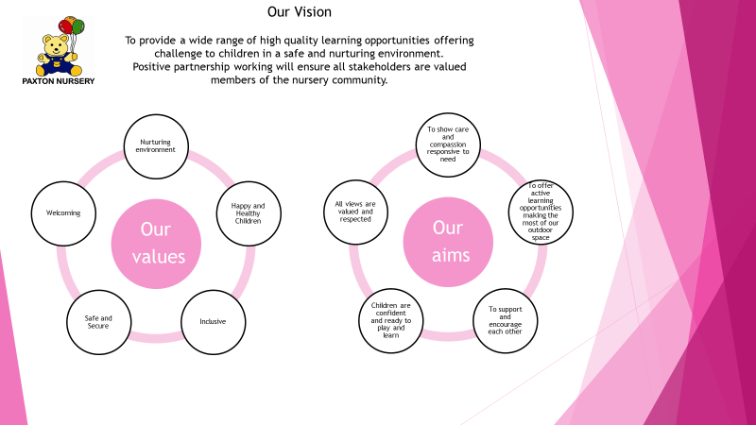

Improvement for Recovery Priority Work

Session 2020 – 2021

Improvement Priority 1: Begin to embed the recovery curriculum to ensure positive outcomes for Improvement

Aims:

Staff will have broadened their knowledge of play pedagogy behind self-regulation and recognising emotions

Children will be confidently using the emotions resources to enable them to express their feelings.

All Staff will confidently use the Leuven scale to assess children’s emotional wellbeing and involvement.

Plans will reflect a broad range of mindfulness activities for all children to access.
(planning meetings, room observations)

ASN children will have robust strategies in place to suit their individual needs.

Families will value the activities they engage in with their child
NIF Priority  - School Improvement  - School leadership  - Practitioner professionalism  - Assessment of children’s progress  NIF Driver | HGIOELC Quality Indicators  2.1 – Ensuring Wellbeing  2.5 – Family Learning  2.7 – Partnerships  3.1 – Wellbeing, equality and inclusion  3.2 – Securing children’s progress  3.3 – Developing skills for life  5.1 – Children’s health and wellbeing are supported and safeguarded during COVID-19  5.2 – Infection prevention and control practices support a safe environment for children and staff  5.3 – Staffing arrangements are responsive to the changing needs of children during COVID-19
Progress:

A staff working party created universal resources to enable staff to support children in recognising and regulating their emotions. All staff have received in-house training in using these emotions resources to support children’s development.

All staff have engaged in professional learning activities which focussed on supporting children’s wellbeing through regular mindfulness activities. These techniques and activities have been used regularly with children and have been shared with families through telephone conversations and the Seesaw app.

All new staff received training on Solihull approaches. Experienced staff model approaches and share knowledge with new staff to support their development. Senior EYO’s support all staff with this to promote consistency of approaches.

Our Family Worker promotes the 5 Ways to Wellbeing with families, through Facebook, Seesaw and virtual groups.

We continue to have strong links with our EP, who has supported us with AMG applications for 2 of our children. She attends regular review meetings to support children’s development. HT and PT have regular virtual meetings with EP to discuss individual needs of children and the setting.

All staff are confident in identifying families who require support from our Family Worker. Staff make referrals to our Family Worker, who plans appropriate supports with families. Senior EYO’s support staff in rooms to discuss concerns and appropriateness of support strategies offered.

Families with children in our Early Entrants provision are invited to join our Butterfly Blether group where they can receive support from our family worker on a variety of subjects relevant to them.

Families also receive a weekly activity pack linked to children’s interests and learning.
Impact:

Emotions resources are accessible and used well in all nursery rooms to allow children to talk about their feelings. Majority of children can express at least 4 emotions and use emotion cards and emotion spoons to support regulation. Evidence of progress in PLJ’s tracks progress for individuals. Most children are more aware of their feelings and can use language to express these.

Almost all children have engaged with mindfulness activities. Staff have recorded a reduction in emotional outbursts for children. Families have engaged with mindfulness activities shared through the seesaw app. A few of our parents have left some positive feedback or posted photos on the app to say that they have engaged with activities.

All staff are confident in using Solihull strategies in the setting.

Our Family Worker has encouraged families to discuss their own wellbeing through virtual groups and has included families in identifying new groups to support their wellbeing.

Children with a high level of ASN are supported well. We have identified one child who will benefit from access to support in an additional support setting for P1. Through the AMG process the child has been offered a spilt placement between Buckhaven ASC and their mainstream primary school to support their next steps and development. Strong links with our EP means that all staff in our setting are supported to meet the needs of individual children. Our HT and PT meet regularly with our EP to track progress and supports for children with ASN.

Our team work co-operatively and effectively to support families and make referrals to agencies where appropriate. Support is tracked to evaluate and identify impact and next steps for families. This also allows us to highlight families who might require additional support from school staff when their child makes the transition to P1. All staff are confident in seeking advice from our Family Worker on ways they can support families.

Families with children in Early Entrants have taken an active role in their children’s learning through engaging with the weekly activity packs. Evidence of this is through photos uploaded to the Seesaw app.

Staff make use of Learning Walls to support learning, although the children’s interest is not always sustained. The majority of children can talk about learning evidenced on the learning wall/floor book.

Most EYO’s are confident in identifying meaningful next steps in children’s learning. They are further supported to do this through support form SLT monitoring of PLJ’s and planned professional conversations with colleagues.

Next Steps:

We will continue to promote and extend use of emotions resources to support children’s development in being able to recognise and talk about their emotions.

All Staff will attend training on the use of the Leuven scale to assess children’s emotional wellbeing and involvement.

Improvement Priority 2: All children should be experiencing high quality play pedagogy

Aims:

All children will experience quality interactions during their session

Significant observations will be evident in all PLJ’s to show progression of learning for each individual child

Children’s learning will be supported and developed through use of learning walls

Evaluation of learning walls will link with PLJ observations

All children will be motivated and engaged in learning opportunities throughout their session both indoors and outdoors

Resources will support a range of learning opportunities and meet the needs of all learners

Families will feel involved in their child’s learning

NIF Priority  - School leadership  - Practitioner professionalism  - Parental involvement  - Assessment of children’s progress  - Performance information  NIF Driver | HGIOELC Quality Indicators  1.5 Management of resources to promote equity  2.2 Curriculum  2.3 Learning, teaching and assessment  2.4 Targeted support  2.5 Family Learning  2.7 Partnerships  3.2 Securing children’s progress  5.1 Children’s health and wellbeing are supported and safeguarded during COVID-19  5.2 Infection prevention and control practices support a safe environment for children and staff  5.3 Staffing arrangements are responsive to the changing needs of children during COVID-19
Progress –

All children experience high quality interactions during their sessions. Each room has developed their garden area and they also make use of the two larger gardens on a rota basis to adhere to regulations.

Our planning format initially focussed on Barry Carpenter’s 5 Levers of Recovery, to acknowledge and support children’s return to nursery. Staff were confident in identifying effective support strategies for groups and individuals. In term 2 our PT adapted the planning format to focus on promoting learning opportunities for children and individuals to plan for progress across the curriculum.

The Early Entrants planning was adapted to ensure learning was highlighted whilst considering the My World Triangle prompts and Wellbeing indicators. This also gave a focus on individual need to support and progress learning and development.

All staff are becoming more confident and support each other to create Learning Walls which reflect children’s interests and learning. Photographic evidence is collated to record impact of learning.

SLT monitor PLJ’s and give feedback to EYO’s. We have introduced planned learning conversation time for EYO’s to engage in professional dialogue with colleagues to identify gaps in children’s learning and identify next steps.

All EYO’s continue to regularly audit resources to ensure provision provides challenge and encourages progression for all learners.

All our children have regular learning updates from staff shared on their Seesaw account. EYO’s also connect with families through phone calls. Families are given regular opportunities to engage in activities at home with their child, including rhymes, stories and other curricular areas.

Impact –

Staff are more responsive to supporting observation of children outdoors since the children’s outdoor environment is used by a small bubble of children. Children’s learning outdoors is evident through significant learning observations in PLJ’s and in room planning. Next steps are identified in planning to plan for progress for individuals and groups.

All children are supported to feel safe and secure and are able to engage in learning activities indoors and outdoors.

Our 3-5’s planning format has evolved to focus on promoting experiences and outcomes across the curriculum and the Early Entrants planning has a more focussed approach to learning and skills using the My World prompts. This has led to staff being more focussed on planning for quality learning opportunities and achievements for individuals and groups. Planning is child-centred and links to observations of children’s interests.

Regular review of resources is included in fortnightly planning to plan for progression of children’s skills. Observations in PLJ’s and planning show evidence of this.

Across the setting the majority of families engage with information shared via the Seesaw app. This has helped families feel connected and involved in their child’s learning journey. EYO’s share child’s learning in nursery with families, through phone conversations. This encourages families to value progress in learning and be involved in planning next steps.

Next Steps -

We will continue to develop individual room’s outdoor spaces to create further opportunities for learning across the curriculum.

Families to further engage with digital platforms to enhance their input in their child’s learning supported by a confident staff team.

Improvement Priority 3: Staff are supported with and are engaged in leadership of change

Aims –

Staff will feel at ease during staff meetings when working with each other and when engaging in professional dialogue and reflection activities

Staff will feel a sense of belonging within the whole staff team
Staff will have a safe space to discuss their wellbeing and feel supported
We will have a successful platform for the sharing of information to all staff
All children will have specific, achievable targets set for each term that reflects the 7 principles of curriculum design
A robust, quality assurance calendar is in place which ensures in depth planning and monitoring across the setting
NIF Priority  - School improvement  - School leadership  - Practitioner professionalism  - Assessment of children’s progress  NIF Driver | HGIOELC Quality Indicators  - Evidence based improvement / ensuring impact  - Professional learning  - Leadership of change  - Leadership of management and practitioners  2.3 Learning, teaching and assessment  3.1 Ensuring wellbeing, equality and inclusion  5.1 – Children’s health and wellbeing are supported and safeguarded during COVID-19  5.2 – Infection prevention and control practices support a safe environment for children and staff  5.3 – Staffing arrangements are responsive to the changing needs of children during COVID-19
Progress –

All staff took part in virtual Wellbeing Group sessions to encourage connection and peer support. Wellbeing Walks with SLT were offered to individuals to further support wellbeing. Weekly virtual staff meetings take place to share information and answer questions and to drive forward improvements and priorities.

Senior EYO’s support room staff.

Staff WhatsApp group is used effectively to share operational information with all staff.

EYO’s and SLT meet termly with EYO’s to identify children’s progress and next steps in literacy, numeracy and HWB.

Our Operational Monitoring Calendar is updated to plan across the academic year.

All staff have engaged in mandatory training and professional reading in connection to the recovery curriculum.

In May 2021 all staff began to evaluate our Vision, Values & Aims. All stakeholders were also included in this.

All staff now use digital platforms to engage with families.

All staff have engaged in PRD process with a member of the SLT.

EYO’s have used Care Inspectorate Key Question 5 to reflect on our provision and adapt/enhance our current practice(s).

Impact –

Due to Covid restrictions, staff have not had opportunities to develop and strengthen professional relationships with other members of the wider nursery team.

Support from Senior EYO’s in rooms has ensured staff feel supported.

Our staff WhatsApp group chat ensures that appropriate operational and concise messages are shared with all staff in an accessible way. This is useful to share urgent messages with all staff.

Termly learning conversations between EYO’s and SLT support EYO’s to identify progress, next steps and challenge for individuals.

Our Operational Monitoring Calendar supports all staff to maintain consistency and quality for monitoring, planning and self-evaluation across the academic session.

Newly qualified EYO’s have felt supported in their roles.

All staff can confidently engage in professional dialogue relating to the recovery curriculum. Evidence in floor books in each area tracks evidence of progress and supports for children, families and staff.

Most EYO’s are confident in using digital platforms to engage with families. The majority of our families engage with activities and posts.

Next Steps:

Plan for opportunities for staff to be offered a range of tools to support their own wellbeing and to build relationships with wider members of the nursery team.

Continue to build staff capacity and parental engagement with digital platforms to enhance the link between home and nursery learning.

Attainment of Children and Young People
Attainment evidence/Achievement within a level information from ELC/school from this session
Successes and gaps identified throughout session (this should link to improvement plan for session 2021 – 2022)

Almost all of our children in 3-5’s nursery are working within the Early level. Children with identified additional support needs have adapted targets to track progress.
Evidence of significant wider achievements
We offer weekly pop-up shop bags for families, priced at £4. On average, 6 families in the setting purchase one of these each week. This helps to support families to eat a range of healthy and nutritious food and reduces financial pressure on families.

Our families have participated in virtual Bookbug sessions to promote literacy skills at home.

What have been the success and challenges of school/setting closure period (school/class/playroom isolation, remote learning between January – March 2021)
Successes During the Closure Period
- Home Learning opportunities to support progression
- Maintaining relationships with families and establishing new ones for our children who started in January
- Engagement with stakeholders
- Family support
- Upskilling staff to use digital platforms
- Staff commitment to deliver high quality learning experiences

Home Learning Opportunities to Support Progression

- A plan was implemented to ensure breadth of learning opportunities with a weekly literacy, numeracy and health & wellbeing focus
- In addition, activity ideas were shared weekly
- SeeSaw and Facebook were used so parents/carers had a choice of platforms

- Learning activity packs were offered weekly from the nursery eg. Art packs, play dough packs and soup packs

Maintaining and Establishing Relationships with Families

- Weekly phone calls between key workers and families to ensure learning was being shared and any support offered to the family
- £4 food bags continued to be offered to all families
- Relationships established with new families who enrolled in January via phone calls

Engagement with Stakeholders

- With staff –
- WhatsApp group to share appropriate operational and concise messages to all
- Wellbeing meetings held weekly via TEAMs with a focus on the 5 Ways between smaller staff teams
- Weekly SLT meetings via TEAMs
- Weekly whole staff meetings via TEAMs
- SLT in the setting to support those on rota

- With families (including Family Support) –
- Weekly phone calls
- Engagement at pick up and drop off times with those who attended the setting
- Virtual Family Learning opportunities eg.PEEP and Bedtime Bookbug
- Responses shared on Seesaw to learning ie.Photographs from home of the children taking part in suggested activities to be transferred to PLJ’s
- Family Worker offered additional support where required via telephone

- With partner agencies –
- Positive relationships already established and continued throughout closure period via email and phone calls
- Partner agencies identified children they thought would benefit from continuing to attend during lockdown under the vulnerable category
- Regular contact continued between DHoC and partner agencies to support families where necessary
- DHoC continued to attended Wellbeing & LAC reviews as well as Case Conferences and Core Groups via TEAMs

Upskilling Staff to use Digital Platforms

- Staff were offered training to use SeeSaw which supported the delivery of home learning
- Support offered to those who were not confident using technology, particularly using their own devices at home to access the server, TEAMs etc
- Staff were encouraged to participate in online learning through Fife Council. All staff were invited to make a list of any online training they had previously completed which they felt would be beneficial for their colleagues. PT made a list of recommended courses and how to access these, this was sent out to all staff as recommended online learning.

Staff commitment to deliver high quality learning experiences

- Staff provided activities, stories and songs to go on SeeSaw and Facebook supporting learning

- Staff dedicated time each week to their phone calls with their key group families,
- showing flexibility when required to meet the needs of the families
- Staff supported each other through these uncertain times during wellbeing meetings on TEAMs
- As staff worked on a rota system, the room senior had a weekly handover, via Teams, with the staff team on rota the following week. This ensured continuity of learning
- If any concerns were identified during staff’s weekly calls to families this was highlighted to DHoC and / or Family Worker to offer support.

Data for Engagement Levels

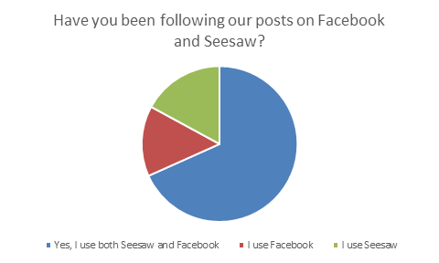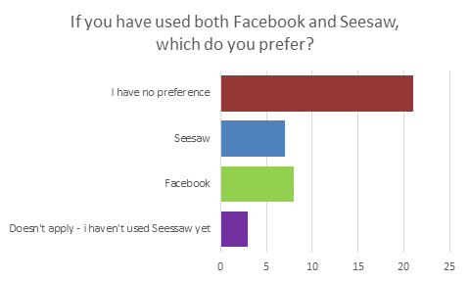

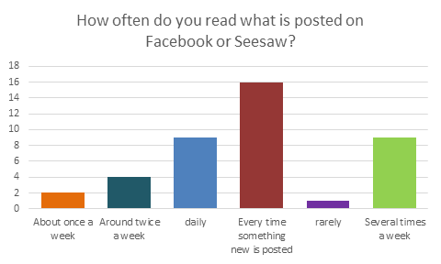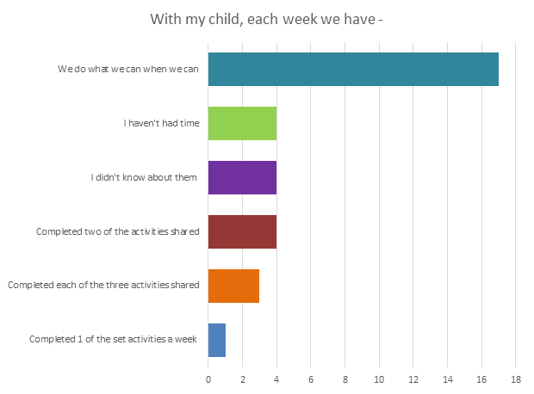

- “My daughter likes to look through the Seesaw app at the stories and activities, she recognises the teachers”
- “It’s a little hard as I have older children and I help them with their home learning. We try our best to add what you post into our daily routine as the posts give me ideas”
- “Both myself and my child enjoy taking part in these activities alongside we already do at home”

Challenges During the Closure Period
- The wellbeing of all, these were unprecedented and uncertain times which we all had to adapt to
- Lack of engagement from some families – some requested they didn’t want a weekly phone call and responded to email or less frequent calls. They were reassured they could contact us at any time outwith the planned calls

- Some families lack of confidence to use digital platforms to support learning
- Pressure on parents if they were working from home whilst supporting siblings school learning and nursery learning
Changes to previous practice as the result from learning/engagement which will be sustained
- Use SeeSaw to establish a greater link between home/nursery learning and develop staff confidence when doing so
- Wellbeing opportunities for staff to attend
- Family Learning and Support programme developed

NIF Quality Indicators (HGIOS ELC) Early Years Self- Evaluation (Nursery)
Quality Indicator | 2018 - 2019 | 2019 - 2020 | 2020-2021 | Inspection Evaluation  (within last 3 years)
1.3 Leadership of change | 4 | 4 | 5 | 4
2.3 Learning, teaching and assessment | 4 | 4 | 4 | 4
3.1 Ensuring wellbeing, equity and inclusion | 4 | 5 | 5
3.2 Securing children’s progress | 4 | 4 | 4

Care Inspectorate (within last 3 years) | Grade (if applicable)
 | 2018 - 2019 | 2019 - 2020 | 2020-2021
Quality of care and support |  | 6  Excellent
Quality of environment |  | Not assessed
Quality of staffing |  | Not assessed
Quality of leadership and management |  | 5  Very good

