Asset and Corporate Services Committee

Thursday 19th August 2021
Agenda Item No.
Finance & Corporate Services
Performance Report 2020/21
Report by: Eileen Rowand, Executive Director – Finance & Corporate Services
Wards Affected: All
Purpose
To present the performance scorecard for Finance & Corporate Services for 2020/21
Recommendation(s)
Members are asked to:
- Consider the Finance & Corporate Services performance information presented at appendix 1.
- Consider if any further review work or scrutiny is required and the scope of that review.
- Note the arrangements set out to fulfil the Council’s obligation to comply with Audit Scotland’s 2018 SPI Direction.
- Note the information regarding the workforce profile, appendix 2.
Resource Implications
None
Legal & Risk Implications
None
Impact Assessment
An EqIA is not required because the report does not propose a change or revision to existing policies and practices.
Consultation
None required

1.0 Background
  - Audit Scotland published the Statutory Performance Direction in December 2018. 2020/21 is the second year to which that direction applies. The Council is required to report a range of information setting out:

- Its performance in improving local public services, provided by both (i) the council itself and (ii) by the council in conjunction with its partners and communities.
- Its progress against the desired outcomes agreed with its partners and communities.
- Its performance in comparison (i) over time and (ii) with other similar bodies including information drawn down from LGBF in particular and from other benchmarking activities
- Its assessment of how it is performing against its duty of Best Value, and how it plans to improve against this assessment

  - The first requirement, to report the Council’s performance in improving local public services (including with partners) will be satisfied by the series of reports (of which this is one) that will be presented to the Council covering the whole of the Council’s performance for 2020/21

  - The other requirements of the Statutory Performance Direction will be satisfied by a combination of

- Update reports to the Fife Partnership regarding progress against the Plan for Fife, with reports also going to Policy and Co-ordination Committee.
- Public performance reporting, assurance statements and governance arrangements.
- Reviewing the External Audit Annual Report for its view on our Best Value performance and any action plans thereafter.
- Carry out a Best Value Self-Assessment using the updated Audit Scotland Guidance in conjunction with the Council’s Corporate Governance Statements.
1.4 Taken together, these reports will cover the whole of the Local Government Benchmarking Framework, plus selected service performance indicators that give a balanced picture of Council performance.
1.5 The appendix to this report is presented in the form of a balanced scorecard covering the areas of Financial, Key Business Delivery, People and Customer results. This mirrors the approach used for internal management reporting throughout the year.
1.6 This is the first Performance Report submitted following implementation of Oracle Cloud. This system has sophisticated reporting tools and better reporting functionality but some of these reports are still in development, particularly those relating to sickness absence.
1.7 Members should therefore be aware that the numbers in this section are different due to the system change. Previously, absence was reported as WDL per FTE. At the moment, the output data being produced is for WDL per employee and as a result, there is likely to be a slight but immaterial difference in the figures. WDL per FTE will be available for next year’s report.

2.0 Best Value and Plan for Fife
2.1 Fife Council and the Fife Partnership are currently completing a three-year review of the Plan for Fife to ensure that adequate progress is being made towards the Plan's twelve ten-year ambitions, while at the same time setting out a recovery and renewal plan following the Covid-19 emergency. A draft Plan was considered by the Fife Partnership Board and by Fife Council's Policy and Co-ordination Committee. Once agreed, the updated Plan will provide the basis for regular reporting to the Fife Partnership Board and relevant Fife Council committees on the delivery of agreed outcomes, this will in turn drive service performance and improvement activities.

2.2 Following the BVAR in 2018, the Best Value Action Plan will be reviewed and updated as per the new Best Value direction. From 2021/22, Councils will be asked to self-assess against this new direction and then produce a new action plan.

3.0 Service Performance
3.1 The functions within the Directorate are Finance, Revenue & Commercial Services, Assessors, Human Resources, Legal & Democratic Services and Business Technology Solutions.
3.2 The Directorate performed remarkably well during 2020-21 given the significant pressures faced in responding to the Pandemic and delivering business as usual services. During this year the majority of employees worked from home and BTS ensured that the Council adapted quickly in order that staff could access systems and had equipment that allowed them to deliver services. Remote committees were also delivered during this period and support was provided to members to be able to participate. HR had to focus on a number of challenging areas to ensure that front line services were supported, employees were able to work in different ways and that their wellbeing was protected. This included areas such as health and safety, community testing and reviewing policies and practices. Good working relations with trade unions were maintained during the challenging year. A financial strategy was developed and agreed by members to ensure that the Council could respond to the unique financial challenges it faced. A conscious decision was taken to focus attention on the corporate position given the level of uncertainty and the scale of the impact on both costs and income.
3.3 The scale of change that could be delivered by all services reduced however the Oracle Cloud system was implemented during the year. The original plan was for the finance and procurement modules to go live on the 1st April and payroll and HR in July however with the onset of the pandemic this was delayed until the 1st July and 1st November respectively as it was deemed to be too risky given the shift in focus to respond to the Pandemic. The change in working practices and timescale meant that the project team had to adapt the method to implement the system and change the training approach to ensure that this could be delivered remotely. The unique challenges caused by the Pandemic increased both the type and scale of implementation risk however the project has been successfully implemented. As with all change initiates of this scale there are post implementation issues that are being addressed.
3.4 The financial outturn of the Council has already been reported to the Policy and Co-ordination Committee in June. This was an exceptional year that involved the Council receiving an additional £87.3m of funding from the Scottish Government to allow the Council respond to the Pandemic. A significant proportion of the funding (50%) was received in the last month of 2020-21 and this resulted in a high level of reserves being carried forward. The financial impact of the Pandemic was £66m and this was volatile area for predicting during the year given the level of uncertainty, changing restrictions and late notification of additional funding. Capital project delivery was also impacted but despite construction sites being closing for part of the year slippage was restricted to 14.75%. The financial position on the Housing Revenue Account was strong and rent collection increased. This reflected the one off support that was agreed to deal with both hardship and the impact of the Pandemic. The debt collection policy was relaxed for a period in order to support individuals who were dealing with exceptional circumstances.
3.5 Looking forward a number of challenges remain, and the focus will continue to be on adapting how we operate through flexible workstyles and other initiatives to ensure that performance is optimised. The last year has shown the importance of support services in ensuring that front line services can be maintained and improved. The directorate responded well to the unforeseen challenge that was faced by the Council however it is recognised that resilience has been tested and it is important that we continue to support the wellbeing of our employees.

4.0 Conclusions
4.1 This report is the first in a series covering the whole of the Council’s performance against key indicators, including the Local Government Benchmarking framework.
4.2 The overall performance of Finance & Corporate Services Directorate has been affected by the pandemic and this is highlighted in appendix 1.
List of Appendices
- Performance Report 2020/21
- Workforce Profile

Report Contacts:

Eileen Rowand
Executive Director
Finance and Corporate Services Directorate
Email: Eileen.Rowand@fife.gov.uk

Iain Duncan
Programme Manager
Communities Directorate
Email: Iain.Duncan@fife.gov.uk
Customer
Performance | Progress
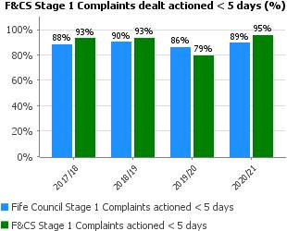 | Following a restructure within the Directorate, the complaints received significantly reduced and because of this we were able to deal with a higher number of complaints within SPSO timescales
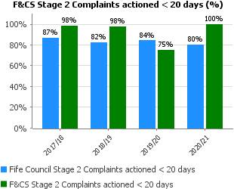
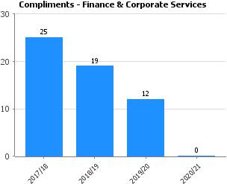 | There were no formal compliments received within 20/21 for the Directorate, however this does not reflect the recognition that the Directorate received in responding to issues caused by the Pandemic. The Directorate went above and beyond in responding to the challenges faces and at the same time maintaining business as usual.
People
Performance | Progress
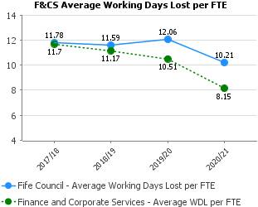 | April 2020 to end October 2020 was during the initial 6 months of the pandemic when staff were in lockdown and the vast majority working from home and supporting the crisis.
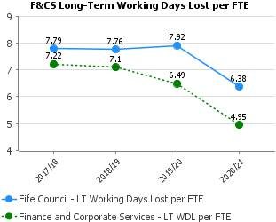
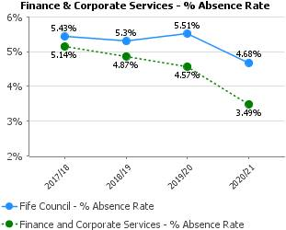
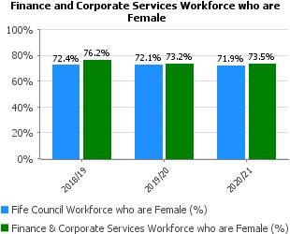 | The gender balance has remained static over the period
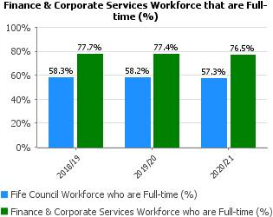 | The proportion who are full time has remained fully static over the period
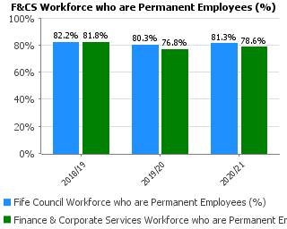 | The proportion who are permanent has remained static over the period
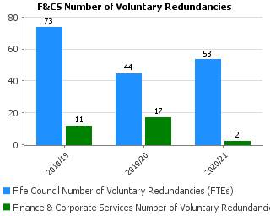 | Change has been paused for the most part during the pandemic
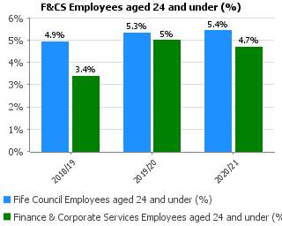 | There is a degree of natural turnover as apprenticeships and traineeships conclude (or young people become 25). The pandemic meant recruitment focused on business critical service delivery roles, rather than focusing on roles for young people such as apprenticeships or traineeships.
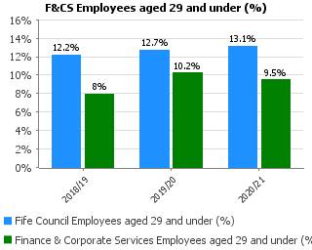 | There is a degree of natural turnover. The pandemic meant recruitment focused on business critical service delivery roles, rather than focusing on roles for young people such as apprenticeships or traineeships
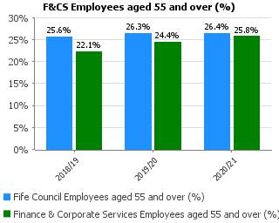 | This is consistent with the Council's profile and reduced recruitment and reduced managing change activities during the pandemic
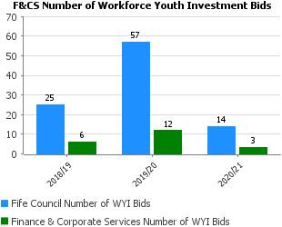 | The number of Workforce Youth Investment Bids received was impacted by the pandemic
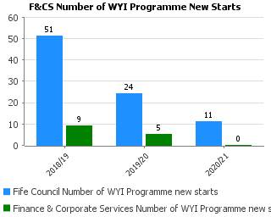 | The number of young people starting the Workforce Youth Investment Programme was significantly reduced by the pandemic
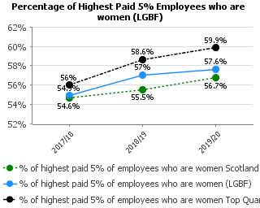 | Encouragingly we continue to see the gender balance in our senior posts move towards a more accurate reflection of our workforce as a whole in which 72% are female.
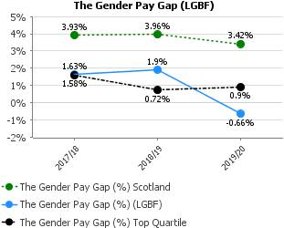 | The gender pay gap across the whole Council has fallen to -0.66% (as at 31st March 2020) which means that across the Council the average hourly rate of pay between men and women is about the same. Our gender pay gap continues to be below the Scottish Local Authority average (3.4% as at 31st March 2020).
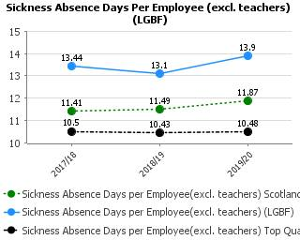 | October 2020 figure shows a slight improvement but has not been published. The pandemic period is difficult to predict/anticipate impact on staff absence.

Key Business Delivery
Performance | Progress
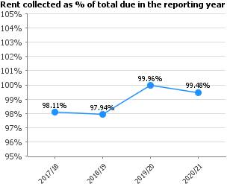 | Our rent collection rate of 99.48%, is an excellent performance and exceeds our target for this financial year. The uncertainty of the pandemic made predicting performance tricky. We expected a decline in collection and an increase in arrears but this not happened.
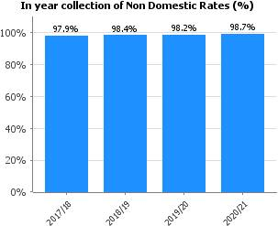 | The Rates collection rate has increased from 98.2% from 2019/20 which is excellent performance given the impact the pandemic has had on businesses. It will also be reflective of the 100% Retail, Hospitality and Leisure relief awarded so this year the target has been set at 98.7%
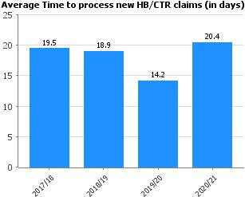 | Target has not been met due to increased workload arising from the pandemic and targets for next year have been adjusted accordingly to allow us to recover.
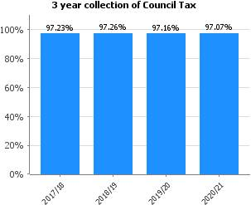 | While the in-year collection rate reduced by 0.9% compared with 2019-20, the actual income collected, in cash terms, rose by £6.389 million in 2020-21 to £231,939 million - and increase of 2.83% on the previous year (2019-20).
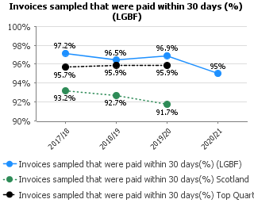 | The invoices paid on time for the first quarter was as expected, the resultant impact of Covid, working from home and the introduction of Oracle Cloud created additional challenges for the team. However, the team performance improved on familiarisation of the system achieving a final result of 95%, just below the top quartile.
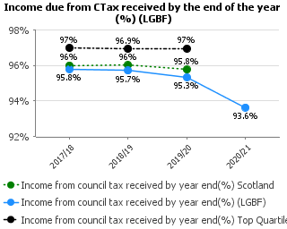 | Collection rate is much better than expected give the pandemic and the impact this had had on some citizens' income. The collection team have worked closely with customers and sheriff officers to exercise care and compassion during these unprecedented times.
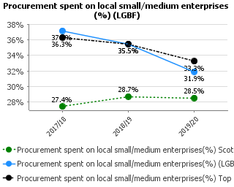 | Fife has consistently had a high rate of local spend in comparison to the average, but work is ongoing to continue to improve this where feasible to do so.

Financial
Performance | Progress
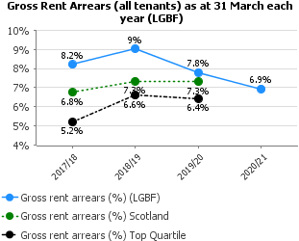 | Performance in rent arrears has exceeded targets in this year, especially taking into account the Covid-19 pandemic. The expectation of increasing rent arrears has been reversed through a supportive approach to tenants and financial assistance if affected by unemployment or furlough.  At the start of the Covid-19 pandemic a £2m rent support fund was put in place to assist tenants with rent payments where they become unemployed or furloughed. New software has been introduced for early identification of arrears which is followed up with a direct tenant contact and additional staff have been appointed to provide specialist advice around rents, benefits and income maximisation.
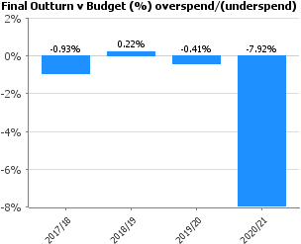 | Significant underspend in 2020-21 due to a significant level of grant funding received but not used in respect of COVID19.
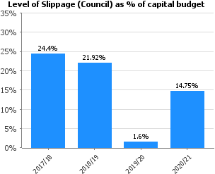 | The increased level of slippage at 14.75% for 2020-21 reflects the delays in progressing projects as a direct result of the lockdown arrangements associated with COVID-19.  Construction sites were closed, and projects put on hold whilst restrictions were in place, however, as these were lifted, good progress was made and although an increased level of slippage compared to 2019-20, it has improved compared to 2017-18 and 2018-19.
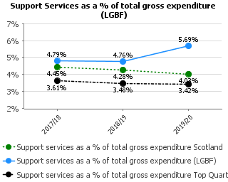 | There is an increase in support services as % of gross expenditure as a result of the additional costs of the Oracle Project team which were employed during 2019/20. As a result of the COVID-19 outbreak the implementation was delayed into 2020/21 therefore it is anticipated that the % will continue to be slightly higher than previous years.
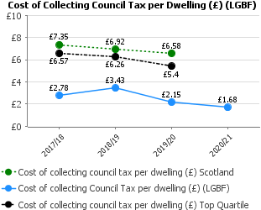 | The cost per dwelling has decreased from 2019/20 due to an increase in central supports for 20/21. Council Tax Reduction was moved from Housing Benefits to Council Tax as it is no longer classed as a benefit. The number of eligible dwellings has also increased from 2019/20
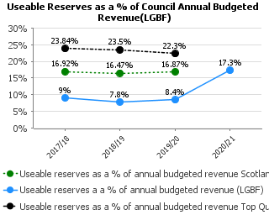 | The percentage of useable reserves has remained consistent level over the period 2017-18 to 2019-20 with a slight increase. This is because there was a slight increase in the level of useable reserves held in respect of the Insurance Fund as a result of settlement of claims for Woodmill High School.  As a result of significant underspends and additional funding in 2020-21 the results show that the level of useable reserves has increased to 17.3%
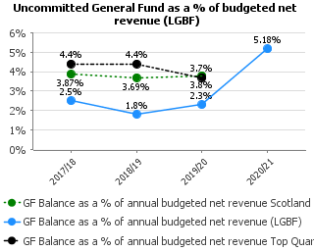 | The indicator represents the level of general fund balances that are not committed for any purpose as a percentage of the budget. There is a slight upturn in 2019/20 due to the level of underspend making a positive contribution to balances. At 2.3% the level is slightly greater than the policy minimum of 2%.  Again it was anticipated that we would see an increase in this percentage in 2020-21 as a result of underspends and additional funding for COVID-19. The result did come through at 5%.
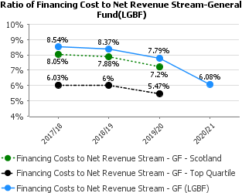 | Loan Charges or the costs of financing the debts associated with Capital Expenditure has decreased over the last 3 years as a result of implementing the revised Loan Fund policy. This policy allows for the loans fund advances to be charged over a longer period of time such as the asset life which reduces the annual cost as the payments are spread over a longer period.  The adoption of this policy is in line with the Scottish Government Loans Fund Regulations and most authorities across Scotland have implemented as can be seen in the Scotland and Top Quartile results.  For 2020-21 we see the % reduce further to 6.08%
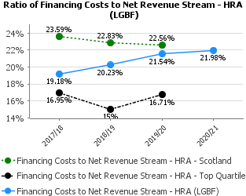 | This indicator has steadily increased reflecting increased capital expenditure on HRA and Affordable Housing, therefore there is an increased cost of covering the borrowing associated with these projects.  This remains fairly constant at 21.98% for 2020-21 and is in line with the agreed levels per the HRA Business Plan
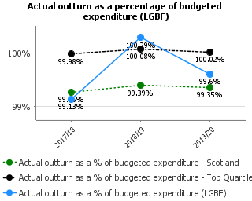 | There was a slight overspend in 2018/19 which resulted in the outturn being greater than 100%. This improved in 2019/20 as a result of an underspend on general fund services. This follows a period of expected overspend and Services were instructed to take corrective action to mitigate against an overspend and contain expenditure where possible. This was achieved.  The COVID-19 pandemic has had a significant on 2020-21 with areas of significant costs as well as underspends due to lock down arrangements. In addition, further government funding was provided which was not needed in 2020-21 and this resulted in a significant underspend. The results of this indicator for 2020-21 are 92%.

Service | No Budgeted (FTE) April 2019 | No of Budgeted (FTE) April 2020 | No of Budgeted (FTE) April 2021 | Difference in FTE 2020-2021
FC&S Management | 8.00 | 8.00 | 4.00 | -4
Assessors Service | 28.00 | 39.00 | 38.00 | -1
BTS | 230.31 | 230.55 | 215.31 | -15.24
Finance | 92.01 | 94.89 | 96.24 | 1.35
HR | 81.00 | 78.81 | 75.81 | -3
Legal & Democratic | 53.67 | 54.47 | 55.27 | 0.8
Revenue & Shared Services | 779.17 | 596.39 | 584.78 | -11.6
Total | 1,272.16 | 1,102.11 | 1,069.42 | -32.69

