ROUNDABOUT SPONSORSHIP POLICY

GROUNDS MAINTENANCE SERVICE

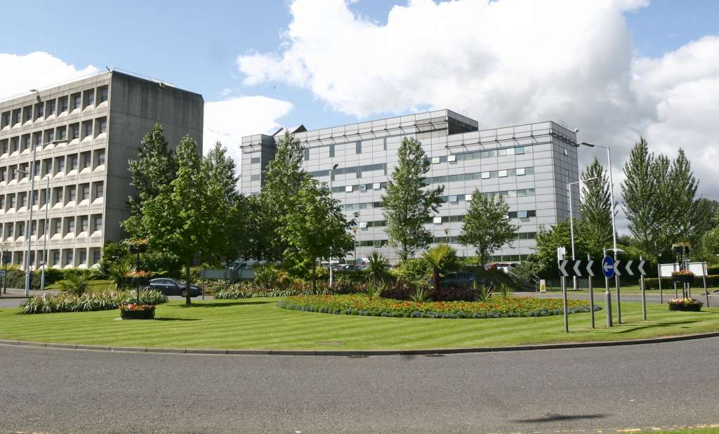

- INTRODUCTION

With over 200 roundabouts across the district, Fife Council offers excellent opportunities for
large or small businesses to advertise year round at very affordable rates. The roundabout sponsorship scheme allows local and national businesses to demonstrate their commitment to supporting the local community while providing a cost effective way to raise their company's profile and promote their business.

The scheme enables Fife Council to:-
- improve the appearance of roundabouts
- improve the image of Fife as a vibrant location for businesses, and
- promote the range of businesses already located here.

Roundabout sponsorship is offered on yearly contracts and the cost is based on the location and traffic flow.

- CONDITIONS OF THE SCHEME
General
Fife Council will manage all arrangements for the sponsorship of all available roundabouts. These include:
- Management of the planning, development and undertaking of landscaping, planting and maintenance for each site.
- Design, commissioning and placement of sponsorship signage.
Fife Council will give similar priority to all roundabouts which are available for sponsorship.
Situations may arise where Fife Council as the highway authority and utility companies are required to undertake work on sponsored roundabouts. In these circumstances reasonable reinstatements will be carried out by Fife Council.
The planting and design of a roundabout can affect drivers’ behaviour and road safety. Fife Council must take this into consideration when designing and landscaping these areas.
No significant changes may be made to the existing design or maintenance frequency of a roundabout which is available for sponsorship.
The species selected for planting should take account of the need for minimal maintenance throughout their life, and not harm native plants. We actively encourage and support an eco-progressive attitude towards the planting and maintenance of the roundabout.
New planting should ensure that there is no detrimental effect on Fife Council property or utility equipment (either in the short-term or long-term, for example tree roots).
Fife Council cannot guarantee the availability of any or all of the roundabouts for sponsorship at particular times.

Sponsorship Sign Design, Manufacture & Placement
Sponsorship signs will be designed and produced to a standard format specification by Fife Council.
In order to ensure the sign is not distracting to motorists, the sign must be facing head-on and legible from the give-way road markings opposite the sign. Both the size of lettering and the number of words on the sign will be designed to ensure that this is achieved.
Signs shall be mounted on posts so that the top of the sign is a maximum of 0.75 metres above ground level.
Sponsorship signing relating to a roundabout may only be placed on the roundabout island.
All sponsorship signs will be produced to a standard height and width, which is 1.0 x 0.42 metres.
Signs will be placed at least 1 metre away from the edge of the carriageway and clear of authorised road traffic signs. Existing highway signs should not be amended or obscured.
A maximum of one sponsoring sign to each approach is permitted. These shall not be illuminated or constructed from reflective material.
Existing plantation and/or vegetation on the roundabout will be maintained by Fife Council.
The sign will be mounted on two 76mm diameter posts and, where possible, both the sign and post will be made from recycled materials.
All traffic management required for the installation of sponsorship signs and maintenance of the sponsored roundabout will be carried out by Fife Council.
Every sign will display the Fife Council logo and sponsors name. Sponsors slogans, logos, telephone numbers, addresses including website addresses are not permitted.
An example of the standard design for the sign is shown below:

No other structure should be included within a sponsored roundabout without prior approval by Fife Council.
Fife Council’s Roads & Transportation Service can instruct immediate amendments or removal of any sign or plant if it is believed to cause or contribute to a road safety problem.
Fife Council cannot guarantee the replacement of dead or damaged trees, shrubs, bedding plants or grassed areas of sponsored roundabouts due to adverse weather, vandalism, theft, or any other event which is outwith Fife Council’s control.
Fife Council will replace any sign which is vandalised, stolen or damaged by vehicle collision at no additional cost to the sponsor.

Financial
Roundabout sponsorship is offered on an annual contract and costs are based on the location and traffic flow of the roundabout.
Roundabouts which are included in the sponsorship scheme are shown in Appendix 1. The annual sponsorship costs are outlined in Table 1 below:-

Roundabout Category | Annual sponsorship cost per sign
A | £184.15
B | £306.91
C | £429.69

In addition to the annual sponsorship amount, a one-off amount of £184.15 + VAT per sign will also be payable to cover production and installation costs.
An invoice for the sponsorship amount will be issued by Fife Council at the time of installation of the sponsorship sign. Invoices must be paid within 14 days of issue.

- ENTERING AND EXITING THE SCHEME
Applications for sponsoring a roundabout must be made by contacting Fife Council’s Contact Centre on 03451 55 00 00 or submitting a general enquiry through www.fife.gov.uk.
Sponsorship applications may be made at any time, providing sponsors agree to adhere to the terms and conditions outlined in this policy.
Applications will be processed within 28 days of receipt and applicants will be advised by letter whether their application has been approved by Fife Council.
If approved, sponsors will be issued with a confirmation letter, confirming the amount due for annual sponsorship.
The signing and returning of the confirmation letter by the sponsor confirms the sponsors agreement to the conditions stated within this policy document.
The date of commencement of the annual contract will be date the sponsorship sign is installed by Fife Council.
If, the sponsor wishes to end the sponsorship agreement, the sponsor must notify Fife Council prior to the end of the annual contract. If notification is not received, an invoice will be issued for the forthcoming year and the agreement will automatically continue for a further year.
Fife Council has the right to terminate the sponsorship contract if a sponsor does not adhere to the terms and conditions outlined in this policy.

- EXCLUSIONS
The sponsorship of small diameter roundabouts (below 10 metre diameter) is not generally considered safe and such roundabouts are excluded from the scheme.
Fife Council will only seek to enter into sponsorship agreements with businesses whose values, practices and products are not in conflict with Council policy.
Fife Council will not enter into advertising or sponsorship arrangements which contravene any current local government or advertising legislation or which promote:
- E-cigarettes, tobacco or alcohol related products or services, directly or indirectly. (Consideration may be given to support the promotion of local breweries, distilleries and alcohol related trading establishments as employers in Fife however this would be by exception)
- pharmaceutical drugs or related products
- manufacturers and distributors of weaponry and related products
- fossil fuels
- fracking
- party-political organisations, including pressure groups, trade unions and lobby groups
- anything seditious, discriminatory, obscene or of a libellous nature
This list is not exhaustive and Fife Council retain the right to decline advertising and sponsorship from any organisation or individual deemed inappropriate.

- ADDITIONAL SPONSORSHIP OPPORTUNITIES
In addition to Roundabout Sponsorship, the Grounds Maintenance Service have a wide range of areas and locations which can be made available for sponsorship on request, these include grassed open space areas, planters of various sizes, and flower baskets and troughs. Sponsors wishing to discuss possible sponsorship sites and the options available should contact Fife Council’s Contact Centre on 03451 55 00 00 or submit a general enquiry to gm.enquiries@fife.gov.uk.

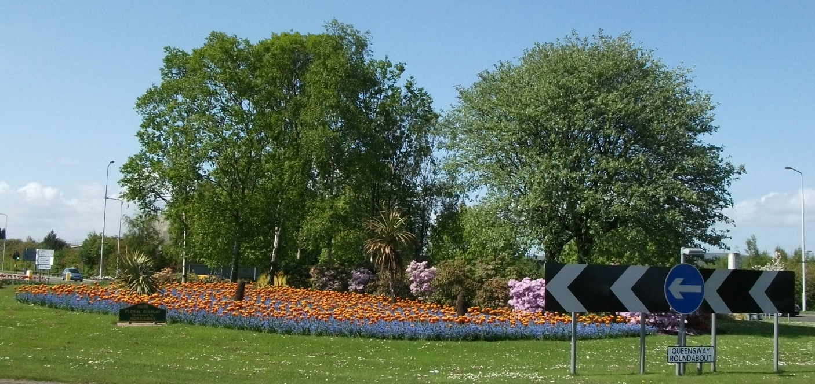

1st April 2024 v.1

