St. Marie’s RC Primary School
Standards and Quality Report
Achieving Excellence and Equity

Review of 2020-2021

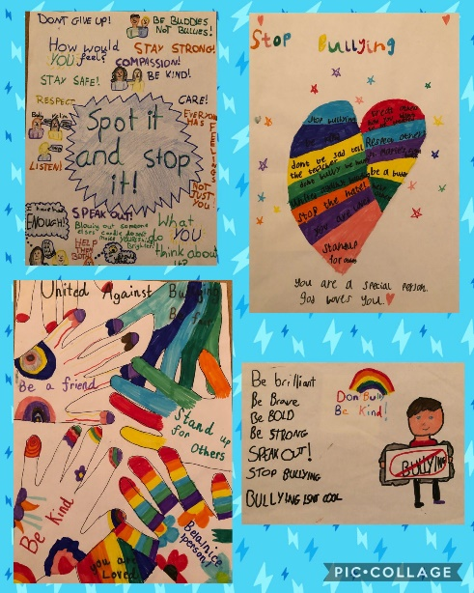

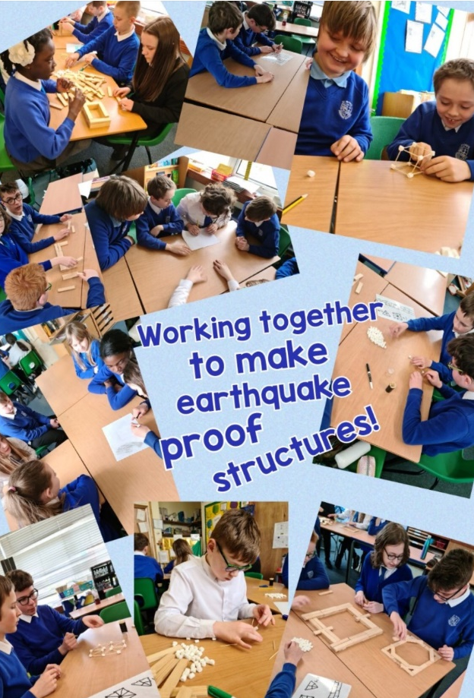

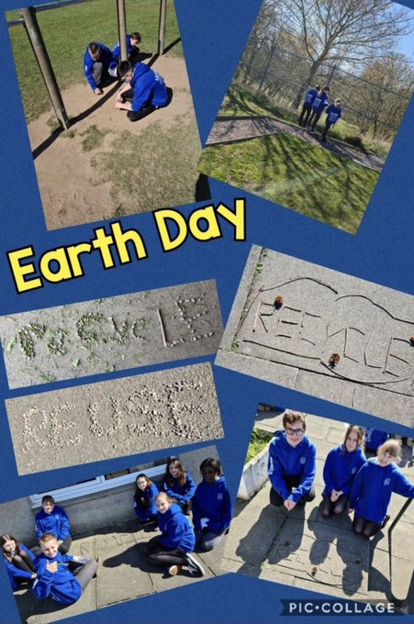
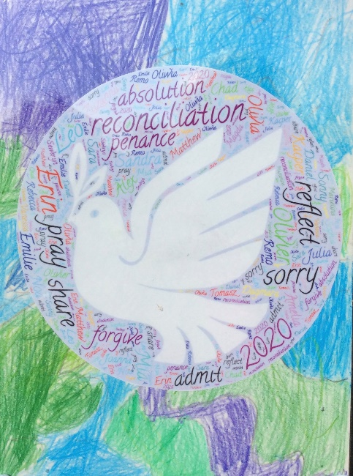

Setting/School Roll (including ELC/ASC) | 381
FME | 83
Attendance (%) 93% | Authorised | 4.3% | Unauthorised | 2.7%
Exclusion (%) | NIL
Attainment Scotland Fund Allocation (PEF and SAC) | £99,240

Our School Setting: Vision, Values & Aims
St. Marie’s Primary is an inclusive, vibrant, forward thinking denominational school with a strong focus on attainment and achievement. We are proud of our multi-cultural school family which helps to create a wonderfully rich context for learning. Our ethos and our practice reflect our shared vision of striving for excellence by developing each person’s God given talent. Our vision values and aims are evident in the interactions within the school and the excellent behaviour of our pupils, with no instances of exclusion over the past 4 years and extremely low levels of violent or racial incidents. Our tag line -'FAIR' reflects our whole school drive towards creating a school environment where there is Faith & Friendship, Ambition, Inclusion and Respect & Resilience. All staff model the school’s vision and values, and this is underpinning their work.
In our unique context, we have tailored our curriculum to fully support all our learners, with a specific focus on continuity and equality of experience. The average SIMD for pupils in St Marie’s is 2.2 and 43% of our pupils are EAL. The relevant, well structured, progressive and visual nature of our programmes and pathways benefits all our pupils and are particularly supportive of our EAL pupils. We have close partnerships with local businesses, ASDA, our 2 Parishes, 2 local care homes [Barrogil & Methven House] & the Carmelite Convent in Dysart.
We place a strong emphasis on Literacy, Numeracy and Outdoor Learning, creating a climate where children develop transferrable skills for learning, life and work. Our strong Catholic ethos and our happy, caring, loving, ambitious school family encourages everyone to have a drive to succeed.
A significant strength of the school is the outstanding commitment of all staff to developing their leadership capacity. This has led to a greater understanding of their collective responsibility as leaders of learning within the school and has impacted positively upon approaches to self-evaluation and school improvement. This strengthening professional relationship has been particularly evident during this Covid period, across the whole school.

Improvement for Recovery Priority Work
Session 2020-2021

School Improvement Priority 1: Improvement in attainment, particularly Numeracy & Literacy
NIF Priority – Learning, Teaching & Assessment/Closing attainment gaps/Increasing Attainment  NIF Driver -Teacher Professionalism, Assessment of children’s progress, Performance Information | HGIOS 4 Quality Indicators  - Raising attainment and achievement
Progress:
- Staff used a varied approach to teaching via Seesaw through videos, PowerPoints, photographs, links to videos online etc. to teach new concepts or progress learning and sharing tasks for the children to consolidate their learning.
- In line with Visible Learning, detailed quality feedback was provided promptly by staff to children. This ensured that children continued to build their understanding and improve their learning.
- An established school learning and teaching policy is in place that emphasises the features of high-quality learning and teaching and the central role of assessment in planning appropriate support and challenge for all learners.
- Staff meetings, planning meetings with stage partners and 1:1 catch ups with individual staff provided ample opportunity for feedback, challenge, sharing ideas and show casing excellent practise.
- Most literacy and numeracy activities were differentiated for each group. Each lesson followed the four-part model and Learning Intentions and Success Criteria were shared to enable relevant and high-quality feedback. Feedback was also moderated during staff meetings.
- Pedagogy – real development through problems solving approaches and sharing of practice with others. Use of breakout rooms on Teams enabled opportunities to continue professional dialogue and ensured that staff stayed focussed.
- Planning -staff have been working and planning across stages for continuity. During lockdown they were sharing video lessons and resources across each stage. Staff reported that this reduced workload significantly and had a positive impact on staff wellbeing.
- SfL teacher coordinating a ‘support plan’ – reaching out to pupils and parents to offer individual support; Toe by Toe; Phonics; English Language which resulted in increased levels of engagement.
- Regular staff meetings using Teams was fundamental to the success of home learning in St. Marie’s. Through these meetings it was possible to motivate, challenge and ensure consistency. There was evidence that they strengthened communication and enabled professional development to continue
Impact
- Attainment is ahead of comparator schools and Fife schools, with improvements across all curricular areas. [Please see chart below].
- St. Marie’s is already achieving the NIF stretch aim for 2024/25 of 92% of P1 children achieving the expected level of Cfe in numeracy. This year, despite Lockdown, 94% of our P1 children have achieved the expected level of CfE in numeracy.
- High quality feedback given to children during lockdown has supported with the continuity of ‘language of learning’ for the return to the classroom.
- Using OneDrive, engagement figures were tracked, monitored and analysed across the school. This data was used to identify children who required further support and resulted in the following interventions: 1:1 kitbag session, Toe by Toe sessions, reading support, regular phone calls, garden visits, paper packs. There is evidence that the interventions planned had an impact for individual children.
Parental Views Home Learning due to COVID 19 Pandemic: Parental Views
Data was gathered from parents via FORMS questionnaire to identify strengths and challenges of online learning. Out of 287 families, we received 120 responses to the survey. Data was analysed, and appropriate action was taken to address points raised.
Our recent questionnaire [January2021] reflected that 83% of parents felt that the teacher feedback during Home Learning was helping to improve their child’s learning.
‘My child enjoys getting her feedback on all her work from her teacher and this helps to motivate her to do more.’
85% of parents believed that the live lessons and video lessons were meeting the needs of their child.
‘The recorded lessons make it easier to split the day up and you can work your work/family around it.’
‘Maria loved the video call the most’. ‘My child enjoys when the teacher has videos to explain things’

‘Kids really enjoy seeing their teacher and classmates online.

‘The quality and range of activities is excellent and is keeping my daughter busy and challenged. Well done!’

88% of parents believed that the online learning activities and lessons were of high quality.
‘We appreciate the time and effort that the teachers are putting into ensuring the children are not missing out on their learning.

Next Steps:
- Use the school data to inform the School Improvement Planning and subsequent improvement activity during session 21/22.
- All staff will learn how to develop, test and implement changes identified as high-leverage change ideas in relation to numeracy and literacy.

School Improvement Priority 1 Continued: Improvement in attainment, particularly Numeracy & Literacy
NIF Priority – Learning, Teaching & Assessment/Closing attainment gaps/Increasing Attainment  NIF Driver -Teacher Professionalism, Assessment of children’s progress, Performance Information | HGIOS 4 Quality Indicators  - Raising attainment and achievement
Teacher Professionalism, Assessment of children’s progress, Performance information.
Progress and Impact: Initiative
Upper School Conceptual Numeracy (Model for Improvement Project: P4 – P6)
Focusing on the development of conceptual understanding and improving attitudes towards the use of concrete materials to support learning.
Progress – The focus of our improvement project has been to develop conceptual understanding in multiplication within four upper school classes. Following discussions with the Conceptual Numeracy team and the development of our Driver Diagram, a baseline assessment was carried out and system process agreed upon. The results from the baseline were used to create a Pareto for each class involved which clearly showed the weakest to strongest areas. This gave a starting point for each class. The teacher then carried out an introductory lesson, where a new strategy and appropriate concrete materials were used. The children then had daily practise in using the strategy and the data collected in our run chart. Once it was clear that the children were confident in the use of the strategy (8 consecutive days of achieving the target %), the class moved on to the next focus. There were regular check-ins with the staff involved, to look at the data and to share ideas/collaborate so that good practice could be shared as well as ensuring a consistent approach. For those children who were not finding success, teachers completed a Force Field Chart which provided more targeted support through collaboration with the learner. Once the children had experienced all 4 strategies, the teacher then carried out a final assessment to evaluate understanding and progress.
Impact – Each of the classes involved in this improvement project achieved their target % following daily practise and engagement with the data. An example of progress made can be seen in P5’s final assessment of 81% which is very significant increase of 74%. At the start of the Improvement project, only 7% of P5 children were able to confidently use four strategies to solve multiplication problems. This compared with a significant rise to 81% of the children confidently able to use the four strategies. By the end of the project, almost all pupils were able to achieve this aim. By using data to inform next steps, the teachers involved have enabled their learners to build skills and confidence in this area of maths. All decisions were made as a result of the engagement with data which meant that the children did not spend too long focusing on an area if it was not necessary and adjustments could be made if an approach was not working

Pupil Views –
All children who participated in this project spoke positively of its impact. This reflects their understanding and their confidence. Because of the project, the children are now demonstrating increased conceptual understanding and displaying ambition and resilience during maths lessons.
Almost all children commented on how the daily practise of the strategies they have focused on has made them more confident and given them the ability to have a range of tools to tackle different calculations. Some discussed their favourite strategy to use, whilst others said that they don’t use the same strategy all the time. In discussions with their class teacher, one child highlighted how they were now so confident in using the strategies that they could work the answer out in their head rather than using concrete materials/drawings.
Staff Views –
All staff who participated in this project recognised a marked improvement in the children’s conceptual understanding. They also commented on the vast improvement in confidence, which had an impact on how the children approached their maths activities. This is particularly true of P6 where there had been a group of children who lacked confidence and often found maths lessons upsetting. Even those children found that upon moving forward to another focus in maths, they now felt much more confident and could use the strategies they had learnt in a different context.
As a result of having the experience of working with the QI tools and engaging with data to make informed decisions regarding next steps and evaluating progress, the staff feel that they would like to take part in further improvement projects. They can see the impact and benefits of engaging with data and with further support would like to take their learning forward
Next steps –
- Continue to adopt a conceptual approach throughout the upper school.
- The project will be shared with other teachers so that they can use this approach/strategy with their class.
- Teachers will be encouraged to use QI tools (with support) to carry out improvement projects within their class.

School Improvement Priority 2: 2.3
Focused Priority: Reconnecting and promoting the Wellbeing of our entire school community (Wellbeing Recovery)
- Emotional Wellbeing of Pupils and families and ongoing support plans where required
- Staff Wellbeing – Mindfulness, reduction of workload, Continuum of Support, Our Minds Matter,
- Relationships and Behaviour
NIF Priority  Improvement in children and young people’s health and wellbeing.  NIF Driver  School Leadership, Teacher Professionalism, Parental Engagement; Assessment of Children’s Progress | HGIOS 4 Quality Indicators  3.1 Ensuring wellbeing, equality and inclusion.
Progress: Priority 2 – HWB
- Staff meetings, planning meetings with stage partners and 1:1 catch ups with individual staff provided ample opportunity for feedback, challenge, sharing ideas and show casing excellent practise. This also provided the opportunity to support the H&WB of all staff members
- Staff Wellbeing – All staff engaged with Our Minds Matter resources to support their own emotional wellbeing and used the Fife continuum of Support Strategy (Checkmates on GLOW Tile).
- We agreed a flexible approach with parents who could not post during the day. This also supported continued engagement and the H&WB of families.
- Using OneDrive, engagement figures were tracked, monitored and analysed across the school. This
data was used to identify children who required further support and resulted in the following
interventions: 1:1 kitbag session, Toe by Toe sessions, reading support, regular phone calls, garden visits, paper packs. There is evidence that the interventions planned had an impact for individual
children.
- Strong leadership supported the above progress and ensured appropriate decisions were made to
support and challenge the school community throughout this period.
- Staff were encouraged to use the 5 ways to wellbeing to structure learning and encourage pupils to take opportunities to connect, be active, to give, to take notice, and to learn.
- Planned development of live interactions and online video lessons to support learning were agreed by staff. Online assemblies across the whole school received very well by children, staff & parents. There is clear evidence that these live communications had a very positive impact on the mental health of
children & staff and provided parents with support
- During lockdown we agreed a flexible approach with parents who could not post work during the day.
This also supported continued engagement and the H&WB of families.
- Two of our PTs took leadership roles in supporting the H&W aspects of our SIP. Once children returned
to school they also organised weekly walks for staff.
- The supports that we have put in place have had a positive impact. This is evidenced in a recent Health
& Wellbeing staff survey carried out in May 2021 indicated that 100% of the staff feel that there is a supportive culture in St. Marie’s [27 members of staff took part].
- Almost all staff indicated that the communication within the school was good & that the number of staff meetings was about right [93%]
- Through effective team work there was evidence of strengthening professional relationship across the school.
- Weekly live TEAMS meetings with the residents from Barrogil and Methven House care homes in Kirkcaldy were very happy experiences. There is evidence that they had a very positive impact on the mental health of children, staff and residents.
Staff Commented that they appreciated;
‘being able to speak in an open space but also having the opportunity to speak 1:1’
‘use of chat function during Teams meetings is working well’
‘I always have the opportunity to ask questions & clarify the information that has been shared’.
Data from our Forms survey evidenced that most parents also felt well supported during lockdown.
- Most (86%) parents said that they felt supported by the school.
- Most (86%) parents said that their child felt supported by the school.
- Almost all (95%) parents felt that live interactions had a positive impact on mental health
Parents also appreciated the positive impact of live lessons/interactions on the child’s Health & Wellbeing.
‘Teams- when my eldest child had this on Friday she came off motivated seeing her classmates and teacher.’
‘We are really happy with the idea of using Teams for the meetings as it’s helping the kids to meet their friends and teachers.’
‘I think it's a great idea being able to feel like he's still part of the school although he's working from home.’
‘My daughter enjoyed assembly as she enjoyed seeing all the teachers & feeling that she still had an attachment to the school.’
‘I think the staff are going above and beyond any expectations and are putting so much great tools in place for all of the children and to support their learning. Over the moon at the dedication from all of the staff.’
Next Steps:
- Continue to develop our digital technologies to support any future Home Learning
- Continue to support the Health & Wellbeing of children and staff.

Attainment of Children and Young People
St. Marie’s RC Attainment over 3 Years
Successes - As a school community we are committed to improving outcomes, ensuring that children have high quality experiences which enhance their learning. We are outperforming our comparator schools and Fife schools across all 3 curricular areas. We are also almost reaching our NIF stretch targets for 2024/25.
Gaps Identified – CfE Attainment in Reading in P4 has fallen by 6% over the past session. We also noted a significant dip in our CEM assessments for P3 when we tested the children after lockdown in February. Less than half (42%) of the children achieved or exceeded their actual age in reading. A small test of change was carried out on a group of children who underperformed. Additional support was provided to build the children’s experience of using cloze reading. When retested in May all of the target group of pupils had made significant progress. Reading age improved by an average of 12 months.
Improving attainment in reading will be addressed in the SIP for 2021-21 with a special focus on P4 & P5.
CfE Achieved at appropriate level | 3 Year Comparison
 | Primary 1 |  |  | Primary 4 |  |  | Primary 7
 | 2018-2019  % | 2019-2020  % | 2020-2021  % | 2018-2019  % | 2019-2020  % | 2020-2021  % | 2018-2019  % | 2019-2020  % | 2020-2021  %
Numeracy and Maths | 94 | 94 | 94 | 93 | 92 | 81 | 75 | 79 | 81
Reading | 92 | 90 | 91 | 85 | 83 | 77 | 80 | 87 | 89
Writing | 92 | 88 | 94 | 83 | 81 | 81 | 84 | 87 | 81
Listening and Talking | 90 | 96 | 96 | 85 | 93 | 100 | 91 | 90 | 100
% for P1, P4 & P7 combined  [2019-20] | Numeracy  85 |  |  | Literacy  86
Stretch Aims for St. Marie’s 2020/21 | 69.7 |  |  | 86.6
Stretch Aims for St. Marie’s 2024/25 | 86.6 |  |  | 86.8

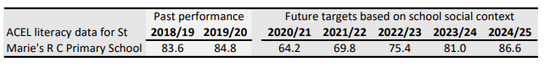
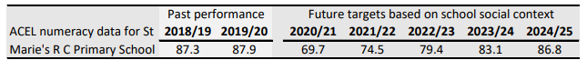
Gaps Identified through CEM assessments and SNSA
- Multiplication and Division skills in P3. Less than half of the children were at their chronological age for attainment in these skills.
- Reading skills in P4. Less than half of the children were at their chronological age for attainment in these skills.
- These areas will be a priority for the SIP 2021-2022.

Evidence of significant wider achievements

- St. Marie’s achieved their 5th Green Flag in June 2021. This reflects the ongoing commitment to environmental sustainability and eco initiatives in our local community and beyond. Through this work the children developed important life skills such as team work, collaboration, problem solving, perseverance, resilience and ambition. These skills are also embedded in our school Tagline. Assessment feedback stated
‘It is clear that you worked hard to adapt your actions to cope with the challenge of home learning and the need for social distancing. We also noted aspects of your work as being examples of good practice. We may use these on our website and social media as case studies to support other schools with their Eco-Schools Scotland work’.
- We achieved 1st Place in the Fife Active Schools Euro Step Challenge [Big Schools] May 2021. The children developed skills in fitness whilst also building self-motivation and independence. This also increased family engagement.

- We achieved 2nd Place in the Fife Active Schools Euro Step Challenge [Big Schools] June 2021.

- P5-7 have been working on the challenges in the John Muir Award. They have been demonstrating real enthusiasm and commitment and are helping to make a positive difference to wildlife in our local environment. This is incorporated in our Outdoor Learning programme which runs throughout the school. Children are developing their ability to reflect on their place and impact on the world around them.

- Our P6 & 7 pupils took part in Fife’s Virtual Athletics Festival 2020 and developed skills in track and field events.

- A number of our pupils developed their performance skills and their confidence by performing in the Fife Music Service Virtual Performances - Junior String Orchestra.

- Our P4, 5, 6 & 7 pupils enjoyed weekly Teams meetings with some of the residents from Methven and Barrogil Nursing Homes. They are developing very worthwhile life skills and have been living out our school/Christian values of being kind, respectful, caring and compassionate individuals.

- Our P4 & P7 children have increased their spiritual knowledge and understanding and have received the sacraments of First Holy Communion and Confirmation.

- All P5 and P6 pupils have achieved Level 1 in the Bikeability programme, developing skills in cycling and road safety awareness. The school worked closely with the parent council to fund raise and purchase a set of 10 new bikes and helmets to enable all pupils to benefit and participate.

Next Steps
- Building on our previous success around sustainability, the school has now registered to become a Laudato Si school. Using the Gospel values in the real world and developing a culture of care for all.
- All P5 and P6 pupils will complete Level 2 Bikeability, learning to cycle safely on roads in our local community.

What have been the success and challenges of school/setting closure period (school/class/playroom isolation, remote learning between January – March 2021)
Impact of COVID 19 : Successes
- The continued whole school use of SeeSaw from last lockdown ensured a smooth and prompt transition into remote learning in January. This ensured excellent communication with parents and pupils and robust quality assurance processes across the school.
- Two of our PTs took leadership roles in supporting the IT aspects of Seesaw and remote learning. Expectations were discussed and agreed at the first staff meeting in January before remote learning began. These included the requirement for 3 lessons per day: Literacy, Numeracy & H&W/IDL plus live catch ups [this was suggested at 3 per week for the first week of lockdown]. This ensured high standards and a consistent approach across the whole school for all children.
- Headteacher & DHTs participated in professional dialogue to share successes and challenges with Education Scotland as part of the national sampling of remote learning. Positive feedback was received.
- Staff used a varied approach to teaching via Seesaw through for example videos, PowerPoints, photographs, links to videos online etc. to teach new concepts or progress learning and sharing tasks for the children to consolidate their learning with.
- Staff were feeding back using the voice function or written comments on each piece of learning, daily.
- Whole school community events e.g. sports day, talent show & assemblies, virtual Christmas Production.
- High levels of engagements.
- The introduction of live interactions and video lessons in lockdown 2 had the most positive impact of all when compared with the 1st period of lockdown. This ensured that new learning was happening, pace and challenge were in place and communications with children and families were ongoing. This would certainly be something that we would take forward in the future.
Challenges
- The major challenge of keeping everyone safe was significant.
- Wi-Fi connections were often problematic, and connections could be easily lost.
- Finding new ways to keep children motivated and challenged could be difficult.
- Supporting positive levels of mental health for children, staff and families was a key concern.
- The introduction of weekly Live Assemblies was stressful in the beginning, but clearly very beneficial. Parental feedback indicates that they had a positive impact.
Home Learning due to COVID 19 Pandemic: Parental Views [January 2021]
Data was gathered from parents via FORMS questionnaire to identify strengths and challenges of online learning.
- Almost all (91%) parents felt the children benefitted from live learning with their class or whole school.
- Almost all (95%) parents felt that their child benefitted from seeing the wider staff on a regular basis every week
‘Definitely a positive event for the children- seeing all of the staff from around the school, as well as some of their peers, helps them to realise they're not alone in this situation and enforces the idea that teachers are still there to help and praise them, even though they're not in school. It's tough for them not seeing their friends and they do miss them, ever so much. My boys both have big smiles after any online meetings, having seen their teachers and friends.’

Stakeholders
A post on Kingdom Homes Limited’s Facebook page titled: Operation Cheer stated that;
‘The children from St. Marie’s Primary have been enjoying weekly online activity sessions with Barrogil House and Ruth, as part of their intergenerational partnership. We would like to thank St Marie’s for their amazing support in this new venture and would like to thank the children for their kindness’.

Impact of Local/National resources to support recovery within your setting (digital devices, additionality of staffing)
Number of devices provided to support learning at home | 27 reconditioned laptops  52 new netbooks & 11 WiFi dongles
Additionality in staffing | 0.5

These devices enabled more children to engage in home learning and reduced stress levels in many families where a number of people were all trying to use the same device. The data relating to pupil engagement from the first and second lockdown demonstrated a rise of more than 10% from 80 to 91%.
In our home learning survey January 2021 almost all (98%) parents reported that they had adequate devices at home.
Parents reported that:
‘My child is very comfortable using the online education and he is really enjoying it. I really appreciate the efforts taken by the school and teachers for their support and feedback given to my child.’
‘I have 2 daughters P6 and P2. The daily work and communication from their teachers is just fantastic. I don't feel like they are missing too much as they are continuing work from class. The teachers also give optional additional challenges which is a good idea too. All of the staff are doing an amazing job and going above and beyond.’
‘Having a device at home has made a huge difference to the progress of my girls. Thank you for everything the school has done.’

Attainment Scotland Fund Evaluation (PEF/SAC)
Progress:
EYOs
Continuing to employ two EYOs to help support the development of play-based learning and attainment in reading and numeracy in Primary 1 has had a very positive impact on attainment.
Family worker
Working in consultation with staff, parents/pupils who needed support to regulate emotions in class or who were struggling to engage in learning were identified.
Consistent support on a weekly basis for all pupils identified. Weekly consultations and feedback with SLT, SfL and class teachers to identify pupils requiring support, monitor progress and inform next steps. This has ensured that support is effective and having a positive impact. Detailed assessments are recorded weekly and shared with SLT to ensure that effective next steps are agreed and monitored. Sessions are flexible and timescales are varied and suited to each pupil to fully meet their needs. Regular feedback to parents is given, when appropriate, to keep parents informed and sustain the support at home.
.’
Impact:
The impact of having two EYOs in Primary 1 has been that almost all P1 children have achieved the appropriate CfE level in reading [91%] and numeracy [94%]. This is providing children with a strong foundation of basic numeracy and literacy skills on which to build.
The impact of having a family worker/play therapist was very positive in terms of pupil mental health and that of families. All pupils reported 100% positive feedback.
Impact statements:
Quotes from class teachers highlights the success of sessions this year:
‘TM has really benefited from her weekly sessions and always comes back to class as if something has been lifted from her shoulders. She finds it easy to talk to Lesley which is what she needs.’
‘KM has really been struggling with his emotions but has really improved since working with Lesley. He enjoys going to talk and this is making things easier for him in class.’
Quotes from pupils highlights the positive impact of support provided:
‘Personally to me I felt a lot better because I was getting someone to talk to regularly. It was hard at first because I was getting used to sharing my feelings. I had some big worries and being able to talk about them was really good. The more I talked about it, the worries got smaller and smaller.’
‘Seeing Lesley has helped me a lot. I’m not worrying as much as I used to. I can picture the scale in my head now to help me and I use it when I’m feeling sad. I can talk to my mum about the scale and she can give me advice.’
‘It felt like I had someone to talk to and understand what I was going through. We played fun games and she tried to make me feel happy again and it did make me feel happy again.’
‘I got to talk to someone and I liked talking about my emotions

NIF Quality Indicators
Quality Indicator | School Self-Evaluation | Inspection Evaluation  (where appropriate)
1.3 Leadership of Change | Very Good | Good [2017]
2.3 Learning, teaching and assessment | Good | Good [2017]
3.1 Ensuring wellbeing, equity and inclusion | Very Good | Very Good [2017]
3.2 Raising attainment and achievement | Very Good | Good [2017]

