Asset and Corporate Services sub-committee

19th August 2021
Agenda Item No.
Enterprise and Environment Directorate Section/Service Performance Reports
Report by: Keith Winter, Executive Director, Enterprise and Environment
Wards Affected: All
Purpose
To present the performance scorecard for Property Services, Facilities Management, Building Services & Fleet Operations for 2020/21
Recommendation(s)
Members are asked to:
- Consider the Property Services, Facilities Management, Building Services & Fleet Operations performance information presented at appendix 1, 2 & 3.
- Consider if any further review work or scrutiny is required and the scope of that review.
- Note the arrangements set out to fulfil the Council’s obligation to comply with Audit Scotland’s 2018 SPI Direction.
- Note the information regarding the workforce profile at appendix 4.
Resource Implications
None
Legal & Risk Implications
None
Impact Assessment
An EqIA is not required because the report does not propose a change or revision to existing policies and practices.
Consultation
None required

1.0 Background
  - Audit Scotland published the Statutory Performance Direction in December 2018. 2020/21 is the second year to which that direction applies. The Council is required to report a range of information setting out:

- Its performance in improving local public services, provided by both (i) the council itself and (ii) by the council in conjunction with its partners and communities.
- Its progress against the desired outcomes agreed with its partners and communities.
- Its performance in comparison (i) over time and (ii) with other similar bodies including information drawn down from LGBF in particular and from other benchmarking activities
- Its assessment of how it is performing against its duty of Best Value, and how it plans to improve against this assessment

  - The first requirement, to report the Council’s performance in improving local public services (including with partners) will be satisfied by the series of reports (of which this is one) that will be presented to the Council covering the whole of the Council’s performance for 2020/21

  - The other requirements of the Statutory Performance Direction will be satisfied by a combination of

- Update reports to the Fife Partnership regarding progress against the Plan for Fife, with reports also going to Policy and Co-ordination Committee.
- public performance reporting, assurance statements and governance arrangements.
- Reviewing the External Audit Annual Report for its view on our Best Value performance and any action plans thereafter.
- Carry out a Best Value Self-Assessment using the updated Audit Scotland Guidance in conjunction with the Council’s Corporate Governance Statements.
1.4 Taken together, these reports will cover the whole of the Local Government Benchmarking Framework, plus selected service performance indicators that give a balanced picture of Council performance.
1.5 The appendix to this report is presented in the form of a balanced scorecard covering the areas of Financial, Key Business Delivery, People and Customer results. This mirrors the approach used for internal management reporting throughout the year.
1.6 This is the first Performance Report submitted following implementation of Oracle Cloud. This system has sophisticated reporting tools and better reporting functionality but some of these reports are still in development, particularly those relating to sickness absence.
1.7 Members should therefore be aware that the numbers in this section are different due to the system change. Previously, absence was reported as WDL per FTE. At the moment, the output data being produced is for WDL per employee and as a result, there is likely to be a slight but immaterial difference in the figures. WDL per FTE will be available for next year’s report.

2.0 Best Value and Plan for Fife
2.1 Fife Council and the Fife Partnership are currently completing a three-year review of the Plan for Fife to ensure that adequate progress is being made towards the Plan's twelve ten-year ambitions, while at the same time setting out a recovery and renewal plan following the Covid-19 emergency. A draft Plan was considered by the Fife Partnership Board and by Fife Council's Policy and Co-ordination Committee. Once agreed, the updated Plan will provide the basis for regular reporting to the Fife Partnership Board and relevant Fife Council committees on the delivery of agreed outcomes, this will in turn drive service performance and improvement activities.

2.1 Following the BVAR in 2018, the Best Value Action Plan will be reviewed and updated as per the new Best Value direction. From 2021/22, Councils will be asked to self-assess against this new direction and then produce a new action plan.

3.0 Service Performance
Property & Bereavement Services
3.1 The Property Service vision is to lead effective management of our estate and use our land and property assets to deliver better outcomes, empower communities and leverage economic stimulus.
Bereavement Services manage our care of the dead and are responsible for the operation of our crematoria at Kirkcaldy and Dunfermline. The service also undertakes interments and looks after Fife’s 115 cemeteries.
3.2 Strong cross service working across the Council and with partners was one of the dominant themes of activity over the last year. In the case of Property Services this involved working with other services and partners to support our collective response to COVID and the lockdown. Initiatives included support for NHS colleagues, support for services in the adaptation and safe use of our estate and the delivery and advancement of key projects such as the restoration of Woodmill High School (following the fire in 2019), delivery of Madras College (opening in Aug 2021) and progress with Dunfermline Learning Campus. The challenges faced by Bereavement Services were different and through the year the service worked with local partners to try to ameliorate the impact of lockdown restrictions, whilst at the same time strengthening service resiliency through initiatives such as web streaming, provision of additional capacity and the cremator replacement programme.
3.3 Project delivery arrangements were safely modified and adapted to allow projects to progress, to include Dunfermline Learning Campus, Madras, early years programme, New Care Village in Methil, continuing progress in the Affordable Housing Programme, to list a few.
3.3 Thanks to the support and goodwill of staff and investment by BTS, both Property and Bereavement Services was able to respond quickly to lockdown restrictions and the need to change working practices. In turn that allowed the services to support delivery of the various projects noted in this report as well as the development of new safe systems of work enabled as restrictions were adapted and modified over the year.
Many of the changes in working practices are now embedded and will continue as we adapt to new hybrid working arrangements.
3.4 As noted above, Bereavement Services worked collaboratively over the year to ameliorate the impact of lockdown restrictions whist investing to improve service resiliency to include replacement of cremators at Kirkcaldy (similar replacement is currently taking place at Dunfermline) and provision of webcasting services for funerals. The service also worked closely with NHS, funeral directors and other council services to improve data tracking and to manage storage capacity. Alongside this activity, work continued to improve the condition of our cemeteries. Around 12,000 headstones have now been made safe (inspections continue to show a failure rate of 40-60% of all headstones) and of the £1.2m committed in improving the condition of cemetery walls and structures over a 4-year programme, over £700k has been spent since work began in 2019/20.
3.5 During the initial period of lockdown, Bereavement Services were heavily involved in contingency planning/actions for what fortunately never came to pass. The Service has continued to amend working arrangements to ensure continued, dignified service provision and support to bereaved families across Fife. wrong section?
3.6 Regarding reported PIs, customer satisfaction remains high across both Services and attendance levels shows continued improvement across Bereavement and remain high within Property.
3.7 Adaption to new hybrid workstyles will be a key challenge for the services over the year ahead.
Facilities Management
3.8 The Service provides Catering, Cleaning, Facilities Management, Meals on Wheels and Janitorial for the Council.
3.9 Facilities Management Services (FMS) have managed to successfully deliver all services as demanded by various services including Schools, Social Care Residential Homes, Meals on Wheels (MOW), Corporate Buildings and Community Services etc. The service has taken on many additional duties and activities including more daytime cleaning in schools, increased number of MOW customers and supporting Fife Council/NHS asymptomatic testing clinics in various locations.

3.10 Commercial catering services have suffered trading losses due to the Scottish Government directives on closure of cafes/food outlets. However, the Service observed a marked increase in take-up during the “Eat out Help out” period – particularly in secondary schools. The schools experience has shown that the potential customers are price sensitive, and this may influence future pricing policies.

3.11 FMS teams have also successfully enabled the smooth operation of corporate buildings, e.g., Fife House complex and Bankhead, to ensure that critical services and officers could operate successfully. They assisted by helping to remedy the operational challenges that were encountered e.g., desk booking facilities to help with “track and trace”. Much of the knowledge gained from these modified operational changes and innovations will help to inform the Fife Council’s future way of (hybrid/blended) working.

3.12 It cannot be overstated that many FMS staff have demonstrated they undoubtedly care about their local communities and services by volunteering to work in unfamiliar work locations and have been very flexible in assisting the service i.e., working out of contracted hours, working split shifts etc.

Building Services & Fleet Operations
3.13 Building Services provides Fife Council with a 24 hour, 365 day a year repairs, maintenance and construction development service. There is a large and highly skilled workforce undertaking all mainstream trade activities and delivering quality works at competitive prices through a best value partnership with Property Services.
Fleet Operations are primarily responsible for the management and maintenance of the Council's vehicles, plant and equipment, of which the Council owns and operates a vast range. They range from car-derived vans and minibuses to large specialised commercial vehicles and road registered plant.
3.14 Building Services operational delivery has been significantly impacted by Covid-19 in 2020/21. Many workstreams were stopped or slowed by distancing measures diminishing productivity levels. Recovery is underway and altered working practices have become business as usual, minimising downtime. The service continues to work with the Corporate Procurement and Economic Development Services on a local procurement strategy which will increase construction tender opportunities for Fife based companies. There are regulatory barriers to direct engagement with local companies but innovative strategies and a more balanced approach to risk is being considered.
3.15 Compliance measures have significantly restricted productivity levels with workstreams involving house access being stopped completely during lockdown periods. Performance is being managed carefully and has improved as working practices have bedded in. Recovery plans should see productivity return to normal when restrictions are lifted. However, material shortages in the coming year will present a new set of challenges and mitigating actions are being considered presently.
3.16 With access to council housing and public buildings restricted for most of 2020/21, mainly emergency repairs were undertaken, and performance levels remained high, as did customer satisfaction despite potential virus transmission concerns for some. Working days lost has understandably risen as a result of the pandemic and that situation should improve as things return to normal. Plans are being made to mitigate the impact of forthcoming material shortages and a number of procurement and design practices are being considered. Apprentice training has been delayed but steps are being taken to recover the missed onsite exposures and academic learning. No apprentice will be disadvantaged by the disruption in their training or compromised in the final recruitment process for permanent employment with Building Services.
3.17 Fleet Services continue to deliver high standards of contract hire maintenance and vehicle management services. Work continues with Transport Scotland on the introduction of electric vehicles and charging infrastructures. Opportunities to reduce fleet volumes are continually being explored with client services.
3.18 Covid compliance measures have not significantly impacted day to day operations and recovery plans are underway with blended workstyles already implemented and working well. Significant reductions in fuel usage were experienced across all services, with savings exceeding £1m.
3.19 Fleet service provision was maintained during the pandemic and performance remained high. The fleet size has been reduced in working towards financial efficiencies and carbon reduction commitments. The focus is now on the introduction of electric vehicles and further fleet reductions accruing from blended workstyle opportunities.

4.0 Conclusions
4.1 This report is the first in a series covering the whole of the Council’s performance against key indicators, including the Local Government Benchmarking framework.
4.2 The overall performance of Property Services, Facilities Management, Building Services & Fleet Operations has been affected by the pandemic and this is highlighted in appendix 1, 2 & 3.

List of Appendices
- Property Services Performance Report 2020/21
- Facilities Management Performance Report 2020/21
- Building Services & Fleet Operations Performance Report 2020/21
- Workforce Profile

Report Contacts:

Ken Gourlay Iain Duncan
Head of Assets, Transportation and Environment Programme Manager
Enterprise and Environment Directorate Communities Directorate
Email: Ken.Gouraly@fife.gov.uk Email: Iain.Duncan@fife.gov.uk

Customer
Performance | Progress
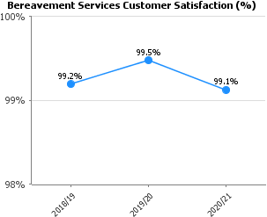 | Bereavement Services continue to deliver high levels of customer satisfaction.
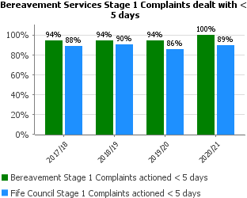 | There were 19 stage 1 complaints and 11 stage 2, all of which were dealt with within the given timescales.  Bereavement Services has strived to maintain high levels of customer service across their area, and where issues arise every effort is made to resolve in a timely manner.
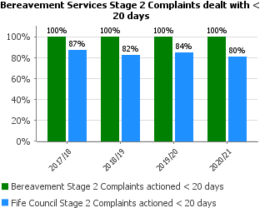
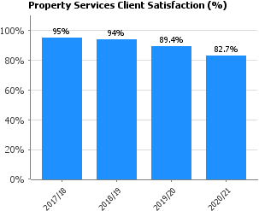 | Property services continue to deliver high levels of satisfaction.  There has been a change to the way data is collected for this PI. The previous methodology was overly complicated, and a more consistent and clearer approach is now in place. This has resulted in a slight decrease in performance; however, customer feedback remains positive.
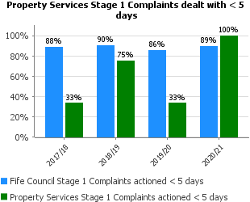 | Property Service received two Stage 2 complaints one of which took longer than 20 days to respond to.
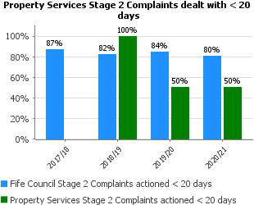

People
Performance | Progress
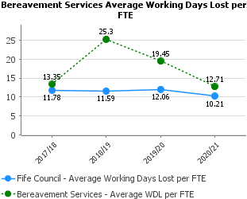 | Owing to the nature of the service Mental and Physical health is typically an issue, however with increased focus and support the figures have returned to the pre 18/19 levels and absence continues to be managed.
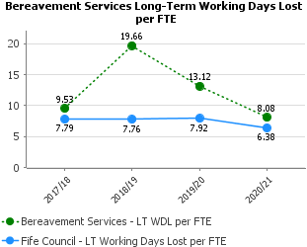
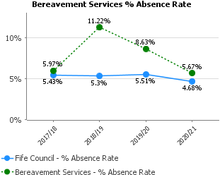
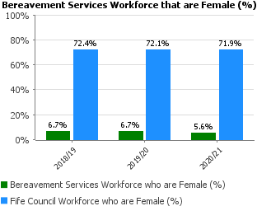 | Recruitment in line with Council HR policy.
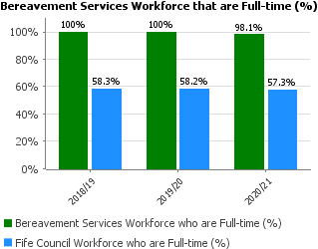 | Cemetery maintenance teams made up from core staff supplemented with temporary seasonal staff over the growing season.
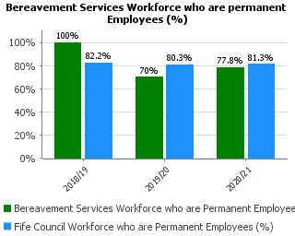
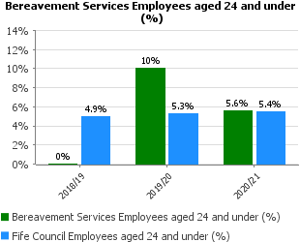 | Bereavement retain a stable and committed workforce to include utilising seasonal staff who are often younger members of staff.
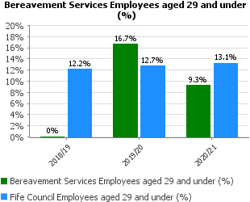
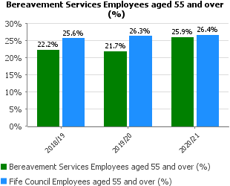
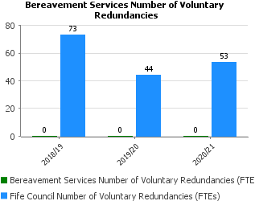 | No NOI’s progressed during 20/21
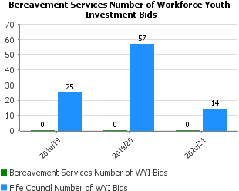 | Consideration will be given to future use of workforce youth investment bids.
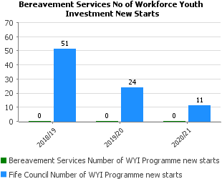
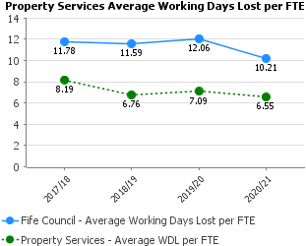 | Attendance levels within Property Services remain high.
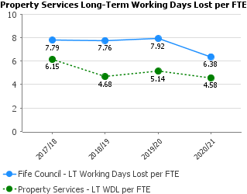
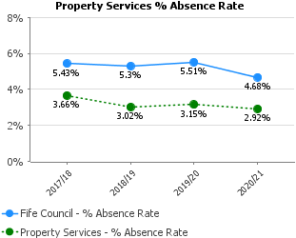
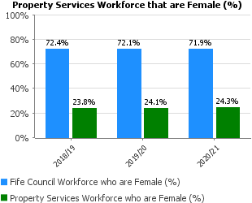 | Recruitment in line with Council HR policy.
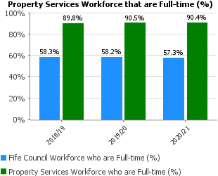 | Over time it is anticipated more staff will embrace alternative working arrangements, which could include reducing hours or alternative work patterns.
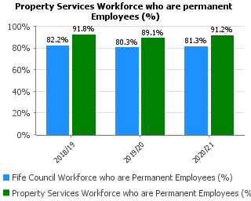 | A small no of employees have been recruited on temporary contracts to support project/programme delivery.
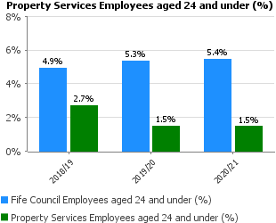 | Property Service have a stable but aging workforce.
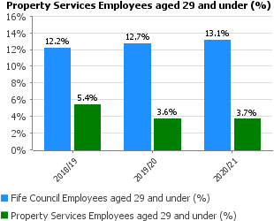
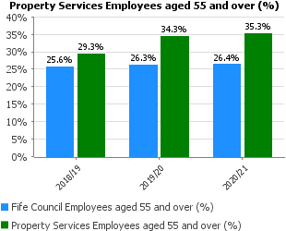
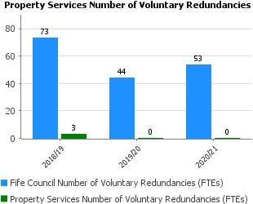 | No NOI’s progressed during 20/21
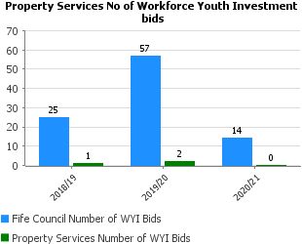 | Property continues to support workforce youth investment.
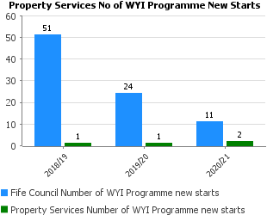
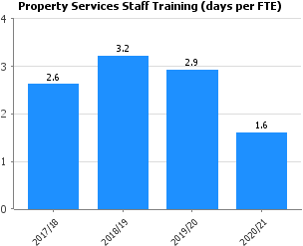 | There has been a decrease in training during the COVID pandemic.

Key Business Delivery
Performance | Progress
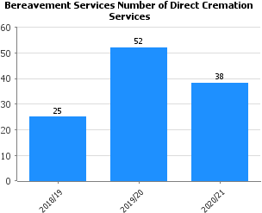 | Direct cremations form part of our broader offer and take up reflects customer demand.
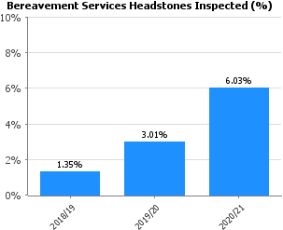 | Originally there was only one team engaged in headstone safety, this has now been increased to three. Work has been carried out to approx. 12,000 headstones over the last 3 years.
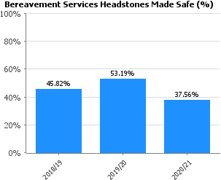 | The challenges associated with headstone safety vary from cemetery to cemetery but typically the failure rate remains 40% to 60%.
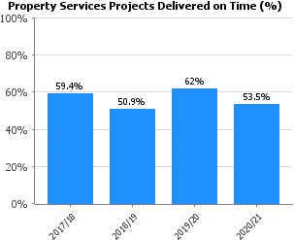 | Increased focus on early Client and Project involvement has led to improved budget management. Further work is required to ensure more projects are delivered on time. However, in 2020/21 performance was impacted by COVID.
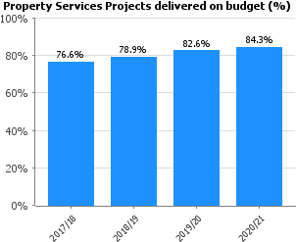 | Increasing focus on early Client and Project involvement leading to improved Time/Budget management.
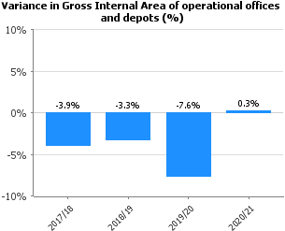 | The slight Increase reflects a small amount of additional provision for grounds maintenance at Dunnikier Park.
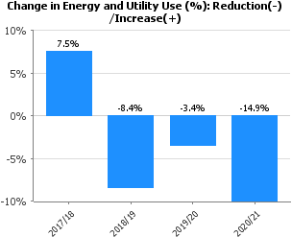 | In 2020/21 the decrease reflects the impact of COVID, however the pattern of reduction in energy use remains.
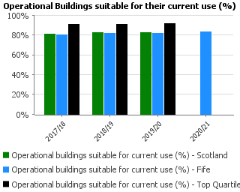 | This improvement has occurred as we have consolidated services into buildings that are fit for purpose. Surplus assets are then repurposed or sold.
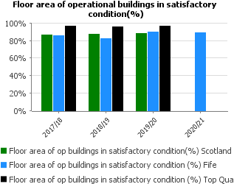 | The slight dip in performance is explained by the return to the portfolio of Woodmill High School (C Condition) after the fire in 2019. Alongside St Columba's RC HS, it is proposed Woodmill will become part of the new Dunfermline Learning Campus which is due for completion in 2024.

Financial
Performance | Progress
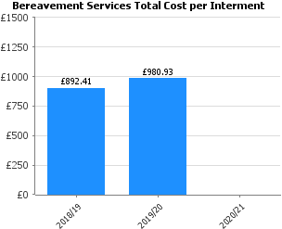 | 2020/21 data is currently not available, although we expect an increase in cost. Owing to H&S Covid mitigations.
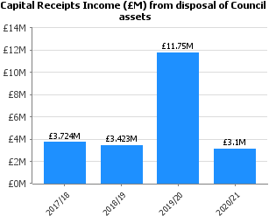 | Following last year’s boost (due to the inclusion of the Madras school transfer at £8.1M), capital receipts returned to a level more representative of historic trend.  Some slippage occurred to transaction timescales due to Covid related matters, however those sales should conclude in 2021/22.
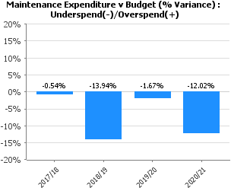 | The underspend is in line with forecasts and reflects the impact of lockdown which impacted on our ability to undertake planned maintenance activity.  Planned maintenance activity is expected to return to normal in 2021/22.

Customer
Performance | Progress
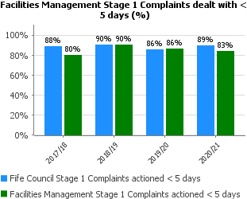 | Performance has been largely consistent over the last 4 years. Some of the reasons that we have not improved our response time is to gather information and to validate it for veracity before responding. In most cases where we are unable to meet the deadlines then we will always respond to the complainant and explain when we will respond.
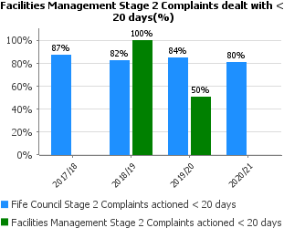 | The service had no stage 2 complaints during 2020/21.

People
Performance | Progress
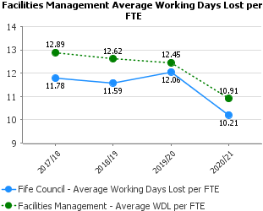 | Facilities Management Service have made a concerted effort to improve attendance and that is reflected in the welcome downward trend.  Managers regularly review the reasons for absence and as can be expected much of the absence relates to Musculo-skeletal causations. Also, we have now appointed a temporary attendance officer to help review cases and improve attendance.  We will continue to vigorously review this data.
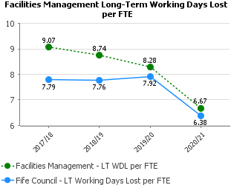 | Again, managers have been working hard to reduce long term absence and the downward trend reflects the management focus and activity.  Most absences are related to serious long-term health issues (e.g., cancer etc.) that are outside of our control and influence.  Also, we have now appointed a temporary attendance officer to help review cases and improve attendance.
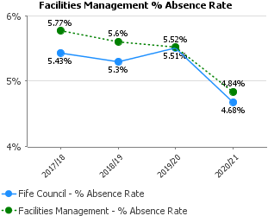 | Facilities Management Service have made a concerted effort to improve attendance and that it reflected in the welcome downward trend.  Managers regularly review the reasons for absence and as can be expected much of the absence relates to Musculo-skeletal causations. Also, we have now appointed a temporary attendance officer to help review cases and improve attendance.  We will continue to vigorously review this data.
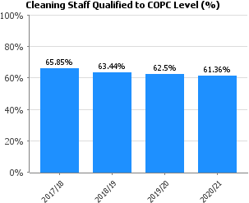 | Our qualification figures have been very stable over the past 4 years. However, we will seek to review and improve this through our forthcoming workforce planning work.  Furthermore, other training opportunities are being explored to assist staff and improve service quality.  Members and officers should note that all staff go through a comprehensive induction process to apprise them of work standard, safe working and how to deliver a good service to our clients.
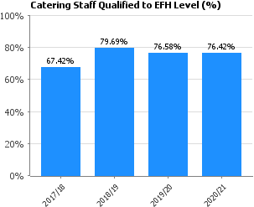 | Our qualification figures have been very stable over the past 3 years. However, we will attempt to improve the number of staff holding this qualification.  Members and officers should note that all staff go through a comprehensive induction process to apprise them of work standard, safe working and how to deliver a good service to our clients.
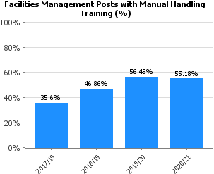 | These figures are disappointing, but we would have made more progress in 2020-2021 had it not been for the restrictions and demands imposed on us by Covid.  Most of this training requires face to face training and evaluation and with distancing guidelines traditional training could not be completed.  Officers are now exploring how to deliver this training in a novel way e.g., video etc.
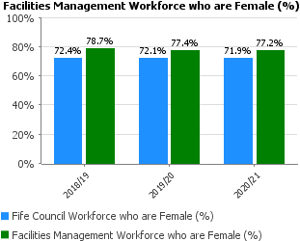 | We are proud to have a high percentage of female workers and they often work in key services i.e., Catering, cleaning. Many of the posts are part-time and non-office hours which meets with their domestic and personal circumstances.
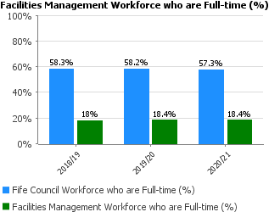 | Most of our services are provided in non-traditional office hours e.g., early morning and evenings. So, jobs are configured accordingly and therefore part-time workers are invariably the best option. We do have some posts e.g., Janitors and managerial staff that are fulltime and these numbers are unlikely to increase in short term.
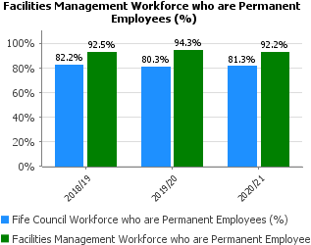 | Again, a stable set of figures. It should be noted that most of these employees are occupying part time posts.  Some temporary post/increased hours were in place to deal with the additional demand of Covid.
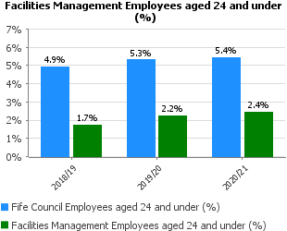 | Most of our posts are part-time and operate in non-traditional office hours and largely and operate when schools are open. Therefore, these types of posts are unlikely to be attractive, in salary and career progression terms, to this age group.
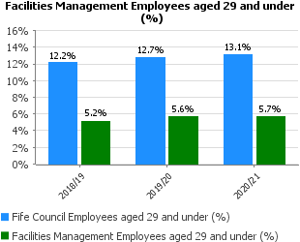
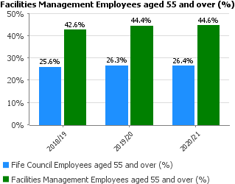 | We are not targeting to increase the number of employees in this age group.  Most of our services are provided in non-traditional office hours e.g., early morning and evenings. So, jobs are configured accordingly and therefore part-time workers are invariably the best option. Furthermore, these types of jobs are more attractive to an older age group.
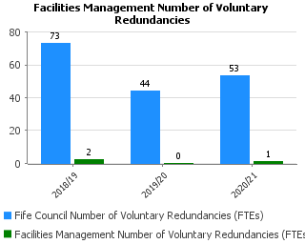 | No major restructures have been completed in the last 3 years and therefore voluntary redundancies have not been required.
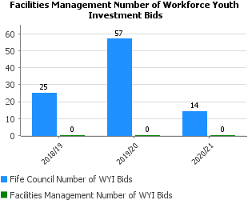 | We have not targeted this sector previously but will explore opportunities as they arise.
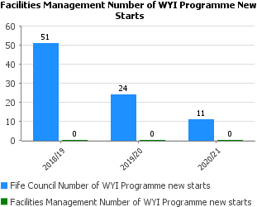 | We have not targeted this sector. Youth “workers” tend not to prefer to elect to come into FM services.

Key Business Delivery
Performance | Progress
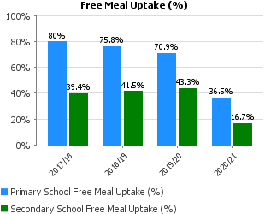 | Putting aside the Covid factor, there continues to be a gradual decline in uptake in primaries.  This could be due to menu restrictions and lack of understanding of the health agenda by some parents.  The uptake in High schools whilst stable remains low although comparable to other areas.  The decrease largely mirrors what is happening in Scotland overall.
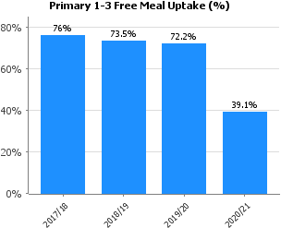 | During 2020-21 schools did close and children eligible for free school meals then received a payment and this has not been reflected in the chart.
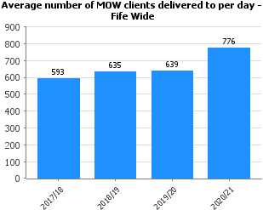 | As a result of Covid there has been an increased demand for Meals on Wheels. We would expect this to level out over the next financial year.
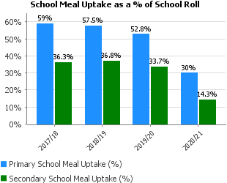 | It is inevitable that uptake against school roll would reduce when access to schools, limited menus and customer concerns, all due to Covid have been such a factor.  This however does not account for year on year reduction over the past years – something experienced by the majority of authorities in Scotland.  This may be due to aggressive, price lead, marketing from supermarkets and food outlets and further restrictions on menu content.

Financial
Performance | Progress
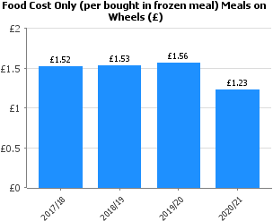 | This may be due to increase in demand and an increased number of customers choosing the soup and sweet option.  This could again level out over the next financial year.
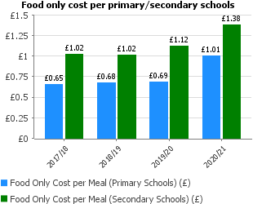 | Food cost have increased due to change in delivery method and the type of menu items served to minimise the risk of Covid. We have shave been forced to serve more prepared type meals for delivery into classrooms. This would include some prepacked products like yoghurts, juices etc. which are more expensive.  When normal menus are reinstated these food costs should reduce to 85p per meal in primary schools and £1.10 per meal in High schools.
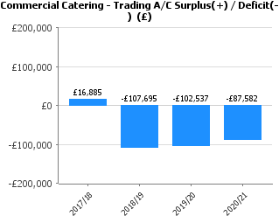 | This relates to staff restaurants and other services. Much of the loss is due to the absence or lower number of customers experienced in 2020-21. We will review our service demand in 2021-22 and make necessary adjustments.
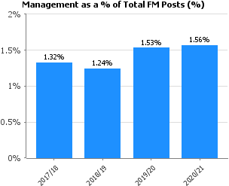 | A very low ratio and this is unlikely to increase in the next 2-5 years.  This ratio also reflects the good training, direction and the quality of support given by managers to frontline staff. It should be recognised that frontline staff are diligent and receptive to management guidance and instructions.  Furthermore, as services adopt new working practices and especially ICT that will negate the need for more management.

Customer
Performance | Progress
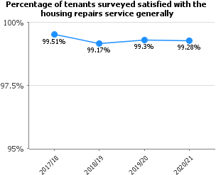 | Target met continuing to use handhelds for tenants feedback where practicable this may deplete in numbers with current COVID restrictions. Method statement in place to continue.
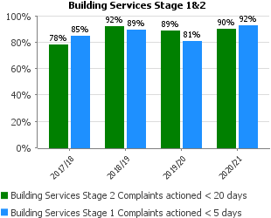 | Building Services have administration in place to ensure we strive to meet targets. Target exceeded in line with expectations.

People
Performance | Progress
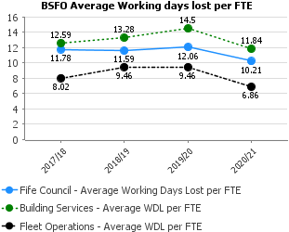 | Attendance management figures have improved through the COVID pandemic.
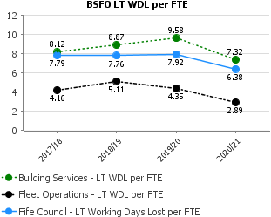
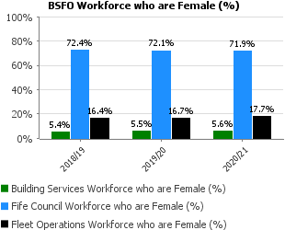 | Services strive to encourage females into the workplace. Recruitment roadshows are held at schools and educational establishments
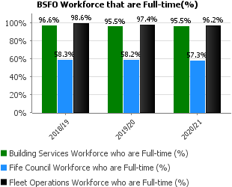 | Recruitment of staff is buoyant in the Full-time arena in the professions offered within a trade and skilled environment.
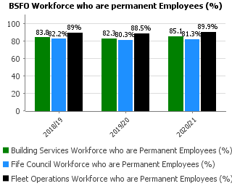 | There is room to improve our permanent establishment in line with future budget provision.
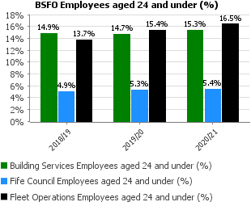 | A continuing apprentice programme contributes to keeping this at acceptable levels across the trades.
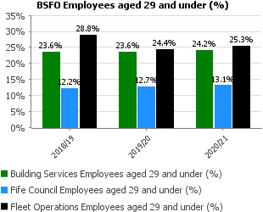 | There is a good balance in age groups across this area of the service.
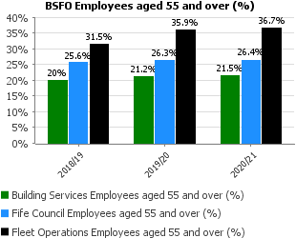
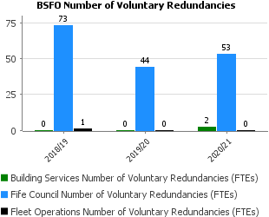 | Few redundancy packages have been made available for staff.
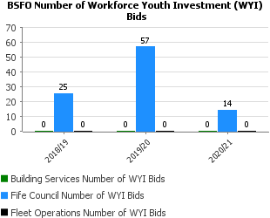 | Building services use the apprentice scheme to target youth employment.
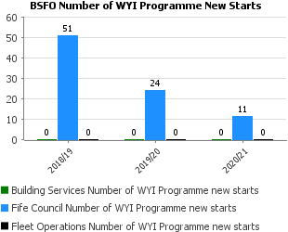
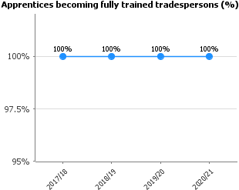 | Building Services Apprentice management team have continued to deliver apprenticeships completely and successfully.
 | Recruitment has remained at a good level following the current restrictions which is encouraging.
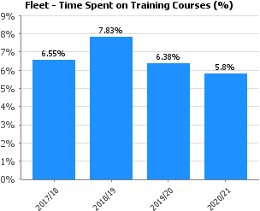 | Fleet Operations are continuing to deliver training to technical staff. This includes electric vehicles and a new annual Driver & Vehicle Standards Agency MOT Tester.  An annual exam and Continuous Personal Development helps improve road safety across the Council.

Key Business Delivery
Performance | Progress
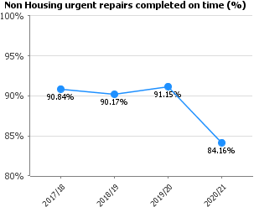 | Performance has dipped due to access issues and working restrictions due to COVID. This should improve back to normal levels as restations ease.
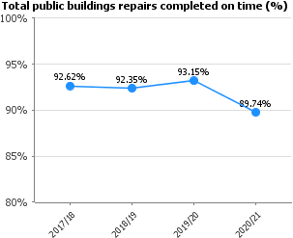 | Additional COVID restrictions and measures means the number of repairs requested is not comparable with normal circumstances. This should return to pre pandemic performance once restrictions ease and we are operating more business as usual.
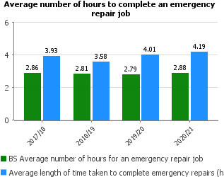
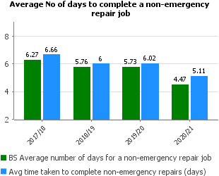 | Performance has dipped due to access issues and working restrictions due to COVID. This should improve back to normal levels as restrictions ease.
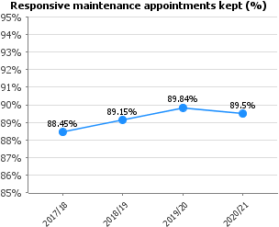 | Levels remain good and are constantly reviewed investment in new systems for appointments will aid us in the future.
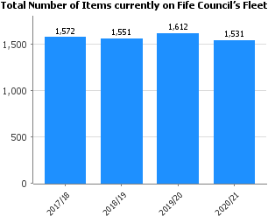 | The total number of Fleet items has continued to decrease since 2015. We currently have 52 full electric vehicles and 19 plug in hybrids which helps to lower carbon emissions. Fleet Operations and Procurement Services work closely with user services to ensure the reductions do not affect service delivery and new purchases are kept within the approved Capital Budget.
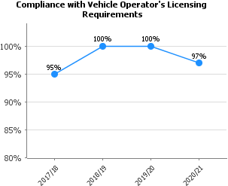 | The HGV first time pass rate is showing 97% for 2020/21. This is well above the average in the UK which is 91.24%. The Driver Vehicle Standard Agency reporting website is currently being upgraded so the pass results for April/May are not included which were 100%.

Financial
Performance | Progress
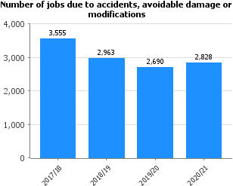 | The accidents figures have reduced which takes the winter period into account. The Professional Driver CPC annual mandatory training of 7 hours along with driver induction training by front line services may have helped here. There has been a slight increase in avoidable damage which relates to minor repairs.

PROPERTY SERVICES, FACILITIES MANAGEMENT, BUILDING SERVICES & FLEET OPERATIONS – WORKFORCE PROFILE 2020/2021 FINANCIAL YEAR (01 APRIL 2020 – MARCH 2021)

Service | Budgeted FTE April 2018 | Budgeted FTE April 2019 | Budgeted FTE April 2020 | Budgeted FTE April 2021 | Difference in Budgeted FTE 2020-2021
ATE Management | 1 | 1 | 1 | 1 | 0
Property | 203.54 | 199.54 | 201.02 | 201.83 | 0.81
Facilities Management | 1,198.81 | 1,182.33 | 1,166.74 | 1,171.60 | 4.86
Building Services | 1006.12 | 988.92 | 981.80 | 984.3 | 2.5
Fleet Operations | 77.40 | 76.40 | 83 | 83 | 0
Total | 2,486.87 | 2,463.39 | 2,441.96 | 2441.73 | 8.17

