Community & Housing Services Committee

24/11/2020.
Agenda Item No.
Communities Directorate Section/Service Performance Reports
Report by: Michael Enston, Executive Director, Communities.
Wards Affected: All
Purpose
To present the performance scorecard for Communities & Neighbourhoods and Housing & Community Safety for 2019/20
Recommendations
Members are asked to:
- Consider the Communities & Neighbourhoods and Housing & Community Safety performance information presented at appendix 1 & 2;
- Consider if any further review work or scrutiny is required and the scope of that review.
- Note the arrangements set out in section 1 to fulfil the Council’s obligation to comply with Audit Scotland’s 2018 SPI Direction.
- Note the information regarding the workforce profile at appendix 3.
- Note the information regarding workforce data at appendix 4.
Resource Implications
None
Legal & Risk Implications
None
Impact Assessment
An EqIA is not required because the report does not propose a change or revision to existing policies and practices.
Consultation

None required
1.0 Background
  - Audit Scotland published the Statutory Performance Direction in December 2018. 2019/20 is the first year to which that direction applies. The Council is required to report a range of information setting out:

- Its performance in improving local public services, provided by both (i) the council itself and (ii) by the council in conjunction with its partners and communities.
- Its progress against the desired outcomes agreed with its partners and communities.
- Its performance in comparison (i) over time and (ii) with other similar bodies including information drawn down from LGBF in particular and from other benchmarking activities.
- Its assessment of how it is performing against its duty of Best Value, and how it plans to improve against this assessment.

  - The first requirement, to report the Council’s performance in improving local public services (including with partners) will be satisfied by the series of reports (of which this is one) that will be presented to the Council covering the whole of the Council’s performance for 2019/20. Where possible, comparative performance is given for the Scottish average, top quartile, and peer group averages.

  - The other requirements of the Statutory Performance Direction will be satisfied by a combination of

- Update reports to the Fife Partnership regarding progress against the Plan for Fife, with reports also going to Policy and Co-ordination Committee.
- public performance reporting, assurance statements and governance arrangements.
- Reviewing the external Audit Annual Report for it’s view on our Best Value performance and any action plans thereafter.
- Carry out a Best Value Self Assessment using the updated Audit Scotland Guidance in conjunction with the Council’s Corporate Governance Statements.

1.4. Taken together, these reports will cover the whole of the Local Government Benchmarking Framework, plus selected service performance indicators that give a balanced picture of Council performance.

1.5 This report deals primarily with the performance of the Communities Directorate, however it also includes several Council-wide indicators that fit best within this report. These indicators are clearly marked in the relevant narrative.

  - The appendices to this report are presented in the form of a balanced scorecard covering the areas of Customer, People, Responsiveness and Cost results. This is consistent with the format used for the 2018/19 Public Performance Report and mirrors the approach used for internal management reporting throughout the year.

- Workforce Profile/data

2.1 It was agreed by CET in December 2019 that to streamline performance reporting, workforce Profiles and Data shall be incorporated into Annual Service Reports to eliminate the need for separate reporting.

- Conclusions

3.1 This report is part of a series covering the whole of the Council’s performance against key indicators, including the Local Government Benchmarking framework.

3.2 The overall performance of Communities & Neighbourhoods and Housing & Community Safety Services is positive; areas for improvement focus are identified in appendices 1 & 2.

List of Appendices

Appendix 1 – Communities & Neighbourhoods Performance Report 2019/20
Appendix 2 – Housing & Community Safety Performance Report 2019/20
Appendix 3 – Workforce Profile
Appendix 4 – Workforce Data

Report Contacts
Pamela Pate
Corporate Development Officer
Communities Directorate
pamela.pate@fife.gov.uk

Carly Duke
Corporate Development Assistant
Communities Directorate
Carly.duke@fife.gov.uk

Communities & Neighbourhoods
Performance Report 2019/20

This report provides a strategic overview of performance against key indicators.  - The service continues to benefit from high levels of attendance and in addition to the systems and processes the local working and ability to see changes with people and communities where we work continues to benefit strong partnership working across all areas of Fife.  - The impact of the pandemic on the final quarter of the year has resulted in some data not being available.  - The pandemic has had a negative impact on performance indicators across many parts of service delivery within the final quarter. | However, we continue to face significant challenges.  - The impact of Covid-19 on the delivery across the service and our partners presents the single biggest challenge for the service.  - The reopening of facilities and developing confidence in communities and service users to safely return to learning, development, culture and physical activity will be a significant challenge while working within the Covid-19 restrictions.  - The social and economic impact of the pandemic will require us to work in new ways to support as many communities and people as possible. Already further use of online and telephone support has allowed us to maintain and extend services.  - The continued work on facilities and community infrastructure across Fife will present challenges.

Customer
Performance | Progress
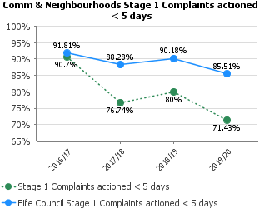 | The service received few complaints over the year. The nature and complexity of some complaints has resulted in lower performance.
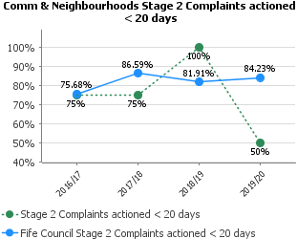
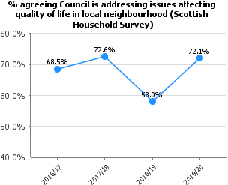 | 72.1% of Fifers agree that the Council is addressing issues affecting quality of life in their local neighbourhood, compared with 52.9% for Scotland. Note data relates to Scottish Household Survey 2018.
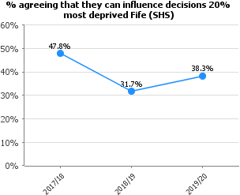 | 38.3% of those living in 20% most deprived areas of Fife agree they can influence decisions affecting their local area. This compares with 25.2% for those living in 20% most deprived areas of Scotland. Note: data relates to 2018 Scottish Household Survey.
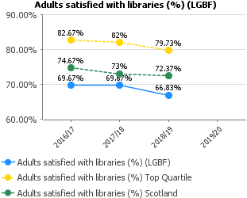 | Any decrease in satisfaction rates in 18/19 or 19/20 is likely to be a hangover from the closure of sixteen libraries in 2017 and a reduction in opening hours in most libraries in 2019.  Data relating to 19/20 is not yet available until December 20.
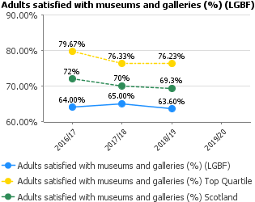 | Data taken from the Scottish Household Survey includes users and nonusers of the service. There are no clear factors to account for the slight decrease in satisfaction which mirrors the national picture in 2018-19.  Data relating to 19/20 is not yet available until December 20.
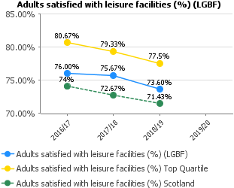 | Satisfaction with leisure facilities is a declining trend across Scotland. However Fife’s satisfaction levels are above the Scottish average. As with the previous year, the continued enhancement of communications mechanisms, programme variety and well-presented good quality services have all contributed to keeping Fife above the Scottish average.  Data relating to 19/20 is not yet available until December 2020.

People
Performance | Progress
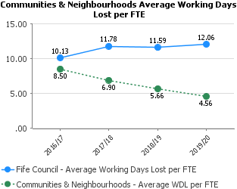 | Attendance continues to improve on both short term and long-term measures.  The Service is proactively managing absence and greater focus is being given to supporting our employees to be healthy in order to improve attendance. Work is in progress to focus on different ways to support employees to stay at work or return to work as soon as possible.
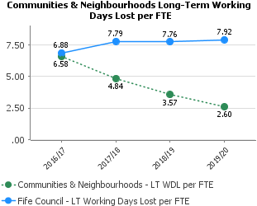
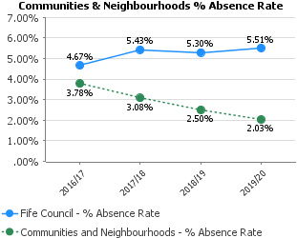

Responsiveness
Performance | Progress
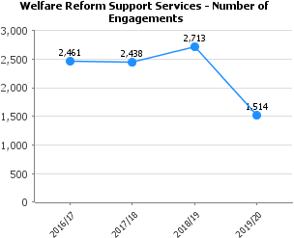 | The data shows the stabilising in community job club user numbers after the expected steep increase when the full roll out of Universal Credit took place in Fife 2017/18. We now see fewer but more complex cases that require an increased level of advocacy and support for vulnerable clients from the Welfare Support Workers.
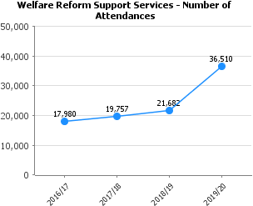 | There has been an increasing number of people accessing and being supported by welfare reform workers in the community job clubs that were developed in order to mitigate the impact of welfare reforms and provide a place for immediate help as well as signposting to other services.  It is not expected that the numbers will continue to rise but there will be an increase in the amount of time each person gets support within the job club sessions which is now to be recorded.
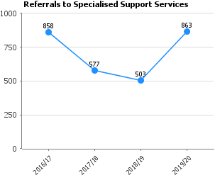 | The data identifies an issue with a decreasing number of referrals to specialist services which when investigated identified that in some locations where specialist services were co located with community job clubs the workers referred informally. Once this was identified the staff were actioned to record ALL referrals hence a steep increase.
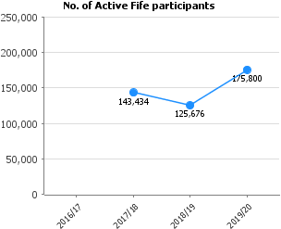 | There has been an increase in participation 143,434 (17-18) to 175,800 (19-20). The number of Adult 18+ sessions has seen the biggest drop whilst number of participants has increased by 78% from 17-18. Participant figures have increased for Adults through a mixture of training & sports specific sessions offered and these have been done in areas which has reduced the amount of sessions required but increased the capacity in the sessions
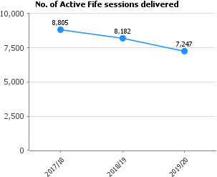 | We have seen a drop in the number of Active Fife sessions delivered from 8805 (17-18) to 7247 (19-20).  The number of Adult 18+ sessions has seen the biggest drop whilst number of participants has increased by 78% from 17-18. Participant figures have increased for Adults through a mixture of training & sports specific sessions offered and these have been done in areas which has reduced the amount of sessions required but increased the capacity in the sessions
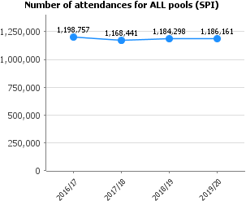 | Fife Sports and Leisure Trust- Over 1.1 million attendances were recorded for wet side activities, a slight increase of 1.17%. This is driven by 6720 customers in the learn to swim programme, the highest ever recorded at the end of March 2020. Throughout the year, 9 learn to swim programmes on average had an 88% occupancy rate and overall 7.81% growth on the previous year.  Community Use Schools - There was a decrease in the number of attendances in our pools. This was primarily due to Woodmill HS being closed for 4 months due a major fire. There were also issues with heating at Lochgelly and ceiling tiles at Inverkeithing which led to multiple cancellations. Although many of the issues we encountered in 19/20 have been resolved, fundamentally we are still left with ageing pools in ageing buildings.
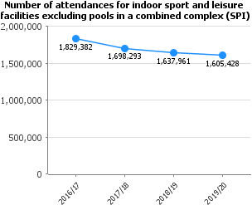 | Fife Sports and Leisure Trust - A slight reduction in dry side by -0.80%, without the impact of COVID-19 we were on course for a 4% increase. In 2018/19 we had a particularly poor performance due to an extended period of good weather we had through the summer of 2018, so improvement was expected through the same period this year.  Community Use Schools - A small decrease particularly in West Fife. Partially due to a fire at Woodmill High School which closed the facility for 4 months. A downturn in 2100 - 2200 bookings was also witnessed. In 2020/21 we will focus on promoting indoor facilities. In addition, we are already reviewing our opening times as it would appear that bookings after 2100 are becoming less common.
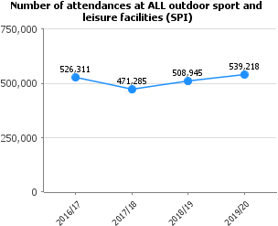 | Fife Sports and Leisure Trust - Sites usage in the main has slightly increased despite the closure of the leisure facilities in March due to COVID. Outdoor activities increased by 4.31%, with the attendance the highest recorded in our 12 years. The improvement attendances relates to astro pitches for the following reasons, to improve attendances we introduced a new weekend rate to encourage customers to use the astro pitches. The first full year of operation of the indoor football arena at Michael Woods and increase in attendance in 6 out of 8 venues that have astro pitches.  Community Use Schools - Healthy increase in participation. In 19/20 we offered a 50% discount on our synthetic pitch hire charges on Saturdays and Sundays which was well utilised. We have also been working closely with community clubs to increase use of our grass pitches. We will extend these initiatives into 2020/21.
The service has been working with smaller group sizes as a result of targeting provision at CBAL learners in SIMD areas and with a greater focus on addressing complex learning issues and barriers. There has been an increase in personal development programmes such as 7 Habits for Highly Effective People.
There have also been resource reductions and in some areas partner agencies are no longer operating meaning less or no provision is now available in some community areas.
As the learning offer has moved to better support adults with complex or longer-term learning requirements there has been a refocusing away from formal accreditation based qualification routes such as SQA, to a broader achievement agenda allowing quicker celebration of learner progress linked to building self-confidence and self-esteem.
Changes within ESOL funding arrangements with the College have also led to reduced SQA awards being offered. Moving forward, we have now agreed a new funding delivery model with the College and that should enable us to draw down additional funds.
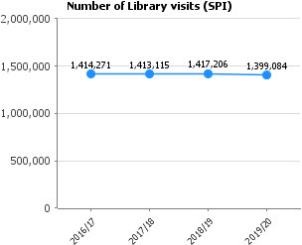 | Actual full year number for physical visitors to libraries is 1,399,084. The decrease will be due to a reduction in opening hours across some libraries and lower numbers visiting in Q4 due to fears over the pandemic.  The number of library visits has held up well given the reduction of 39 hours of opening times across the library portfolio & the closure of libraries in March due to COVID. The opening of Dunfermline Carnegie Library & Gallery has had a positive effect in underpinning the attendance figures.
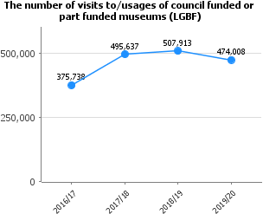 | Actual figures for 2019-20 are 474,008 for all Fife Museums (those operated by OnFife and the three independent museums which receive grant support from Fife Council. This reduction is partially due to the effects of the COVID pandemic in Q4, particularly March, when usage fell by 50%.

Housing & Community Safety
Performance Report 2019/20

This report provides a strategic overview of performance against key indicators.  - The Services continue to meet the requirements of the Council, our Tenants & Residents, and the Scottish Housing Regulator in a positive way. We are committed to performance improvement and 2019/20 evidences that continued improvement.  - Due to the Covid pandemic and lockdown, we were not able to complete tenant satisfaction surveys in time for the completion of the Annual Return on the Charter. The Housing Function Services are investigating how we achieve tenants’ surveys in 2020/21.  - The alignment of Safer Communities with Housing is enabling a greater focus on anti-social behaviour and concierge and caretaking service development to meet tenants needs following the Grenfell tragedy in 2017.  - We continue to build new affordable houses and improve factoring, and Housing in Multiple Occupation | However, we continue to face significant challenges.  - The Covid pandemic has had a significant impact on the Service’s ability to deliver its House Improvement & New Build Programmes. The effect of lockdown has also had a significant negative impact on the turnover of empty housing, reducing opportunities for people to access affordable housing.  - The associated economic recession will present challenges in terms of poverty and increasing homelessness going forward.  - We are striving to offer enhanced rent support for tenants affected by moving to Universal Credit and impacted by the Covid Furlough Scheme.  - The impact of Covid on our staff is being assessed and enhanced support offered to ensure mental wellbeing is a priority for Managers and Lead Officers

Customer
Performance | Progress
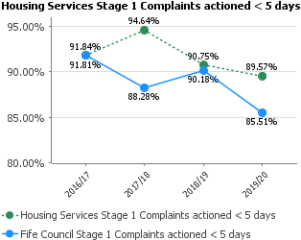 | The Services have focussed on ensuring that stage 1 & 2 complaints are prioritised for an effective response to the complainant in time. Although performance has slipped based on 2018/19 performance, we are above the corporate performance.  The Housing Operations Manager will continue to chase outstanding complaints to improve performance.
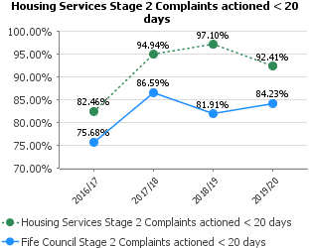
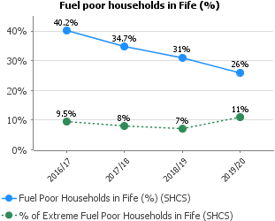 | 26% of Fife households are fuel poor (estimated 44,000 households), compared to 25% for Scotland (note the difference is not statistically significant). 11% of households are in extreme fuel poverty (this equates to 19,000 households), compared to 12% for Scotland (again not a significant difference). Data relates to Scottish House Condition Survey 2016-18.
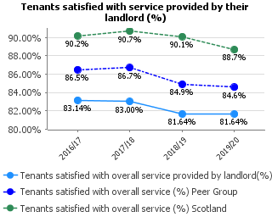 | Provided through face-to-face survey of 700+ Council tenants. Due to the Covid-19 emergency, the planned survey in 2020 had to be cancelled. This figure represents the results from 2018-19.
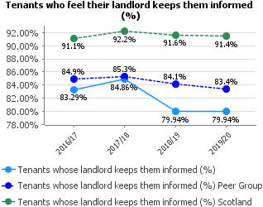 | Provided through face-to-face survey of Council tenants. Due to Covid-19, the planned survey for 2020 had to be cancelled so these figures reflect 2018-19 results.
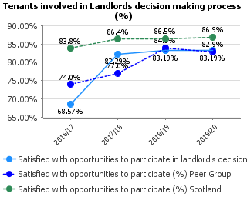 | Provided through face-to-face survey of 700+ Council tenants. Due to the Covid-19 emergency, the planned survey in 2020 had to be cancelled. This figure represents the results from 2018-19.
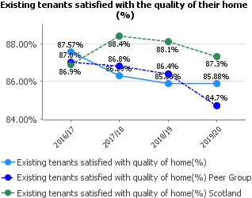 | Provided through face-to-face survey of Council tenants. Due to the Covid-19 emergency, the planned survey in 2020 had to be cancelled. This figure represents the results from 2018-19.
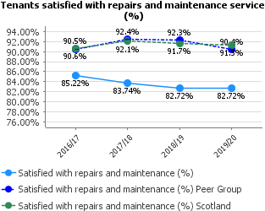 | Provided through face-to-face survey of Council tenants receiving a repair or maintenance service in previous year. Due to the Covid-19 emergency, the planned survey in 2020 had to be cancelled. This figure represents the results from 2018-19.
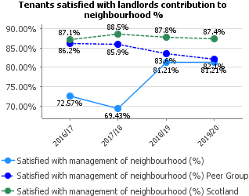 | Provided through face-to-face survey of 700+ Council tenants. Due to the Covid-19 emergency, the planned survey in 2020 had to be cancelled. This figure represents the results from 2018-19.
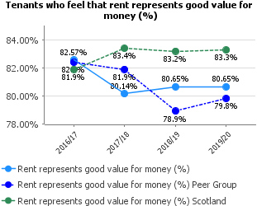 | Our Customer Satisfaction Survey was not carried out this year due to the COVID19 outbreak. Last year’s figures were input, as it was the only figure available. This is not obviously ideal, but it was felt this was better than entering a 0 return, and then justifying the 0 figure.
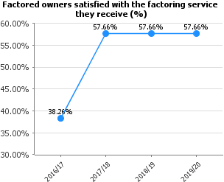 | No satisfaction survey has been carried out during 2019/20 – Scottish Housing Regulator guidance suggests a survey be carried out a minimum of once every three years. Therefore, a survey will be carried out during 2020/21 and updated figures provided.
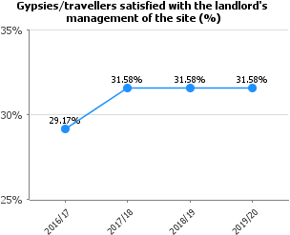 | This is based on last year’s survey due to Covid 19 pandemic. There was no opportunity to formally survey tenants due to the restrictions in place and to ensure the safety of tenants on the Gypsy Traveller sites.

People
Performance | Progress
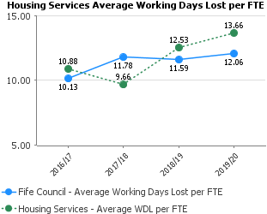 | Absence for 2019/20 deteriorated due to a number of factors, including longer-term illness and stress-related conditions.  We are working closely with all staff; HR and our trade union colleagues to focus on efforts to support staff in the highest stressed areas of work. This includes close support from Lead Officers and Managers to ensure that flexible working and absence can be discussed at the most appropriate time to assist staff to be maintained at work.  Early results confirm that our absence position is improving.
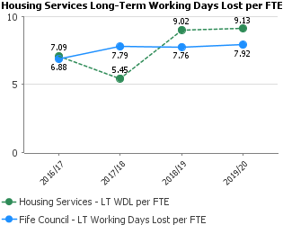
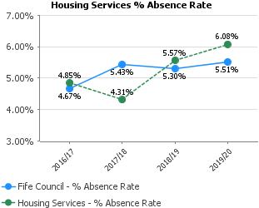

Responsiveness
Performance | Progress
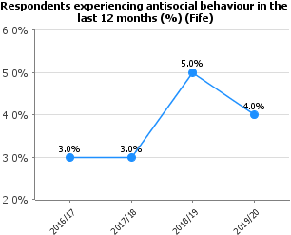 | The percentage of respondents who have experience of antisocial behaviour within the last 12 months - vandalism/graffiti/damage to property is now 4% for Fife compared to 6% for Scotland. Note data relates to 2018 Scottish Household Survey.
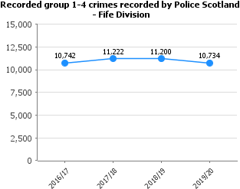 | Recorded Crimes Group 1 - 4 (Group 1 = 582, Group 2 = 1,085, Group 3 = 6370, Group 4 = 2697 = Total 10,734. Data from Police Scotland Management Information Police Division Report Quarter 4 2019/20 (Council Area Report) year to date. Data taken from report as at 28/07/20.  http://www.scotland.police.uk/about-us/our-performance  This indicator is to be discussed for future years reporting.
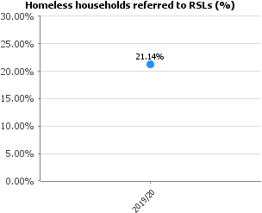 | The Fife Housing Register (FHR) system provides RSL partners with direct access to statutory homeless households and diminishes the need for formal S.5 Referral arrangements. Performance targets are collectively set by the FHR Executive and performance is monitored on a regular basis. This collaborative approach has enabled a more sophisticated discussion around homelessness.  New performance indicator – no comparison for previous years
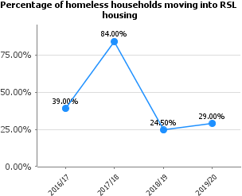 | Fife Housing Register partners are demonstrating an increasing contribution to rehousing homeless households and work is ongoing to achieve the 40% target in year. There has been a positive reaction and partnership contribution in response to the Covid-19 outbreak and positive signs of the partnership commitment to prevent and resolve homelessness as a key priority.
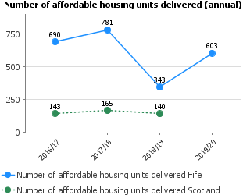 | Total target for phase III of affordable housing program is 3500. Annual targets have been set 500, 500, 1000, 1250, 250 over life of the programme. 2017-2022. Recorded completions for 18/19 343 looks like we are short for first target, when in fact 243 units were recorded in 17/18 from phase III programme so the first target of 500 units has been exceeded.  The Scottish average data for 19/20 has not yet been published by the Scottish Government and may not be available until January 2021.
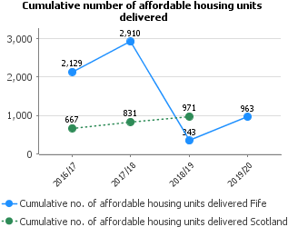 | Phase 2 and Phase 3 both ran concurrent in year 2017. Phase 2 completed in May 17 and Phase 3 began. Pentana didn't allow for two separate targets. As per notes in 2017/18 from LF, 243 units recorded were for Phase 3 but technically counted against Phase 2 target of 2700. Therefore, the number of completions for 18/19 seem low, when in fact if added to the completions for 18/19, it exceeds the 500 target.  The Scottish average data for 19/20 has not yet been published by the Scottish Government and may not be available until January 2021.
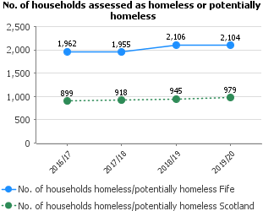 | The health, economic and social impact of Covid-19 is expected to have a significant impact on those in vulnerable housing circumstances. Homeless presentations reduced significantly in the lockdown environment, but presentations have consistently and steadily increased compared to previous year throughout the easing and recovery phases. Demand and analytics research demonstrates that demand could double over the recovery period without effective intervention to increase prevention activity. As an identified area of Reform, there is a focus on paced up action to implement Fife’s Rapid Rehousing Transition Plan and transformational change across housing access and wider prevention services across the Council and partner services.
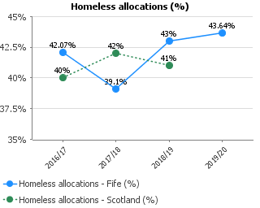 | The impact of Covid-19 has had a significant and devastating impact on housing operations and, in particular, turnover of empty properties. The current estimate is that around 1,200 housing opportunities will be lost in year due to reductions in Council turnover alone. An enforced focus on specific housing allocations during lockdown meant that statutory allocations had to be prioritised and around 400 households were assisted to move into new homes. In recovery and renewal, this has been balanced with a focus on generating allocations to existing tenancies to generate turnover and create more housing opportunities for a range of priority customer groups.  The Scottish average data for 19/20 has not yet been published by the Scottish Government and may not be available until January 2021.
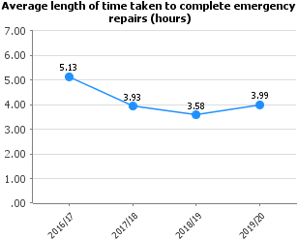 | Slight slippage this year due to errors in categorising jobs or closing job tickets timeously. Continue to monitor and review processes and anomalies.
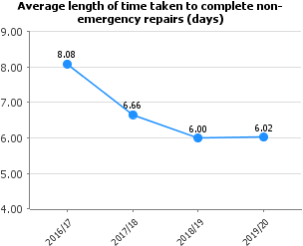 | Coming in slightly above target at 6.02 days. Work is ongoing to review processes and monitor anomalies in order that we achieve the 6 day target.
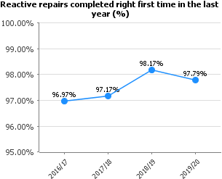 | Performance on Right First Time remains consistently high.
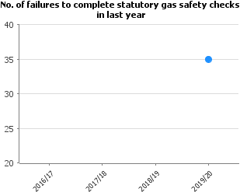 | Q1 reported 12 failures, Q2 3 failures, Q3 3 failures and Q4 17 failures, 10 of which had a direct link to COVID with no access permitted.  This is a true reflection on the gas failures calculated on a monthly period, rather than the year end figure previously reported.  Housing, Building Service and Contact Centre staff are working in close partnership to work towards the zero target. We were on track to introduce new system to manage our gas servicing programme and to improve our performance then the COVID-19 crisis struck.  New performance indicator – no comparison for previous years
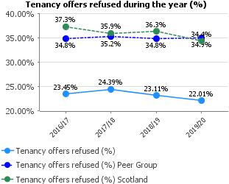 | Performance continues to be considered as top quartile based on Allocations processes. No improvement action has been identified
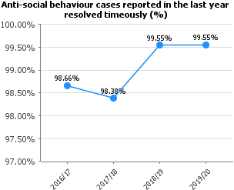 | Our percentage has remained at 99.55% this reporting year. Improvements to recording and timescales are being reviewed at present in order to sustain the high level of performance when dealing with anti-social behaviour.
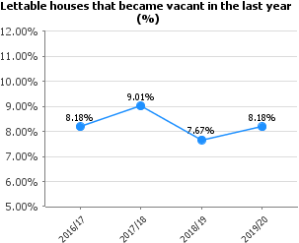 | Performance has exceeded previous year performance due to a commitment to transfer led allocations and an overall increase in property assets.
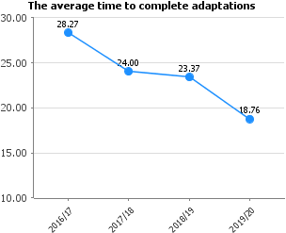 | The performance has improved further against this indicator due to process improvements – Occupational Therapists can now order a range of adaptations direct through the Housing Management Information system – this has reduced steps in the process and has made this quicker.
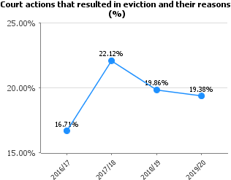 | There has been a concerted effort to ensure that cases don’t proceed to Court unless they are fairly water tight. This may justify the slight increase in our overall eviction rate.
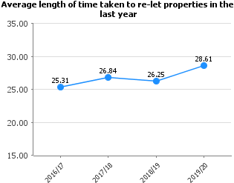 | The annual figure includes tenancies created e.g. 1st week of a month with a start date of the previous quarter. The quarter reports would exclude these, however, the annual report will pick these up.  The Voids Partnership Performance Management framework has been refocused to improve repairs performance. External contractual management arrangements are being re-procured to improve responsiveness and process impact. The relet standard will be reviewed to improve works commissioning and there is a wider process review planned for later in the year.
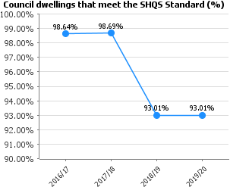 | The SHQS compliance figure is more accurate than in previous years as it is based on actual property condition survey, rather than cloned data.  We aim to carry out additional area focussed stock condition surveys to improve targeting of capital programme as we work towards achieving as near to 100% compliance as possible.
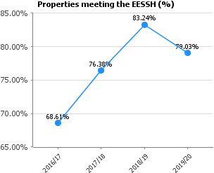 | The 80% EESSH 1 compliance falls below our projection to meet the 31st December 2020 deadline. We are adjusting our approach to focus on replacing up to 5900 gas boilers in 2020/21 to narrow the ESSH gap.  Another factor which will assist the council to meet ESSH1 is the number of abeyances we are allowed to declare, and the recognition by the Scottish Government that work can continue to meet EESSH past the statutory deadline.
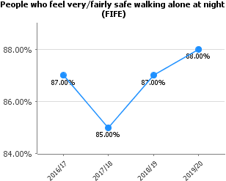 | 88% of Fifers feel very or fairly safe when walking alone in their neighbourhood at night, compared to 85% for Scotland. Note, data relates to 2019 Scottish Household Survey.

Cost
Performance | Progress
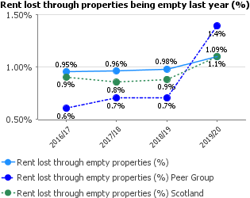 | Performance has slipped against previous year performance largely due to an increase in the number of longer-term empty homes in small scale regeneration areas and slippage in void relet times. The Voids Partnership has renewed focus on performance using a 4DX methodology to improve accountability and identify systematic areas for improvement.
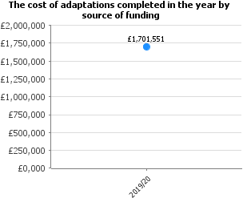 | This is a comparable spend to previous years – budgets have been maintained at a consistent level. In future years this could change if budgets reduce  New performance indicator – no comparison for previous years
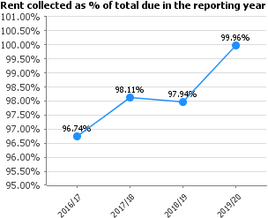 | Our collection figure has significantly improved this year. Partly this was down to receiving 14 DWP UC files, in the year. This has boosted our collection by approx. £1.3million. Financial year 20/21 we will only receive 13 DWP UC files. Therefore, we will instantly be approx. £1.3million down on 19/20.
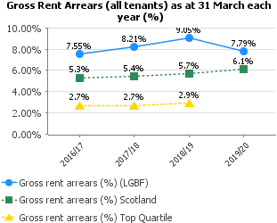 | Our Gross Rent Arrears figure have improved this year. Partly this was down to receiving 14 DWP UC files, in the year. This has boosted our collection by approx. £1.3million. Financial year 20/21 we will only receive 13 DWP UC files. Therefore, we will instantly be approx. £1.3million down on 19/20.

Cost
Performance | Progress
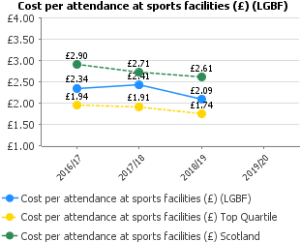 | Although a slight decrease in cost per attendance, the stabilisation of variable and fixed costs for the operation of facilities coupled with retaining visitor numbers despite some facilities part closured for maintenance represents a strong performance.  Due to COVID, the deadline for the LFR for 19/20 has been extended until end of November/beginning of December.
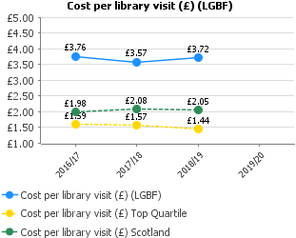 | Costs decreased in 2017/18 as it had been agreed that virtual visitors could be included, however in 2018/19, Fife Council decided to include in these figures costs for library buildings that closed in 2016/17 but which are still vacant and owned by Fife Council, so any benefit that increased virtual visitors could have had has been negated.  Due to COVID, the deadline for the 19/20 LFR has been extended until end of November/beginning of December.
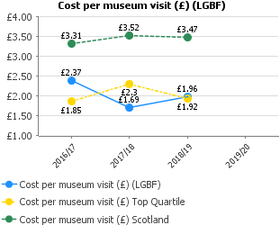 | Total costs for museums in 2017-18 and 2018-19 include figures for buildings which are no longer occupied as museums by OnFife. The increased cost per visit in 2018-19 is in part due to a significant spend on buildings repairs at St Andrews Museum and Kirkcaldy Galleries (£150K increase on 2017-18) which are included in the figures.  Due to COVID, the deadline for the 19/20 LFR has been extended until end of November/beginning of December.

COMMUNITIES & NEIGHBOURHOODS, HOUSING & COMMUNITY SAFTEY – WORKFORCE PROFILE 2019/2020 FINANCIAL YEAR (01 APRIL 2019 – MARCH 2020)

Service | No of Employees (FTE) April 2018 | No of Employees (FTE) April 2019 | No of Employees (FTE) April 2020 | Difference in FTE 2019-2020
Communities & Neighbourhoods | 522 | 467 | 519 | 52
Housing & Community Safety | 321 | 355 | 330 | -25
Total | 843 | 822 | 849 | 27

ANNUAL WORKFORCE DATA

