**Community Justice Fife**

**Annual Performance Report**

**2023-2024**

**Introduction**

The Community Justice (Scotland) Act 2016 places a statutory duty on community justice partners to determine how services are delivered in Fife, specifically with the aim of supporting the prevention of re-offending.  In 2022, A new [National Strategy for Community Justice](https://www.gov.scot/publications/national-strategy-community-justice-2/) was published by the Scottish Government in, this set the strategic direction for community justice partnerships across the country.  The national strategy sets out four national aims for community justice:

|  |
| --- |
| * Optimise the use of diversion and intervention at the earliest opportunity |
| * Ensure that robust and high-quality community interventions and public protection arrangements are consistently available across Scotland |
| * Ensure that services are accessible and available to address the needs of individuals accused or convicted of an offence |
| * Strengthen the leadership, engagement, and partnership working of local and national community justice partners |

Following the launch if the new str a revised [Community Justice Performance Framework](https://www.gov.scot/publications/community-justice-performance-framework/) (CJPF) was published in April 2023.  This framework sets out nationally determined outcomes which are to be achieved in each local authority area, and national indicators which are to be used in measuring performance against these. The first version of this, which was called the Outcomes, Performance and Improvement Framework (OPIF), was published in 2016. The Community Justice Performance Framework (CJPF) is a revised version of that framework.

There are two main components to the CJPF:

* 9 nationally determined outcomes which are to be achieved in each local authority.
* 10 national indicators which are to be used to measure performance in achieving the outcomes.

| **Priority Action** | **Priority Action from the National Strategy for Community Justice** | **Nationally determined Outcome** | **National Indicators** |
| --- | --- | --- | --- |
| 1 | Enhance intervention at the earliest opportunity by ensuring greater consistency, confidence in and awareness of services which support the use of direct measures and diversion from prosecution | More people successfully complete diversion from prosecution | Number of diversions from prosecution:   * assessments undertaken * cases commenced * cases successfully completed |
| 2 | Improve the identification of underlying needs and the delivery of support following arrest by ensuring the provision of person-centred care within police custody and building upon referral opportunities to services including substance use and mental health services | More people in police custody receive support to address their needs. | Number of referrals from custody centres |
| 3 | Support the use of robust alternatives to remand by ensuring high quality bail services are consistently available and delivered effectively | More people are assessed for and successfully complete bail supervision. | Number of:   * assessment reports for bail suitability * bail supervision cases commenced. * bail supervision cases completed. |
| 4 | Strengthen options for safe and supported management in the community by increasing and widening the use of electronic monitoring technologies | *No nationally determined outcome.* | *N/A* |
| 5 | Ensure that those given community sentences are supervised and supported appropriately to protect the public, promote desistance from offending and enable rehabilitation by delivering high quality, consistently available, trauma-informed services, and programmes | More people access services to support desistance and successfully complete community sentences. | Percentage of:  community payback orders successfully completed.  drug treatment and testing orders successfully completed |
| 6 | Ensure restorative justice is available across Scotland to all those who wish to access it by promoting and supporting the appropriate and safe provision of available services | *No nationally determined outcome.* | *N/A* |
| 7 | Enhance individuals’ access to health and social care and continuity of care following release from prison by improving the sharing of information and partnership-working between relevant partners | More people have access to, and continuity of, health and social care following release from a prison sentence. | Number of transfers in drug/alcohol treatments from:  • custody to community |
| 8 | Ensure that the housing needs of individuals in prison are addressed consistently and at an early stage by fully implementing and embedding the Sustainable Housing on Release for Everyone (SHORE) standards across all local authority areas | Ensure that the housing needs of individuals in prison are addressed consistently and at an early stage by fully implementing and embedding the Sustainable Housing on Release for Everyone (SHORE) standards across all local authority areas | More people have access to suitable accommodation following release from a prison sentence |
| 9 | Enhance individual’s life skills and readiness for employment by ensuring increased access to employability support through effective education, learning, training, career services and relevant benefit services | More people with convictions access support to enhance their readiness for employment | Percentage of:  • those in employability services with convictions |
| 10 | Enhance community integration and support by increasing and promoting greater use of voluntary throughcare and third sector services | More people access voluntary throughcare following a short-term prison sentence. | Number of:  • voluntary throughcare cases commenced |
| 11 | Deliver improved community justice outcomes by ensuring that effective leadership and governance arrangements are in place and working well, collaborating with partners, and planning strategically | *No nationally determined outcome.* | *N/A* |
| 12 | Enhance partnership planning and implementation by ensuring the voices of victims of crime, survivors, those with lived experience and their families are effectively incorporated and embedded | *No nationally determined outcome.* | *N/A* |
| 13 | Support integration and reduce stigma by ensuring the community and workforce have an improved understanding of and confidence in community justice | More people across the workforce and in the community understand, and have confidence in, community justice | Percentage of people who agree that:  • people should help their community  as part of a community sentence rather than spend a few months in   prison for a minor offence |

To comply with legislative responsibilities under Section 23 of the [Community Justice (Scotland) Act 2016](https://www.legislation.gov.uk/asp/2016/10/contents), this report will outline Fife’s progress against the above national outcomes (using the data provided by Community Justice Scotland). As this is the first year Fife has produced a report of this kind, it will not, as standalone document, fulfil all the requirements of the act, however it does complement existing performance and activity reports including the [Fife Community Justice Activity Annual Return 203-24](https://www.fife.gov.uk/kb/docs/articles/community-life2/safer-communities/community-justice), and individual justice partners annual performance reports, all of which together provide detailed information on local activity.

What is missing is a partnership wide local assessment of progress, while the indicator data has been discussed with individual local partners responsible for leading activity, there has not been partnership wide discussion or reflection. As such the decision was made not to include any reference to local assessment of progress, but rather to note this as a gap and prioritise some form of partnership self-assessment over the next six months or so. It is likely, therefore, that next year's report, will look considerably different to this one, and provide a much fuller response in line with the requirements of the act.

In noting this gap, however, it is important to be reassured that there is not there is not a gap in partnership activity, discussion or prioritisation, as evidenced in the recent publication of Fife’s Community Justice Outcome Activity Report.

|  |
| --- |
| **Priority Action 1**  Enhance intervention at the earliest opportunity by ensuring greater consistency, confidence in and awareness of services which support the use of direct measures and diversion from prosecution.  **Nationally determined outcome**:  More people successfully complete diversion from prosecution  **National Indicators:**  Number of diversions from prosecution:  • assessments undertaken  • cases commenced  • cases successfully completed.  **Local Evidence:**  • Mechanisms are in place to understand the views of people undertaking diversion from prosecution and are used to support improvement.  • Mechanisms are in place to understand the views of people supporting the delivery of diversion from prosecution and are used to support improvement. |

The graph below shows the performance indicators for Fife, (as provided by Community Justice Scotland) relating to Priority Action 1. This accompanying assessment from CJS noted:

* The number of assessments undertaken shows no emerging pattern where the desired direction is to increase.
* The number of commencements shows an emerging pattern of increase in line with the desired direction.
* The number of completions shows an emerging pattern of increase in line with the desired direction.

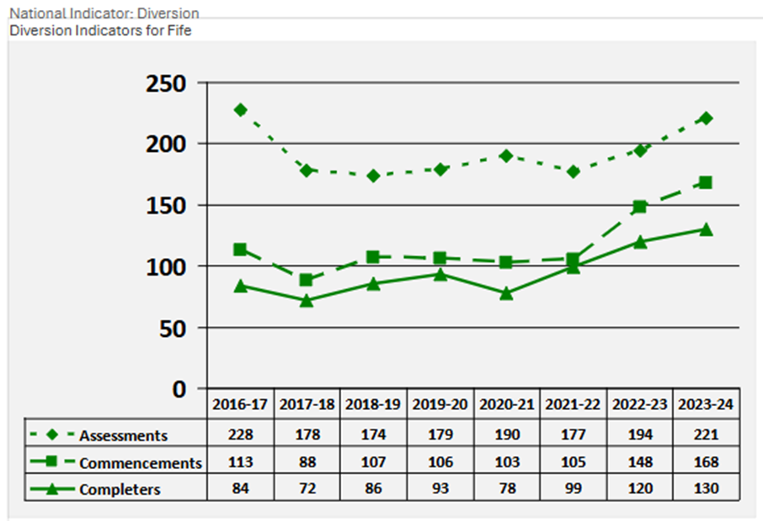

As noted, further detail on work within Fife to support delivery of this outcome is available within other reports, (including [Fife Community Justice Outcome Activity Report 2023-24](https://www.fife.gov.uk/kb/docs/articles/community-life2/safer-communities/community-justice)) however key points to note are:

* Within Fife, all intervention work, including that relating to Diversion and Structured Deferred Sentences (for males) is managed by a single team – Justice Social Works ‘Early Intervention Service. Delivery through one single team is proving to work well with the team working in a pro-active, welfare-oriented way with those who are deemed to require lower-level intervention and supervision.
* It is recognised locally that crucial to success of diversionary activity is confidence within the local judiciary to use diversion. In addition to attending local Court User Groups, JSW staff have facilitated face to face meetings with local Sheriffs, to raise awareness of local programmes and encourage open and honest discussion.
* All individuals who undertake in diversion are given feedback forms to complete but it is recognised that response to this is limited and increasing opportunities for service user involvement is a priority within [Fife Justice Social Work Outcome Improvement Plan 2024-2027](https://www.fife.gov.uk/__data/assets/pdf_file/0029/593732/Fife-Justice-Outcome-Improvement-Plan-2024-2027.pdf) (page 10).

**Priority Action 2**

Improve the identification of underlying needs and the delivery of support following arrest by ensuring the provision of person-centred care within police custody and building upon referral opportunities to services including substance use and mental health services.

**Nationally determined outcome**:

More people in police custody receive support to address their needs.

**National Indicator:**

Number of referrals from custody centres.

**Local Evidence:**

● There is an effective relationship between community justice partners, Alcohol and Drug Partnerships (ADPs) and police custody centres for the local population.

● Referral pathways and support are in place from police custody centres for the local population.

There is insufficient data available to allow either publication or assessment of progress towards this outcome at a local level – what is desired is that direction is to increase referrals.

CJS have advised that new data collection procedures are being introduced during 2024-25, with 2024-25 then being used as a baseline.

Key points to note from a local perspective are:

* Fife Custody Navigators, funded by Fife Alcohol and Drug Partnership, delivered by SACRO, supported by the Violence Reduction Unit continue to offer support in local custody suites. Although they only visit the centres once a week (Sunday evening) they can accept referrals from custody staff. From April 2023 to March 2024, the service received 240 referrals. (Further detail see [Fife Justice Social Work Outcome Improvement Plan 2024-2027](https://www.fife.gov.uk/__data/assets/pdf_file/0029/593732/Fife-Justice-Outcome-Improvement-Plan-2024-2027.pdf))
* Fife Alcohol and Drug Partnership are active local community justice partners as evidenced in their funding of the Fife Custody Navigators and attendance at local and national meetings focussing on support from custody.
* Support from custody is a local priority within Fife’s latest Community Justice Outcome Improvement Plan ([Fife Justice Social Work Outcome Improvement Plan 2024-2027](https://www.fife.gov.uk/__data/assets/pdf_file/0029/593732/Fife-Justice-Outcome-Improvement-Plan-2024-2027.pdf))

**Priority Action 3**

Support the use of robust alternatives to remand by ensuring high quality bail services are consistently available and delivered effectively.

**Nationally determined outcome**:

More people are assessed for and successfully complete bail supervision.

**National Indicators**:

Number of:

● assessment reports for bail suitability.

● bail supervision cases commenced.

● bail supervision cases completed.

**Local Evidence:**

● Mechanisms are in place to support a high-quality bail assessment.

● Referral pathways are in place that support identified needs of people on bail supervision.

The graph below shows the performance indicators for Fife, (as provided by Community Justice Scotland) relating to Priority Action 3. This accompanying assessment from CJS noted:

* The number of commencements shows an emerging pattern of increase in line with the desired direction.
* There was a notable spike in 2021-22.
* No trend data is available for assessments or for cases completed yet. There is a notable high number of bail assessments undertaken.

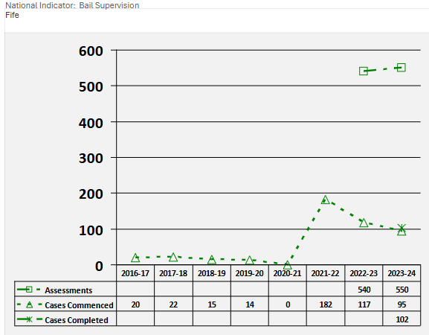

Further detail on work within Fife to support delivery of this outcome is available within other reports, (including [Fife Community Justice Outcome Activity Report 2023-24](https://www.fife.gov.uk/kb/docs/articles/community-life2/safer-communities/community-justice)) however key points to note are:

* Justice Social Work’s Bail Supervision service continues to operate in the Dunfermline and Kirkcaldy Sheriff Courts. Delivered by Justice Services ‘Early Intervention Service, the bail supervision service offers the Court a robust and credible alternative to remand, whilst supporting the early identification of risk and needs. Unlike practice in other Local Authorities, assessments are made to all cases, not only those who have been ‘bail opposed’.
* This service is deeply welfare orientated, and the team takes a proactive, community-based approach to deliver holistic support.
* Integral to the service is recognising the critical role of stable accommodation, and JSW work in close collaboration with Fife Council Housing Services to ensure that from the point of assessment, individuals have access to safe and secure housing. The service has also been pioneering a range of therapeutic interventions designed to address emotional regulation and negative thinking patterns. From traditional psychological approaches to a variety of holistic therapies, the service offers a broad spectrum of support aimed at fostering mental and emotional well-being.

**Priority Action 4**

Strengthen options for safe and supported management in the community by increasing and widening the use of electronic monitoring technologies.

**Nationally determined outcome**:

No nationally determined outcome

As there is not a nationally determined any, progress relating to delivery of this action, will relate to local activity. Points to note regarding Fife are:

● There has been a relatively low update of RMR’s in Fife to date, but staff have been given training and support to staff to ensure they are confident when managing this requirement.

● Justice partners in Fife recognise that while an RMR can provide victims of offences with a level of safety and reassurance that would not have been provided otherwise. some individuals struggle to adhere to the requirements of an RMR due to issues including a chaotic lifestyle, mental health, and / or a lack of maturity. If an RMR is imposed by the Court against report recommendations, it can at times, have a detrimental impact on both the victim and the individual.

**Priority Action 5**

Ensure that those given community sentences are supervised and supported appropriately to protect the public, promote desistance from offending and enable rehabilitation by delivering high quality, consistently available, trauma-informed services, and programmes.

**Nationally determined outcome**:

More people access services to support desistance and successfully complete community sentences.

**National Indicators:**

Percentage of:

● community payback orders successfully completed.

● drug treatment and testing orders successfully completed.

**Local Evidence:**

● Availability of local programmes to support desistance from domestic abuse and sexual offending.

● Availability of referral pathways to support the needs of local population on community disposals.

● Mechanisms are in place to understand the views of people with experience of community disposals to support improvement.

● Mechanisms are in place to understand the views of the community justice workforce with regard to supporting the needs of people subject to community disposals to support improvement.

The graph below shows the performance indicators for Fife, (as provided by Community Justice Scotland) relating to Priority Action 1. This accompanying assessment from CJS noted:

* The percentage of CPO completions shows an emerging pattern of increase in line with the desired direction.
* The small numbers of DTTOs means that the percentage of completions is not statistically valid.

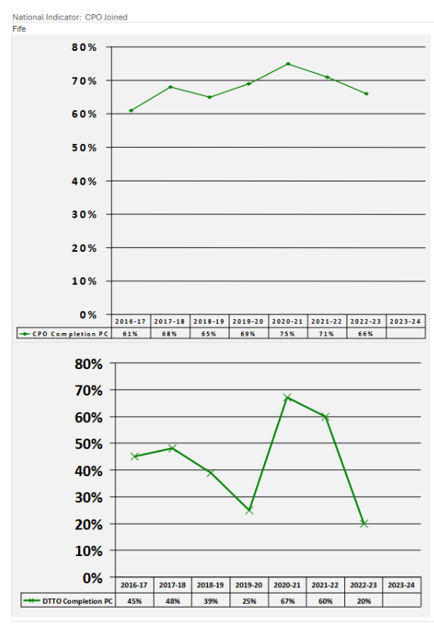

The aforementioned [Fife Community Justice Outcome Activity Report 2023-24](https://www.fife.gov.uk/kb/docs/articles/community-life2/safer-communities/community-justice) provides a lot of detail of local activity towards delivering this outcome. Some key points of interest include:

* Offence focused intervention continues to be integral to the delivery of Justice Social Work services, regardless of whether that engagement is mandated through Community Payback Order, Statutory Licence, Structured Deferment or Diversion from Prosecution. Specific offence focussed work occurs on a one-to-one basis and often involves work around understanding and controlling strong feelings, handling conflict, improving relationships, and managing impulsive behaviour.
* Fife Justice Social Work continue to deliver the Caledonian Programmes for men who commit domestic abuse offences. The programme is delivered through effective collaboration between supervising social workers and staff in our Groupwork team. These are intense and demanding interventions which require a high level of commitment and reflection from participants as they are supported to better understand the connection between their thoughts, feelings and behaviours, and to develop safer, more effective strategies in complex and challenging situations. JSW are in the process of improving how we gather feedback from men who attend the Caledonian Programme and their partners, and this has already outlined some very positive case studies.
* The Groupwork team have also developed a Healthy Relationships Workbook which can be used to undertake focused work with perpetrators on a 1:1 basis. The workbook can be used as part of any community-based sentence (including Diversion and Structured Deferred Sentence) where there are concerns around the development of healthy relationships. Service wide training is being provided by the Groupwork team, and the initiative increases the reach of our early intervention and preventative work.

**Priority Action 6**

Ensure restorative justice is available across Scotland to all those who wish to access it by promoting and supporting the appropriate and safe provision of available services.

**Nationally determined outcome**:

No nationally determined outcome

As there is not a nationally determined any, progress relating to delivery of this action, will relate to local activity. Points to note regarding Fife are:

* While there is a commitment to delivering RJ within Fife, there has not been a focus area within the CJ working group arena, with locally partners waiting on direction nationally. There is a great deal of’ restorative practice’ used daily by CJ partners within Justice Social Work, FC Education and as part of the

activity SACRO deliver with young people.

**Priority Action 7**

Enhance individuals’ access to health and social care and continuity of care following release from prison by improving the sharing of information and partnership-working between relevant partners.

**Nationally determined outcome**:

More people have access to, and continuity of, health and social care following release from a prison sentence.

**National Indicators:**

Number of transfers in drug/alcohol treatments from:

● custody to community.

**Local Evidence**

● Health and social care circumstances/care plans are reflected in collaborative plans for release.

● Referral pathways and information sharing arrangements are in place to support timely access to health and social care supports upon release.

The graph below shows the performance indicators for Fife, (as provided by Community Justice Scotland) relating to Priority Action 7. The accompanying assessment from CJS noted:

* The number of transfers in drug/alcohol treatments from custody to community shows no emerging pattern due to insufficient data. The desired direction is to increase.

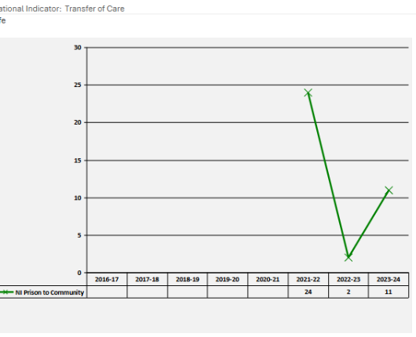

Ensuring accessing of support from custody to community has and continues to be a priority for Fife’s community justice partners. This is evidenced in the commitment to fortnightly ‘Liberation Meetings’ where services, including Fife Alcohol and Drug Partnership, Fife Council Housing, Justice Social Work and Safer Communities, NHS Fife and representatives from Third Sector Services offering voluntary Throughcare meet to discuss individuals due to be released from custody with a view to ensuring support, tailored to their needs, is in place. (This is currently being piloted with those being released from Perth Prison),

This commitment is further evidenced in Support from custody is a local priority within Fife’s latest Community Justice Outcome Improvement Plan and within some of the ongoing local activity:

* Justice Social Works Women’s Justice Teams have a dedicated NHS Team comprising of a Mental Health Nurse, Clinical Psychologist and Assistant Psychologist. The benefits of this holistic approach have been significant in addressing underlying needs for women involved in the justice system. The NHS team provides direct service user support, consultation, and training for the wider team.
* As well as clinical work, the NHS Team also supports the Women’s Justice Teams with Service improvement. The teams have recently taken part in a Trauma Informed Practice Audit, using the Quality Standards for Fife, developed by Fife Trauma Training Collaborative.
* Housing staff assess individuals returning to tenancies, offering housing support and or referrals to public and private agencies.

**Priority Action 8**

Ensure that the housing needs of individuals in prison are addressed consistently and at an early stage by fully implementing and embedding the Sustainable Housing on Release for Everyone (SHORE) standards across all local authority areas.

**Nationally determined outcome:**

More people have access to suitable accommodation following release from a prison sentence.

**National Indicators:**

● Number of homelessness applications where prison was the property the main applicant became homeless from

**Local Evidence:**

● Scottish Prison Service (SPS) admissions and liberations information is shared with relevant partners to support suitable accommodation planning.

● Proportion of admissions where housing advice was provided.

● Percentage of people leaving prison who have been housed by the local authority and have maintained tenancy for more than 1 year.

The graph below shows the performance indicators for Fife, (as provided by Community Justice Scotland) relating to Priority Action 8. The accompanying assessment from CJS noted:

* The number of homelessness applications where prison was the property the main applicant became homeless from, shows no emerging pattern where the desired direction is to decrease.

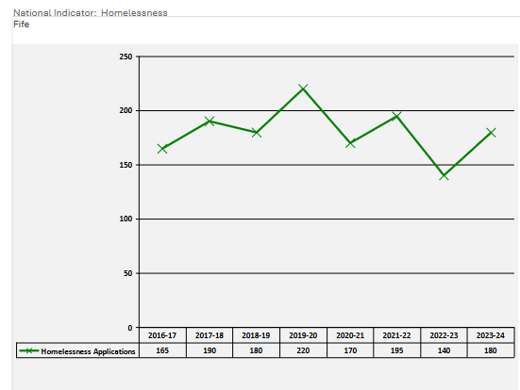

Ensuring those who leave custody have access to suitable accommodation has long been a priority in Fife, with local Housing staff working hard to not only having effective working relationships with Scottish Prison Service colleagues but also, importantly direct access to individuals themselves, wherever possible, a presence in local prisons (and more recently using emerging technologies to engage with those in custody).

Further points to note from Fife include:

* Access to suitable accommodation is a local priority within Fife’s latest Community Justice Outcome Improvement Plan ([Fife Justice Social Work Outcome Improvement Plan 2024-2027](https://www.fife.gov.uk/__data/assets/pdf_file/0029/593732/Fife-Justice-Outcome-Improvement-Plan-2024-2027.pdf))
* Fife Council’s Public Protection Team (Housing) work closely with all partner agencies (SPS, JSW, health & Social Care, SACRO and other Housing Providers) to ensure that everyone who is liberated and wishes to return to Fife, is offered accommodation. The preference is for prisoners to return to their existing homes/tenancies whenever possible but otherwise they are offered some form of Temporary Accommodation if presenting as Homeless on release.
* As Fife is currently going through a Housing Emergency, we have a distinct lack of accommodation to be offered, therefore a minority of mainstream offenders are being offered shared accommodation, while waiting on secure accommodation.

**Priority Action 9**

Enhance individual’s life skills and readiness for employment by ensuring increased access to employability support through effective education, learning, training, career services and relevant benefit services.

**Nationally determined outcome:**

More people with convictions access support to enhance their readiness for Employment.

**National Indicators:**

● Percentage of those in No One Left Behind (NOLB) employability services with convictions.

**Local Evidence:**

● Effective links between the Local Employability Partnership (LEP) and Community Justice Partnership supports:

● Local employment, education and training providers to respond to the needs of those with convictions.

● Local employment, education and training providers are confident and competent in providing effective conviction disclosure support.

● Local employers to develop more inclusive recruitment processes and employ people with convictions.

● Referral pathways are in place to connect people to appropriate services and support:

● At commencement of, during and at the end of a CPO

● Following release from custody.

The table below shows the performance indicators for Fife, (as provided by Community Justice Scotland) relating to Priority Action 9. The accompanying assessment from CJS noted:

* The percentage of people referred to NOLB employability programmes with a criminal record shows no emerging pattern due to insufficient data. The desired direction is to increase.

|  |  |
| --- | --- |
|  | **2023-24** |
| Percentage of participants with criminal convictions | 7 |
| Number of participants with criminal convictions | 112 |

The data for this indicator is limited, in so much as it only relates to No one Left Behind programmes and there are several other local and national employability programmes which support individuals with convictions. Not all programmes record conviction data, making it difficult to gain an accurate understanding of all those supported and importantly the outcomes for them.

Further points to note from Fife include:

* Support for those with convictions to enhance readiness for employment is a local priority within Fife’s latest Community Justice Outcome Improvement Plan ([Fife Justice Social Work Outcome Improvement Plan 2024-2027](https://www.fife.gov.uk/__data/assets/pdf_file/0029/593732/Fife-Justice-Outcome-Improvement-Plan-2024-2027.pdf))
* Employability provision is currently commissioned via Opportunities Fife with a number of providers across Fife who either knowingly or unknowingly support those with an offending history. Unfortunately, there is no current markers on their statistics regards offence history wither this be current or historic offending histories so true numbers are unknown. Disclosure of offending is purely a voluntary measure although some people do self-disclose especially if they perceive it themselves to be a barrier.
* One of the largest adult providers is BRAG Enterprises who is a third sector provider that works with anyone 19+. They also act as the lead partner in the Fife Employment and Training Consortium.

**Priority Action 10**

Enhance community integration and support by increasing and promoting greater use of voluntary throughcare and third sector services.

**Nationally determined outcome:**

More people access voluntary throughcare following a short-term prison sentence.

**National Indicators:**

Number of voluntary throughcare cases commenced.

**Local Evidence:**

Mechanisms are in place for partners to support people serving short term sentences.

Proportion of people liberated from short term custody:

made aware of support.

Accepting support offer

With a co-ordinated pre-release plan in place.

Mechanisms are in place to understand the views of people accessing voluntary throughcare to support improvement.

Mechanisms are in place to understand the views of community justice partners in delivering voluntary throughcare to support the needs of people leaving short term custody.

The graph below shows the performance indicators for Fife, (as provided by Community Justice Scotland) relating to Priority Action 10. The accompanying assessment from CJS noted:

* The number of voluntary throughcare cases commenced shows no emerging pattern where the desired direction is to increase.

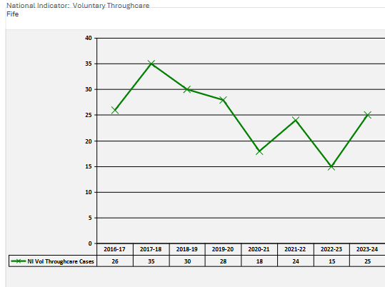

The data reported relates to voluntary throughcare provided by Justice Social Work. Within Fife voluntary throughcare is also offered through Third Sector services. Unfortunately figures from these services was not available for this report but following the introduction of the new voluntary throughcare service (April 2025), it is hoped that this data will be available in future years.

Other points to note in Fife:

* Fife Council’s Justice Social Work Throughcare teams have always offered guidance and support to service users (in addition to statutory supervision of licences). However, it was determined that this required to be bolstered to ensure people were consistently receiving focused and individualised welfare support, which would hopefully increase the likelihood of positive engagement whilst reducing overall levels of risk. Two additional Social Work Assistants were recruited to support delivery of the service, which was officially launched in April 2023.
* Since April 2023, 80 men have received or are receiving support across the two Throughcare teams. The support offered covers a range of issues relating to the individual’s welfare needs under six main areas including accommodation, finances, health, substance use, support networks and education / employment. Our recent review of the Service has informed us that 12 men have required support beyond the first review stage at 12 weeks post release, and that support has lasted between 5 weeks and 8 months, depending on individual needs.

**Priority Action 11**

Deliver improved community justice outcomes by ensuring that effective leadership and governance arrangements are in place and working well, collaborating with partners, and planning strategically.

**Nationally determined outcome:**

No nationally determined outcome

**Local Evidence:**

● Mechanisms are in place to support engagement in each local authority, specifically:

► *a community justice outcome improvement plan (CJOIP)*

*► a participation statement*

*► an annual report on progress towards nationally and locally determined outcomes*.

● Mechanisms are in place to support an effective interface between national partner organisations and their local representatives within Community Justice Partnerships.

● Use of the Care Inspectorate 'self-evaluation guide to support quality improvement for community justice in Scotland', with focus on Leadership and Direction

While not a focussed priority within Fife’s last Community Justice Outcome Improvement Plan, activity to deliver against this is ongoing ‘business as usual’ for the local community justice strategic lead and partners.

Further points to note:

* The Community Justice Working Group meets on a quarterly basis. Meetings are well attended and generate useful and thought-provoking discussion. Much of the community justice activity in Fife takes place outwith the CJ working group environment, however there is no doubt the group provides an effective mechanism to raise awareness, build local relationships and facilitate local improvement activity.
* The CJ Working Group is also the avenue through which the local community justice strategic lead, facilitates the relationship between local and national CJ.
* The local CJ lead participates in all appropriate national groups/meetings and has a productive and supportive relationship with CJ Improvement Lead.

**Priority Action 12**

Enhance partnership planning and implementation by ensuring the voices of victims of crime, survivors, those with lived experience and their families are effectively incorporated and embedded.

**Nationally determined outcome:**

No nationally determined outcome.

As there is not a nationally determined any, progress relating to delivery of this action, will relate to local activity. Points to note regarding Fife are:

* While there is some local activity to ensure the voices of those with lived experience are incorporated into service design and delivery, particularly so within Justice Social Work and Violence against Women activity, this remains a priority action – reflected as in a joint outcome within the local VAW Delivery Plan.
* Families Outside are active community justice partners both in their individual service activity supporting local families and as partners on the working group.

**Priority Action 13**

Support integration and reduce stigma by ensuring the community and workforce have an improved understanding of and confidence in community justice.

**Nationally determined outcome:**

More people across the workforce and in the community understand, and have confidence in, community justice.

**National Indicators:**

Percentage of people who agree that:

● people should help their community as part of a community sentence rather than spend a few months in prison for a minor offence.

**Local Evidence:**

● Community justice partner contribution to joint activity across policy areas to tackle stigma.

Currently the only data available for this indicator is at Scotland-wide level. The CJ assessment notes that there is no meaningful change in this indicator across Scotland, with the desired indicator direction being ‘*Increase from the base year to the year of the next revision of the CJPF*’. Movement of the data to be examined and considered every year:

|  |  |
| --- | --- |
| Year | Percentage |
| 2017-18 | 84% |
| 2018-19 | 84% |
| 2019-20 | 83% |
| 2021-21 | 82% |

Local partners acknowledge the need to address stigma and work to encourage others to ‘think with community justice in mind’, and this is reflected in this being a priority within the current [Community Justice Outcome Improvement Plan](https://www.fife.gov.uk/kb/docs/articles/community-life2/safer-communities/community-justice). Other points to note around local activity include:

* Fife Justice Social Work administer a successful social media page, (X), used regularly to raise awareness of local unpaid work projects of particular interest to the community. These posts receive positive feedback and help to increase public knowledge around the benefits of community sentences. Justice Social Work also work closely with the Council’s communication team to further raise awareness both internally and externally regarding unpaid work projects and the positive impact of the work undertaken.
* Other partners have also facilitated ways to improve awareness of key community justice issues, an example being a partnership visit to Perth Prison, organised by Opportunities Fife (local employability partnership).

**For any further information on local Community Justice activity in Fife, please see** [**Community Justice Fife**](https://www.fife.gov.uk/kb/docs/articles/community-life2/safer-communities/community-justice) **or contact: Tricia Spacey** [**patricia.spacey@fife.gov.uk**](mailto:patricia.spacey@fife.gov.uk)