

**Kinghorn Primary**

2021 – 2022

Right to Education (Article 28)

Right to Achieve Full Potential (Article 29 )

**“Sailing To Success”**

**Kinghorn Primary School**

**Vision, Values and Aims**

In Kinghorn Primary School we aim to provide a respectful, happy, safe, nurturing learning environment where our children are encouraged to be all they can be to ensure positive destinations for all.

Right to Achieve Full Potential (Article 29 )

***“Sailing To Success”***

**Kind**

**Include  
Nurture**

**Generous**

**Honest**

**Open**

**Respect**

**Never Give Up**

Our **Aims** have been re-written by our Pupils.

* Be open-minded, try new things and provide opportunities for everyone to be successful learners
* Believe in yourself and keep trying to get even better
* Develop our understanding of the world and our place within it helping us become effective global citizens
* Have a better understanding of each other and work together to achieve more
* Be positive, never give up and always do your best
* Respect and value each others’ skills, talents, similarities and differences. We all learn from each other
* Learn important life skills and prepare us for the future
* Learn how to take care of ourselves and others, making choices that keep us active, safe and healthy

Right to be listened to and Right to be heard (Article 12)

Kinghorn Primary School Improvement Plan Priorities 2021-2022

|  |  |  |
| --- | --- | --- |
| **Leadership and Management** | **Learning Provision** | **Successes and Achievements** |
| * 1. Self-evaluation for   self-improvement  1.3 Leadership of Change | 2.3 Learning, Teaching and Assessment | 3.1 Ensuring Well-Being,  Equality and Inclusion  3.3 Increasing Creativity  and Employability |

**Right to Information (Article 17) Right to reach full potential (Article 29)**

**QI: 1.3 - Leadership of Change QI: 1.1 Self-Evaluation for self-improvement   
- Developing a shared V,V, A relevant to school - Collaborative approaches to self-evaluation   
- Strategic planning for continuous improvement - Analysis and evaluation of intelligence and data   
- Implementing improvement and change - Ensuring impact on learners’ successes and achievements**

**Improvements in learning and teaching, importance of professional commitment to improving pedagogy**

**Develop a clear curriculum rationale and vision for our learners and wider community**

|  |  |  |  |  |  |
| --- | --- | --- | --- | --- | --- |
| **Action point** | **Key tasks** | **Person Responsible** | **Timescale** | **Impact** | **Evidence** |
| Increase involvement of stakeholders and partners in strategic planning | * Continue opportunities for   pupil voice through RESPECT group and Sports Committee whilst meeting Covid restrictions   * Include aspects of Eco Warriors and JRSOs * Regular consultation with stakeholders is shared | Emma Grundy  Kathy Turner  Sally Borthwick  Fiona Ramos  All Staff  Parent Council | Regular meetings of each group  Termly meetings of P6 and P7 members from both groups to meet as one with HT and relevant staff  Termly PC meetings | * The whole school community has a shared understanding of the strengths of the school and plans for improvement and change * Planning for improvement and change impacts positively on learners and the whole school community * Stakeholders and partners are fully involved in strategic planning for improvement and change | * Pupil Voice gathered across school * Focus groups inclusive of staff, parents and pupils established to look at strategic areas * Pupil and parent questionnaire (Participation toolkit can be used) * Parent Council used as voice across al families * Links to RRS explored at all times |

**Right to be safe (Article 19)**

**QI: 2.3 – Learning, Teaching and Assessment QI: 3.1 – Ensuring wellbeing, equality and inclusion QI: 3.3 Increasing Creativity and Employability**

- **Learning and engagement - Wellbeing - Creativity Skills**

**- Quality of teaching - Fulfillment of statutory duties - Digital Innovation**

**- Effective use of assessment - Inclusion and Equality - Digital Literacy**

**- Planning, tracking and monitoring - Increasing employability skills**

**Develop consistency in pedagogical approaches across the school and high quality learning experiences for pupils**

**Learning pathways support pupils to build on prior learning and ensure appropriate progression**

**Provision of high-quality support that enables all learners to achieve success**

**Achieving best possible outcomes for all learners**

|  |  |  |  |  |  |
| --- | --- | --- | --- | --- | --- |
| **Action point** | **Key tasks** | **Person Responsible** | **Timescale** | **Impact** | **Evidence** |
| Continue to develop consistency in pedagogical approaches to teaching of Numeracy  Article 29  Right to achieve your full potential | * Catalogued inventory of resources in own area * Maths equipment audited and gaps identified * Mental Maths requires additional consolidation to build fluency * Link learning and experiences to skills development/progression pathway * Staff sharing practice to enhance teaching and learning, assessment and moderation * Agreed progression and use of resources | Kathy Turner  Sally Borthwick | Term 1  (one hour)  Term 2  Term 1    Term 2  (one hour)  Term 2 | * Pupils confidently applying skills when learning new concepts * Improved pace of teaching and attainment * Use of benchmarks to underpin professional judgement when completing a CfE level, moderation across stages and levels * Staff more confident in declaration of CfE levels in own judgement * CfE and AfE results are more in line with each other * Staff become more confident in teaching and assessing and will improve outcomes for pupils | * Identify PEF pupils, monitor and track * Staff feedback on increased confidence at making judgements around CfE levels * Pupil participation groups – baseline assessment (Toolkit) * Attainment data * Standardised assessment data from SNSA results * Feedback from Learning Partnership visits * School wide moderation focus * Mental Maths progression linked to Benchmarks with resources linked in |
| Develop Digital Literacy across Kinghorn Primary School and Nursery  Article 17  Right to information | * Need clarity on ‘What is Digital Literacy?’ – use Digital Literacy posters * GLOW training offered to all staff * Use Fife Pict to create progression * Progression of online safety Nursery – P7, in line with Fife Pict, source ‘best’ resources * Parental engagement with Digital | ICT group  L Bauld  A MacDonald  S Cathcart  S Gilfillan  G Swanson | Term 1  (one hour)  Term 2  (2/3 hours)  Term 3  Term 4 | * Create a more digital friendly classroom/learning environment * Clarity on ‘What is Digital Literacy?’ * Shared understanding of digital literacy * Upskilling of staff, pupils and parents * Use of Internet Safety. Police material and CEOP resources | * Shared understanding of Digital Literacy and what this is * Seesaw guidelines – shared with staff, pupils and families * Whole school audit reviewed, and budget plan set * Staff more confident in digital literacy and creating a digital friendly classroom * Pupils engaging in more digital experiences * Parents/Families sharing they feel more confident and able to engage in home learning through online/digital medium |
| Create a positive climate for learning to take place through use and understanding of Nurture Approaches  Article 19  Right to be safe | * All staff involved in embedding positive relationships and behavior strategy/policy * Creation of Nurture Guidance – include de-escalation/5 Point Scale/PCP etc. * SWAY for parents to share Nurturing Approaches in school * Examples of good practice/examples * Creation of Nurture Areas in classrooms – in line with covid restrictions | Fiona Ramos (PT)  Jillian Gillespie | Term 1  (4 hours)  Term 1  (4 hours)  Term 1  (4 hours)  Term 2 | * Targeted nurture work ensures pupils are ‘ready to learn’ and adequately supported * Pupils and staff positive in their approach and a ‘can do’ culture created contributing towards positive destinations * Awareness raised of how learning environment, family circumstances, social or emotional factors affect learning and the need to address this positively and proactively with all staff involved * Staff more aware of importance of own role and self-efficacy * Staff become more confident in teaching and assessing improving outcomes for all | * Shared understanding within parent population of positive behaviour approaches in use * Opportunities for staff to get together to talk with each other, look at evidence gathered and share good practice * Enhanced range of experiences for pupils and parents |

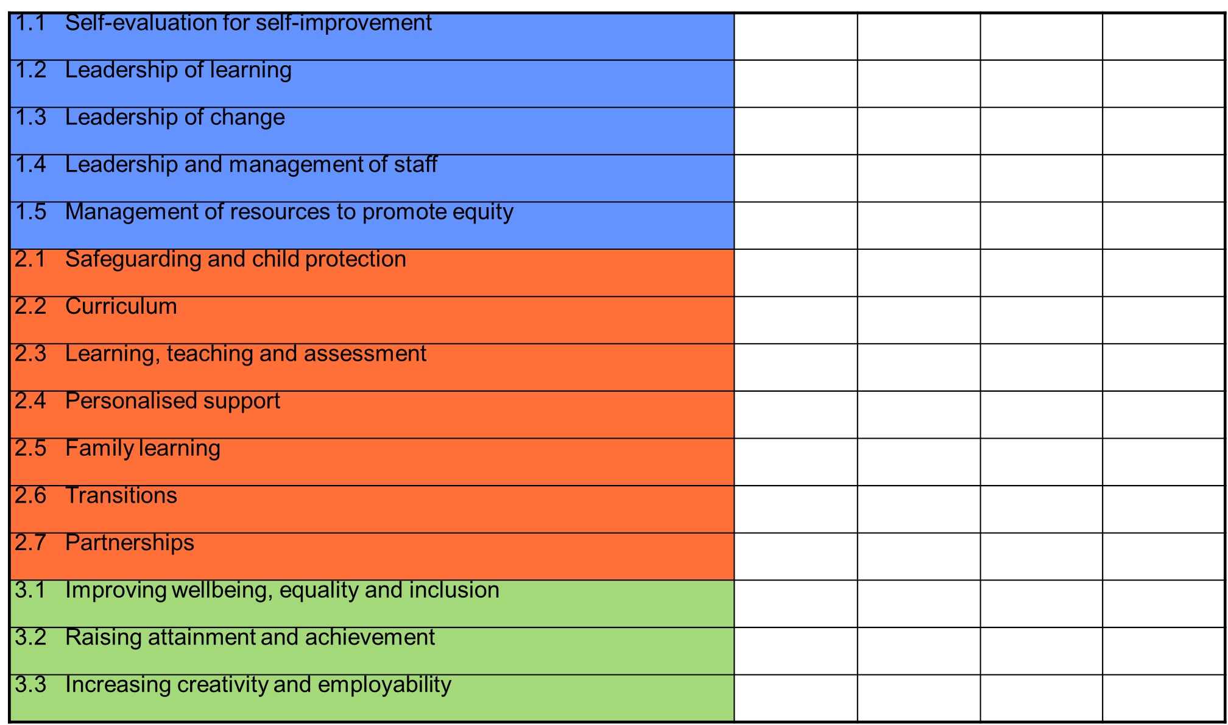 

Good

Good

Good

Good

Good

Good

Good

Good

Good

Good

Good

Good

Good

Good

Good

Good

Good

Good

Very Good

Good

Good

Good

Good

Good

Good

Good

Good

Good

Good

Good

Good

Very Good

Very Good

Good

Good

Good

Good

Very Good

Good

Good

Good

Good

Very Good

Good

Good

Good

Good

Good

Good

Good

Good

Good

Good

Good

Good

Good

Good

Good

HGIOS 4 Quality Indicator Evaluations 2015 - 2017 2018 - 2019 2019 - 2020 2020 - 2021

**School Evaluations**