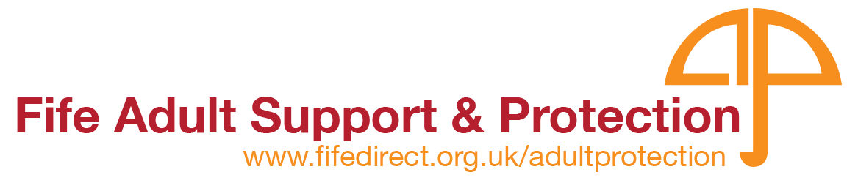

**ADULT PROTECTION**

**REPORTING HARM PROTOCOL**

**INFORMATION RECEIVED**

**You suspect an adult is being harmed**

**You have seen an adult being harmed**

**An adult has told you they are being harmed**

**What is harm? Who is an adult at risk of harm?**

**See Fife Inter-agency Adult Protection Guidance, page 18**

THE ADULT IS **NOT**

AT RISK OF IMMEDIATE HARM

THE ADULT NEEDS

**IMMEDIATE** MEDICAL

ATTENTION

CONSIDER

CRIMINALITY

THE ADULT IS IN

**IMMEDIATE** DANGER

CALL POLICE

**Remember to preserve evidence**

**Lock door and restrict access**

**CALL**

**AN**

**AMBULANCE**

**Immediately call Social Work Contact Centre on 01383 602200**

Or contact allocated social worker (if known)

**IN ALL CASES**

**You have a duty to report harm, even if the adult does not want you to**

**It is good practice to inform the adult that you are reporting harm**

**Inform your line manager and follow your organisation’s**

**Adult Protection procedures**

**Complete a Report of Harm referral form**

**Police ONLY—** **Complete a Vulnerable Person Report - Adult at Risk**

**Fire Service ONLY - Complete AP1 Form Adult at Risk**