Environment & Protective Services Sub Committe

03 December 2020.
Agenda Item No.
Enterprise and Environment Directorate Section/Service Performance Reports
Report by: Keith Winter, Executive Director, Enterprise and Environment
Wards Affected: All
Purpose
To present the performance scorecard for Protective Services, Parks, Streets & Open Spaces and Waste Operations for 2019/20
Recommendations
Members are asked to:
- Consider the Protective Services, Parks, Streets & Open Spaces and Waste Operations performance information presented at appendix 1 & 2.
- Consider if any further review work or scrutiny is required and the scope of that review.
- Note the arrangements set out in section 1 to fulfil the Council’s obligation to comply with Audit Scotland’s 2018 SPI Direction.
- Note the information regarding the workforce profile at appendix 3.
- Note the information regarding workforce data at appendix 4.
Resource Implications
None
Legal & Risk Implications
None
Impact Assessment
An EqIA is not required because the report does not propose a change or revision to existing policies and practices.
Consultation

None required
1.0 Background
  - Audit Scotland published the Statutory Performance Direction in December 2018. 2019/20 is the final year to which that direction applies. The Council is required to report a range of information setting out:

- Its performance in improving local public services, provided by both (i) the council itself and (ii) by the council in conjunction with its partners and communities.
- Its progress against the desired outcomes agreed with its partners and communities.
- Its performance in comparison (i) over time and (ii) with other similar bodies including information drawn down from LGBF in particular and from other benchmarking activities.
- Its assessment of how it is performing against its duty of Best Value, and how it plans to improve against this assessment.

  - The first requirement, to report the Council’s performance in improving local public services (including with partners) will be satisfied by the series of reports (of which this is one) that will be presented to the Council covering the whole of the Council’s performance for 2019/20. Where possible, comparative performance is given for the Scottish average, top quartile, and peer group averages.

  - The other requirements of the Statutory Performance Direction will be satisfied by a combination of

- Update reports to the Fife Partnership regarding progress against the Plan for Fife, with reports also going to Policy and Co-ordination Committee.

- Public performance reporting, assurance statements and governance arrangements.

- Reviewing the external Audit Annual Report for its view on our Best Value performance and any action plans thereafter.

- Carry out a Best Value self Assessment using the updated Audit Scotland Guidance in conjunction with the Council’s Corporate Governance Statements.

1.4. Taken together, these reports will cover the whole of the Local Government Benchmarking Framework, plus selected service performance indicators that give a balanced picture of Council performance.

  - The appendices to this report are presented in the form of a balanced scorecard covering the areas of Customer, People, Responsiveness and Cost results. This is consistent with the format used for the 2018/19 Public Performance Report and mirrors the approach used for internal management reporting throughout the year.

- Workforce Profile/data

2.1 It was agreed by CET in December 2019 that to streamline performance reporting, workforce Profiles and Data shall be incorporated into Annual Service Reports to eliminate the need for separate reporting.
2.2 The workforce profiles at appendix 3 indicate that there has been a small reduction of 0.3% and 2.1% in staff resources within Protective Services and Parks Streets and Open Spaces respectively.
2.3 The annual workforce data contained within Appendix 4 highlights the gender balance in these service areas along with hours of work, contract (full time/part time/permanent/temporary), number of voluntary redundancies, age profiles for those employees who are 29 and under and Workforce Youth Investment (WYI) bids and new starts. This information is of importance in understanding equality issues and also to inform the service of age profiles of staff cohorts to identify suitable training and development needs and enable robust succession planning.
- Conclusions

3.1 This report is part of a series covering the whole of the Council’s performance against key indicators, including the Local Government Benchmarking framework.
The overall performance of Protective Services, Parks, Streets & Open Spaces and Waste Operations is positive; areas for improvement focus are identified in appendices 1 & 2.

List of Appendices

Appendix 1 – Protective Services Performance Report 2019/20
Appendix 2– Parks, Streets & Open Spaces and Waste Operations Performance Report 2019/20
Appendix 3 – Workforce Profile
Appendix 4 – Workforce data

Report Contacts

Anne-Marie Fleming
Corporate Development Officer
Communities Directorate
Anne-marie.fleming@fife.gov.uk

Robert Norrie
Corporate Development Officer
Communities Directorate
Robert.norrie@fife.gov.uk

Protective Services
Performance Report 2019/20

This report provides a strategic overview of performance against key indicators. We’ve worked hard to maintain and improve performance, and this year has seen a number of important achievements for Protective Services:  - Shortlisted for the most improved Environmental Health Service at the APSE Performance Networks Seminar Awards 2019.  - Over 99% of building warrant applications responded to within 20 days – an increase from 92% last year.  - Building warrants issued within 10 days of receipt has increased from 74.5 to 82.2%.  - Protective Services Environmental Health & Trading Standards Teams have played a pivotal role in dealing with the COVID pandemic from the lockdown in March 2020. | However, we continue to face significant challenges etc  - A new Food Standards Scotland Code of practice was issued in early 2019, followed by an additional interventions code in late June 2019. As a result, indicators relating to broadly compliant food standards and hygiene inspections have been removed from this report. Work is underway to identify suitable replacements.  - COVID-19 has had a significant impact due to the required re-prioritisation of resources from March 2019; this will potentially affect the performance report for 2020/21.  - Brexit preparations including analysis of potential impacts from different planning assumptions has been a challenge.  - We continue to face challenges in recruiting new staff within Environmental Health and Trading Standards.

Customer
Performance | Progress
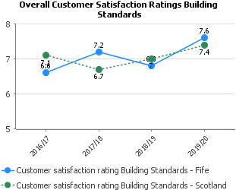 | Feedback from customer surveys mainly included comments about contacting case officers.  A new generic mailbox was set up for all incoming building warrant related enquiries. It is supported by Assistant Building Standards Surveyors and has reduced average response times. An optional telephone appointment system was also introduced for customers who wish to speak to a specific case officer.
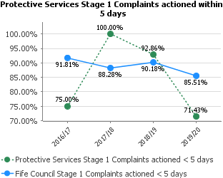 | Protective Services strives to maintain a high level of compliance when dealing with complaints within timescales however there has been a reduction in performance for stage 1 complaints target in 2019/20.  The performance for stage 2 complaints is slightly improved from the previous year and in line with the Fife Council average.
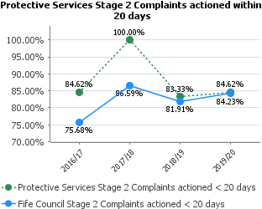

People
Performance | Progress
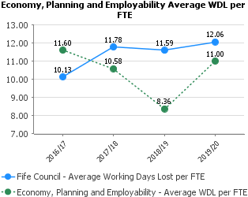 | Absenteeism across Planning, Protective Services, Business & Employability Services is below the Council average. The long-term working days lost (LT WDL) often relates to a small number of Staff.  Currently staff absence is only available on Pentana at Service Level but will be broken down further in future reports following the migration to Oracle Cloud.  Overall the absenteeism with the Service is managed and Staff are supported through training on areas such as Mental Health Awareness, utilising Reality Check tools and ensuring where required Staff are provided support through the Council’s Support Services.
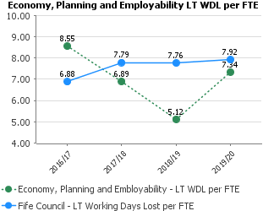
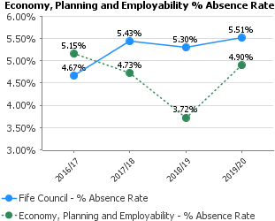

Responsiveness
Performance | Progress
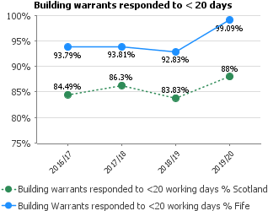 | A realignment in April 2019 changed how we allocate time to processing applications, based on risk. Additional support from Assistant Surveyors was used to allow case officers to focus on application responses.  The national target for this measure is 95%. Fife’s performance is now green and above the Scottish average
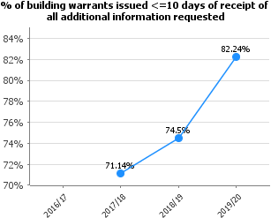 | These were given a higher priority in our Enterprise workflow system and this has improved turnaround times. Additional support from Assistant Surveyors and Leads is being developed to continue improvements towards the national target of 90%.
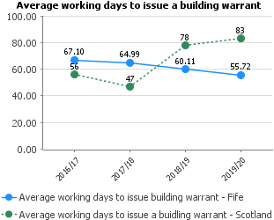 | Previous years’ work to implement the deemed refusal process led to a reduction which has now been reversed. Next steps will include breaking the data down to analyse average times for minor applications and larger applications separately.  Long term average remains steady and this year we are significantly lower than the Scottish average

Cost
Performance | Progress
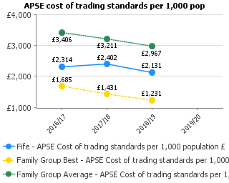 | These costs do not include the Money and Consumer Advice payments (see LGBF section below). The costs have decreased slightly from last year and we compare well with the average for the family group.
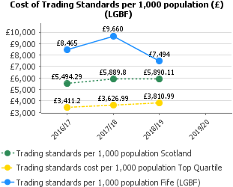 | The cost of trading standards per 1000 population has decreased over the last year and sits at £1604 above the Scottish average. These costs are influenced by the inclusion of costs for the Money and Consumer Advice service which Fife Council pays an annual sum. These costs are not included within some LGBT returns for other local authorities.
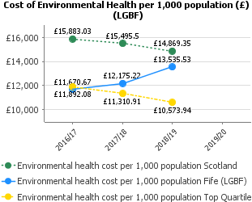 | Whilst it would appear that the costs for Environmental Health have increased in 2018/19, in real terms they have actually reduced. This disparity has been a result of the way the information was collected for this reporting year. Clarification to guidance had been sought and has been provided for the collection of costs from 2019/20 onwards.

Parks, Streets and Open Spaces Domestic Waste Service
Performance Report 2019/20
- An organisational restructure has taken place in 200/21. Including a new operating model, electronic asset management system and Fife wide Service Level Maintenance Agreement this will help address performance issues.  - The Domestic Waste Service continues to perform well despite absorbing significant new build housing growth. The physical nature of the job remains a challenge for the workforce.  - Reducing recyclate values and increasing fuel and fleet maintenance costs will need to be monitored closely going forward. | - The main challenges facing both services in the coming years will be absorbing new build growth against a backdrop of reducing income to the service.  - The street cleansing function has now been separated from grounds maintenance and returned to the Domestic Waste Service. This will create greater transparency with finance and the deployment of resources on an area by area basis.  - A new and dedicated Grounds Maintenance Service will engage more constructively with communities to establish local priorities. Sharing an understanding of available resources will enable people to shape their places and make decisions on an informed and empowered basis.  - The street cleansing team will move to a more localised model to promote local engagement and a fast response to arising issues.

Customer
Performance | Progress
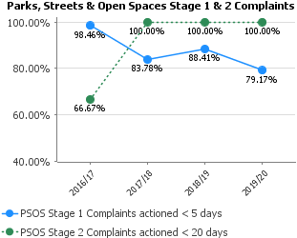 | Stage 1 performance remains strong; however, Stage 2 has dipped as management reductions have impacted on the review activity. This will be addressed in the new structure moving forward.
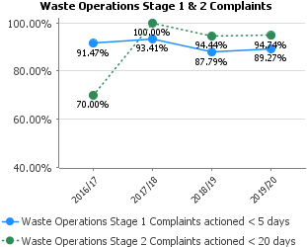 | Performance remains high with both Stage 1 and 2 complaint responses. The service is acutely aware of the importance of the domestic waste function to the community and try to react quickly when problems arise.
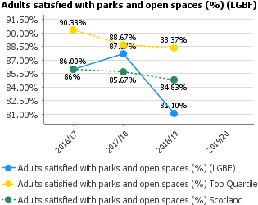 | Budget cuts have seen significant staff reductions within PSOS and inevitably there is a drop in activity and corresponding public satisfaction.
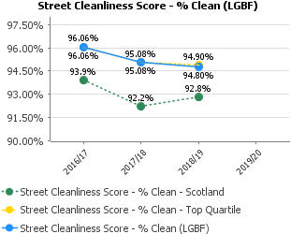 | Street cleanliness is measured on a sampling basis. The figures remain high for these sampled streets.
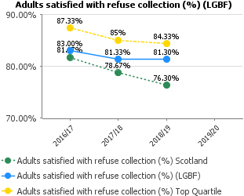 | Missed collections are the main source of customer complaint. Each year Waste Operations absorbs all new build properties with no additional resources. As the size of routes increases there is less capacity to return for missed bins. Lack of capacity fleet can also cause issues as there is less capacity to handle multiple breakdowns. This can lead to service failure and further complaints.
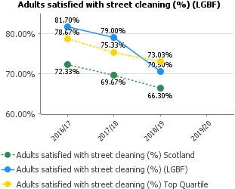 | Satisfaction levels are decreasing, this is reflective of the reduced staffing levels in this area. It is hoped a more focussed approach will generate an upturn in satisfaction.

People
Performance | Progress
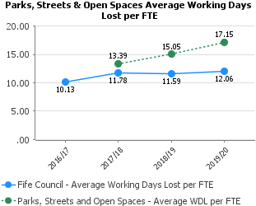 | The service has an older age profile and correlating sickness levels. The reduced staffing levels have further pressured the workforce and may potentially be the cause of increased stress related and musculoskeletal absence.
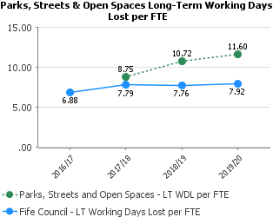
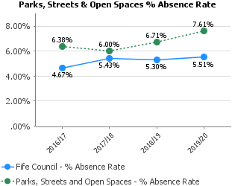
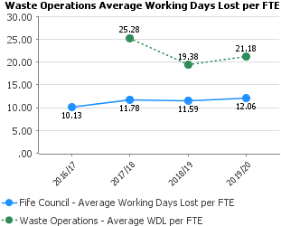 | Short term absence has improved significantly, however long-term absence continues to be a pressure on the service. There are genuine musculoskeletal issues caused by the nature of the job and the older age profile of the workforce are more susceptible to physical wear and tear issues.
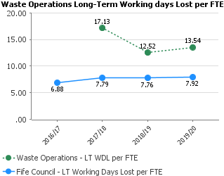
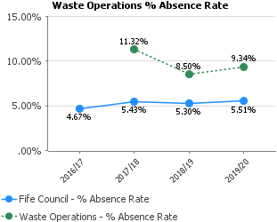

Responsiveness
Performance | Progress
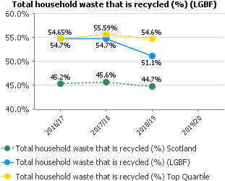 | Contributing factors to the reduction in recycling rate include stricter guidelines on compost accreditation thereby reducing the percentage of material which can be recycled and increasing the percentage sent to landfill. Moreover, wood waste is now used as biomass for district heating and cannot now be included in the recycling tonnage but is diverted from landfill.

Cost
Performance | Progress
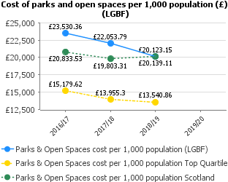 | Costs are reducing in line with available budget.
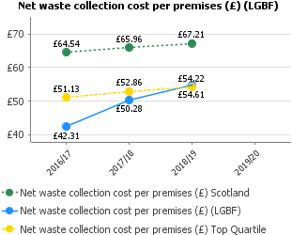 | Costs increased because of rising fuel prices and increased vehicle maintenance.
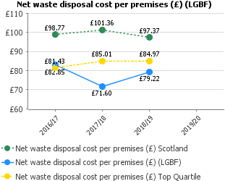 | Disposal costs were relatively stable despite the volatility of recyclate values.
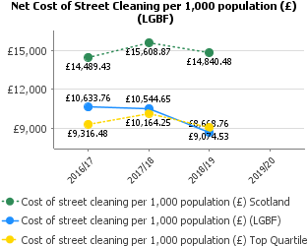 | Costs are reducing in line with available budget.

PROTECTIVE SERVICES, PARKS, STREETS & OPEN SPACES AND WASTE OPERATIONS – WORKFORCE PROFILE
2019/20 FINANCIAL YEAR (01 APRIL 2019-MARCH 2010)

Service | No of Employees (FTE) April 2017 | No of Employees (FTE) April 2018 | No of Employees (FTE) April 2019 | No of Employees (FTE) April 2020 | Difference in FTE 2019-2020
Protective Services Management | 1 | 1 | 1 | 1 | 0
Protective Services | 108.74 | 106.99 | 104.82 | 104.51 | -0.31
ATE Management | 1 | 1 | 1 | 1 | 0
Parks, Streets & Open Spaces | 462.08 | 447.57 | 455.73 | 446.21 | -9.52
Waste Operations | 226.27 | 226.77 | 226,77 | 226.77 | 0
Total | 799.09 | 783.33 | 789.32 | 779.49 | -9.83

ANNUAL WORKFORCE DATA

