Fife Council Education Service
WOODLANDS
FAMILY NURTURE CENTRE
Methilhaven Road, METHIL, Fife KY8 3LE
Telephone 01334 659483
Head of Centre: Sandie Johnston

Standards and Quality Report
Achieving Excellence and Equity

Context

Setting/School Roll (including ELC/ASC) | 125
FME | 125
Attendance (%) | Authorised |  | Unauthorised
Attainment Scotland Fund Allocation (PEF and SAC) | N/A

We reviewed and updated our vision, values and aims in May 2021 through consultation with current staff, children, parents and partners.

Our Vision
To provide a safe, welcoming and nurturing environment for all. We work in partnership with others to empower, support and influence positive life changes and lifelong learning for all our children and families.

Values

- Value Partnerships
- Included
- Friendly, fun and nurturing Environment
- Child centred learning
- Learning for all

Aims

- We work alongside professionals and agencies to support our families

- Children are treated as individuals and staff are
responsive to their individual learning needs

- We provide a rich and stimulating environment with
a range of challenging resources

- Children are involved in their own learning through
responsive planning, learning walls, floor books and PLJ
folders

- We support families to participate in family learning

Improvement for Recovery Priority Work

Session 2020 – 2021

Improvement Priority 1: Begin to embed the recovery curriculum to ensure positive outcomes for Improvement

Aims:

Staff will have broadened their knowledge of play pedagogy behind self-regulation and recognising emotions

Children will be confidently using the emotions resources to enable them to express their feelings.

All Staff will confidently use the Leuven scale to assess children’s emotional wellbeing and involvement.

Planning will include a broad range of mindfulness activities for all children to access.
(planning meetings, room observations)

ASN children will have robust strategies in place to suit their individual needs.

Families will have opportunities to value the activities they engage in with their child
NIF Priority  - School Improvement  - School leadership  - Practitioner professionalism  - Assessment of children’s progress  NIF Driver | HGIOELC Quality Indicators  2.1 – Ensuring Wellbeing  2.5 – Family Learning  2.7 – Partnerships  3.1 – Wellbeing, equality and inclusion  3.2 – Securing children’s progress  3.3 – Developing skills for life  5.1 – Children’s health and wellbeing are supported and safeguarded during COVID-19  5.2 – Infection prevention and control practices support a safe environment for children and staff  5.3 – Staffing arrangements are responsive to the changing needs of children during COVID-19
Progress:

A staff working party created universal resources to enable staff to support children in recognising and regulating their emotions. All staff have received in-house training in using these emotions resources to support children’s development.

All staff have engaged in professional learning activities which focussed on supporting children’s wellbeing through regular mindfulness activities. These techniques and activities have been used regularly with children and have been shared with families through telephone conversations and the Seesaw app.

All new staff received training on Solihull approaches. Experienced staff model approaches and share knowledge with new staff to support their development. Senior EYO’s support all staff with this to promote consistency of approaches.

Our Family Worker promotes the 5 Ways to Wellbeing with families, through Facebook, Seesaw and virtual groups.

We continue to have strong links with our EP, who has supported us with AMG applications for 2 of our children. She attends regular review meetings to support children’s development. HT and PT have regular virtual meetings with EP to discuss individual needs of children and the setting.

All staff are confident in identifying families who require support from our Family Worker. Staff make referrals to our Family Worker, who plans appropriate supports with families. Senior EYO’s support staff in rooms to discuss concerns and appropriateness of support strategies offered.

Families also receive a weekly activity pack linked to children’s interests and learning.

Impact:

Emotions resources are accessible and used well in all nursery rooms to allow children to talk about their feelings. Majority of children can express at least 4 emotions and use emotion cards and emotion spoons to support regulation. Evidence of progress in PLJ’s tracks progress for individuals. Most children are more aware of their feelings and can use language to express these.

Almost all children have engaged with mindfulness activities. Staff have recorded a reduction in emotional outbursts for children. Families have engaged with mindfulness activities shared through the seesaw app. A few of our parents have left some positive feedback or posted photos on the app to say that they have engaged with activities.

All staff are confident in using Solihull strategies in the setting.

Our Family Worker has encouraged families to discuss their own wellbeing through virtual groups and has included families in identifying new groups to support their wellbeing.

Children with a high level of ASN are supported well. We have identified children who will benefit from access to support in an additional support setting for P1. Through the AMG process two children have been offered a spilt placement between Buckhaven ASC and their mainstream primary school to support their next steps and development. Strong links with our EP means that all staff in our setting are supported to meet the needs of individual children. Our HT and PT meet regularly with our EP to track progress and supports for children with ASN.

Our team work co-operatively and effectively to support families and make referrals to agencies where appropriate. Support is tracked to evaluate and identify impact and next steps for families. This also allows us to highlight families who might require additional support from school staff when their child makes the transition to P1. All staff are confident in seeking advice from our Family Worker on ways they can support families.

Families with children in Early Entrants have taken an active role in their children’s learning through engaging with the weekly activity packs. Evidence of this is through photos uploaded to the Seesaw app.

All staff make use of Learning Walls to support learning, although the children’s interest is not always sustained. The majority of children can talk about learning evidenced on the learning wall/floor book.

Most EYO’s are confident in identifying meaningful next steps in children’s learning. They are further supported to do this through support form SLT monitoring of PLJ’s and planned professional conversations with colleagues.

Next Steps:

We will continue to promote and extend use of emotions resources to support children’s development in being able to recognise and talk about their emotions.

All Staff will attend training on the use of the Leuven scale to assess children’s emotional wellbeing and involvement.

Improvement Priority 2: All children should be experiencing high quality play pedagogy

Aims:

All children will experience quality interactions during their session

Significant observations will be evident in all PLJ’s to show progression of learning for each individual child

Children’s learning will be supported and developed through use of learning walls

Evaluation of learning walls will link with PLJ observations

All children will be motivated and engaged in learning opportunities throughout their session both indoors and outdoors

Resources will support a range of learning opportunities and meet the needs of all learners

Families will feel involved in their child’s learning

NIF Priority  - School leadership  - Practitioner professionalism  - Parental involvement  - Assessment of children’s progress  - Performance information  NIF Driver | HGIOELC Quality Indicators  1.5 Management of resources to promote equity  2.2 Curriculum  2.3 Learning, teaching and assessment  2.4 Targeted support  2.5 Family Learning  2.7 Partnerships  3.2 Securing children’s progress  5.1 Children’s health and wellbeing are supported and safeguarded during COVID-19  5.2 Infection prevention and control practices support a safe environment for children and staff  5.3 Staffing arrangements are responsive to the changing needs of children during COVID-19
Progress –

All children experience high quality interactions during their sessions. Each room has adapted their outdoor areas to adhere to regulations. There is no shared garden across the setting anymore. All rooms have their own outdoor space which is only used by the bubble in the room. This has resulted in each area being able to observe, plan and extend children’s learning experiences outdoors on an individual basis. All staff feel they know their key group of children well and can interact with them during the play activities they engage with outside. Consequently, the planning process has become more beneficial as there is a clear link between each indoor / outdoor learning environment.

Our planning format initially focussed on Barry Carpenter’s 5 Levers of Recovery, to acknowledge and support children’s return to nursery. Staff were confident in identifying effective support strategies for groups and individuals. In term 2 our PT adapted the planning format to focus on promoting learning opportunities for children and individuals to plan for progress across the curriculum.

All staff are becoming more confident and support each other to create Learning Walls which reflect children’s interests and learning. Photographic evidence is collated to record impact of learning.

SLT monitor PLJ’s and give feedback to EYO’s. We have introduced planned learning conversation time for EYO’s to engage in professional dialogue with colleagues to identify gaps in children’s learning and identify next steps.

All EYO’s continue to regularly audit resources to ensure provision provides challenge and encourages progression for all learners.

All our children have regular learning updates from staff shared on their Seesaw account. EYO’s also connect with families through phone calls. Families are given regular opportunities to engage in activities at home with their child, including rhymes, stories and other curricular areas.
Impact –

All staff are more responsive to supporting observation of children outdoors since the children’s outdoor environment is used by a small bubble of children. Children’s learning outdoors is evident through significant learning observations in PLJ’s and in room planning. Next steps are identified in planning to plan for progress for individuals and groups.

All children are supported to feel safe and secure and are able to engage in learning activities indoors and outdoors.

Our 3-5’s planning format has evolved to focus on promoting experiences and outcomes across the curriculum, which has led to staff being more focussed on planning for quality learning opportunities and achievements for individuals and groups. Planning is child-centred and links to observations of children’s interests.

Regular review of resources is included in fortnightly planning to plan for progression of children’s skills. Observations in PLJ’s and planning show evidence of this.

Across the setting the majority of families engage with information shared via the Seesaw app. This has helped families feel connected and involved in their child’s learning journey. EYO’s share child’s learning in nursery with families, through phone conversations. This encourages families to value progress in learning and be involved in planning next steps.

Next Steps -

We will continue to develop individual room’s outdoor spaces to create further opportunities for learning across the curriculum.

Families to further engage with digital platforms to enhance their input in their child’s learning supported by a confident staff team.

Improvement Priority 3: Staff are supported with and are engaged in leadership of change

Aims –

Staff will feel at ease during staff meetings when working with each other and when engaging in professional dialogue and reflection activities

Staff will feel a sense of belonging within the whole staff team
Staff will have a safe space to discuss their wellbeing and feel supported
We will have a successful platform for the sharing of information to all staff
All children will have specific, achievable targets set for each term that reflects the 7 principles of curriculum design
A robust, quality assurance calendar will be in place which ensures in depth planning and monitoring across the setting
NIF Priority  - School improvement  - School leadership  - Practitioner professionalism  - Assessment of children’s progress  NIF Driver | HGIOELC Quality Indicators  - Evidence based improvement / ensuring impact  - Professional learning  - Leadership of change  - Leadership of management and practitioners  2.3 Learning, teaching and assessment  3.1 Ensuring wellbeing, equality and inclusion  5.1 – Children’s health and wellbeing are supported and safeguarded during COVID-19  5.2 – Infection prevention and control practices support a safe environment for children and staff  5.3 – Staffing arrangements are responsive to the changing needs of children during COVID-19
Progress –

All staff took part in virtual Wellbeing Group sessions to encourage connection and peer support. Wellbeing Walks with SLT were offered to individuals to further support wellbeing. Weekly virtual staff meetings take place to share information and answer questions and to drive forward improvements and priorities.

Senior EYO’s support room staff.

Staff WhatsApp group is used effectively to share operational information with all staff.

EYO’s and SLT meet termly with EYO’s to identify children’s progress and next steps in literacy, numeracy and HWB.

Our Operational Monitoring Calendar is updated to plan across the academic year.

All staff have engaged in mandatory training and professional reading in connection to the recovery curriculum.

In May 2021 all staff began to evaluate our Vision, Values & Aims. All stakeholders were also included in this.

All staff now use digital platforms to engage with families.

All staff have engaged in PRD process with a member of the SLT.

All EYO’s have used Care Inspectorate Key Question 5 to reflect on our provision and adapt/enhance our current practice(s).

Impact –

Due to Covid restrictions, staff have not had opportunities to develop and strengthen professional relationships with other members of the wider nursery team.

Support from Senior EYO’s in rooms has ensured staff feel supported.

Our staff WhatsApp group chat ensures that appropriate operational and concise messages are shared with all staff in an accessible way. This is useful to share urgent messages with all staff.

Termly learning conversations between EYO’s and SLT support EYO’s to identify progress, next steps and challenge for individuals.

Our Operational Monitoring Calendar supports all staff to maintain consistency and quality for monitoring, planning and self-evaluation across the academic session.

Apprentice EYO’s and newly qualified EYO’s have felt supported in their roles and one of our apprentice EYO’s is now fully qualified.

All staff can confidently engage in professional dialogue relating to the recovery curriculum. Evidence in floor books in each area tracks evidence of progress and supports for children, families and staff.

Most EYO’s are confident in using digital platforms to engage with families. The majority of our families engage with activities and posts.

Next Steps:

Plan for opportunities for staff to be offered a range of tools to support their own wellbeing and to build relationships with wider members of the nursery team.

Continue to build staff capacity and parental engagement with digital platforms to enhance the link between home and nursery learning.

Attainment of Children and Young People
Almost all of our children in 3-5’s nursery are working within the Early level. Children with identified additional support needs have adapted targets to track progress.

Evidence of significant wider achievements
We offer weekly pop-up shop bags for families, priced at £4. On average, 6 families in the setting purchase one of these each week. This helps to support families to eat a range of healthy and nutritious food and reduces financial pressure on families.

Our families have participated in virtual Bookbug sessions to promote literacy skills at home.

What have been the success and challenges of school/setting closure period (school/class/playroom isolation, remote learning between January – March 2021)
Successes During the Closure Period
- Home Learning opportunities to support progression
- Maintaining relationships with families and establishing new ones for our children who started in January
- Engagement with stakeholders
- Family support
- Upskilling staff to use digital platforms
- Staff commitment to deliver high quality learning experiences

Home Learning Opportunities to Support Progression

- A plan was implemented to ensure breadth of learning opportunities with a weekly literacy, numeracy and health & wellbeing focus
- In addition, activity ideas were shared weekly
- SeeSaw and Facebook were used so parents/carers had a choice of platforms
- Learning activity packs were offered weekly from the nursery eg. Art packs, play dough packs and soup packs

Maintaining and Establishing Relationships with Families

- Weekly phone calls between key workers and families to ensure learning was being shared and any support offered to the family
- £4 food bags continued to be offered to all families
- Relationships established with new families who enrolled in January via phone calls

Engagement with Stakeholders

- With staff –
- Whats App group to share appropriate operational and concise messages to all
- Wellbeing meetings held weekly via TEAMs with a focus on the 5 Ways between smaller staff teams
- Weekly SLT meetings via TEAMs
- Weekly whole staff meetings via TEAMs
- SLT in the setting to support those on rota

- With families (including Family Support) –
- Weekly phone calls
- Engagement at pick up and drop off times with those who attended the setting
- Virtual Family Learning opportunities eg.PEEP and Bookbug
- Responses shared on Seesaw to learning ie.Photographs from home of the children taking part in suggested activities to be transferred to PLJ’s
- Family Worker offered additional support where required via telephone

- With partner agencies –
- Positive relationships already established and continued throughout closure period via email and phone calls
- Other professionals identified families they felt required extra support during the closure and space in nursery was made for those under the vulnerable category.
- Regular contact continued to be made between DHoC and Health Visitors / Social Workers to identify and support vulnerable families where necessary.
- DHoC continued to attended Wellbeing & LAC reviews as well as Case Conferences and Core Groups via TEAMs

Upskilling Staff to use Digital Platforms

- Staff were offered training to use SeeSaw which supported the delivery of home learning
- Support offered to those who were not confident using technology, particularly using their own devices at home to access the server, TEAMs etc
- Staff were encouraged to participate in online learning courses through Fife Council. All staff were invited to make a list of online training they had previously completed which they felt would be beneficial for their colleagues. PT made a list of recommended courses and how to access these, this was sent out to all staff as recommended online learning.

Data for engagement levels

Parents were asked these questions to help us evaluate the impact.

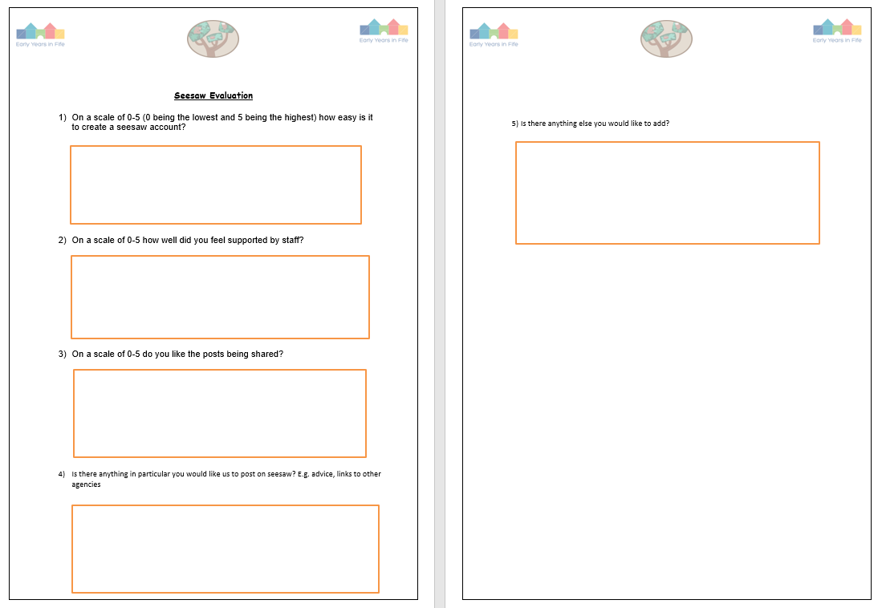

- Five parents responded to the questionnaire.
All parents were asked if they felt supported by staff, liked the posts being shared and were happy with the posts and virtual groups on offer

- L loved his first story time with you”

- “K listened to you but was not interested in counting the mermaids, just kept saying nursery mummy. We shall keep trying”

- That’s good, L has flash cards but they’re animals and objects. Never thought to get emotion ones but it’s good that we can make some at home”

- “she came home opened her pack right up and started drawing”

Staff commitment to deliver high quality learning experiences

- Staff provided activities, stories and songs to go on SeeSaw and Facebook supporting learning
- Staff dedicated time each week to their phone calls with their key group families, showing flexibility when required to meet the needs of the families
- Staff supported each other through these uncertain times during wellbeing meetings on TEAMs
- Staff area / playroom teams had weekly handover meetings to discuss individual children/families. This information was passed on and acted upon by whoever was on rota the following week.
- If any concerns were identified during staff’s weekly calls to families this was highlighted to DHoC and / or Family Worker to offer support.
- Weekly CP meetings continued to take place over TEAMs– DHoC updated SLT with all CP Matters.

Challenges During the Closure Period
- The wellbeing of all, these were unprecedented and uncertain times which we all had to adapt to
- Lack of engagement from some families – some requested they didn’t want a weekly phone call and responded to email or less frequent calls. They were reassured they could contact us at any time outwith the planned calls
- Some families lack of confidence to use digital platforms to support learning
- Pressure on parents if they were working from home whilst supporting siblings school learning and nursery learning
- High numbers of vulnerable families requiring a place made it difficult to plan – ensuring staff and children remained in bubbles. This resulted in the majority of nursery areas/ playrooms being open. There was also a growing number of Keyworker families who were entitled to a place
Changes to previous practice as the result from learning/engagement which will be sustained
- Use SeeSaw to establish a greater link between home/nursery learning and develop staff confidence when doing so
- Wellbeing opportunities for staff to attend
Family Learning and Support programme developed

Using TEAMS for meetings with other professionals and encouraging and supporting parents to become more familiar with this and to gain confidence with this.

NIF Quality Indicators (HGIOS ELC) Early Years Self- Evaluation (Nursery)
Quality Indicator | 2018 - 2019 | 2019 - 2020 | 2020-2021 | Inspection Evaluation  (within last 3 years)
1.3 Leadership of change | 4 | 4 | 5
2.3 Learning, teaching and assessment | 4 | 4 | 5
3.1 Ensuring wellbeing, equity and inclusion | 5 | 5 | 5
3.2 Securing children’s progress | 4 | 4 | 5

Care Inspectorate (within last 3 years) | Grade (if applicable)
 | 2018 - 2019 | 2019 - 2020 | 2020-2021
Quality of care and support
Quality of environment
Quality of staffing
Quality of leadership and management

