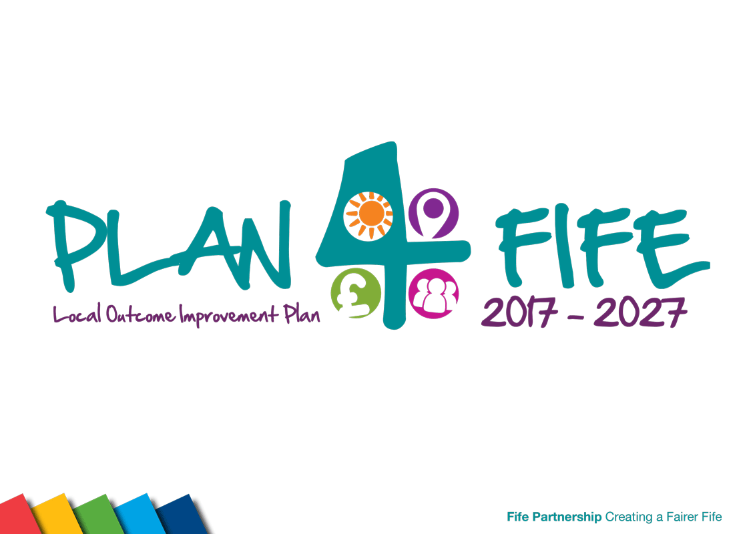

Opportunities for All

Thematic Report: discussion document

February 2020

Introduction 
Opportunities for All
Opportunities for all is about ensuring that no-one is left behind. We aim to ensure that everyone can access opportunities in education, training, jobs and wider society, and have equal access to the support and advice they might need to support a fulfilling and decent life.
It is important that we as a partnership focus on removing barriers to allow our communities to maximise opportunities that are open to them. We need to focus on small and big changes so that individuals can progress.
There are a number of opportunities that we want to sound the Partnership Board out on in order to test whether we are in the correct territory for the specific areas we want to enhance. These include: -
- Harnessing the procurement activity across the partnership to spend local and at the same time pursue the payment of the living wage to ensure we increase earnings and prospects within Fife.
- Making use of the NHS and Fife Council as local “Anchor Institutions” to work with communities to address inequalities
- Working with Opportunities Fife Partnership to increase activity related to mental health and increasing wellbeing amongst the Fife working age population
- Consider the role of Community Wealth building in our future community partnerships
- Using your influence to engage and encourage local businesses to become business links with schools to allow young people the opportunities to see what types of work can be available in Fife through the private and public sectors
- Promoting the opportunity for staff across our organisations to become part of mentoring schemes for our young people who may find seeking a positive destination quite a challenge
- Building on our community-led work to encourage parents and local communities to develop and run parent/community led childcare facilities.

The Opportunities for All section of the Plan for Fife has 7 areas of focus and 21 shorter term actions.

This is a discussion report for consideration by partners and partnership groups before being finalised and presented to the Fife Partnership Board at its February 2020 meeting. This should enable challenge questions, issues and solutions to be identified and discussed prior to consideration by the Partnership Board.

Focus: Maximise household income through access to support, affordable finance, concessions and benefits, affordable energy.

What we are doing now?
A great deal of work to alleviate poverty is being taken forward across all partner agencies. The Welfare Reform & Anti-Poverty Partnership (WRAP) has been overseeing progress on actions set out in the Plan for Fife.

- Raising awareness of poverty through campaigns like Challenge Poverty Week 2019.
- Bringing together local welfare reform and anti-poverty groups through a WRAP Network event to share best practice and strengthen the links between the strategic partnership and local groups.
- Developing an action plan to identify gaps in income maximisation services, increase signposting and actively refer people to sources of help.
- Reviewing Fife Council budgets for welfare reform and anti-poverty to determine whether they are demonstrating best value in delivering meaningful and evidence-based interventions.
- Monitoring actions set out in the first annual Fife Local Child Poverty Action Report published in June 2019 and starting to prepare the 2020 child poverty report.

What’s missing?
A strong overview of anti-poverty work across Fife and a clear understanding of the impact of interventions through the use of data and insights.

A sound understanding of the multiple budgets supporting anti-poverty and equalities initiatives, including grant funding, across the Partnership. Knowledge of what funding is due to end and what measures need to be put in place to ensure the sustainability of funding.

What should we do next?
Greater collaboration and communication by partners to maximise take up of welfare support, free school meals, clothing grants, etc. Gain a deeper understanding of whether our interventions are having the desired impact.

Clearly align the Child Poverty Action Plan to the Plan for Fife. Ensure effective monitoring and evaluation of child poverty actions in line with the Plan for Fife performance framework.

Map the profile of expenditure on reducing inequalities across Fife Council and NHS Fife and target spend in line with the priorities in the Plan for Fife.

Use the public health reform whole systems work on child poverty to test new approaches across Fife

CARF/Child Poverty
£11.5m
 | In 2018/19, £11.5m financial gain achieved for clients in Fife through CARF activity - equivalent to an extra £31 for every person living in Fife.
  36.4% | While there has been little change in levels of child poverty in Fife and Scotland, child poverty appears to be increasing in the poorest neighbourhoods in Fife. This is in line with the expected impacts of UK welfare reform changes including a freeze on benefits.

Focus: Early Years support to ensure that children are ready to learn when they start school.

What are we doing now?
Over the past year, as part of the Children and Young People Improvement Collaborative work was undertaken to look at family nurture in an area of Fife. This included engaging with 2-year olds and their families to promote the value of the developmental review and to increase uptake. Provisional data indicates that uptake from March 2018 to March 2019 increased from 88.66% to 97.62%.

Ages and Stages Questionnaires (ASQs) are being used more routinely as well at child health surveillance points. This allows a proactive approach with parents being aware of how to support their child’s development.

Over the last year PEEP continues to be delivered across schools. PEEP is an evidence based early learning intervention designed to improve the life chances of young children by raising attainment. This approach helps to develop positive attitudes to children and parents learning together. A revised feedback tool for use with participants is helping to plan sessions to better reflect child/parental needs and interests. Bookbug sessions continue to be facilitated across settings. Data collection continues to highlight the positive trend in the engagement of families in sessions from SIMD 1 and 2 areas.
Almost all practitioners are trained in the use of the eLIPS data collection tool which provides evidence to support appropriate planning to help the development of young children's use of expressive language. The Early Years service is increasingly working with Speech and Language Therapy (SALT) to develop programmes to help practitioners support children's communication development, particularly those practitioners who are new to the profession.

What’s missing?
In line with other areas the 4 – 5 ½ year assessment is not fully in place but families with additional support needs are being offered a full assessment at this point.

What should we do next?
Assess whether concerns identified at the 13-15-month review are still concerns by the 27-30-month review.

Childhood Development
  90% | In 2017 Fife’s uptake of the 27 – 30-month developmental review was below the Scottish average 87.1% Fife, 90.1% Scotland, over the past year uptake in Fife has increased and at 90% is now in line with the Scottish average.
  766 | Data collection continues to highlight the positive trend of engagement of families with 766 sessions being delivered between January and August 2019 involving 4,367 adults and 5,771 children.

Focus: Maintain a stronger focus on the wellbeing of children and young people including mental wellbeing.

What are we doing now?
The Council’s Kinship Team has an additional three staff members and is now able to undertake family finding for young people at risk of being accommodated. The team carries out emergency initial kinship assessments to allow children to be placed with a family while assessment and planning is undertaken. The team has been able to increase the support available to help sustain kinship placement. The intention is that all kinship assessments will be undertaken within 12 weeks. The team now works work more closely with area teams to ensure that kinship is explored for all children who are looked after away from their family to ensure a timely return to family-based options.

Developing and piloting of the ‘Branch Out’ mental health curricular resource to support transition from primary 7 -S3 in partnership with NHS clinical psychology staff.

Providing a wide range of project work in schools to address wellbeing. including mindfulness, low-level anxiety management groups, body image training for staff, bereavement and loss support, and carrying out inquiry-based workshops with focus groups of young people to gather their views and ideas to support emotional wellbeing and transitions.

Introducing Wellbeing Collaborative networks within schools which contribute to emotional and physical wellbeing priorities across Fife. These networks also feed into seven locality groups to ensure that priorities are linked to local and national strategies.

Developing and rolling-out a guided workshop and film supporting practitioners to consider the impact of trauma and Adverse Childhood Experiences (ACEs) on young people and families they work with, reflecting on and developing their practice, using the five ways to wellbeing.

What’s missing?
Wellbeing Collaboratives have only recently been introduced and will require strengthening and support to ensure that schools and key partners from across Fife are represented.

Kinship carers often experience additional pressure due to their home being overcrowded, moving them to a larger home in a different area can create additional challenges.

Barriers to accessing CAMHS for young people placed in kinship care arrangements.

What should we do next?
Explore a family group decision making model.

The Fife school counselling model for children aged 10 and over will be introduced in schools. This will build on the broad, universal practices of nurture, listening, signposting and coaching support which a wide range of adults provide for young people on a day-to-day basis.

Health data on key themes will be shared via Locality Improvement Forums and Networks to enable each locality to reflect on the particular health challenges within their locality and to identify key actions.

Increase awareness with partner agencies or the role that kinship carers can play and the value to children of remaining within their extended family. This should be a key focus for the corporate parenting board.
Undertake service evaluation to better understand the support services needed to sustain kinship.

Wellbeing
  46% | In 2018, 46% of 15-year olds, surveyed through the Strength & Difficulties questionnaire, perceived their mental health and wellbeing as poor. This is a 9% increase on the 2013 result of 37%.

Focus: Improve staff confidence in using interventions to close the attainment gap.

What are we doing now?
Fife’s Children & Young People’s Improvement Collaborative is delivering local quality improvement training, inviting small multiagency teams from across Fife’s Children’s Services to take forward improvement work over a three-month period. Almost all teams are focusing improvement work on pupils identified through work associated with the Pupil Equity Fund.
Training is focused on a coaching model and is grounded on contextual examples. Teams are supported to test, measure, implement and spread new and better ways of working. To date we have delivered seven cohorts of training with over 70 teams actively leading improvement. Many teams have several improvement projects up and running focused on improving children’s outcomes across literacy, numeracy and health and wellbeing.
Improvement work tested across several Fife Primary Schools has developed learning and an evidence base of ‘what works’ to improve children’s writing outcomes. This improvement work has since been scaled up and has supported six schools across Fife to improve primary 4 children’s writing outcomes.
Teams have captured their improvement journeys and learning within a poster format enabling us to share good practice across Fife Council and further afield.
What’s missing?
Due to recent successes, momentum and requests for support are evolving at a pace that our systems capacity and expertise cannot fulfil.

What should we do next?
Build support for quality improvement methodology with contextual examples, across Fife’s Children’s Services.

Spread successful improvement work, scaling these up across Fife.

Grow our local faculty of expertise in quality improvement methodology to sustain local training delivery.

Offer an infrastructure of support to practitioners leading improvement work to support sustainability and momentum.

Improvement in staff confidence
70
 | Teams across Fife’s Children’s Services are actively leading improvement, with many teams having several improvement projects across literacy, numeracy and health and wellbeing.
  4 | Successful improvement projects (robust vocabulary instruction, improvements in writing, Times Tables and supporting self-regulation) have been spread whole school and to other contexts across Fife.
  78% | The percentage of P5 learner’s achieving Curriculum for Excellence (CfE) First Level Writing Outcomes increased from 54% to 78% within 10 academic weeks.

Focus: Work with employers, schools, colleges and universities to maximise opportunities for school leavers.

What are we doing now?
Following a period of change and transition we are starting to build momentum and move forward in delivering on both the National and Fife KPI’s and objectives. More robust and reliable data gathering processes allow us to map progress and target areas where we feel additional input or support is required. Developing the Young Workforce (DYW) Coordinators have been appointed in all 18 Secondary Schools and are responsible for taking forward key aspects of the DYW strategy, with a focus on enhancing links with local businesses and employers.

A strategic approach among partners including the DYW Lead, Regional Board, Fife college and the Fife Council Employability Team has seen an increase in partnerships.

What’s missing?
There has been only limited use of both Marketplace and Founders 4 Schools across Fife to assist with DYW activity. We have lacked a media presence and need to showcase the good work currently taking place in Fife. Although an equalities action plan is in place this needs to be taken forward.

What should we do next?
A collaborative approach in embedding employability programmes into the curriculum will continue to be supported by key partners.

Continued focus to increase employer engagement and the number of strategic partnerships across Fife. We aim to raise the profile of DYW Fife through marketing on social media channels and a new website.

A mid-year review in all Fife secondary schools with focus on the Fife KPI’s to track progress and identify schools who require support in driving the DYW agenda. Our DYW Coordinators will continue to be key influencers in taking the DYW strategy forward in Fife.

Fife Council and NHS Fife to increase the number of modern apprenticeships available to young people.

Engagement

  78 | DYW has been working with local businesses to develop “industry led learning” to help make sure that what young people are learning is more linked to the world of work. During the past school year, there have been 12 different types of engagement with employers, amounting to 337 occasions. 78 of which were work placements.

Work with employers, schools, colleges and universities to maximise opportunities for school leavers.

Focus: Improve access to learning, work and voluntary opportunities (through childcare)

What are we doing now?
Seven family nurture centres offer a 52-week service, ensuring those who are most vulnerable and in greatest need of support in each local area can access family learning and parenting support as well as additional hours of Early Learning Childcare (ELC) during holiday periods. 28 early years lead officers are working to promote equity and excellence in areas of need in Fife through targeted interventions. Gaps in children’s learning and experience are identified early through their work and targeted interventions put in place to ensure children’s progress. All ELC services in Fife are supported by quality improvement through access to specialist early years specialists. including peripatetic nursery teachers, Area principal teachers and development officers. Almost all providers are meeting the Care Inspectorate quality standards of ‘good’ or above with a high number achieving very good or excellent.

From August 2020, there will be an increase in funded hours of ELC to 1,140 hours per year. New models of ELC delivery have been created to meet the increased provision, fully utilising the current workforce and estate. The Fife Council early years workforce is being expanded through on-going recruitment and a highly successful apprenticeship programme. New nursery builds, and refurbishments are in development to that ELC places are available for all pre-school children. Work to strengthen and increase partnership working with a range of providers is on-going. The increased ELC hours will provide increased opportunities for children to experience quality play, learning and care, impacting on learning outcomes. The expansion will help working families with childcare costs and will provide greater opportunities for parents to take part in volunteering or study, to get back into the workplace or to meet the needs of family life.

Work to improve the transition for children moving from nursery to primary school includes the promotion of playful pedagogy in primary 1. Seventy primary schools have become early adopters of a more principled approach to learning in the early years of school, with over 130 teachers taking part in an intensive primary 1 teacher collaborative programme. The aim of this work is to improve children’s wellbeing and attainment, evidence of impact is being gathered in this first year of implementation.

What’s missing?
The expansion of ELC will not be fully implemented until August 2020 and the work to promote playful pedagogy in primary 1 is at the early stages of being rolled out across Fife. The positive impacts and important learning from this work must be gathered and analysed.

What should we do next?
Support all funded providers in their delivery of quality ELC across a range of settings that meet the needs of Fife children and families. Families will be able to use the hours flexibly, choosing from a range of providers and models on offer. blending ELC more than one provider and to help meet their childcare needs.

Childcare
  600hrs | All 3-5-year old children and eligible 2 year olds can access 600 hours of quality early learning and childcare (ELC) in a Fife Council nursery, private nursery, playgroup or childminder working in partnership with Fife Council

employers, schools, colleges and universities to maximise opportunities for school leavers.

Focus: Develop integrated and community-based programmes of intervention particularly around obesity, alcohol and smoking.

What are we doing now?
Following the 3-month test phase the Macmillan Improving the Cancer Journey (ICJ) Service was launched Fife wide on 10th September 2018. The ICJ was established to address the multifaceted consequences of receiving and living with a cancer diagnosis. Since its inception the service has offered holistic, individualised support to over 600 local people diagnosed with cancer.
We are taking forward a programme of work across the Fife Partnership to prevent and reduce Type 2 diabetes. As well as weight management programmes for people who already have Type 2 diabetes, and existing services such as child healthy weight, we are taking a whole systems approach to preventing obesity in children and young people. This whole systems approach involves working collaboratively to identify the roles and actions which all partners across Fife can take to ensure our children and young people are able to eat well, be active and be a healthy weight. We are working particularly in the Dunfermline and Cowdenbeath areas to make changes in areas such as the built and natural environments, transport options, food outlets and food availability for children and young people. Our collaborative work includes working closely with children and young people, and with community and voluntary organisations.
Throughout 2019, the seven Health & Social Care Locality Planning Core Group have been driving forward identified priorities on behalf of their localities. This saw a range of projects being delivered in our communities. For example, the ongoing roll out of The Wells and the commissioning of Meal Makers across Fife in response to social isolation.

The Health and Social Care Partnership has established a Digital Innovation Board to drive forward its ambitions to extend digital solutions across the health and social care system. Over the past year, the Partnership has rolled out Total Mobile to all external care at home providers and has made significant progress with the replacement of SWIFT, the social work information system. The Partnership is currently preparing a proposal to introduce “Just Checking” sensor technology. This will be used to support and refine our assessment processes, to inform community care provision and enable us to continue to support people to live at home, maximising both safety and independence.

What’s missing?
A coordinated approach to our work on food and physical activity. This relates to the Thriving Places action “Promote participation in sport, physical activity and healthy lifestyles

There has been an increased focus on mental health and wellbeing with partners looking at prevention, support and treatment.

What should we do next?
We plan to better coordinate our work on food and physical activity under the banner of public health priority six. This will include prevention work, weight management and diabetes prevention.

Implement our new mental health strategy for Fife. This will give us a stronger focus on mental health improvement for people living in Fife.

Smoking
90%
 | In 2018/19, our Fife target was to deliver a minimum of 490 post 12 weeks smoking quits in the 40% most deprived areas of Fife. We achieved nearly 90% of the target in Fife with our three key distinct delivery services.

Ambition: Fife has lower levels of poverty in line with national targets.

Key Actions | Expected Outcome Status
 | Feb 2019 |  | Feb 2020
Co-ordinate support locally to deliver mitigation measures and monitor the impact of welfare changes.
Promote access to affordable credit and banking facilities.
Promote Fife as a Living Wage region and look at the role of procurement in supporting this. |  | 
Integrate accessible income maximisation at key points in service provision across the partnership.
Explore a local pilot of basic income.
Improve advocacy and support to enable families and pregnant women to deal with benefit changes, maximise income and be more financially resilient.
Develop our approach to concessions and cost reduction to ensure cost is not a barrier to participation.
Identify and address cost barriers to participation in school.
Reduce the number and percentage of households experiencing fuel poverty. | N/A
Ambition: Educational attainment continues to improve for all age groups.
Key Actions | Expected Outcome Status
 | Feb 2019 |  | Feb 2020
Improve access to local, affordable and flexible childcare, including exploring parent led approaches to take advantage of learning, training and job opportunities.
Improve family engagement and support the need for early communication and language development.
Implement evidence-based approaches to closing the poverty related attainment gap.
Implement the ‘Our Minds Matter Framework’ to improve support for the emotional wellbeing and reduce the number of children and young people who need intensive support with mental health issues
Improve awareness of the impact of Adverse Childhood Experiences (ACE).
Improve prevention to increase the proportion of children supported in a home/kinship setting and reduce the proportion of looked after children placed out with Fife.
Implement the Universal Health Visiting Pathway and support families in building positive attachments at the earliest stages.
Implement an action plan to develop the young workforce, in partnership with businesses and colleges.

Ambition Fife has reduced levels of preventable ill health and premature mortality across all communities.
Key Actions | Expected Outcome Status
 | Feb 2019 |  | Feb 2020
Strengthen the role of preventative health interventions, particularly in the most disadvantaged communities.
Develop community capability and resilience by establishing locality groups and plans, and supporting community projects
Redesign care and support services to provide greater collaboration, more user choice and control, and to support people at particular risk of harm, deterioration or hospital admission
Invest in digital solutions to promote self-monitoring, early intervention and prevention

Key
 | Warning - Issues to be addressed to ensure delivery |  | Alert - Potential issues further work required |  | OK – Going well, progressing as planned |  | Completed

Note: Progress at August 2018 was based on a different scoring system, as follows:
Key |  | No clear delivery plan, lack of activity |  | Work initiated |  | Delivery plan in place and on target

