Programme title | Procurement Programme
Programme Manager | Stuart Fargie
Business Change Manager
Date & version | 19/3/2021 Final

Document history
Date | Version | Last revised by | Details of revision

12/03/2021  19/03/3021 | 1  2 | S Fargie  S Fargie | 1st draft  Final Draft

1. Background

Fife Council, like most other LA’s in Scotland, faces significant challenges with regard to ongoing service provision with greatly reduced resources going forward in the short to medium term.

Following the approval of the Revenue Budget in February 2018, the remaining budget gap was £43.4m which highlighted a degree of uncertainty regarding future resources. This was placing pressure on the sustainability of services being delivered at that time. The Changing to Deliver programme seen as key to the financial strategy and financial sustainability of the Council.

Following two separate reviews of third-party Council spend (circa £500m including Health & Social Care) by a consultancy firm Ernst & Young and Scotland’s Public Centre of Procurement Expertise Scotland Excel a significant opportunity was identified to reduce third party spend.

The Commercialisation Programme was established with an aim of reducing Fife Councils third party spend by £16m by undertaking a consistent and commercial approach to Procurement activity. The Policy and Co-ordination Committee endorsed the Procurement Business case on the
12th April 2018. The business case projected an estimated £16m procurement saving
from the reduction of Council third party spend (circa £500m).

The estimated £16m savings figure was broken down into 3 areas
- £6m Revenue
- £6m Capital
- £4m HRA

The Programme commenced in September 2018 with the first two years supported by Scotland Excel, who are a public body and are the Centre of Procurement Expertise for Local Government in Scotland. Scotland Excel exited from Fife on 24th September 2020.

2. Blueprint
There was no blueprint prepared by the Programme as the purpose was not to change the structure of the procurement operating model within the Council. The Procurement Transformation Programme had two clear objectives. Reduce third party spend on goods and services by £16m. The target measure was “Identification of £16m savings & benefits from external third party spend (CAT A, B, C) by August 21”. The second objective was “Improve Procurement & Commercial Skills and Capabilities”. The work undertaken by the programme could inform any potential changes that may be required to current procurement operating structures.

3. Benefits

Reduced third party spend by £16m
The Programme has achieved its financial target “Identification of £16m savings & benefits from external third party spend (CAT A, B, C) by September 2021. Delivery plans set the date to be met at 2nd August 21. A financial summary table below shows both identified and delivered procurement savings from the start of the programme in 2018. The achieved value of benefits and savings to the Council is in now in excess of £20m surpassing the Programme benefit target. This is on the assumption that the £9.3m that is currently in phase (delivery plan/pipeline) is delivered.

Table 1 Procurement Savings & Benefits 2018-21 (up to Q3)
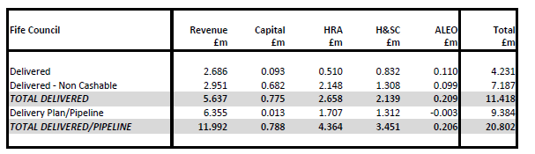

Improve Procurement & Commercial Skills and Capabilities
The programme measured upskilling progress against high level outputs around Demand Management, Operational Control, Strategic Sourcing, Contract Review. Procurement Competencies were based on the Scottish Governments Procurement Development Framework and benchmarks were created for each job role type i.e. Buyer, Procurement Officer and Category Manager. This was replicated for the Delegated Procuring Areas (DPA). Following the Procurement team’s completion of the framework an analysis was undertaken to identify skills gaps and develop training plans for areas of greatest need e.g. Negotiation, Contract Management etc. Skills development activity would be measured over the 2 years of the programme.

At Programme Close there has been significant increases across almost all procurement competences as shown in the table below. This has also provided the Councils Procurement function with a clear understanding for all areas of focus going forward.

The Procurement Development Framework is a subjective tool and used to inform personal and team development, ensuring team members have the necessary skill set to conduct their job effectively. The initial scores submitted may be subject to change following a peer review and conversation with the manager. Some of the benchmarks may not be applicable to certain category areas due to varied activity therefore there is acceptance that the benchmark is not always the target area for all individuals, even if it is noted as a target for the overall role. The tool is a useful snapshot for training plans but for the reasons noted above, it is a tool rather than an evidence-based tracker.

Table 2 – Skills and Competencies

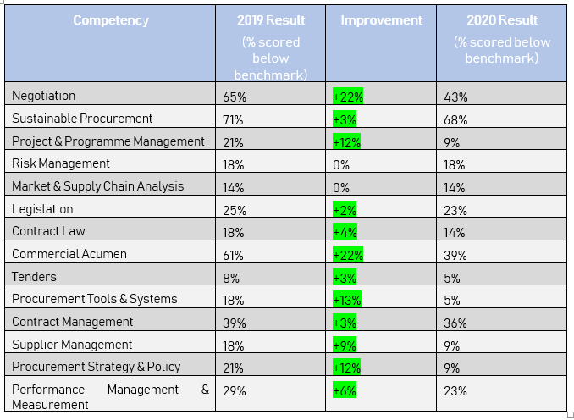
*Note in relation to above table – highlighted green areas demonstrate the improvement. The percentages in the columns indicate the percentages that scored below the benchmark – therefore a decrease in this number illustrates an improvement, i.e. less now under the benchmark.

3.2 Handover

All project outputs have been delivered in line with Programme delivery plans and signed approved by the Commercialisation Board or any benefits that has yet to be fully realised, list who is the new owner of the benefits realisation activities and whether or not this responsibility has been formally handed over and accepted.

4. Outstanding Risks
All programme risks outstanding and ownership in Appendix 1

5. Outstanding Issues
All programme Issues are now closed. A copy of the Issues log including outcomes will be handed over to procurement as part of programme closure.

6. Future / follow-on projects
Following the successful conclusion of the Programme project deliverables, all follow on activity which forms part of Business As Usual (BAU) was transferred to the Procurement Team to embed. Follow on activity was impacted by COVID19 as access to people and information was challenging but good progress is being made. As part of the transfer all follow on actions were logged on Teams with owners allocated. Delivery of the follow-on actions are regularly monitored and managed through the Procurement Management Team. Figure 1 below shows progress to date against the follow-on actions.

Figure 1 - BAU - Progress to date (17.3.21)

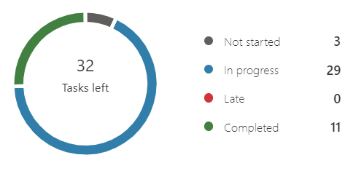

7. Highlight key Lessons Learned
Note: Highlight key lessons learned (positive and negative) here that should be passed to on-going and future programmes.

 | Key Lessons Learned
Add/delete as required | Positive | Negative
Governance | The Board structure and terms of reference provided a clear understanding of Board Members roles and responsibilities has helped with key decisions making and progressing the programme to a successful conclusion. | SXL Executive Mgmt team were to attend boards on a rotating basis. This took place on a regular basis in Year 1 but dropped off to limited attendance in Year 2  Limited internal programme support provided. Programme Manger became responsible for all administration and management of all programme, documentation, creation, mgmt, meetings etc
Stakeholder engagement and communications | Co-location of services over short periods of time helped SXL better understand how each service operates and where opportunities for improvements may lie helping to foster better working relationships  Having Scotland Excel embedded within the procurement team helped create a ‘team effort’ approach to the transformation activity | At the outset of the programme  SXL at times created unnecessary tension and friction between services and procurement teams through poor communication, planning  Board decisions and messages would not always filter down through to the wider organisation
Benefits Realisation | Programme has met and exceed both financial outcomes within the agreed Business Case. This will allow the Councils procurement functions to continue delivering savings and benefits well beyond the life of the programme | The complexity of reporting procurement benefits using multiple manual systems across multiple service areas (DPA) did delay financial reporting on progress to the board
Business Case management | Business Case was established and approved at P&C with a Business Case Refresh at end of Year 1 approved by Commercialisation Board
Financial management | As part of programme activity, a clearly defined benefits realisation process has been established from Opportunity identification to budget removal | Despite establishing a benefits realisation policy and process challenges remain when seeking to remove budgets
Resource management | As a result of the COVID impact both the Programme and Procurement areas of the Council were able to repurpose activity quickly to support the Councils response to the pandemic.  Once a consistent financial support resource to the programme was established, the benefits tracking process was taken forward successfully allowing programme financial reporting to the Board.  SXL acknowledged their resource challenges and provided more remote resource at times to compensate as well as extended support beyond the initial contracted time period. | Difficulties existed with SXL duplication of a Programme Manager role. No formal authority for FC Programme Manager over SXL team created friction and tensions  Despite multiple requests SXL did not use Fife Council systems. This reduced Council visibility and control over SXL activity including meetings/holidays etc. This impacted speed of delivery and service continuity with individuals being off at the same time.  SXL staff did work on other SXL projects  SXL had challenges in securing and sustaining suitably qualified and experienced resource at times. Lesson learned is that evidence of being able to access appropriate resource should have been sought.  Financial support at the start of the programme was inconsistent with multiple accountants allocated to support over the life of the programme.  C2D and Programme communications would have benefited from consistent specialist service support around communications.  Anyone taking forward a change programme should have experience in delivering successful projects and undertake recognised Programme Management training
Programme risk and issue management | Spending time identifying programme risks at the outset helped with the management and solutions around issues that arose | Programme Managers should have formal authority for their programme as it can be difficult to determine, and present risks and issues being raised
Programme planning, monitoring and control | Having clearly defined delivery plans and outputs (with timelines) including clearly defined processes for reporting and monitoring helped with the successful delivery of this programme | Contract Mechanisms for managing external providers should be more explicit within contract documentation  No visibility of days available to Council. Prioritisation of Council work during critical time periods at times was lacking e.g. Staff on holidays, training days etc
Quality management |  | SXL took time to understand Fife Councils programme and project management approach. Prior to bringing external consultancies on-site, training should be given on how the Council operates e.g. document preparation, content expectations etc  SXL at times were too passive in how they approached work. Would not always follow up on email but wait for replies. Contract mechanisms may help promote more proactive approaches.
Change control | Clear change control procedures in place and adhered to throughout delivery of project outputs.

8. Programme Closure sign-off
Note: This should be signed off by SRO who will report to the Sponsoring Group in order to gain approval to the formal closure of the programme.

Approved by | Role | Date approved

Stuart Fargie | Programme Manager | 12.3.21
Eileen Rowand | SRO | 19.3.21

