Staqe 2: Full Application

This is an Asset Transfer Request in terms of Section 5 of the Community Empowerment (Scotland) Act 2015.

Before completing this application, please ensure you have read:
- Scottish Government Guidance for Community Bodies; and
- Fife Council Guidance for Community Bodies

About the Property

Property Name and Address (see section 5 in the Guidance Notes)

Beech Walk car park
St Andrews Road, Crail, Fife (KY10 3UH)

.

Application on behalf of Crail Community Partnership (SC149189)
Section A - About the Proposal
(see Section A in the Scoring Matrix)

Please provide a brief outline of your proposed initiative (see section 2 in the Guidance Notes). A description of the aims and objectives of your proposal and a description of the service and
community benefit that you propose to deliver.
This project aims to bring a currently underused area of common good land into active community use, transforming it into a shared, flexible space that responds to local needs in Crail.
At its core, the project addresses a well-recognised community issue: the shortage of parking, particularly during peak visitor periods and when local events are taking place. By increasing parking capacity in a managed and accessible way, the project will help reduce congestion on surrounding streets, improve safety for residents and pedestrians, and support easier access to the town centre, harbour, and key community facilities.
However, the intention is not simply to create additional parking, but to develop a multi-purpose community asset. The space will be designed to support a range of uses, particularly in connection with Crail Community Hall. Accessibility is a central consideration. The design will include clearly designated accessible parking bays and safe, easy movement throughout the space, ensuring it can be used by all members of the community, including those with mobility challenges.

The project also has a longer-term community sustainability focus. There is potential to incorporate environmentally responsible features such as solar-powered lighting and, over time, infrastructure to support electric vehicle charging. Any income generated through managed parking would be reinvested into the maintenance of the site and could contribute to wider community initiatives.

Importantly, this project is intended to be shaped with community input, ensuring the space reflects local priorities and is used in ways that bring the greatest shared benefit.
Overall, the aim is to create a well-managed, inclusive, and adaptable community space-one that
not only addresses a practical issue but also enhances local facilities, supports events, and contributes to the long-term sustainability and vibrancy of Crail.

At its heart, the proposal addresses the ongoing shortage of parking in the town, particularly during the busy summer months and when events are taking place. Increasing parking capacity will ease pressure on surrounding streets, improve safety, and make it easier for residents, visitors, and local businesses to access the town centre, harbour, and community facilities.

There is also a longer-term ambition to improve the site's sustainability.
The demand/need for the proposal and why it is required.
The need for this project is driven by a well-recognised and ongoing shortage of parking in Crail, particularly during peak visitor periods, weekends, and when local events are taking place. As a popular coastal town with a historic centre and active harbour, Crail regularly experiences levels of visitor traffic that exceed the capacity of existing parking provision.

This results in congestion, inconsiderate parking within residential streets, and reduced accessibility for residents, emergency services, and essential service vehicles. These pressures have a direct impact on the day-to-day experience of those living in the community, as well as on the safe and effective functioning of the town.

Demand is further increased by the growing use of Crail Community Hall for events such as weddings, community gatherings, and private functions. During these occasions, parking availability becomes significantly constrained, with visitors often unable to find suitable spaces nearby. This can affect the overall experience of attendees and limits the hall's potential as a well-used and sustainable community venue.

At the same time, there is a clear opportunity to bring currently underutilised common good land into more productive use for the benefit of the community. At present, the absence of a dedicated, well-managed, and flexible space for parking and event support restricts the town's ability to respond effectively to visitor demand and to maximise the use of key community assets.

This proposal seeks to address a practical and ongoing infrastructure gap while also supporting wider community needs. Without intervention, parking pressures are likely to continue to increase, particularly during peak tourism seasons, placing further strain on local roads and reducing overall quality of life for residents.

By creating additional capacity alongside a flexible, multi-use space, the project responds directly to a clearly identified and recurring local need. It will support safer, more accessible parking, enhance the usability of Crail Community Hall, and contribute to the long-term sustainability and vibrancy of the local community.
Why do you require the asset to deliver your proposal, and what difference will this make to the
delivery of_�eryices in your areal_

This asset is required because there is currently no suitable, managed space within Crail that can provide additional parking capacity while also supporting flexible community use. Without access to this land, it is not possible to address existing parking pressures in a coordinated and sustainable way, nor to create a space that can effectively support larger community events linked to Crail Community Hall.
At present, parking demand is largely absorbed by surrounding streets and informal areas that are not designed to accommodate high levels of use. This results in congestion, inconsiderate parking, and reduced accessibility, particularly during peak visitor periods and organised events. It also creates challenges for residents, emergency access, and service vehicles. Securing and developing this asset would enable a planned, community-led approach to managing demand, reducing reliance on unmanaged overspill into residential areas.

The difference this would make is significant. In practical terms, it would increase parking capacity, improve traffic flow, and enhance safe access to the town centre, harbour, and key community facilities. It would also improve the experience of those attending events at Crail Community Hall, particularly weddings and larger gatherings, where parking availability is currently a constraint on use.

Importantly, the asset would provide a flexible, multi-purpose community space. In addition to day-to-day parking, part of the area could.

Overall, gaining control of this asset would enable a coordinated, community-focused solution to parking and event demand. It would improve accessibility, reduce pressure on surrounding streets, and enhance the capacity of local facilities to serve both residents and visitors, delivering lasting benefits for the Crail community.
If already operational, provide details of the anticipated additional activity or outputs resulting from the acquisition of the property.
Crail currently has a small number of public car parks and informal parking areas, primarily serving the town centre. While these provide some capacity, they are frequently at or near full during peak visitor periods, weekends, and local events. This results in overspill parking into residential streets, particularly during the summer months, creating pressure for residents and limiting safe and convenient access.At present, there are no comparable community-managed spaces in Crail that combine additional parking capacity with flexible use to support community events linked to Crail Community Hall. Existing parking provision is largely designed for short-stay, general use and does not offer the scale, adaptability, or integration with community facilities that this project proposes. Across the wider East Neuk area, similar seasonal pressures exist, but responses have typically focused on standard parking solutions rather than multi-functional, community-led assets. As a result, there remains a clear gap for an approach that not only manages visitor demand but also actively supports local events, community infrastructure, and shared spaces.

This proposal is designed to complement and enhance, rather than duplicate, existing provision. By increasing capacity and introducing a flexible, well-managed space, it addresses a recognised infrastructure gap while supporting both everyday use and peak demand.
Importantly, it strengthens the role of Crail Community Hall and contributes to a more coordinated, community-focused approach to managing local resources.When the asset is acquired, it will deliver a significant increase in formal, managed parking capacity within Crail. This will help relieve pressure on surrounding residential streets, reduce congestion, and improve access for residents, visitors, and local businesses, particularly during peak tourism periods and community events.

The project will also directly support the ongoing use of Crail Community Hall. Improved parking provision will address a current constraint for weddings, community gatherings, and larger functions,
where demand regularly exceeds available capacity. This will enhance the usability and attractiveness of

the venue, benefiting both organisers and attendees while supporting its long-term sustainability as a key community asset.

Accessibility is a central outcome. The inclusion of designated accessible parking bays will improve access for disabled users and those with mobility challenges, ensuring the space is inclusive and usable by all members of the community.

In addition, the site will function as a flexible, multi-purpose space. Alongside day-to-day p;uking, it will be capable of supporting community events. This will enhance the overall visitor experience and strengthen the role of the community hall as a focal point for local activity.

Looking to the longer term, the site also presents opportunities to incorporate sustainable features, such as renewable energy solutions and potential electric vehicle charging infrastructure. Any income generated through managed use of the space would be reinvested into site maintenance and wider community benefit, supporting ongoing local priorities.

Overall, the acquisition will transform an underused and 1.mmanaged area into a well-maintained, accessible, and community-led asset, delivering practical improvements in parking, supporting local events, enhancing inclusion, and providing lasting value for the Crail community.·

your experience in delivering the services. _ _ _
, _
1
Crail Communit'y Partnership has a strong track record of delivering community-led projects and managing local assets for the direct benefit of residents. Our work is rooted in collaboration, bringing together volunteers, local stakeholders, and partner organisations to deliver practical improvements that respond to clearly identified community needs.

We have experience in developing and managing projects that enhance community infrastructure, support local events, and improve the accessibility and usability of shared spaces. This includes coordinating the day-to-day use of community facilities, enabling a wide range of activities and events, and ensuring that spaces are maintained in a way that is inclusive, welcoming, and beneficial to both residents and visitors.

The Partnership is also experienced in working with external funders and delivering projects to agreed outcomes. We have established processes for financial management, monitoring, and reporting to ensure that funding is used effectively and transparently. Our approach prioritises community accountability, balancing immediate operational needs with longer-term planning to secure sustainable benefits from community assets.

In relation to this proposal, Crail Community Partnership brings a detailed understanding of local conditions, including ongoing parking pressures, seasonal visitor demand, and the operational requirements of Crail Community Hall. This insight ensures that the project is firmly grounded in local priorities and can be delivered in a way that is practical, sustainable, and responsive to the community's needs.

Some of the best examples of our experience in managing properties or services are Crail Community Hall and Kilminning.

Other similar projects or services available in the area.

Crail currently has a small number of public car parks and informal parking areas, primarily serving the harbour and town centre. While these provide some capacity, they are frequently at or near full d1,.1ring peak visitor periods, weekends, and local events. This results in overspill parking into residential streets, particularly during the summer months, creating pressure for residents and limiting safe and convenient access.

At present, there are no comparable community-managed spaces in Crail that combine additional parking capacity with flexible use to support community events linked to Crail Community Hall. Existing parking provision is largely designed for short-stay, general use and does not offer the scale, adaptability, or integration with community facilities that this project proposes.

Across the wider East Neuk area, similar seasonal pressures exist, but responses have typically focused on standard parking solutions rather than multi-functional, community-led assets. As a result, there remains a clear gap for an approach that not only manages visitor demand but also actively supports local events, community infrastructure, and shared spaces.

This proposal is designed to complement and enhance, rather than duplicate, existing provision. By increasing capacity and introducing a flexible, well-managed space, it addresses a recognised infrastructure gap while supporting both everyday use and peak demand. Importantly, it strengthens the role of Crail Community Hall and contributes to a more coordinated, community-focused approach to managing local resources.

Section B - Wider Support & Wider Public Support
(see Section Bin the Scoring Matrix)

Community Consultation (see section 3 in the Guidance Notes) - The Community Empowerment Act requires that the local community be consulted before an asset transfer application is submitted.

Please demonstrate sufficient support from the local community. You should also consult community artners and local councillors. Please 2_wvide evidence ahv stakeholder consultation.
The survey was carried out to make sure the proposed Beech Walk car park improvements are based on the views and needs of the Crail community, rather than being decided by CCP alone.

It allowed residents, businesses and other community members to comment on what they would like to see from the project, including accessible parking, EV charging, renewable energy, free parking and parking provision during busy periods. This provides evidence that the proposal has been developed through community involvement and helps CCP demonstrate that the asset would be managed for the benefit of the wider community.

It also gives the Community Asset Transfer application a clear evidence base: CCP can show Fife Council tha1 the proposal responds to issues identified locally and that the community has had a meaningful opportunity to influence how the site could be used.

The text and graphs below and text sets out the scope of the survey as published, followed by the survey results Community Survey ran from the 26th ot June 2026 to 31st July 2026, and 226 people responded to it

Crail Community Partnership (CCP) is currently progressing a Community Asset Transfer (CAT) application for the Beech Walk car park site. If the application is successful, ownership of the car park would transfer from Fife Council property and a small part of Common Good Land to CCP. The asset would then be held and managed by CCP for community benefit, enabling local control over how the site is maintained and developed.

Completing this short survey will provide important evidence to support CCP's application to take over this area of common good land from the council, helping ensure it delivers real benefits for the community. Your input w play a key role in shaping what happens next.

The most recent upgrade to the car park, unfortunately, resulted in a reduction in the total number of available parking spaces. This has contributed to ongoing concerns locally about parking capacity, particularly during peak periods when demand is highest.

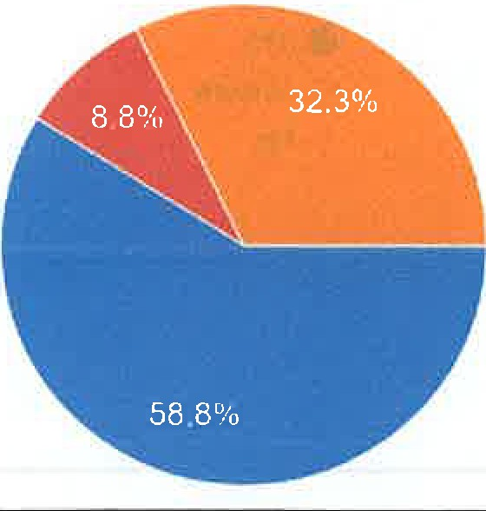
Parking is a well-documented and frequently raised issue within the village. The Crail Local Place Plan highlights this clearly, with parking identified as a consistent concern among residents and stakeholders. This reflects both the scale of the issue and the need for practical solutions.

As part of its plans under the proposed transfer, CCP intends to expand the car park. The current proposal includes the creation of 23 parking spaces, increasing overall capacity compared to its present layout. This expansion aims to make more effective use of the available space while addressing existing shortfalls in parking provision.
The proposed expansion of the Beech Walk car park forms part of a wider effort to respond directly to priorities set out in the Local Place Plan, delivering a practical, locally managed solution to an issue that affects both residents and visitors.
At present, the project remains at the transfer and planning stage. Further developments will depend on the outcome of the Community Asset Transfer application and any subsequent approvals required for changes to the site. However, CCP remains committed to helping make Crail a better place for everyone.
All feedback will help shape the project to best meet the needs of Crail residents and visitors.'

Results are below:

- Do you support the idea of creating a new community car park?
226 responses

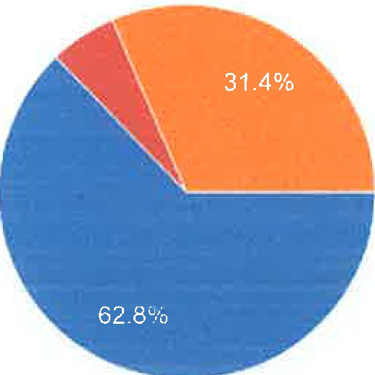
eves
e Unsure No

- Do you believe this project would have a positive impact on the Crail community?
226 responses

eYes
e Unsure
No

... ,._._ , ......... _ --- ---•· '--1--..1- ... , ..._......, ._,_ ... ,_, ..,

- Should the car park include designated disabled parking spaces?
226 responses

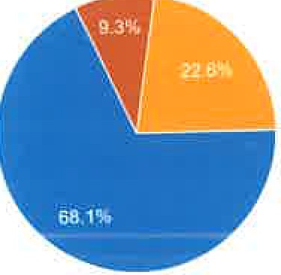
eves
eUnsure
- No

- Should electric vehicle (EV) charging points be included?
226 responses


23.5% 2�.8%

e Yes
e Unsure
- No

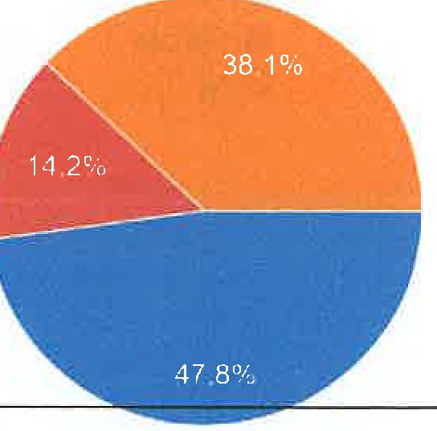

,/'

Should the project include solar panels or other green initiatives to reduce long-term running costs?
226 responses

e Yes
e Unsure

No

- Should parking be free for users?
226 responses

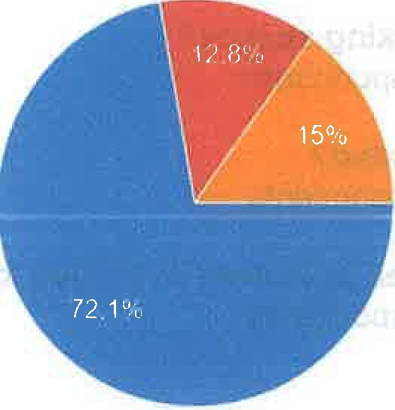
eves
eUnsure
No

- Should the car park include additional features such as bike racks or small camper-van/motorhome spaces?
226 responses

eves
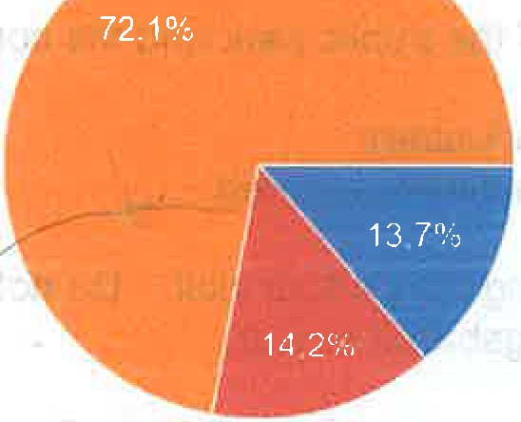
e Unsure
No -

,

If you have any questions, please email crailcommunitypartnership@g�ail.com
226 responses
I
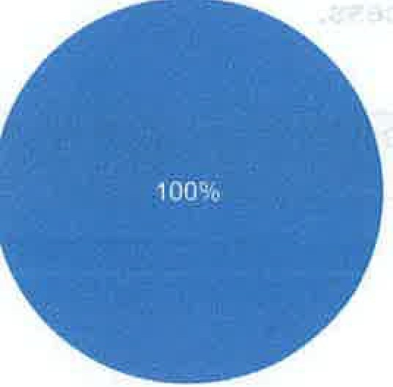
e,Great, thanks!

Do you support the idea of creating a new community car park?

Yes: 142 respondents, Unsure: 13 respondents, No: 71 respondents

Do you believe this project would have a positive impact on the Crail community?

Yes: 154 respondents, Unsure: 13 respondents, No: 71 respondents

Should the car park include designated disabled parking spaces?
Yes: 154 respondents, Unsure: 21 respondents, No: 51 respondents

Should electric vehicle (EV) charging points be included?
Yes: 56 respondents, Unsure: 53 respondents, No: 117 respondents

Should the project include solar panels or other green initiatives to reduce long-term running costs';
Yes: 108 respondents, Unsure: 32 respondents, No: 86 respondents

Should parking be free for users?
Yes: 163 respondents, Unsure: 29 respondents, No: 34 respondents

Should the car park include additional features such as bike racks or small campervan/motorhome spaces?
Yes: 31 respondents, Unsure: 32 respondents, No: 163 respondents

2 comments:

'1. This is not a NEW car park
- It has been in existence to serve the parking needs of the public park and the community hall
- Designated bays not required for disabled
- EV charging points would restrict parking for hall & park users
- Solar panels not required as no lighting or parking machines required
- Should it be free? YES.
- Motor home spaces, NO, for the use of the public using the park or Hall. Do not need this listed on platforms as a motor home site. Would end up like Kingsbarns or Elie.
The land was gifted to the burgh of Crail for use as a pleasure ground by John Duncan, George Gay & George White and opened on 24th July 1929.'

And the second:

'Dear CCP,
Local areas such as Kingsbarns, Ruby Bay, Elie and Pittenweem Braes offer overnight car parking spaces for campervans at a small charge, I think £10. If this were to be included in the car parking facilities, it would bring in extra money for the CCP by using the spaces during a time of day when it would normally be empty.'

The 2 Comments above will be considered in this process.

Please detail any partnership arrangements and state if these are required to deliver the project successfullv.

Support from Local Partners

Fife Council

Will support Crail Community Partnership throughout the Community Asset Transfer process. As the current owner of the land, the Council will work with CCP to oroaress the transfer and provide the information and

support required to reach a successful completion. CCP has already completed Community Asset Transfers with Fife Council, including Crail Community Hall and Kilminning Nature Reserve, giving us experience of working through the process and understanding the responsibilities involved. Fife Council's CAT process also requires community organisations to keep their community informed and involved throughout the process.

Crail Community Council

Crail Community Council will provide local support and help ensure that the proposal remains connected to the wider needs of the community. We will work with the Community Council to keep them informed of progress, listen to any concerns or suggestions and ensure that the development of the car park continues to reflect wha the community wants and needs.

Crail Matters

Crail Matters is a weekly publication for Crail and the surrounding community. It will provide an important way for CCP to keep local people updated throughout the Community Asset Transfer process. We will use Crail Matters to share progress, explain the next stages, provide opportunities for people to give their views and update the community on how the proposal is developing. Crail Matters regularly publishes local community information and welcomes news and items from the local area.

Keeping the Community Involved

CCP sees community involvement as an important part of the whole process, not something that ends once th1 application has been submitted. We will continue to provide updates and listen to the views of local people.

The support from Fife Council, Crail Community Council and Crail Matters will therefore give CCP a good local structure for progressing the transfer while keeping the community informed and involved throughout.

Please demonstrate how you will consider the different needs of the community, including addressing inequalities.

The project has been designed to reflect the needs of the wider community and improve accessibility for all users.
A key feature is the inclusion of designated accessible parking bays, providing closer and safer access for disabled users, older residents, and those with limited mobility. This will help reduce the disadvantage current!� faced by people who struggle with longer walks from parking areas, particularly during busy periods.

By increasing formal, well-managed parking capacity, the project also improves the fairness of access to the town centre, harbour, and Crail Community Hall, ensuring that more people can participate in local services an events regardless of mobility or circumstance.

The flexible use of the space alongside community hall events further supports social inclusion by improving access to weddings, gatherings, and community activities that are used by a wide cross-section of residents.

Overall, the proposal helps reduce inequality by improving physical access, supporting inclusive participation ir community life, and ensuring the space is designed to be usable by everyone.

Advice and support received (see section 4 in the Guidance Notes) - Provide details of any organisation, including the Council, you have approached to seek assistance in developing your preject and application.
Crail Museum
Crail Community Partnership Crail Youth Club

Kirstie Freeman, Fife Council
Crail Community Council

Section C - Impacts I Benefits
(see Section C in the Scoring Matrix)

Demonstrate whether and (if applicable) how the proposal will promote or improve:

- Economic development
� Regeneration
- Public health
- Social well-being
- Environmental well-being
- How will the proposal reduce inequalities?
The proposal is rooted in very practical, everyday issues that people in Crail experience, especially at busy times of the year.

Economic development
Currently, many visitors and community members struggle to park, which can discourage them from stopping in the town or staying as long as they might otherwise. By improving parking, we would make it easier for people to visit local shops and parks, and hospitality businesses.
It also helps Crail Community Hall become a stronger wedding and events venue, which brings additional
income and activity into the local economy. It also will allow more spaces for the uses of Beech Walk Park for things such as football, tennis and the green gym.
Regeneration
This is about making better use of land that currently doesn't serve a purpose, when we can make it have one. Turning it into a well-managed, useful space improves that part of the town and helps present Crail as a more welcoming and organised place for both residents and visitors.

Public health
At peak times, parking pressure leads to congestion and frustration, particularly in residential streets. By providing proper space, we reduce that pressure and make movement around the town safer and less stressful, especially for families, older residents, and visitors unfamiliar with the area.

Social well-being
Crail Community Hall is an important local venue, and the project directly supports it. Making it easier for people to attend weddings, community events, and gatherings helps bring people together and strengthens community life. The added flexibility for event space also improves the experience for guests and organisers.

Environmental well-being
In the longer term, there is an opportunity to incorporate solar panels and potentially EV charging, helping the site contribute to a more sustainable future. Better organised parking also reduces unnecessary driving around the town looking for spaces, which cuts emissions.
Reducing inequalities
We have also made sure the desii:in considers everyone. The inclusion of disabled parking spaces is

important so that people with mobility challenges, older residents, or those with additional needs are not disadvantaged. Improving overall capacity also means people are not forced to park far away and walk long distances, which can be a real barrier for some people.

Section D - Organisational Viability
(see Section Din the Scoring Matrix)

Demonstrate any previous experience your organisation has. in managing an asset, inciuding awareness of relevant legislation. •
>

Previous experience in managing a property asset.

Several Board members have experience in this area (see below). Additionally, Crail Community Partnership has successfully maintained and operated Crail Community Hall Since February 2021. They have been successful in many common good applications including:

CCP has already demonstrated its ability to take ownership of community assets and manage them responsibly for the long-term benefit of Crail.

Crail Community Hall
Crail Community Partnership took ownership of Crail Community Hall in 2021 through a Community Asset Transfer from Fife Council. Since taking ownership, CCP has taken full responsibility for the management, maintenance and development of the building.

CCP has continued to invest in the Hall to ensure that it remains a useful and sustainable community asset. This has included improvements to the kitchen, heating and energy efficiency, as well as ongoing maintenance and improvements to the building.

The Hall is now used by a wide range of local groups, organisations and members of the community, as well as for weddings, events and other activities. Income from appropriate commercial and private bookings helps CCP meet the running costs of the building and supports its continued availability for community use.

This means CCP is not simply the owner of the Hall. It is responsible for running the building, maintaining it, generating income, securing funding and making sure it continues to meet the needs of the community.

CCP has a strong track record of successful Common Good Fund applications, securing community assets and funding that have enabled us to deliver lasting benefits for the people of Crail.

Kilminning
CCP also took ownership of Kilmihning through a Community Asset Transfer from Fife Council in 2021.
Since taking ownership, CCP has taken respbnsibility for managing the land and improving its environmental value. This has included work to develop meadows, woodland and wetland areas, alongside tree planting and wider rewilding and biodiversity work.
The management of Kilminning is focused on protecting and improving the land for the long term while also creating opportunities for the local community to become involved in environmental projects.
As with the Community Hall, CCP has taken on the responsibilities that come with ownership. This includes managing the land, maintaining it, developing projects, securing funding and working with the community to improve the asset.

Our experience
The Community Hall and Kilminning demonstrate that CCP already has practical experience of taking assets from Council ownership into community ownership and then managing them successfully.

Importantly, these are two very different types of assets. The Community Hall is a building requiring financial, operational and maintenance management, while Kilminning is community land requiring environmental management and long-term stewardship.
Through both assets, CCP has shown that it can:
- Take on the responsibilities of asset ownership.
- Manage assets on an ongoing basis.
- Secure funding and investment for improvements.
- Maintain and improve community assets.
- Generate income where appropriate to support sustainability.
- Work with local people and community groups.
- Develop assets for long-term community benefit.
- Take a long-term approach rather than simply acquiring an asset.

This provides CCP with a strong track record for taking on further community assets, including the proposed car park, as we have already demonstrated that we understand the responsibilities involved in community ownership and have the experience of managing assets for the benefit of Crail

Our Trustees who can help with this include:

- Chair
A retired planning lawyer with many years' experience of dealing with major projects, including roads, harbours and other infrastructures. Trustee of a debt relief charity in the southwest of England. Joined the Crail Community Partnership in 2023, and her roles include convening the planning subgroup and giving advice on legal matters
Extensive experience in dealing with local and central Government, drafting and implementing legislation.
- Vice Chair
A Professor of Biology at St Andrews University and has lived in Crail for 21 years. A keen birder and has written the Wild Crail biog for the last 10 years.
Has experience in managing grant-funded research teams to fundraise, write successful community land asset transfers and to manage major environmental improvement projects for Crail. Recently successfully completed the two-year, £260,000 wetland and meadow creation project at Kilminning, converting a neglected brownfield site into a community nature reserve. Currently, I am running the 10,000 Trees for Crail tree planting program.
- Trustee -Secretary of CCP

Retired merchant navy officer & then many managerial positions in the oil and gas sector.
Currently Chairman of Crail Preservation Society and Crail Museum, which owns and maintains many properties and land assets in Crail.
Works very actively in support of community initiatives such as Crail Festival and Crail Folk Club.
Responsible for the running and management of Crail Community Hall and a host of community projects.

- Treasurer

Retired in 2024 after working 43 years in Financial Services, with the majority of this time focusing on personal taxation and trust planning. He was a Chartered Banker for 36 years.
Also served on the Committee of the Association of Member Directed Pension Schemes from 2010 to 2016, the last three years as Chair, representing the interests of the Small Self-Administered Schemes and Self Investment Pension Schemes.
Joined the Crail Community Partnership in April 2025 as a Trustee and Treasurer.

- Trustee
Is the Hon President of Crail Preservation Society, and Convenor of Crail Wine Club. He has also been a Crail resident since 2002 and is now retired, putting all his spare time into supporting the Crail Community.

- Trustee

A member and former chair of Crail Community Council, and an Editor of 'Crail Matters'. Has lived in Crail for 15 years.
A professional background in Legal, Forensic and Criminal Psychology with a strong interest in community engagement. Wide experience of managing personnel and projects in ACADEMIC, Government and International agencies, and distance learning initiatives.
Is heavily involved with history and compliance.

- Trustee
Is an Astronomer and Observatory Director at the University of St. Andrews and has lived in Crail since 2014. Active in research, education, management, engineering, recruitment and public engagement. Leadership roles in iarge research consortia and as an award-winning author. He has a strong interest in sustainability and nature conservation.

- Trustee

Working career spent in various planning departments, with the last 25 years in Argyll & Bute Council. He has vast experience of rural/countryside matters in planning policy and development control, and management of relevant staff.
He is responsible for planning, monitoring, and land acquisition and asset transfer.

Grandparents founded Crail Pottery & grew up in Crail.
Attended Waid Academy (the local high school), followed by studying Events Management with Entrepreneurship at Edinburgh Napier University.
She founded Miss Mobile Disco - A wedding DJ business which has grown into a team that now delivers weddings & events all over Scotland.
Key interest is in Crail Community Hall's growth as a wedding venue. Is excited to help & advise on how the hall can create a memorable experience for couples choosing to celebrate their wedding day at the hall. This will include advising on marketing and assisting with a new wedding website.

- Trustee

Is a freelance media and communications consultant with a particular interest in sustainable energy. Lived and worked abroad for many years but always wanted to return to the East Neuk. That finally happened, and he moved to Crail with family in 2020. He joined the Crail Community Partnership in 2023 and was responsible for media relations and PR.
- Trustee

Has lived in Crail for 12 years and is also a committee member of the Crail Wine Club and a volunteer with the Crail Festival. She has an HR and training background and particularly contributes to the development of policies for CCP. Born in Fife to a farming family, she is very interested in nature and our local environment.

- Co-opted Trustee
A Crail resident for 24 years, with a keen interest in nature conservation and ornithology. Worked in countryside management for the RSPB, several local authorities, including Fife Council, and latterly as Chief Executive of Fife Coast & Countryside Trust.
Responsible for the delivery of CCP land management
Demonstrate anv orevious.expe_tience you'r organisation bas in delivering the,cpmm1.:1nitv benefit.

Crail Community Partnership (CCP) was formed in 2018 by local people to take forward the community's priorities set out in the Local Place Plan. Since then, we have moved from planning into delivery, with a strong focus on practical projects that make a real difference in Crail.

One of our biggest achievements has been taking ownership of Crail Community Hall through community asset transfer in 2021, supported by the Scottish Land Fund. Since then, we have overseen its
development into a busv, multi-use space for local groups, classes, events, weddings, and communit

activities. This has included improving the building through upgrades such as heating, kitchen facilities, and general refurbishment to make it more usable and sustainable.

We also manage the day-to-day running of the Hall, including bookings and user coordination, supported by a dedicated assistant who helps ensure the building runs smoothly and remains accessible to.a wide range of groups and individuals. Our Hall Coordinator previously ran Hill of Tarvit for The National Trust.

Our team brings strong real-world experience to this work. Our Community Development Coordinator, for example, previously founded and ran his own charity for seven years before joining CCP, bringing valuable hands-on experience in setting up, managing, and growing community-led organisations.

Together, this means we are not just planning projects - we are actively delivering and managing community assets on the ground, and ensuring they continue to provide real, lasting benefit for people in Crail.
Please state the names, skills and experience of the individuals who intend to :deliver the proposal.
Several Board members have experience in this area (see below). Additionally, Crail Community Partnership has successfully maintained and operated Crail Community Hall since February 2021.

- Chair
A retired planning lawyer with many years' experience of dealing with major projects, including roads, harbours and other infrastructures. Trustee of a debt relief charity in the southwest of England. Joined the Crail Community Partnership in 2023, and her role includes the planning subgroup and giving advice on legal matters
Extensive experience in dealing with local and central Government, drafting and implementing legislation.
- Vice Chair
A Professor of Biology at St Andrews University and has lived in Crail for 21 years. A keen birder, and has written the Wild Crail biog for the last 10 years.
Has extensive experience in managing grant-funded research teams to fundraise, write successful community land asset transfers and to manage major environmental improvement projects for Crail. Recently successfully completed the two-year, £260,000 wetland and meadow creation project at Kilminning, converting a neglected brownfield site into a community nature reserve. Currently, I am running the 10,000 Trees for Crail tree planting program.
- Trustee -Secretary of CCP

Retired merchant navy officer & then many managerial positions in the oil and gas sector.
Currently Chairman of Crail Preservation Society and Crail Museum, which owns and maintains many properties and land assets in Crail.
Works very actively in support of community initiatives such as Crail Festival and Crail Folk Club.
Responsible for the running and management of Crail Community Hall and a host of community projects.

- Treasurer

Retired in 2024 after working 43 years in Financial Services, with the majority of this time focusing on personal taxation and trust planning. He was a Chartered Banker for 36 years.
Also served on the Committee of the Association of Member Directed Pension Schemes from 2010
to 2016, the last three years as Chair1 representing the interests of the Small Self-Administered

Schemes and Self Investment Pension Schemes.
Joined the Crail Community Partnership in April 2025 as a Trustee and Treasurer.

- Trustee
Is the Hon President of Crail Preservation Society, and Convenor of Crail Wine Club. He has also been a Crail resident since 2002 and is now retired, putting all his spare time into supporting the Crail Community.

- Trustee
A member and former chair of Crail Community Council, and an Editor of 'Crail Matters'. Has lived in Crail for 15 years.
A professional background in Legal, Forensic and Criminal Psychology with a strong interest in community engagement. Wide experience in managing personnel and projects in ACADEMIC, Government, and international agencies, as well as distance learning initiatives.
Is heavily involved with history and compliance. ,

- Trustee
Is an Astronomer and Observatory Director at the University of St. Andrews and has lived in Crail since 2014. Active in research, education, management, engineering, recruitment, and public engagement. Leadership roles in large research consortia and as an award-winning author. He has a strong interest in sustainability and nature conservation.

- Trustee

Working career spent in various planning departments, with the last 25 years in Argyll & Bute Council. He has vast experience of rural/countryside matters in planning policy and development control, and management of relevant staff.
He is responsible for planning, monitoring, and land acquisition and asset transfer.

9.
Grandparents founded Crail Pottery & grew up in Crail.
Attended Waid Academy (the local high school), followed by studying Events Management with Entrepreneurship at Edinburgh Napier University.
She founded Miss Mobile Disco -A wedding DJ business which has grown into a team that now delivers weddings & events all over Scotland.
Key interest is in Crail Community Hall's growth as a wedding venue. Is excited to help & advise on how the hall can create a memorable experience for couples choosing to celebrate their wedding day at the hall. This will include advising on marketing and assisting with a new wedding website.

1O. Trustee

Is a freelance media and communications consultant with a particular interest in sustainable energy. Lived and worked abroad for many years but always wanted to return to the East Neuk. That finally happened, and he moved to Crail with family in 2020. He joined the Crail Community Partnership in 2023 and was responsible for media relations and PR.
11. Trustee

Has lived in Crail for 12 years and is also a committee member of the Crail Wine Club

and a volunteer with the Crail Festival. She has e an HR and training background and particularly contributes to the development of policies for CCP. Born in Fife to a farming family, she is very interested in nature and our local environment.
12. Co-opted Trustee
A Crail resident for 24 years, with a keen interest in nature conservation and ornithology. Worked in countryside managemerit for the RSPB, several local authorities, including Fife Council, and latterly as Chief Executive of Fife Coast & Countryside Trust.
Responsible for the delivery of CCP land management.
Have you identified the number of employees or volunteers available to run/maintain the asset?
Please state the names, skills and experiences of those individuals.
Same as above, but also our 2 employees:
Our Development Coordinator, who mainly handles booking queries, keeps track of who uses the building and when, and our website.

Our Community Development Coordinator, who in his last role raised almost £700,000 in almost 7 years. He is passionate about supporting local people, securing funding, and developing sustainable community assets that create real, lasting impact. Dave combines practical delivery with strategic thinking, helping communities turn ideas into funded, well-managed projects that benefit residents and strengthen local resilience.

We have approximately 100 volunteers.
Provide evidence of your governance and decision-making processes in relation to the asset and delivery of the services, including finance, bookkeeping, emergencies, and compliance with legal and safety issues. Evidence that you have a clear process for decision-making, including
room/hall bookings, dealing with problems, compliance with legal issues, e.g. health & safety.
Crail Community Partnership (CCP) is a registered charity and is run by a board of trustees who are responsible for overall decision-making, finances, and making sure everything is done properly and in line with charity and legal requirements.

The trustees meet regularly to make key decisions, review finances, and oversee how the organisation and Crail Community Hall are being run.
Day-to-day things like hall and room bookings are managed through a clear booking system, supported by our Hall Co-ordinator. This helps make sure enquiries are dealt with quickly, schedules are kept up to date, and users know exactly what's available.

Finances are handled through standard bookkeeping processes (zero), with oversight from the trustees. This includes keeping proper records, budgeting, and making sure everything is transparent and accountable.

Health and safety is taken seriously, with risk assessments carried out for events and hall use, along with clear procedures for fire safety and what to do in an emergency. There are also clear ways to report and deal with any issues if they come up, whether that's a maintenance problem, complaint, or safety concern.
CCP has adopted a suite of policies governing employee interests, governance matters and dealing with the public. These set out procedures, principles and expectations relating to the running of the charity.

Overall, the structure is quite straightforward: trustees provide oversight and make decisions, while day-to-day operations are managed locally in a practical way to keep things running safely and smoothly for everyone using the Hall.
Demonstrate that you understand what is required in relation to managing an asset e.g.
insurances, ongoing maintenance, budgeting for major repairs, health & safety, electrical testing, firefighting, legionella testing.
We understand that managing an asset like this isn't just about creating the space, it's about making sure it's looked after properly over the long term and kept safe and usable.

In practical terms, that means making sure the site is properly insured (public liability and buildings insurance), the same way that Crail Community Hall is already and extending that to include this additional area as needed.

We'd also need to make sure there's a realistic plan for ongoing maintenance - things like keeping the surface in good condition, dealing with drainage, general upkeep, and not just reacting when something goes wrong. Alongside that, we'd budget for longer-term repairs, so costs don't build up unexpectedly. One way of supporting this realistic plan would be to consider permeable paving.

On the safety side, we understand there are standard requirements that would need to be in place, including regular health and safety checks, risk assessments, and clear procedures for how the space is used safely by the public. That would also include things like emergency access and making sure users know what to do if there's ever an issue.

We're aware there are also compliance checks that come with managing any public asset, such as electrical testing where relevant, fire safety requirements, and making sure equipment is serviced properly.

We understand this isn't a "one-off build" - it's something that needs proper planning, budgeting, and ongoing responsibility to keep it safe, compliant, and sustainable for the long term.
Provide evidence of your monitoring arrangements to monitor the success of the proposal and delivery of its likely objectives.
We would keep track of how well the project is working straightforwardly.
For the parking, we'd look at how full it is at different times of the year, especially during busy weekends and events, and whether it seems to be taking pressure off surrounding streets. We'd also pick up feedback from residents, businesses, and people using the Hall to see if they've noticed an improvement.

For events at Crail Community Hall, we'd monitor whether the extra space is making things easier for larger bookings like weddings, and whether it's improving the overall experience for organisers and guests.

CCP trustees would review this regularly at meetings, so we can see if the project is doing what it was meant to do and make changes if needed.
We'd also keep an eye on any income or running costs linked to the site and make sure everything is being used to maintain and improve it in the long term.

Section E - Financial Information
(see Section E in the Scoring Matrix)

You need to identify all the resources required to deliver and sustain the proposal.
Business plan and cash flow forecast - Please provide a full business plan and cash flow forecast for the next 5 years, showing both capital and revenue income and expenditure. If the organisation has a separate business plan, this can be attached to the application and a
summary of the details e_rovided here.
£2500 for legal fees.
Planning permission was last evaluated at £4000, but we would need to have it checked after acquisition.

£13540 to remove hedging, bushes and fencing, moving the gate and extending the parking lot. This was an estimate from 2024 and would need to be re-evaluated after acquisition is complete.
What funding has the organisation obtained so far?
None
Funding source:
Date of application:
Amount received:
Capital funding □ and/or Revenue funding □
What funding has been applied for but a decision has not yet been received?
.
None
Funding source:
Date of application:
Amount received:
Capital funding □ and/or Revenue funding □
Other sources of funding the organisation has access to (e.g. voluntary donations,
borrowing).
Crail Common Good Funds Helen Main Trust Ribbonfield Trust
Fife Council Community Development

-

Crail Settlement Trust
Crowdfunding - very strong track record in Crail
Identify resources for the proposal's long-term sustainability and the future |  | ,maintenance
�f the asset, e.g., future funding and self-financing arrangement | 's.
The long-term sustainability of the proposed community car park will be achieved through a low-cost, environmentally sustainable operating model rather than direct charging for parking. The integration of solar and other renewable technologies will significantly reduce ongoing running costs by powering lighting, CCTV, and any future electric vehicle charging infrastructure, helping to minimise reliance on external energy sources and protect against rising utility costs. This approach ensures that the asset can remain free to use while still being financially viable.
Ongoing maintenance and future improvements will be supported through a combination of external funding, community-led fundraising, and reinvestment from wider Crail Community Partnership activities linked to the site, such as events and hall usage. The organisation has a strong track record of securing grant funding and will continue to access funds aligned with climate action, sustainable transport, and community infrastructure. In addition, local volunteer involvement and planned maintenance schedules will help to keep costs manageable, ensuring the car park remains a well-maintained, accessible, and sustainable asset for the community in the long term.

We set out below details of current assets.

Crail Community Partnership - Asset Portfolio and Investment Overview
Crail Community Partnership (CCP) currently owns and manages a portfolio of five community assets, comprising one significant community building and four areas of community land. These assets demonstrate CCP's proven capacity to acquire, develop, and sustain both built and natural environments for long-term community benefit.

- Crail Community Hall (Primary Built Asset)
The Crail Community Hall, a former church building brought into community ownership in 2021, is CCP's central asset. It serves as a multi-purpose facility supporting a wide range of activities including weddings, events, community groups, and cultural programmes.
Significant investment has been made to improve the building's sustainability, accessibility, and usability. This includes the installation of a new kitchen, heating system upgrades, and energy efficiency improvements.

- Kilminning Land (Wetland Development)
This site has been developed into a community-led wetland project, enhancing biodiversity, climate resilience, and outdoor learning opportunities. The project supports environmental education and contributes to wider ecological goals within the area.

- Denburn Wood
Denburn Wood forms part of CCP's environmental and rewilding work. The site has seen active management and planting, contributing to carbon sequestration, habitat creation, and community engagement through volunteering and education.
- Pinkerton Triangle & West Braes Green Spaces
This land has been developed into meadow space as part of CCP's wider "Wild Crail'' initiative. It
supports biodiversity, pollinators, and low-impact community use while contributing to the local landscape and environmental resilience

Section F - Property
(see Section Fin the Scoring Matrix)

Please specify if you wish to: Lease |  | [ ] | or Purchase [X] the asset.
Value - Have you sought an independent financial assessment of the value of the building/land? If so, please identify the source and the estimated value.
In the past, Fife Council have split the costs with us for the valuation, so upon us purchasing the asset we would hope Fife Council would support us; otherwise, we would identify ( dLvvi" r <;D v vc�> .
Purchase price - State the price your organisation is willing to pay to acquire the asset. |  |  |  |  | - | "  '
,. |  |  |  |  |  | "  '
£1
Annual Rental N/A | I
Please state the:  Proposal annual rental: N/A Duration of the lease: Indefinitely  Any other special lease terms required:  Outright purchase |  | 1 |  | .
If you are requesting a discount, please demonstrate why the asset should be transferred at less
than best consideration. Attempt to quantify in financial terms the benefit to the community as a result of the acquisition.
N/A
Is the asset currently used or occupied by the Council or another party? Please state whether you have made any investiqations to current use/occupation.
It is Fife Council land that is underutilised and a small amount of common good land, and we
feel it is important to be utilised to help the community

Section G - Local and National Outcomes
(see Section Gin the Scoring Matrix)

How will the proposed benefits of the asset transfer request contribute to achieving the Council's outcomes? See Plan for Fife.
By increasing accessible parking capacity in Crail, the project will support the local economy by making it easier for residents and visitors to access the town centre, harbour, beach and local businesses. This will help sustain footfall, encourage longer visits and support local employment and enterprise, directly contributing to the outcome of a thriving, inclusive economy.
The project will also contribute to improved health and wellbeing by reducing congestion on residential streets and improving accessibility for those with mobility challenQes,_including older residents, families

and people with disabilities. Safer and more accessible parking will make it easier for people to participate in community life, attend events and use local facilities such as Crail Community Hall.

Environmental sustainability is a key element of the proposal. The intention to incorporate solar energy, low-impact surfacing and future electric vehicle infrastructure aligns with the Council's commitment to tackling the climate emergency and transitioning to net zero. These measures will reduce the environmental impact of the site while demonstrating practical, community-led climate action.

The transfer will further strengthen community empowerment by placing the asset under local ownership and management. Crail Community Partnership has a strong track record of delivering and sustaining community assets, ensuring that decisions are made locally and that any income or benefits are reinvested into the community. This supports the outcome of empowered communities that are actively involved in shaping their local area.
Overall, the proposal aligns closely with the Plan for Fife by delivering economic, social and environmental benefits in a way that is sustainable, community-led and responsive to local need.
How will the proposal impact on the Council's own delivery of services?
Enhance available parking, allowing for much easier access for disabled people as the car park is directly across from the disabled access to the Community Hall.
Demonstrate how the proposal will contribute to national priorities (refer to National Priorities).
The proposed asset transfer will contribute directly to Scotland's National Priorities by supporting community empowerment, climate action, improved wellbeing and inclusive economic growth.

The project places a local asset into community ownership, enabling decisions to be made locally and ensuring that benefits are retained and reinvested within Crail. This strengthens community resilience and reflects a clear commitment to long-term, sustainable management. -�
Addressing climate change is central to the proposal. The site will incorporate renewable energy, including solar provision, alongside low-impact materials and future electric vehicle infrastructure. This supports Scotland's transition to net zero while demonstrating practical, community-led climate action.
The proposal will also improve health and wellbeing by reducing parking pressure on residential streets and improving accessibility. This will enable more people, particularly those with mobility challenges, to access local amenities, attend events and participate in community life.
Finally, the project supports inclusive economic growth by improving access to local businesses and tourism assets. By making it easier for people to visit and stay longer in Crail, the proposal will help sustain local trade and activity.
Overall, the project delivers clear environmental, social and economic benefits in line with national 2_rioritie_s through a sustainable, community-led approach.

Section H - Other Information
(see Section Hin the Scoring Matrix)

Additional information in support of your application (see sections 6 & 7 in the Guidance Notes) - Include information on how vou have kept the communitv updated about the otol)0sal

and other stakeholders who have been approached who could work in partnership with your
organisatfon.
Crail Matters - local largely online weekly news sheet Social media - Updating the community
Crail Community Council- seeking approval for proposals

Submission Checklist
Before submission, make sure you have read the Council's Guidance on community asset transfer and the Scottish Government Guidance for Community Transfer Bodies.
Please tick that you have included the following accompanying documents:

- Full business plan for use of the asset □
- Most recent full year accounts X
- Constitution/governance document X
Supporting material from community members X
- 5-year cash flow forecast □

Signatures

The application is required to be signed by 3 members of your organisation:
Please note that applications are required to be published for any objections but personal information will be redacted in line with data protection principles.

Further information on how your information is used and why can be found at fifedirect.org.uk/privacy. The Council's Data Protection Officer can be contacted at: dataprotection@fife.goy.uk.

