To make a payment for a partnership addition click on Licences and permits under Make a Payment as seen below which is on the front page of our website www.fife.gov.uk
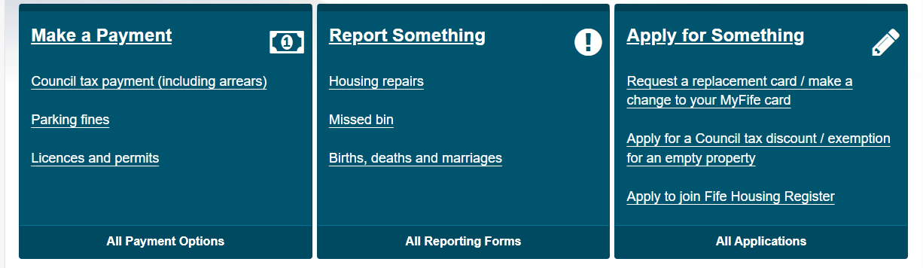
This will then take you to the line below where you click on Pay for a Licence Online
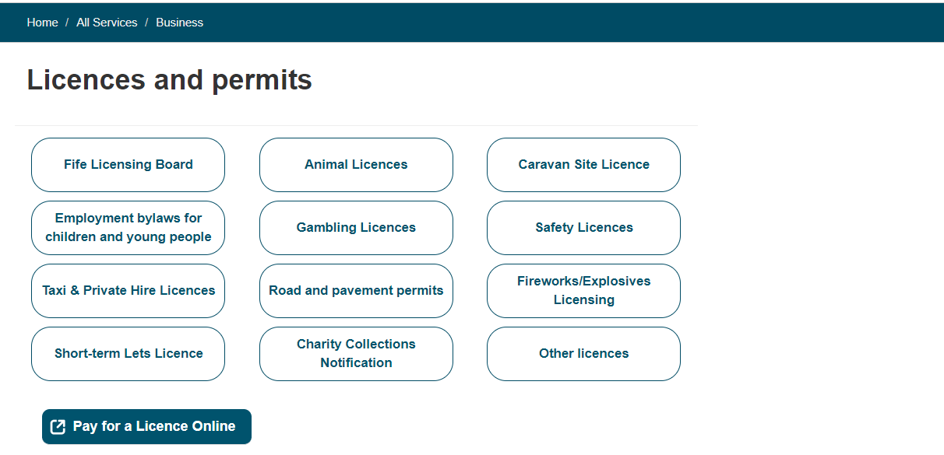
Click on the down arrow where it says Pay For below to go to the drop down menu and choose Taxi Licence then the reference should be your plate number (T or P then the number) and zone. Enter 30.00 in the Amount to Pay then press Add. Complete your personal details then press Pay Now.
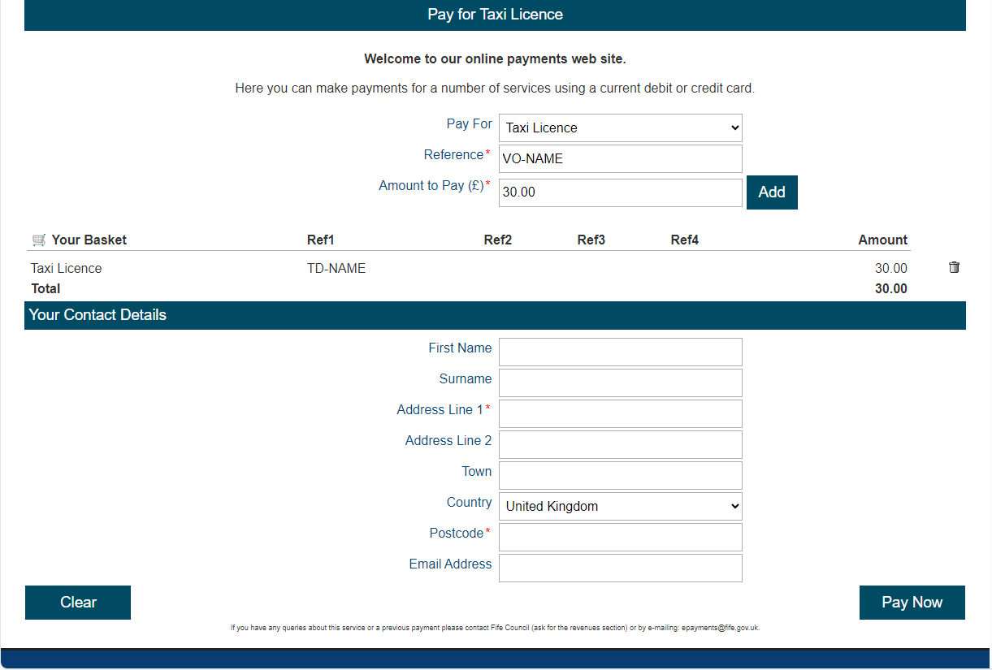

You will then be taken to the screen below where you will verify your details then press Continue
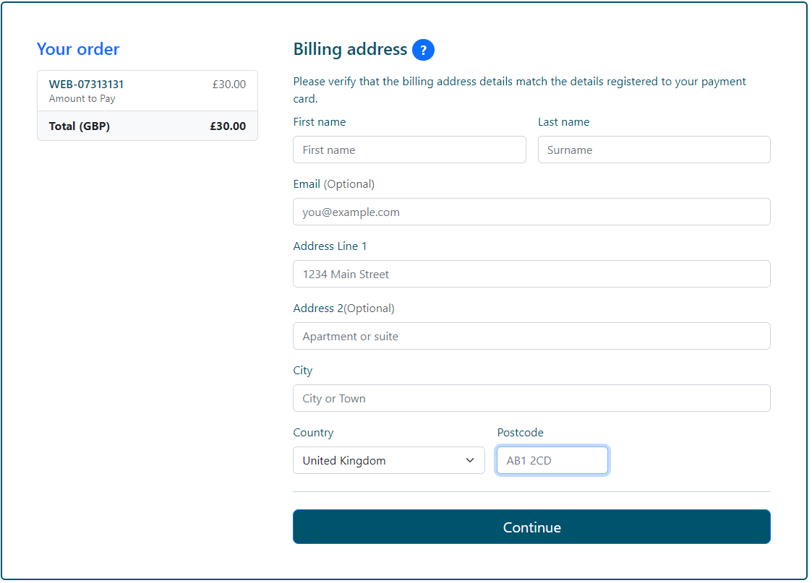
You will then be asked to add your payment details and then press Pay Now
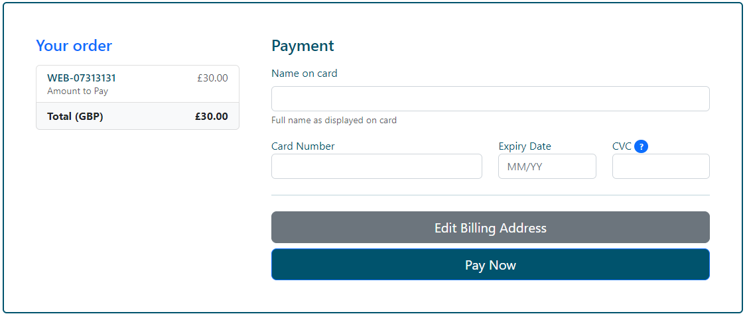
You will then be taken to the screen below which shows you details of your payment
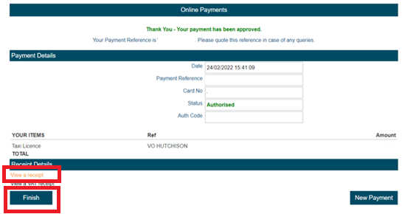
Click on View a receipt as on the above then click on finish and you will be taken to the page below
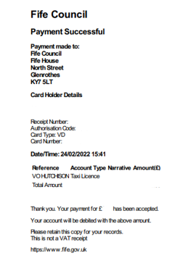
Save a copy of this receipt then forward it to misc.licensing@fife.gov.uk together with your partnership letter which must be signed by all parties on the licence.

