To make a payment for your application click on Licences and permits under Make a Payment as seen below which is on the front page of our website www.fife.gov.uk
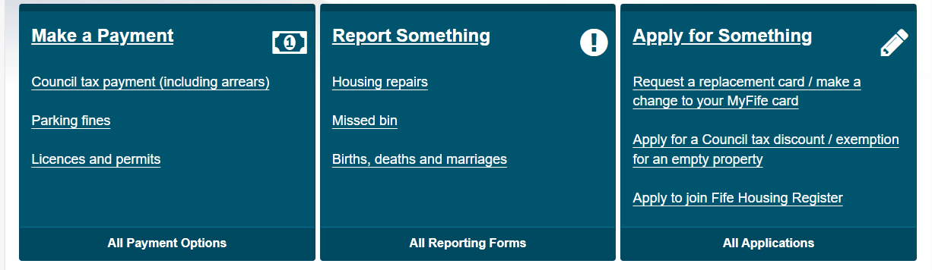
This will then take you to the page below where you click on Pay for a Licence Online
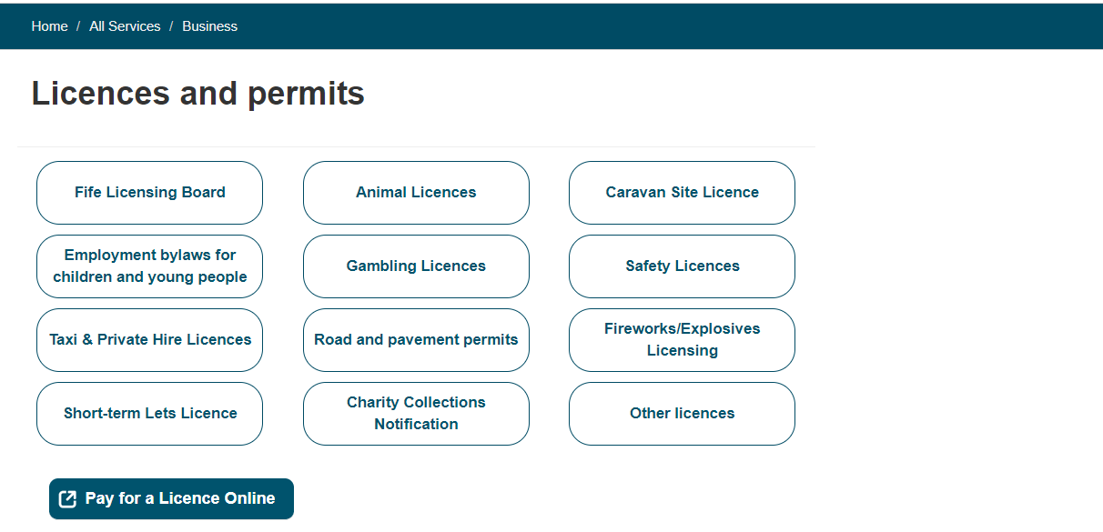
Click on the down arrow where it says Pay For below to go to the drop down menu and choose Miscellaneous Licence then the reference should be BH and your surname. Enter £80.00 (1 year licence) or £195.00 (3 year licence) in the Amount to Pay then press Add. Complete your personal details then press Pay Now.
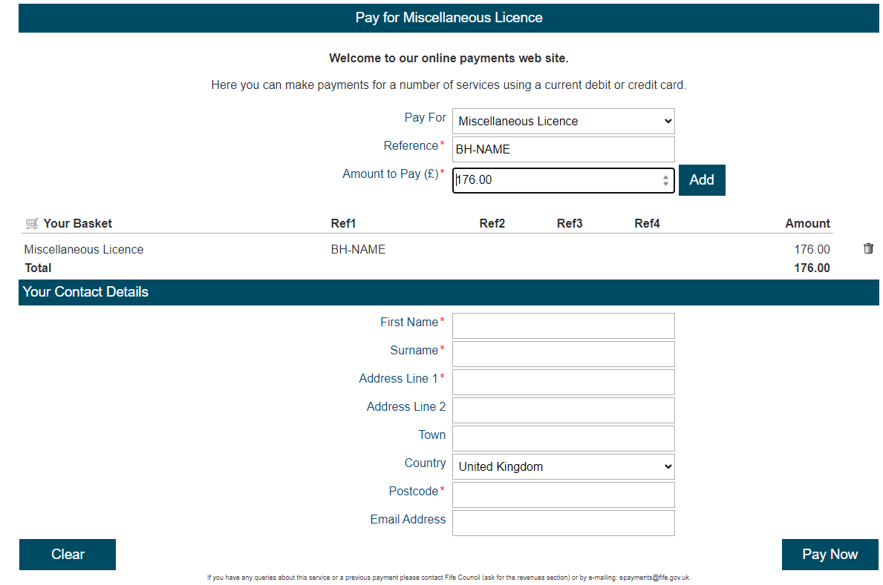

You will then be taken to the screen below where you will verify your details then press Continue

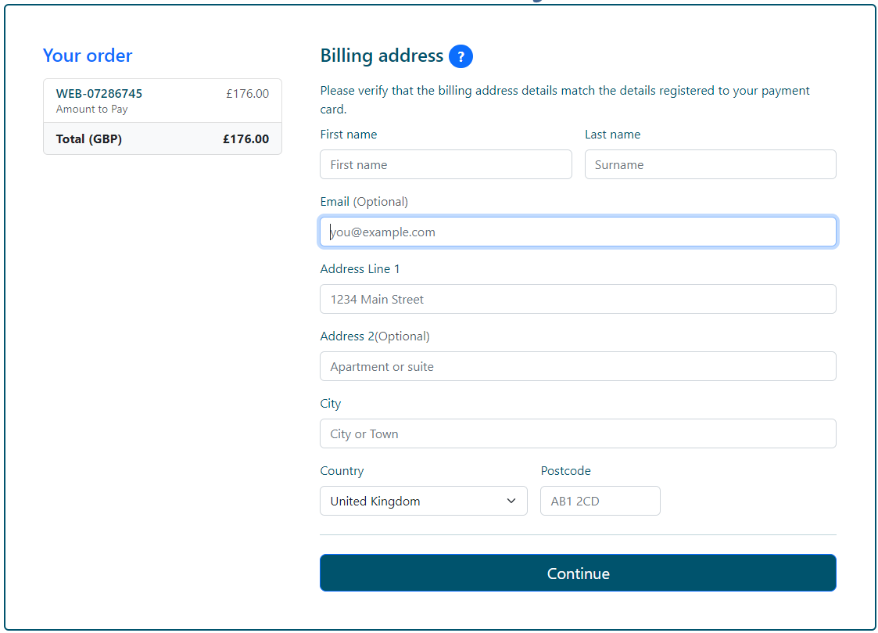
You will then be asked to add your payment details and then press Pay Now
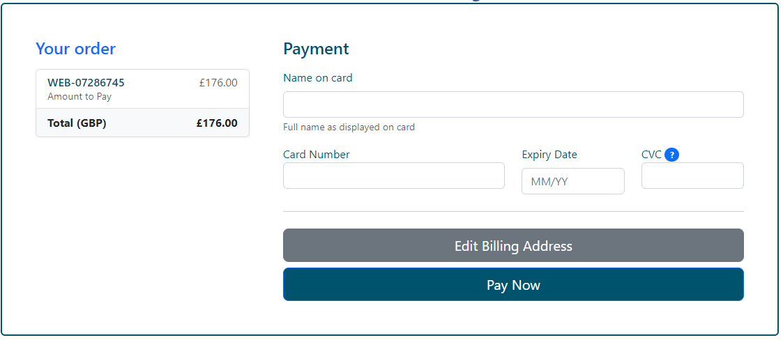
You will then be taken to the screen below which shows you an example of details of your payment
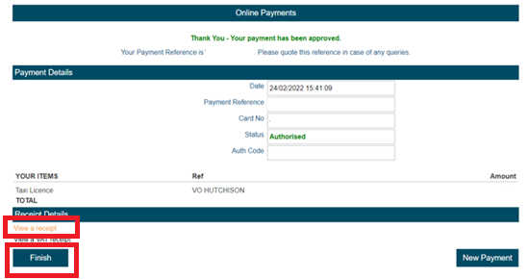
Click on View a receipt as on the above then click on finish and you will be taken to the page below
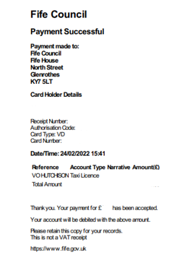
Save a copy of this receipt then forward it to misc.licensing@fife.gov.uk

