08
Fall

Fife Council
Wheelchair & Specialist Housing Study Final Report
December 2022

Table of Contents
1 Introduction 4
1.1 Project Methodology 4
2 Partner Engagement 6
3 Desk Based Analysis 7
3.1 Fife Health & Disability Profile 8
3.2 Fife Specialist Housing Profile 10
3.3 Specialist Housing New Supply 11
3.4 Investment in Property Aids and Adaptations 12
3.5 Support for Independent Living 12
3.6 Key Findings: Statistical Profile of Wheelchair, Accessible & Specialist Housing 13
4 Primary Research Outcomes: Fife Wheelchair & Specialist Housing Survey 15
4.1 Key Findings: Fife Wheelchair & Specialist Housing Survey 20
5 How Accessible is Fife’s Housing Stock? 21
6 Lived Experience Research 25
6.1 Suitability of Current Home 25
6.2 Finding a Suitable Home 26
6.3 Housing Need and Accessible Solutions 27
6.4 Key Findings: Lived Experience Research 28
7 Accessible Housing Requirements 30
7.1 Current Need for Accessible & Wheelchair Housing 31
7.2 Newly Arising Need for Accessible & Wheelchair Housing 32
7.3 Gross Annual Need for Wheelchair & Accessible Housing 32
7.4 Wheelchair & Accessible Housing Estimates by Tenure 34
7.5 Annual Wheelchair & Accessible Housing Supply 35
7.6 Net Annual Wheelchair & Accessible Housing Estimates 36
7.7 Key Findings: Annual Wheelchair & Accessible Housing Estimates 37
8 Key Findings and Recommendations 39
8.1 Wheelchair & Accessible Housing Study Findings 39
8.2 Wheelchair & Specialist Housing Study Conclusions 41
8.3 Wheelchair & Accessible Housing Study Recommendations 42

Appendix A: Fife Wheelchair & Specialist Housing Research Databook
Appendix B: Fife Accessible Housing Study Primary Research Findings
Appendix C: Fife Accessible Housing Study Databook
Appendix D: Fife Accessible Housing Study Primary Research Study Technical Report
Appendix E: Fife Accessible Housing Study Service User Engagement Outcomes
Appendix F: Fife Accessible Housing Study Wheelchair and Accessible Calculation Assumptions

Arneil Johnston
50 Scott Street
Motherwell
ML1 1PN

Introduction
Arneil Johnston were commissioned by Fife Council to carry out a Wheelchair and Specialist Housing Study in February 2022.
The outcomes of this study provide detailed analysis and insight into the extent and nature of wheelchair, accessible and specialist homes across Fife and the extent to which existing housing provision can meet the requirements of households with particular housing needs. The research evidence will also help to inform the Council’s approach to setting wheelchair housing targets within the Local Housing Strategy and Strategic Housing Investment Plan, as well as informing local planning policies on delivering accessible housing.
A range of national and local planning requirements provide the context for the study, including:
- Scottish Government Guidance on the delivery of wheelchair accessible housing targets across tenure (2019)
- Updated LHS Guidance and a proposed national review of the Housing for Varying Needs Standard
- The development of the South-East Scotland Housing Need & Demand Assessment 3 and Tayside HNDA 3 and the delivery of the new Fife Local Housing Strategy 2022-27.
Furthermore, there are recognised challenges in assessing current provision and unmet needs for accessible, specialist and wheelchair housing including:
- No universally agreed standards or definitions of what is meant by accessible or specialist housing
- Limited availability of hard data particularly on the extent and nature of specialist housing across tenure and unmet housing need across a range of disabilities and health conditions
- Fragmented data across partners and professionals with limited insight on housing need, demand and specialist housing supply in the private sector.
In order to overcome these challenges and provide robust evidence to inform strategic planning, the study provides an estimate of current and future requirements for wheelchair and accessible housing across Fife. To achieve this, detailed analysis of Fife’s current housing stock has been performed to better understand how Fife’s housing profile could contribute to meeting future needs for accessible and wheelchair housing.
A key aspect of this study has involved evidencing and better understanding unmet need for specialist housing by commissioning primary research to seek insight from local residents. Primary research outcomes are also instrumental in building a more comprehensive profile of the availability of accessible homes across Fife.
The study has also provided an opportunity for qualitative engagement with households who have a health condition or disability and who are currently living in housing that does not meet the needs of their household. This analysis has included engagement on search pathways for accessible housing and the impact of unsuitable housing on health and wellbeing.

Project Methodology
Scottish Government Guidance published in 2019, sets a requirement to define wheelchair accessible housing targets across tenure as part of the Local Housing Strategy framework. This target will guide delivery planning, including the development of the Strategic Housing Investment Programme for affordable housing, as well as local planning policy for market developers.
To support this process, the study has enabled partners and stakeholders to:
- agree a common set of definitions for accessible, adapted and wheelchair housing
- understand importance of data availability and capture
- create a robust profile of Fife’s existing housing stock, across tenures, to establish the extent of adapted and accessible stock across the area
- consider data analysis and findings from primary and secondary research in evidencing unmet need for wheelchair and accessible housing
- estimate current need and projected need for 5, 7 and 10 y ears by bringing together current provision, unmet need and future supply projections
- ensure those with lived experience have an opportunity to contribute to research findings
- assess the role that in-situ solutions perform and could perform including adaptations, telecare, and floating support
- consider the policy implications arising from the research for the LHS/SHIP, Fife Plan and HSCP Strategic Needs Assessment.
To achieve this, the research programme was executed around the following five stage methodology:
- desk based analysis of secondary data sources including: the Scottish Household and House Condition Survey (2017-19), data from the Fife Housing Register, ARC data from the Scottish Housing Regulator, adaptations data including funding mechanisms
- primary research including an extensive household survey of Fife residents
- qualitative service user consultation to build lived experience evidence of accessing specialist housing
- assessment of the current and future requirements for wheelchair and accessible housing by developing a housing need calculation
- consideration of policy implications arising from the research as part of a final report detailing study findings.
This research report details each aspect of the research, synthesising conclusions and evidencing the need for wheelchair and accessible housing across Fife.

Partner Engagement
A project launch event took place on 1st April 2022 which was a multi-agency, digital event to engage partner agencies and specialist stakeholders (including HSCP, disability groups, registered social landlords, third sector groups) in the research process. It enabled Arneil Johnston to provide an overview of the project and encourage engagement in data capture, analysis and consultation processes. The launch event was also used to further develop the project stakeholder map and identify/plan opportunities for stakeholder and service user engagement.
Furthermore, a multi-agency Steering Group was used to validate the outcomes of the secondary analysis and to scope the range of interventions that should be considered as part of the strategic response to addressing unmet need for accessible, wheelchair and specialist housing.
As one of the major challenges identified at the outset, is the lack of universally agreed standards or definitions of what is meant by specialist housing; the partnership launch event was also used to validate a common set of definitions for wheelchair and accessible housing agreed by the Project Steering Group. Partners and stakeholders accepted the following range of common definitions for accessible and wheelchair housing to ensure clear and consistent language use is achieved by all partners.
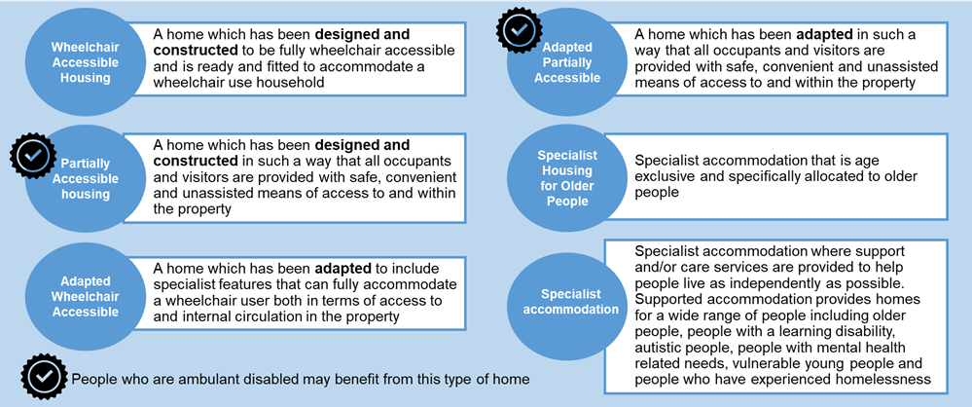
These definitions provide a sound basis to improve multi-agency collaboration and partnership working on data collection, needs assessment, planning and commissioning.

Desk Based Analysis
Arneil Johnston worked with the Project Steering Group to capture, cleanse, assemble and analyse secondary data sources to assess the extent and nature of:
- wheelchair, accessible and specialist housing provision across Fife; and
- unmet need for wheelchair and accessible housing solutions.
A range of data capture tools were assembled to enable partners to audit and map existing information sources across organisations. This information was supplemented with a range of nationally available datasets on the demographic, health, care and housing profile of households across in Fife.
In developing the desk based analysis and gathering and assembling data across partners, it became apparent that there are gaps in insight and intelligence around the current supply of and unmet need for wheelchair, accessible and specialist housing. In particular, there are gaps in intelligence in relation to:
- consistent data on adapted/accessible attributes for Council, RSL and private sector housing stock. This is gathered for each adaptation funding stream but is not consistently held in one central record to allow cross tenure annual reporting to be completed
- accessible and adapted stock in the owner occupied sector. Whilst information will be held in applications and completions for aids and adaptations, this is not shared or collated centrally. It also means that information from privately funded adaptations is unknown other than where it is held by planning/building control services
- information on the extent and nature of accessibility offered by private rented sector stock (which is not a reporting requirement of the landlord registration process)
- demand for wheelchair, accessible or specialist housing out with the social rented sector. Whilst the primary research exercise will have addressed this to some degree, information on the individual circumstances of households that require specialist housing could be helpfully shared more widely across housing, health and social care partners.
Available data is also fragmental across housing, planning, social care, health and voluntary sector partners with no processes or systems in place to gather or share existing information across planners, commissioners and service providers. Whilst the agreement and application of common definitions for wheelchair, accessible and specialist housing should improve data gathering and assembly in the future, the following solutions could be considered by Fife Council and partners to improve data partnership work moving forward:
- create data sharing protocols which use the common definitions for wheelchair, accessible and specialist housing to guide data specification and capture; encouraging partners to sign up to this protocol as part of a data sharing partnership
- use a data-sharing partnership to improve operational relationships and communication channels across partners, enhancing intelligence on the extent and nature of data available via collection, reporting or research processes
- create a planning timetable and data-sharing network across Housing, Planning and the HSCP services to share information and research on specialist housing requirements and provision that is developed to inform:
  - Strategic Needs Assessment (HSCP)
  - Housing Need & Demand Analysis and Local Housing Strategies (Housing and Planning)
- engage Registered Social Landlords across Fife in updating the data matrix developed for this study detailing wheelchair, accessible and specialist housing stock, turnover and demand.
Despite data limitations, there has been comprehensive analysis of secondary data to assemble and map the profile of existing supply of and unmet need for wheelchair, accessible and adapted homes across Fife, including:
- Scottish Household Survey and Scottish Condition Survey (2017-19)
- Fife Housing Partnership Common Housing Register data
- Data on housing stock and turnover from FHP partners
- Annual Return on the Charter data (SHR) (2020/21)
- Data on Fife Council HRA funded and RSL Stage 3 funded aids and adaptions
- Data on Private Sector Housing Grant funded aids and adaptions
- Strategic Housing Investment Plan (2022/23)
- Fife Council Homecare statistics (2019/20).
A statistical data-book detailing this analysis can be accessed by clicking on the following links:
- Appendix A: Fife Wheelchair & Specialist Housing Research Databook.
By analysing the full range of available secondary data and statistics, an evidence base has been assembled which profiles the existing supply and need for wheelchair, accessible and specialist housing across Fife. Chapter 4 details the key findings associated with this analysis.

Fife Health & Disability Profile
Analysis produced by the Fife Health & Social Care Partnership (HSCP) suggests that over 1 in 5 people living in Fife have at least one long term physical health condition ranging from 25% of the population in Cowdenbeath to 19% in North-East Fife. Furthermore over 1 in 5 people in each Fife locality are aged over 65, ranging from 22% in Levenmouth and North-East Fife, to 17% in Dunfermline.
Table 3.1: HSCP Locality Analysis of People 65+ and with Physical Conditions in Fife
The health and mobility of Fife population is projected to change significantly in the next two decades, with major increases in the population of older households (49%) and a reduction in working age households by -27%. Notably the population of people aged over 75 is set to increase by 47% between 2023 and 2043.
Table 3.2: Fife Population Projection by Age (Source: NRS 2018-based Population Projections)
These projections are likely to have a significant impact on demand for specialist housing in Fife and will necessitate housing, health and care interventions that enable the growing population of older people to live independently and well.
Statistics from the Scottish House Condition Survey (2017-19) suggest that 57% of all households in Fife contain one or more households members with a long term health condition or disability. This is notably higher that the rate across the Scottish household base at 44%.
Households in social housing have a significantly higher proportion of people living with a long term health condition or disability, with almost three quarters of all households (73%) containing a person with a long term health condition or disability:
The Scottish Housing Condition Survey also suggests that 5% of all households of which contain a person with a health condition or disability are restricted by the dwelling they live in, which is lower than the Scottish average at 7%. Households with a health condition or disability in the social housing sector in Fife are three times more likely to be restricted by their home (15%), notably higher than the proportion of households in the owner-occupied sector (2%).
Of the 14,908 applicants who have applied for housing under the Fife Housing Register, 22% (3,294 applicants) are seeking specialist housing. A further 3,938 households have been awarded application points as a result of a medical condition. Of those seeking specialist housing:
- 44% require housing for older people (1,459 households)
- 43% require accessible housing (1,430) households. This includes ‘amenity’ and ground floor applications
- 12% require wheelchair housing (405 households).
Applications for older people’s housing are predominately located in Kirkcaldy (22%), Dunfermline (17%) and Glenrothes (16%), which is reasonably in line with the proportion of total applications in these localities. The same is true for the accessible housing waiting list.
As Table 3.3 illustrates, applications for wheelchair housing are concentrated in Dunfermline (24%), Kirkcaldy (21%) and Levenmouth (15%).
Table 3.3: % of Applications for Accessible, Wheelchair and Sheltered Housing by Locality

Fife Specialist Housing Profile
There are 3,902 units of specialist housing provided by social landlords across Fife, 10% of all homes in the social housing sector. The majority (58%) are provided by local operating RSLs, with the remainder provided by Fife Council (42%).
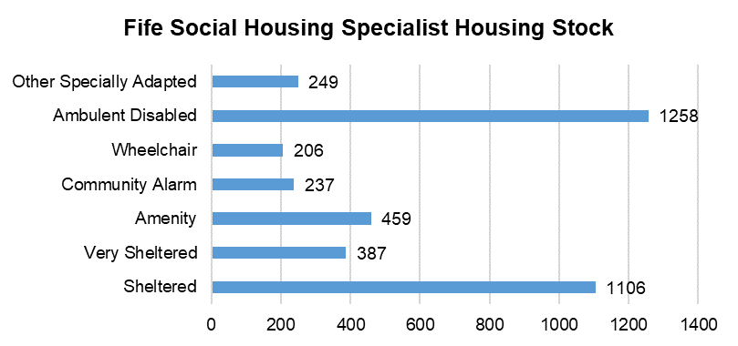
Graph 3.1: Specialist Housing Stock in Fife Social Housing Sector (2022) (Source RSL and Fife Council data returns)
The majority of specialist homes in Fife (56%) can be classified as accessible housing (2,203), including ambulant disabled (1,258), amenity (459) and specifically adapted homes (249). A further 1,493 specialist homes (38%) are either sheltered or very sheltered with 237 homes which offer a community alarm.
Just 5% of all specialist homes in Fife (206) are fully accessible wheelchair homes.
There are clear pressures on the supply of wheelchair accommodation, with just 27 homes on average becoming available for letting each year, over the last 3 years. When this is compared to the number of applicants who have applied for wheelchair housing, a ratio of 1 property for every 15 applicants in Fife is evident.
The pressure ratio for wheelchair housing is 3 times greater than the equivalent for accessible housing, where 1 property becomes available for every 5 applicants. The ratio of applicants to turnover in older people’s housing in Fife is 1:9.
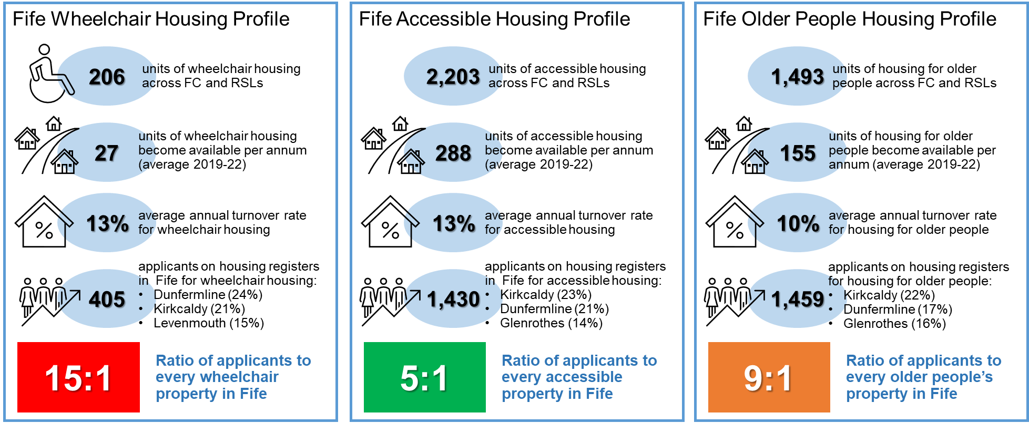
This analysis clearly shows that whilst demand for accessible and older people’s housing is 3.5 times higher in absolute terms (i.e. application numbers), significant pressures on wheelchair housing are evident across the Fife area.

Specialist Housing New Supply
Over the last 20 years, 203 wheelchair homes have been delivered by social housing providers across Fife, which equates to 9.6% of all completions during that period. Over the next five years (2022/23-2026/27), the Strategic Housing Investment Plan is scheduled to deliver 215 wheelchair housing units which equates to 5% of the total affordable housing programme.
Table 3.4: Fife Council Strategic Housing Investment Plan 2022/23-2026/27
29% of all wheelchair completions will be delivered in Dunfermline, followed by 15% in Kirkcaldy and 11% in Cowdenbeath.
Over and above the wheelchair housing programme, 1,126 units of accessible housing will be delivered, a significant 28% of the total affordable housing programme. Again, the majority of accessible homes are scheduled for completion in Dunfermline (29%), followed by Kirkcaldy (11%), Cupar & Howe, Glenrothes and St Andrews (9% respectively).
On this basis, the current SHIP makes a significant impact on enhancing the number of specialist homes in Fife, more than doubling the supply of wheelchair housing (by 104%) and increasing the supply of accessible homes by 51%.

Investment in Property Aids and Adaptations
Whilst delivery of the Strategic Housing Investment Plan will make a very positive contribution to meeting the need for wheelchair and specialist housing, the installation of property aids and adaptation will also make a significant difference, enabling households to live independently and well at home.
According to the Scottish Housing Condition Survey (2017-19), 18% of all homes in Fife have property adaptations, which is slightly lower than the incidence for Scotland at 21%. Over a third of all homes in the social housing sector (35%) have had property adaptations installed compared to just 13% in the owner occupied sector and 16% in the private rented sector.
The Scottish House Condition Survey also estimates that approximately 2% of all households in Fife require property adaptations, with 7% of households in social housing estimated to be in need. To this end, there is considerable expenditure on aids and adaptations in Fife on annual basis, with £2.3M invested across Fife in 2020/21. This includes:
- £689k of Housing Revenue Account funding to Fife Council properties
- £419k of Stage 3 funding to RSL properties via the Scottish Government’s Affordable Housing programme
- £1.2M of Private Sector Housing Grant funding to properties in the owner occupier and private rented sectors.
In total, this investment supported the delivery of 850 property adaptations across Fife. The profile of adaptions varies by housing tenure and is detailed below:
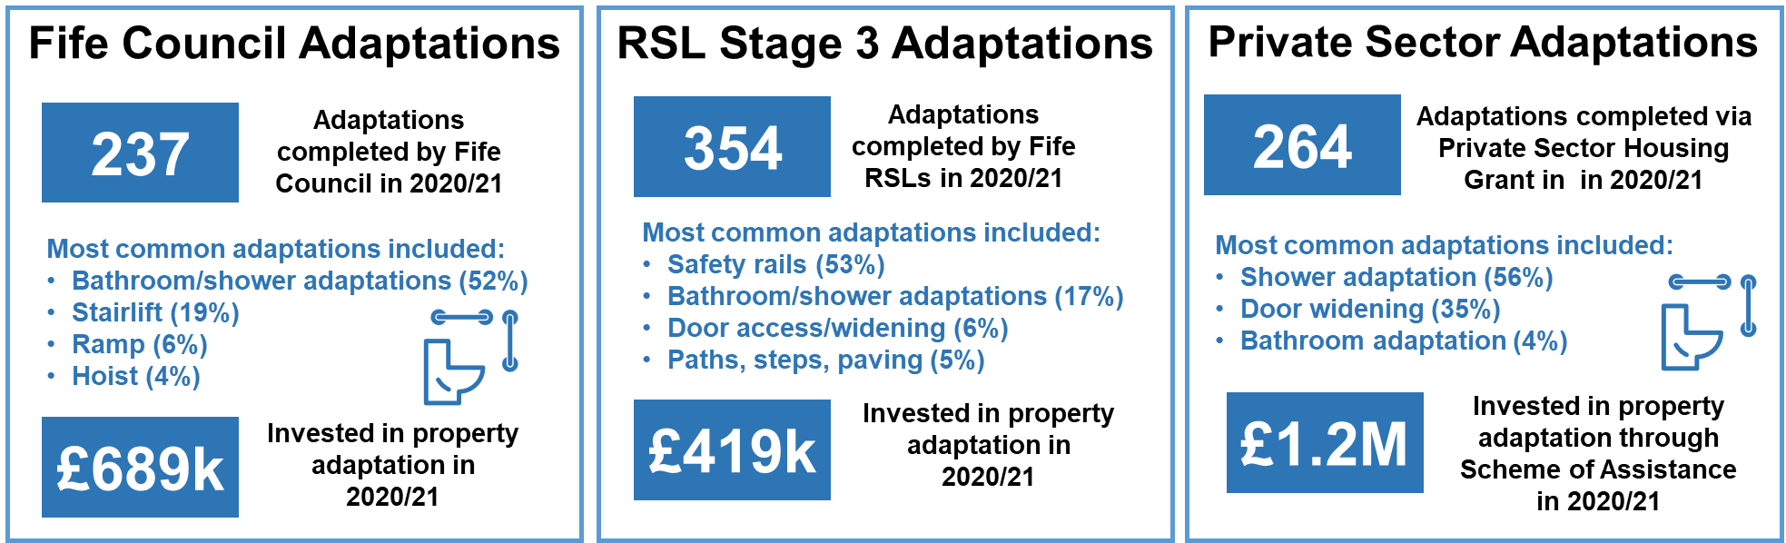

Support for Independent Living
As well as property aids and adaptations, housing support and homecare services play a crucial role in enabling households with health conditions, disability or frailty to live as independently as possible in their own homes for as long as possible.
Fife Council Homecare statistics estimate that in quarter 4 of 2019/20, over 21,000 households across Fife were receiving care and support services to enable independent living, which equates to roughly 12% of all Fife households. Over 4 in 5 service users (81%) were households over the age of 65.
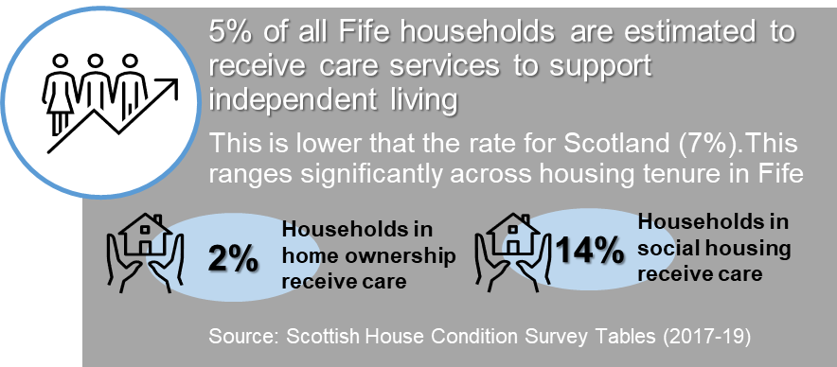
It should be noted that whilst this proportion is lower than estimates provided by the Scottish House Condition Survey (20%), it only accounts for publicly funded care arrangements and does not include private arrangements. The Scottish House Condition survey estimates that 7 times more households in the social housing sector receive care and support services than households in owner occupation.
According to Fife Council statistics, the most common care and support services include community alarm (60%), homecare services (31%) and telecare services (30%). Just under 4,000 households across Fife were using telecare services in 2019/20, a 7% reduction in service usage since 2017.

Key Findings: Statistical Profile of Wheelchair, Accessible & Specialist Housing
Detailed analysis of all known statistical data sources provides an insightful baseline understanding of the scale, concentration and need for wheelchair, accessible and specialist housing across Fife. Overall demand for specialist housing outstrips supply in Fife with specific pressures on the availability of wheelchair homes. Key headlines on the health and disability profile of Fife households and the supply of specialist housing to meet need are as follows:
More than 1 in 2 households in Fife contain a household member who has a long term health condition or disability. This is higher than the rate for Scotland at 44%. It is estimated that three quarters of households in social housing in Fife contain a person with a health condition or disability compared to just 34% in the private rented sector. 1 in 5 applications on the Fife housing register are seeking specialist housing (c. 3,300 applicants). Furthermore, almost 4,000 applicants have been awarded points for medical needs.
10% of all social housing units in Fife offer specialist housing options (3,902). Of the 3,900 specialist homes available, 5% are wheelchair accessible, 56% are accessible/amenity homes and 38% are homes for older people. There is no publicly available data on the accessibility of homes in private housing tenures in Fife. There are clear pressures on the available supply of wheelchair housing with 15 housing applicants for every property that become available. Pressure ratios for accessible housing (5:1) and older people’s housing (9:1) are also considerable relative to expressed need.
Of the 4,011 units that are scheduled for delivery in the 2022/23 – 2026/27 SHIP, 28% are accessible homes (1,126 units). Delivery of the SHIP will increase the supply of accessible housing across Fife by over 50%. Over and above this, a further 215 units of wheelchair housing are scheduled for delivery in the next 5 years (around the same numbers developed in the last 2 decades). This will more than double the number of wheelchair homes available in the social housing sector in Fife.
According to the Scottish House Condition Survey, 18% of Fife homes have been adapted, which is slightly lower than the Scottish average (21%). In 2020/21, over £2.3M was invested in property adaptations across Fife, supporting the installation of over 850 adaptations. The most common adaptations included bathroom/shower adaptations, safety rails and door widening.

Primary Research Outcomes: Fife Wheelchair & Specialist Housing Survey
Assembling housing estimates of accessible, wheelchair and specialist housing is dependent on developing a credible dataset on unmet housing need, to inform both the delivery of cross tenure housing supply targets and to scope investment interventions in existing stock. Given the need for a credible evidence base, the study methodology was predicated on the delivery of a comprehensive primary research programme to supplement the findings from the desk-based analysis, addressing data gaps and delivering more robust insights.
The primary research was undertaken via a household survey delivered by Research Resource (a professional market research agency) and was focused on better understanding the profile of existing homes which meet accessible housing standards (particularly in private housing sectors); as well as providing a detailed profile of the population of households with health conditions or disabilities that require accessible housing. The research also assessed the extent to which the population in Fife is adequately housed and the range of solutions that could/should be considered to meet unmet housing needs.
A total of 500 telephone interviews were carried out in parallel with an online survey which returned 2,121 valid responses. The telephone survey mirrored the online survey but provided an opportunity to carry out more detailed questioning and data collection. This provided a statistically robust sample across Fife offering data confidence to +/-1.9%. The results from the surveys then were weighted by tenure and household composition to provide representative outcomes.
A statistical data-book, summary slide-pack and technical report detailing survey methodology and outcomes can be accessed by clicking on the following links:
- Appendix B: Fife Accessible Housing Study Primary Research Findings
- Appendix C: Fife Accessible Housing Study Databook
- Appendix D: Fife Accessible Housing Study Primary Research Study Technical Report.
The survey questionnaire was designed to address gaps in secondary data analysis and allow for local households to provide insight on current housing circumstances, unmet needs and future intentions. The questionnaire included questions on:
- current home including the accessibility of private housing
- future housing needs and aspirations
- health, care and support needs
- unmet need for specialist housing
- unmet need for adaptations or support.
The research outcomes arising from the 2022 Fife Wheelchair and Specialist Housing Survey provide invaluable insight into the accessibility of homes in Fife, the health and mobility profile of the Fife population and the extent/nature of housing suitability problems.
Key research findings are detailed below.

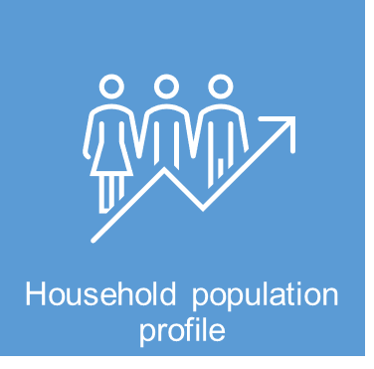
Almost two thirds of all survey respondents (64%) live in owner occupied housing, with 33% indicating that that they own their home with a loan or mortgage (35%) and 29% who owned their home outright. Almost a quarter of respondents (23%) rent from social landlords with a further 13% living in the private rented sector.
Two-adult households account for 35% of the respondent population, with 33% single person households and 24% households with children. All adult households account for 8% of the respondent population. The vast majority of survey respondents are in employment (61%), either working part-time (13%) or full-time (44%). Of those economically inactive, 21% were retired, 8% long term sick or disabled, 4% in caring roles, 3% unemployed and 1% in full time education.

The age profile of the Fife housing stock is relatively young in comparison to other parts of Scotland. Just 16% of current dwellings were built before WWII, with just 7% built pre 1919. The majority of homes were built between 1945 and 1990 (46%), with 19% built in the last 30 years. Excluding the 19% of households who don’t know the age of the home they live in; this means that around 40% of all dwellings in Fife are aged between 50-100 years old. Older properties are generally more challenging to repair, adapt or meet modern energy efficiency standards, making them less able to meet changing needs of households as they get older or experience health problems.
The majority of respondents live in 3 bedroom properties (39%) followed by 2 bedroom homes (34%), 4 bedroom homes (15%) and 1 bedroom or less (10%). Two thirds of households (66%) indicated that they had about the right number of rooms to meet the needs of their household, with 31% suggesting they had a least 1 bedroom fewer than needed. This means that just under a third of households could be experiencing problems with overcrowding which could further limit housing accessibility for households with health conditions or disabilities.
The majority of households live in houses (54%) with 11% living in other types of single story or bungalow type accommodation. Overall, this means that around 65% of households live in homes that provide some form of ground floor accommodation offering some potential of housing accessibility. Over and above this, around 30% of households live in flatted accommodation ranging from four in a block flats, maisonettes, high rise and tenements. Of those living in flats, the majority live in basement or ground floor accommodation (39%). However, this means that 61% of flat dwellers, live at height and as only 7% have access to a lift, 54% live in dwellings that offer limited accessibility to those who may struggle with steps as a result of health conditions or disabilities.
Furthermore, more than 1 in 2 households (53%) indicated that they had internal stairs within their home and a further 20% said they had both internal and external stairs. The volume of dwellings with stairs in Fife is a key factor limiting the potential accessibility of the existing housing stock to those with health conditions or disabilities.
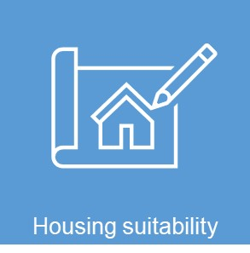
The vast majority of respondents (74%) indicated that someone using a wheelchair would have difficulty visiting their home, including accessing the property from street level and moving around inside without difficulty. Furthermore, over half of those taking part in the survey (58%), felt that the location of their home was either not suitable or very unsuitable for someone using a wheelchair or with mobility issues. These findings indicate that Fife’s housing stock and neighbourhoods offer relatively limited options for households with limiting disabilities or mobility issues.
The majority of households (71%) indicated that the amenity offered by their current home in no way limited the day to day activities of their household and could therefore be considered to be a suitable dwelling. Of the remaining 29%, the most common day to day activity that limited households was bathing and showering, with 11% indicating that they found this challenging. Other common difficulties were around rooms being too small (6%) or kitchen cupboards and shelves being difficult to reach (6%). For those households who indicated that their current home caused some challenges to day to day living, there may be some potential to adapt the property to meet housing needs.
The majority of households with health conditions or disabilities (54%) said no one in their home had difficulty with steps, however, a significant proportion (33%) said that they can manage on their own but with some difficulty, with 9% who need help from another person or aid. 4% of respondents said they were unable to manage steps at all. Should the health of the household deteriorate there are potentially just over 40% of households who would have difficulty with steps, which is particularly problematic given the volume of homes with internal and/or external stairs across Fife (73%).
There are high levels of satisfaction with existing homes across Fife, with 9 out of 10 households (94%) indicating they are either very (68%) or fairly (26%) satisfied with their current home and how it meets the needs of their household. Just 1% of survey respondents indicated that were very dissatisfied with their current housing.
However, when asked whether the household experiences any problems with their current home, almost 1 in 5 (18%) suggested that a need to be closer to a relative/friend (18%) was problematic. Other equally rated problems included: difficulty working from home due to a lack of dedicated workspace (7%), Council Tax not affordable (7%), isolation and loneliness (7%) and utility bills not affordable (7%).
When asked about what type of support could be provided to assist households to cope with the rise in home energy bills, money advice and budgeting was preferred by over half of respondents (53%), followed by support to talk to energy suppliers (46%) and advice on more efficient use of energy (41%). A large proportion of respondents (78%) indicated ‘other’ in response to this question. This could cover a range of support options, however, income maximisation and assistance to minimise energy cost rises are likely to be key drivers in the current context.
Participants were asked about the condition of their home and whether they felt this was a problem. The majority of participants (80%) indicated that they did not have any of the problems with property condition or disrepair. Over and above this, 11% indicated that their property required repair or improvement, with 2.4% identifying that their property suffered from condensation with 1.8% indicating significant dampness. This suggests that repairs and property condition is not an overwhelming concern or driver of housing unsuitability in Fife.
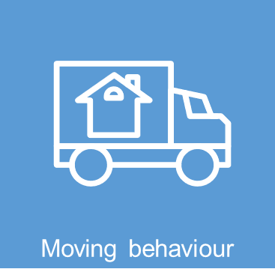
There are significant numbers of respondents who have lived in their current home for 10-20 years (30%) and a quarter (24.5%) over 20 years. These findings could suggest that existing homes across Fife have successfully met the needs of households over a significant and sustained period of time. Nearly a quarter of households have lived in their home 3-5 years (22%), 10% between 1-2 years and 6% having lived in their home for less than a year.
Respondents were asked to identify the main drivers for them moving into their current home. The biggest motivation to move into their current home appears to have been proximity to family/friends (13%), followed by the new home being in a good general location (11%), as well as access to a specific property type (7%). Only 1% of respondents had moved to a property that had been designed to meet their health or disability needs and 1.4% because the property had been adapted to meet the needs of the households. For 5% of respondents, the move to their current home was as a result of no alternative choices - it was the only housing available.
On moving into their current home, a significant number of respondents (62%) said that their home was ‘very suitable’ in meeting the needs of the household, whilst 29% said it was ‘suitable’. Of the remaining group, 8% of households indicated that their home was either not very suitable or not at all suitable for the needs of their household. The position varies considerably when households are asked how suitable their home is now, with 71% indicating that the property is currently suitable or very suitable. However, a much greater proportion of households indicate that their household is either not at all or not very suitable now (29%), in comparison to when they first moved in (8%). Despite this, only 12% households indicated that they need to move whilst 27% said they would like to move home. Overall, the majority of those surveyed (48.1%) said that they don’t want or need to move within the next two years. For those households who indicated that they would like to move, the majority would like to move to Dunfermline (28%), followed by Glenrothes (20%) and Kirkcaldy (18%). There appears to be less demand to move to more rural and coastal areas.
Participants were asked about a variety of housing options their household would like or need. Over half (54%) indicated that they would like to rent from the Council, 46% from a Housing Association, with 40% indicating they would like to live in owner occupied housing. Private rented sector accommodation was the least common response.
For those households who had indicated that they are planning to move in the next two years, 1 in 5 (21%), stated they needed to move to a level access property, with 18% requiring accessible housing to meet health or disability needs. Furthermore, 16% want to move to a bigger home whilst 9% of households want a smaller home. These findings may suggest an increasing number of households whose needs are changing as they get older, with accessible accommodation becoming a greater priority.
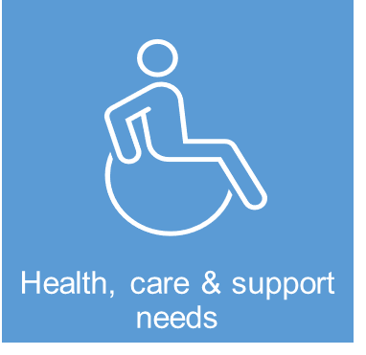
Survey respondents were provided with a range of long term health conditions and disabilities and asked to identify if anyone in the household lived with any of these. Just over half of respondents (52%) have someone in the household with a long-term health condition or disability. The majority of respondents (48%) indicated that there was no one in their home who lived with any of the conditions or disabilities on the list. The most common condition (25%) was a physical health problem followed by mental ill-health (23%) and mobility problems (21%). There was a very small proportion of respondents who indicated that they were impacted by dementia (1%), frailty (2%), developmental disorder (3%), difficulties with sight (3%), learning disabilities (6%) or hearing difficulties (6%).
60% of households surveyed said that their current home met their health and disability needs either very well (18%) or fairly well (42%). Overall, 38% of households with a health condition or disability feel their current housing does not meet their needs. Of this group, large numbers of respondents are living in rented housing which does not meet their needs including the PRS (52%) and social housing (51%). Flat dwellers with health conditions and disabilities are also more inclined to experience housing unsuitability problems including 73% of those with live in high rise dwellings and 48% of those who live in flats.
Households were asked if they had any equipment in their home such as aids and adaptations to help them live independently, with most (64%) saying they did not. The most common form of aids offer assistance with bathing (14%), mobility equipment such as frames or scooters (13%), assisted furniture (8%), care or support (7%) and 7% had a wheelchair.
Most households (91%) do not contain a household member who requires to use a wheelchair. Of those who indicated that they did (9%), 6% require a wheelchair for outdoor use only with 3% who need a wheelchair both inside and outside of their home. Of those households with a wheelchair user, just 22% of households said their property was wheelchair adapted, with 78% living in homes which are not designed to be fully wheelchair accessible.
Survey respondents were asked if anyone in their household had an unmet need for particular forms of specialist housing, with over three quarters (77%) indicating no unmet need. Conversely, 23% of respondents feel that someone in their household has an unmet need for special forms of housing. The most common requirement was for accommodation without stairs (14%) followed by specialist housing for older people (5%) and wheelchair housing (2%).
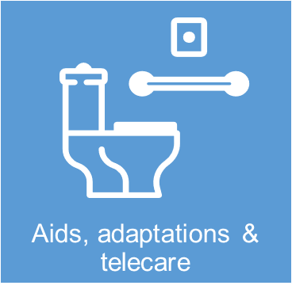
21% of respondents indicated that they receive some form of contact with social services or other caring organisations to enable them to live indepently at home. The majority of households (over 80%) indicate that they do not need any special forms of housing support. 20% of households had made contact with services requesting support but were not eligible for assistance. Given the ageing population in Fife it is likely that the proportion of households who will require this form of assistance will increase in the future.
Two thirds of all households in Fife do not have any property adaptations installed in their home. Of the third who do, the most common form of property adaptation is handrails (20%), followed by bath/shower seats (9%) and level access showers (9%). Overall, 31% of households need property adaptation installed in their home, with the most common requirements including level access showers (11%) followed by handrails (9%). Again, there is likely to be an increase in demand for specialist forms of adaptations to meet the needs of the growing elderly population across Fife. Just 2% of households in Fife have property adaptations installed that they do not need.
Participants were asked about types of telecare facilities they currently have access to in their home, unmet need for telecare services and future appetite to use telecare. Beyond those with access to smoke, gas or carbon monoxide detectors (77%), the most common telecare services in use include GPS tracking devices (15%), with around a third of household also having access to temperature sensors (35%) and voice assisted speakers such as Alexa or Google Assist (32%). In general, most households said they would not consider using telecare facilities if needed in the future, including 56% who would not use a community alarm and 56.7% who would not use movement sensors. These findings suggest that the potential benefits of telecare in enabling households to live indepently and well at home need to be more widely understood by households living in Fife.

Respondents were asked if they had ever thought about the future housing needs of their household. The majority (43%) said they were aware that the housing needs of their household would be likely to change long term, whilst 24% had thought about changing needs within the next five years. A significant proportion of households (33%) said they had never thought about how the households housing needs would change.
For those households who have been thinking about the future, 42% indicated that they had either ‘not done anything about it’ or ‘hadn’t given it much thought’, whilst 17% said they had started looking at future housing options. Some households were considering planning a move to a more accessible home (9%), with just 1% considering specialist housing (1%). Other households were considering property adaptations (7%). Just 5% of households had already moved into a home that would meet their changing needs. The majority (55%) of respondents who hadn’t considered their future housing options said they were putting this off as they didn’t want to make changes to their current home, with 11% indicating that they didn’t have time to look at future housing options.

Key Findings: Fife Wheelchair & Specialist Housing Survey
The 2022 Fife Wheelchair & Specialist Housing Survey has succeeded in delivering credible insight into the extent and nature of accessibility offered by the current Fife housing stock, as well as the circumstances, unmet needs and intentions of Fife households who require wheelchair, accessible or specialist housing. Furthermore, survey intelligence provides crucial contextual evidence of the extent and nature of the population currently living in housing, which is unsuitable for their health and mobility needs, as well as the extent to which households proactively plan to meet future needs.
Headline findings from 2022 Fife Wheelchair & Specialist Housing Survey can be summarised as follows:
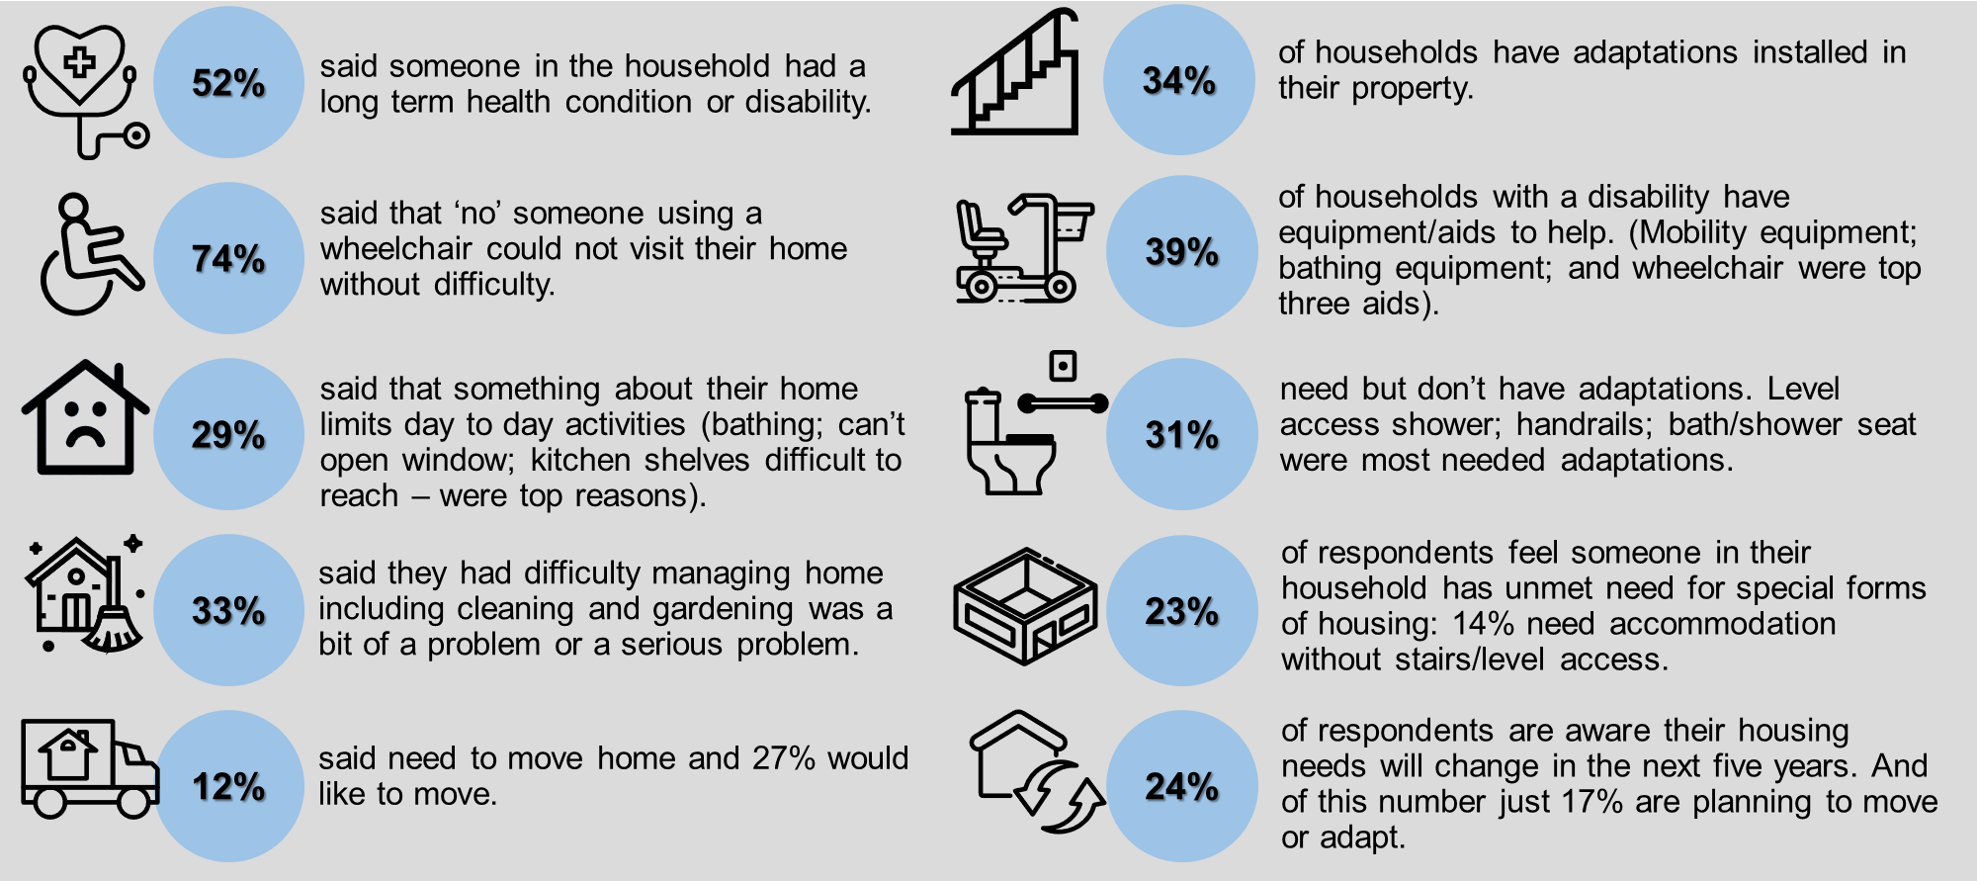

How Accessible is Fife’s Housing Stock?
As well as offering a detailed profile of and unmet need for wheelchair, accessible and specialist housing across the Fife area, primary research findings were utilised to provide:
- analysis of the amenity offered by existing homes in Fife to meet unmet need for wheelchair, accessible and specialist housing
- current measures of the requirement for other specialist forms of housing based on intelligence of the health and disability profile of the Fife population in each housing tenure.
To achieve this, primary research findings were synthesised with desk based analysis to provide insights on:
- the extent, nature and profile of Fife’s housing stock
- the accessibility profile of Fife homes
- Fife’s household health and disability profile.
Analysis of Fife housing stock profile reveals that it predominately offers low rise homes, built in the post war era (post 1945). At a superficial level, this profile suggests good potential for homes in Fife to be more accessible than other parts of Scotland given a lower proportion of flatted homes and older properties which may be challenging to adapt.
However, the high proportion of homes without stairs in Fife is a key factor which limits housing accessibility. Key headlines on the Fife dwelling profile include the following:
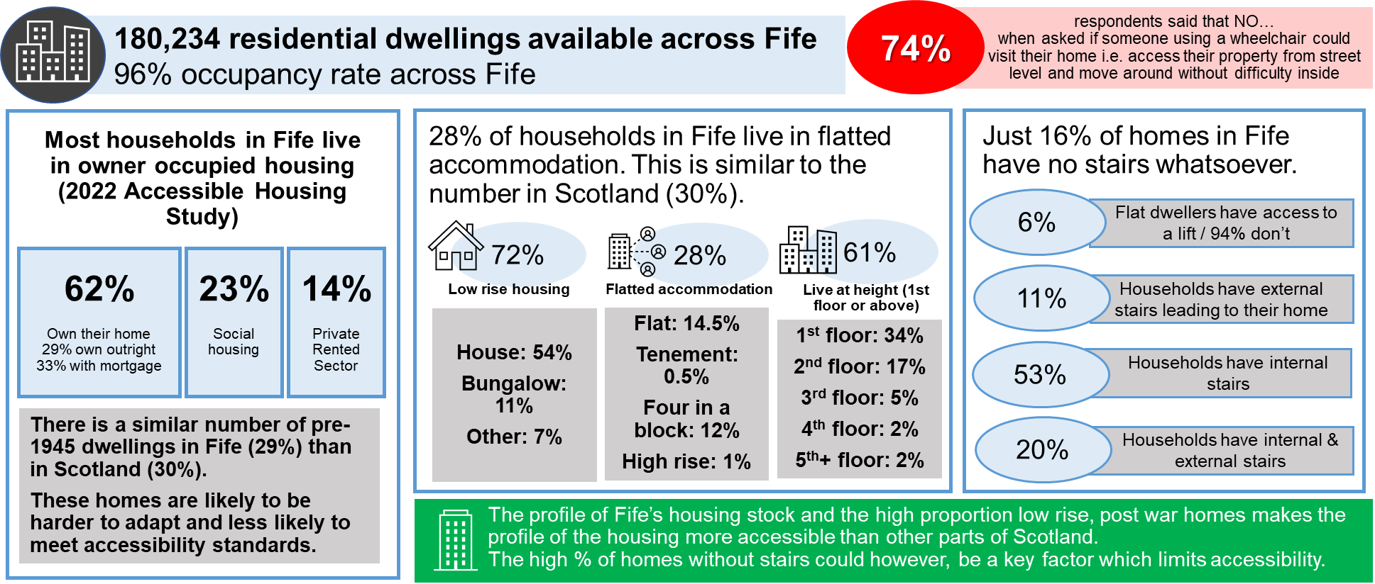
Crucially, primary research findings suggests that just 26% of homes across Fife could be accessible to a person using a wheelchair, offering access from street level and movement around the property with difficulty.
Applying these findings to the housing stock profile across Fife reveals the extent of homes that would not offer housing accessibility to those with health conditions or disabilities i.e.
- 74% which are NOT accessible to someone in a wheelchair including:
  - 73% of all homes (131,000) which have internal stairs (both low rise and flatted dwellings)
  - 61% of flatted homes (31,000) on the first floor or above
  - 96% of homes at height (29,500) without access to a lift.
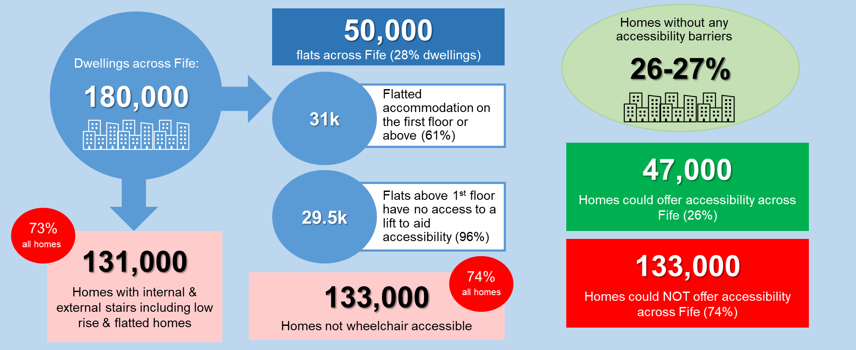
By triangulating these findings, the research suggests that roughly one quarter of Fife’s housing stock could offer accessible options to households with a health condition or disability, with the majority of dwellings (three quarters) not offering appropriate accessibility or amenity.
It can be concluded that Fife’s housing stock profile is particularly limiting from a housing accessibility perspective; with a high proportion of homes with internal or external stairs driving the barriers faced by households who require wheelchair or accessible housing.
Primary research findings suggest that 52% of households in Fife contain a household member with a long term health condition or disability. Whilst this incidence is higher than the rate for Scotland at 44% (Scottish House Condition Survey 2017-19), there is evidence of notable levels of housing unsuitability experienced by this population. Almost 1 in 2 households with a health condition or disability (46%) have trouble managing stairs at home.
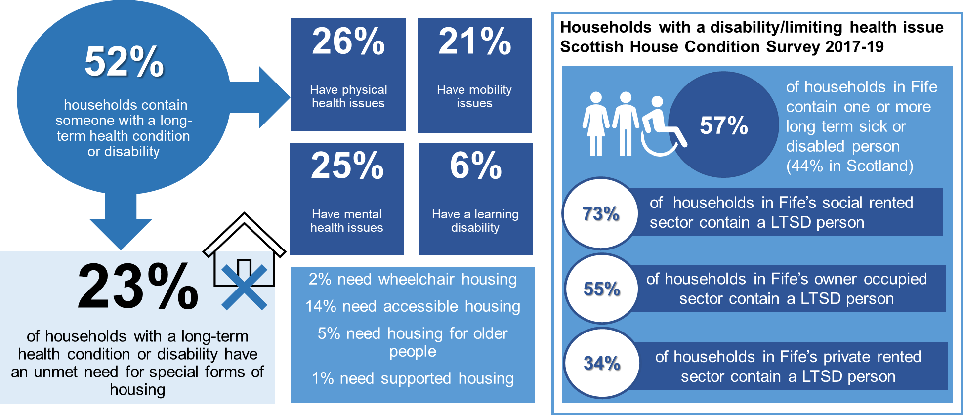

Furthermore, 38% of households with a health condition or disability believe their current home does not meet the needs of the household, with higher instances of housing unsuitability detected in private rented (52%) and social housing (51%) sectors.
Up to a quarter of households with a health condition or disability (23%) suggest that their needs cannot be met in their current home and that they require to move to special forms of housing to meet their housing need, the equivalent of over 13,000 households.
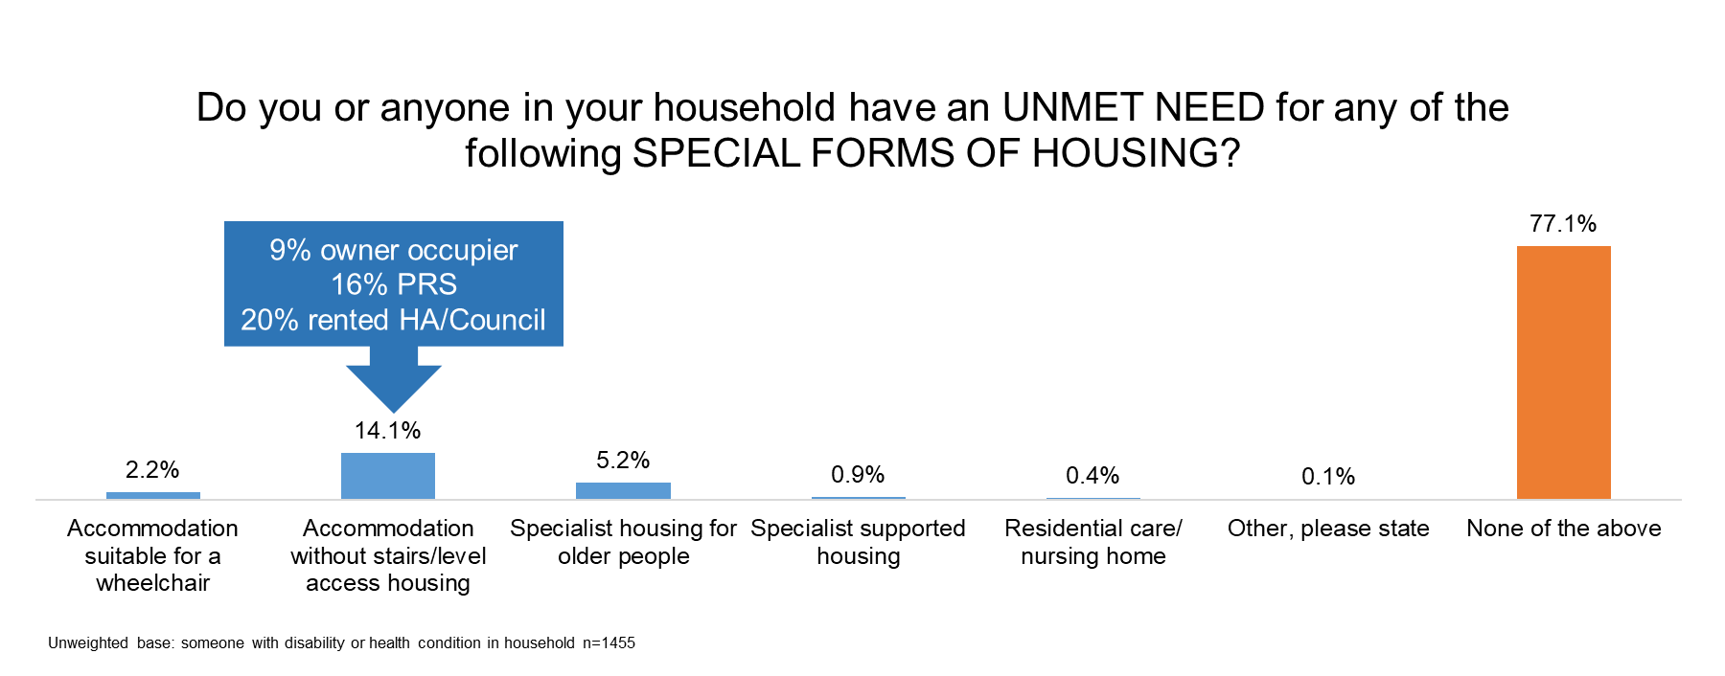Graph 5.1: Proportion of households with a health condition or disability with an unmet need for specialist housing (Source Fife Wheelchair and Specialist Housing Survey 2022)
Unmet need for special forms of housing is dominated by households who self-assess a requirement for ground floor or level access housing, with 14% of households specifying a requirement for this form of housing. This is significantly higher than those who specify housing for older people (5%) or residential supported housing (12%).
When other measures of unmet housing need are assembled, estimates range from just under 7,000 (households who NEED to move to a wheelchair and accessible home in the next 2 years) to over 13,000 (households with an unmet need for wheelchair and accessible housing). Triangulating these findings suggests that roughly 10,000 households across Fife self-assess a need for wheelchair and accessible housing.
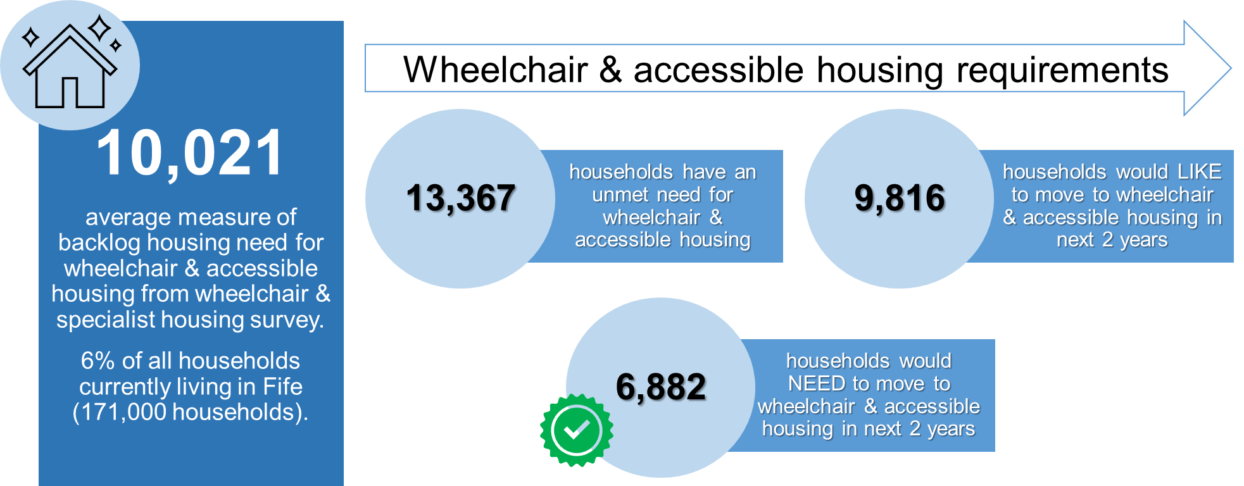
Over and above this, up to one third of households with a health condition or disability (31%), currently NEED adaptations to make their home more suitable for the needs of their household, suggesting a key role for in-situ solutions in improving the accessibility of Fife’s housing stock.
These research outcomes offer a unique insight into accessible housing provision across Fife, as well as unmet need for accessible housing solutions, suggesting that housing accessibility in Fife is particularly challenging given:
- the proportion of homes which are not accessible (estimated to be around three quarters of all dwellings)
- the proportion of households with a long term health condition or disability who do not feel their current home meet the needs of household members (23%).

Lived Experience Research
Assembling evidence of households with lived experience is essential to the research study outcomes by ensuring that service users have a voice in influencing the strategic interventions developed by partners to meet future need for wheelchair, accessible and specialist housing across Fife.
To achieve this, Arneil Johnston worked with trusted partners in health, social care and housing services to encourage participation in the research, as well as third sector disability support and advocacy groups. In total eight service users were interviewed in August 2022 to examine:
- current housing suitability
- evolving/emerging housing needs
- barriers to accessing suitable housing
- perspectives on alternative housing solutions
- perspectives on in-situ solutions (including adaptations, technology enabled care and wrap around support services).
The interviews were used to provide the vital qualitative information to augment the findings from the telephone and online surveys. A standard set of potential lines of enquiry was prepared in advance of the interviews and the interviewer used these discussion prompts flexibly depending on the participant’s circumstances.
Twelve interviews were scheduled, and eight households took part in full qualitative interviews. The range of conditions and difficulties of households who took part in the survey includes:
- one household where the resident has COPD, asthma, and arthritis
- one household where there was a parent with two three-year-old disabled children
- one household where the tenant was registered blind
- one household where the tenant has rheumatoid arthritis
- one household where the tenant has incontinence, mental health challenges and is a wheelchair user
- one household where the tenant had suffered a heart attack and has lung problems and is diabetic and suffers from carpal tunnel syndrome and verticalosis
- one household where the tenant has paranoid delusions and suffers from psychosis as well as hyper mobility, Fibromyalgia and ME
- one household where the tenant is severely disabled and a full-time wheelchair user.
A full service user engagement paper is attached at Appendix E detailing the results of all lived experience interviews. Chapter 6 details the common themes arising from lived experience research.

Suitability of Current Home
Just a quarter of all participants were in homes suitable for their physical needs, with three quarters describing their need to move to suitable housing as increasingly ‘desperate’.
A number of participants did indicate that there were potential adaptations that could help meet housing need in the short term until the household successfully accessed a suitable home. The main challenge for those seeking specialist housing is the ability of each household to live as independently as possible in an existing home which offers unsuitable accommodation.
As well as housing accessibility problems, many households also raised restriction around accessing to family, friends and local support networks as a major challenge, whilst an accessible housing solution is found. This can have a profound impact on the health and wellbeing of the households in question.
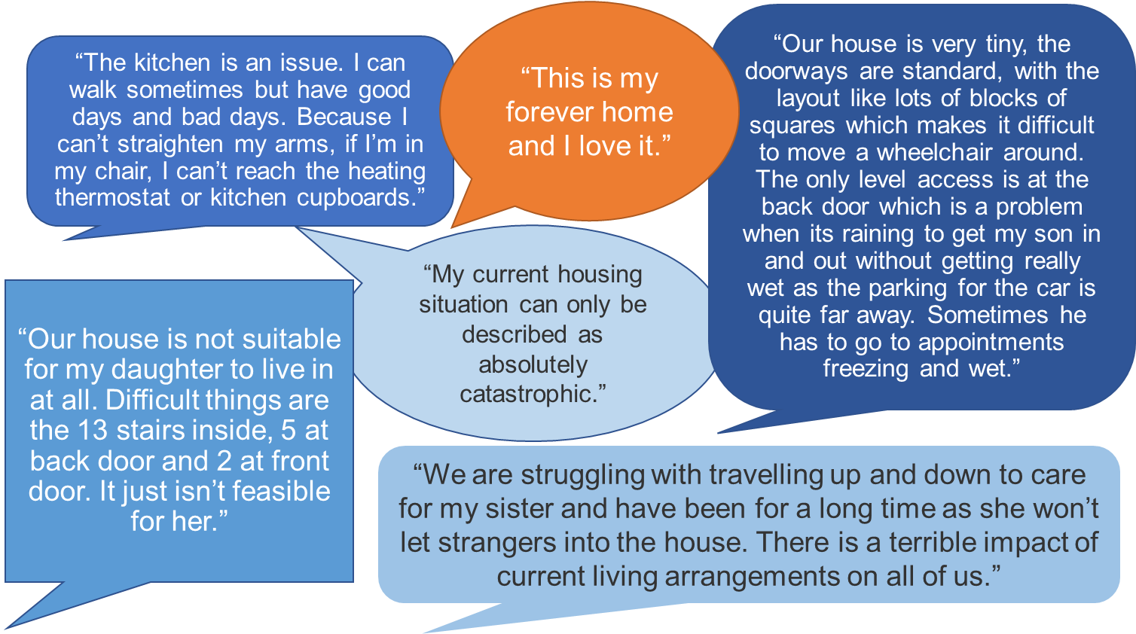

Finding a Suitable Home
Of those participating in the research, just one quarter had successful accessed a suitably accessible home after a period of searching and assessing available options. In contrast, three quarters described the search process associated with finding an accessible home as ‘extremely challenging’.
The availability of advice, information and support was a common theme raised by participants experiencing difficulties in accessing a suitable property. Furthermore, the availability of affordable and accessible homes in the right locations across Fife was identified as the key barrier to meeting housing need, as well as the quality of information provided to social housing applicants on housing options and choice. There is also evidence that households with health conditions and disabilities are struggling to meet their needs in the Fife housing market, with affordability barriers to accessing the right home.
Responses depended on the extent of disability issues faced by the household, as well as the nature of their current housing situation. Common themes focused on the limited range of affordable, accessible housing options in Fife and the length of time it takes to find a suitable home.
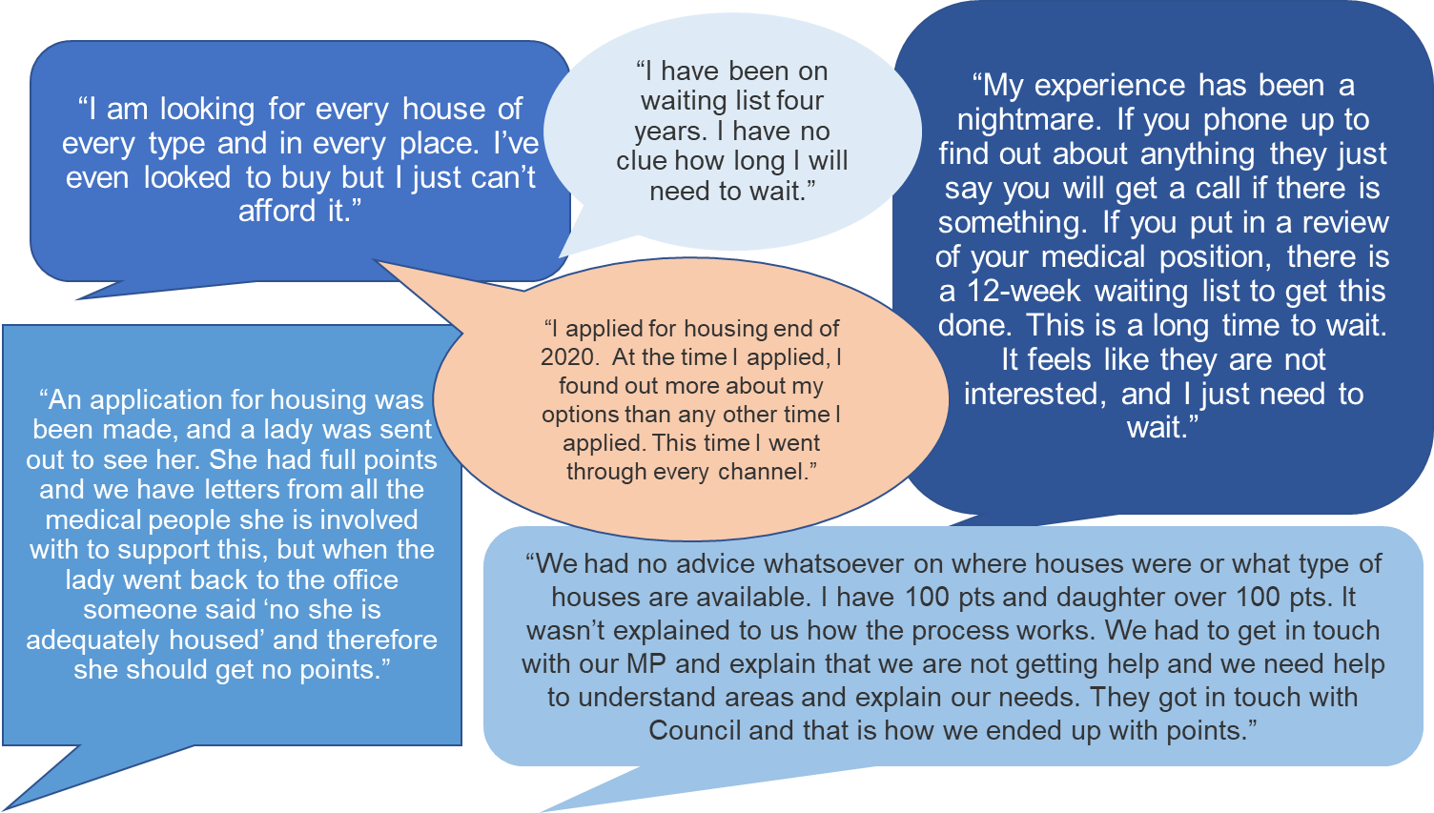

Housing Need and Accessible Solutions
In considering optimum design options, a location close to family and social networks was ranked as high needs by all participants. There was an increasing feeling of helplessness across many of the participants, most of whom have been on housing lists for a long time and are experiencing a deterioration in their physical health and mental wellbeing, with no obvious tangible solutions available in the short term.
In visualising their optimum solution, participants generally indicated that good quality external space is important to them, both for parking and to enjoy the outdoor environment in an accessible way. None of the participants wanted extravagant or ‘dream’ homes, focusing more on a house that was accessible and would improve the situation for their household.
Feedback on solutions to improve the access to suitable housing for those with health conditions and disability in their household include:
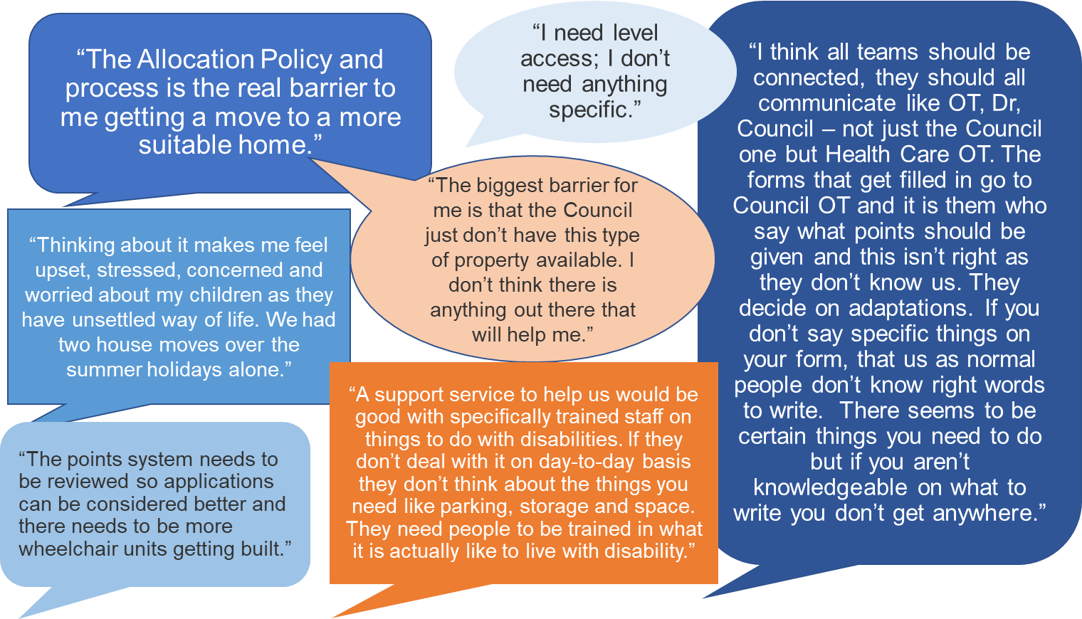

Key Findings: Lived Experience Research
The lived experience research interviews offer invaluable insight into the circumstances, needs and experiences of Fife households with a health condition or disability and their journey to accessing a home that is suitable for their needs. These insights ensure that the wheelchair and specialist housing study places lived experience evidence at the heart of strategic interventions arising from research findings.
Whilst the personal and housing circumstances of participants varied extensively, a number of key themes emerge from qualitative interviews as follows:
- communication, advice and assistance are extremely important to those who have made social housing applications and all participants felt that this could be improved
- adaptations have been carried out in some of the homes lived in by participants, but not in all homes. It is clear from the findings that households who could have their home adapted as an interim solution, would have easier day to day lives as a result. Participants recognise that whilst property adaptations may not solve all their housing challenges, they would help until a more suitable property for the needs of the households becomes available
- all participants recognised that there is a limited supply of the types of housing they require in the areas they want to live. Everyone felt that building more accessible homes would help those with a health condition or disability and unmet housing need
- housing aspirations are not extravagant or unrealistic. Participants simply want to live as independently as possible in a home that meets the needs of their household.
Participants were keen to share their experiences, with a number indicating they be willing to be involved in any future consultation groups or participation opportunities that would help shape future delivery of accessible housing services. Key findings from the lived experience research can be summarised as follows:
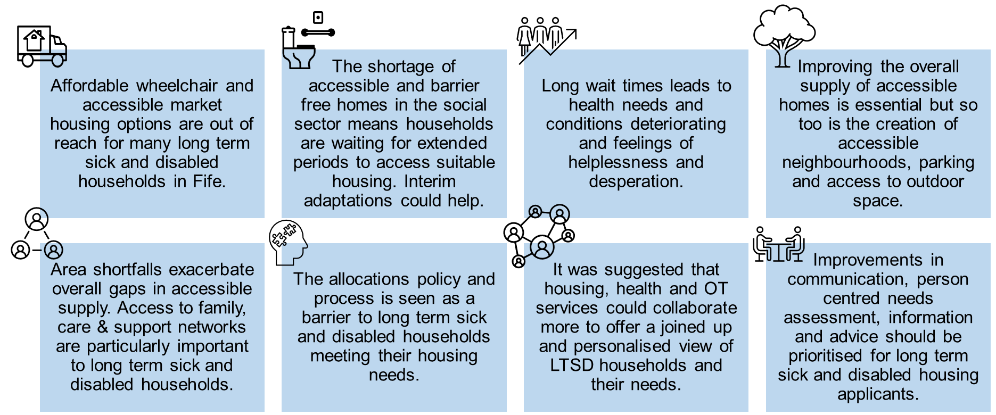

Accessible Housing Requirements
Informed by extensive primary and secondary research on the supply of and unmet need for wheelchair and accessible housing in Fife, research outcomes have been integrated and analysed to prepare accessible and wheelchair housing estimates.
Primary and secondary research outcomes have been synthesized to develop a baseline calculation which provides housing estimates for both wheelchair and accessible homes. The Project Steering Group and partners can use these estimates as the basis of setting all tenure wheelchair targets within the Local Housing Strategy and Local Development Plan, considering the relevant factors which could affect the pace and scale of future delivery.
Research evidence has enabled the delivery of a baseline housing needs calculation which sets out housing estimates for accessible and wheelchair housing in Fife. A data-book has been developed to prepare wheelchair and accessible housing calculation inputs and assumptions, ensuring there is transparency on the evidence base for setting housing supply targets, and an analytical model that assesses unmet need for wheelchair and accessible housing has been developed. This data-book details all assumptions underpinning wheelchair and accessible housing calculations and is available in Appendix F: Fife Accessible Housing Study Wheelchair and Accessible Calculation Assumptions.
The model is structured around the logic of the Scottish Government’s HNDA tool measuring:
- backlog need for wheelchair and accessible housing
- newly arising need for wheelchair and accessible housing
- the impact of the existing housing stock in meeting housing need.
The model is a user-friendly calculation which provides a clear audit trail of data inputs, assumptions and scenario tests. The wheelchair and accessible housing calculation works on the following basis:
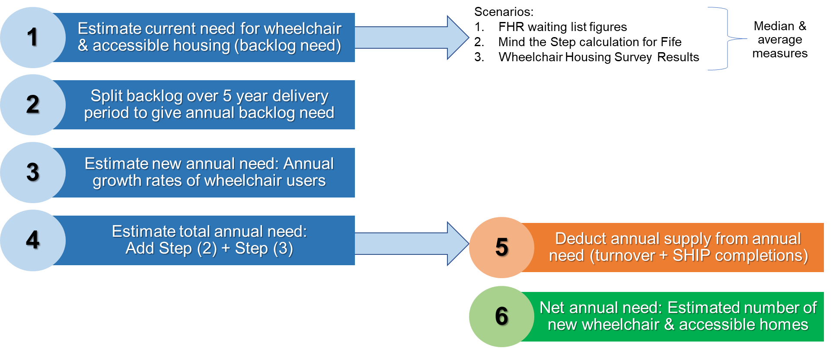
The estimate of current need for wheelchair and accessible housing (Step 1) takes into account Fife Housing Register waiting list figures, the ‘Mind the Step Calculation’ for Fife and Wheelchair and Specialist Housing Survey results. This is then split over a five, seven and ten year delivery period to give an annual backlog (Step 2).
An estimate of new annual need (Step 3) is then added to the backlog to give an estimate of total annual need (Step 4). New build annual supply from SHIP completions and turnover from existing affordable and market housing is then deducted from this figure (Step 5) to give a net annual need estimate.
Chapter 7 details key wheelchair and accessible housing calculation inputs, assumptions and outcomes.

Current Need for Accessible & Wheelchair Housing
A number of estimates were used to derive a measure of current need for both wheelchair and accessible housing including the outcomes of the 2022 Wheelchair and Accessible Housing Survey, Fife Housing Register measures of demand and a calculation reflecting the ‘Mind the Step’ methodology applied in a Fife context.
The 2022 Wheelchair and Accessible Survey reveals that of the 52% of households in Fife who have a household member with a long term health condition or disability, 23% currently have an unmet need for a specialist housing solution i.e. their current needs cannot be met in their existing home.
To measure the needs arising from the wider population, households were asked whether they NEED or would LIKE to move from their current home in the next 2 years in order to access either wheelchair or accessible housing. To ensure that housing estimates are based strictly on need (eliminating any elements of aspiration), the number of households who NEED to move in the next 2 years was identified, providing the following measures:
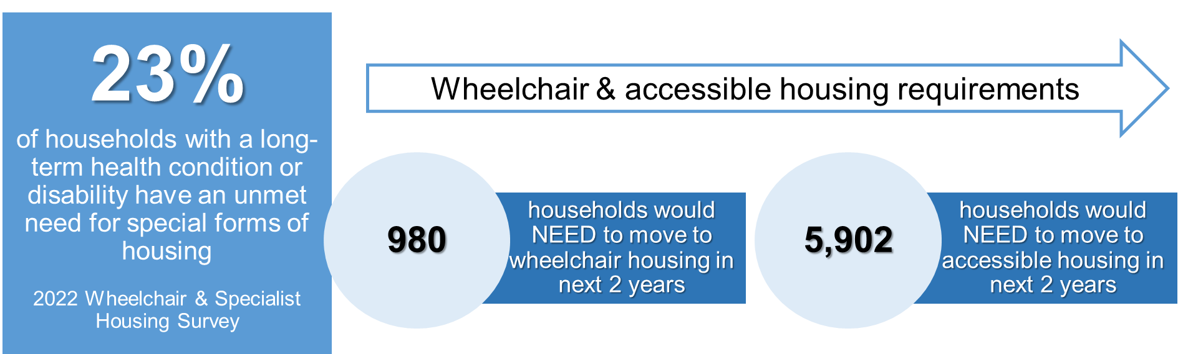
The 2022 survey outcomes suggest that 980 households who have an unmet need for wheelchair housing and 5,908 households who have an unmet need for accessible housing across Fife.
Furthermore, it was identified that 405 households are currently listed on the Fife Housing Register awaiting an offer of wheelchair accessible housing in the social housing sector, with 1,430 households who are awaiting an offer of accessible housing.
Finally, to create a final measure of current need for wheelchair and accessible housing, the Mind the Step Methodology was applied to create estimates for Fife. Still Minding the Step was published by CIH Scotland and Horizon Housing Association in 2018 and offers a nationally recognised methodology for calculating the number of wheelchair users in housing need, estimating the number of wheelchair homes required to meet unmet need in Scotland. Using the results of the Scottish Household Survey, the Mind the Step Calculation estimates the number of indoor wheelchair users in housing need (25%) and the number of outdoor wheelchair users in housing need (19%) to calculate how many wheelchair and accessible homes are required. Future estimates are then calculated using household growth projections.
Using these incidence rates and applying them to the Fife household base creates estimates for wheelchair and accessible housing need as follows:
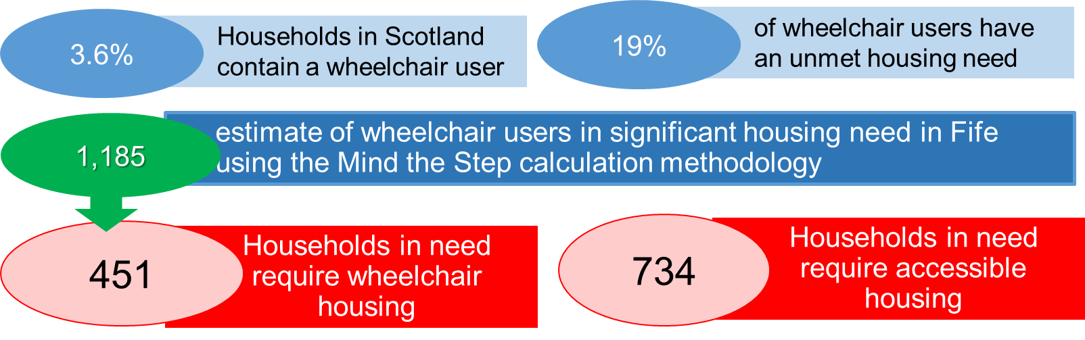
Using all of the evidence available, the various data sources were triangulated to provide the following aggregated estimates of current need for wheelchair and accessible housing (3,301).
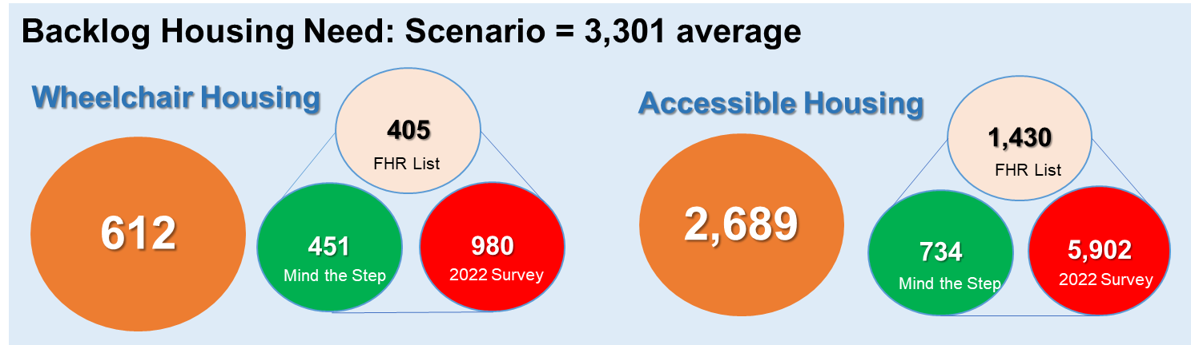

Newly Arising Need for Accessible & Wheelchair Housing
Estimating new annual need is calculated by considering the annual growth rates in wheelchair users derived from the Mind the Step calculation methodology. Applying the same logic, the calculation applies a 7% annual increase to each backlog need scenario, producing estimates of new need for wheelchair and accessible housing as follows:
 | Wheelchair housing | Accessible housing | Total
Backlog = 3,301 | 44 | 190 | 234
Table 8.1: Number of new households requiring wheelchair and accessible housing per annum

Gross Annual Need for Wheelchair & Accessible Housing
Estimates of annual backlog need and newly arising need are combined to provide a gross annual estimate for wheelchair and accessible housing as follows:

 | Wheelchair housing | Accessible housing | Total
1. Backlog Need | 612 | 2689 | 3,301
2. Annual Backlog (5 Years) | 122 | 538 | 660
3. Annual New Need | 43 | 190 | 234
4. Total Annual Need (GROSS) | 166 | 728 | 894
Table 8.2: Total number of new households requiring wheelchair and accessible housing per annum
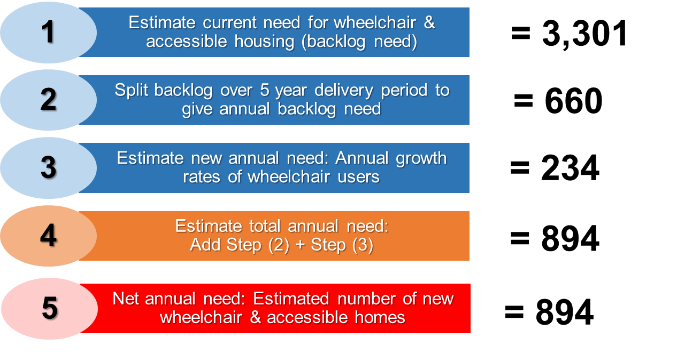
The baseline calculation assumes that the backlog of households in current need for wheelchair and accessible housing will be met over a 5-year period. A range of scenarios have been prepared to produce wheelchair and accessible housing estimates over a 5, 7 and 10 year projection period as follows:
Backlog Need = 3,301 | Wheelchair housing | Accessible housing | Total
Gross annual estimates over 5 years | 166 | 728 | 894
Gross annual estimates over 7 years | 131 | 574 | 705
Gross annual estimates over 10 years | 261 | 303 | 564
Table 8.3: Annual estimates of unmet need for wheelchair and accessible housing over a 5, 7and 10 year period
Gross annual estimates for wheelchair and accessible housing therefore sit in a range between 564 – 894 homes per annum depending on assumptions over how long it should take to eliminate the backlog of existing households who need alternative housing.

Wheelchair & Accessible Housing Estimates by Tenure
Using the wheelchair and affordable housing estimates developed under 5, 7 and 10 year projection scenarios, the calculation also assesses the proportion of homes to be delivered via affordable and market housing developers.
To achieve this, housing estimates have been broken down by tenure using the outcome split provided, by the ‘Steady Growth’ scenario from the 2022 Fife Housing Need & Demand study, as follows:
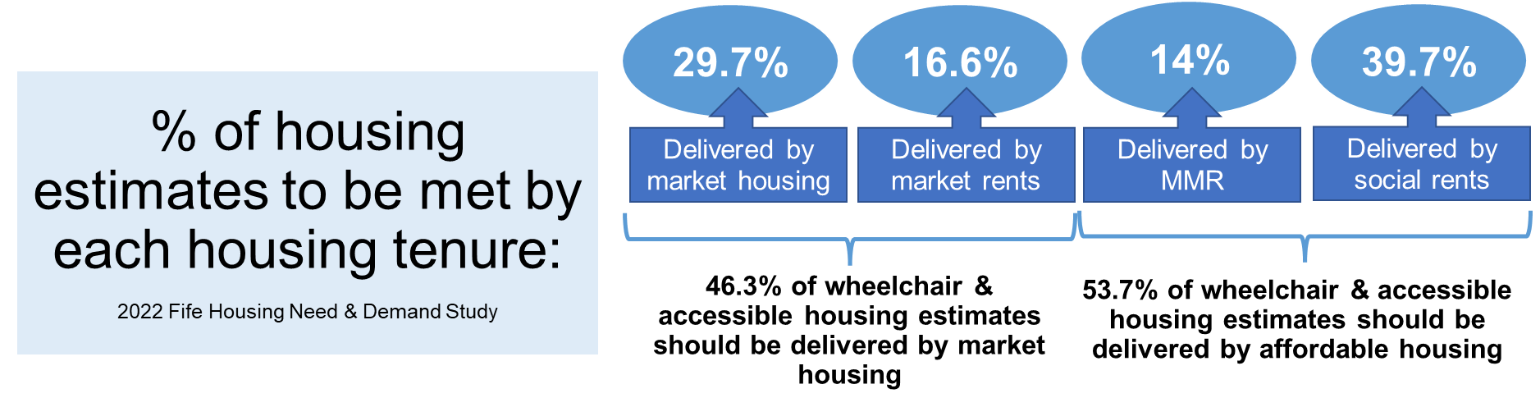
Applying this tenure split over each scenario produces the following outcomes:
 | Market housing | Affordable housing | Total
Wheelchair housing estimates over 5 years | 77 | 89 | 166
Accessible housing estimates over 5 years | 337 | 391 | 728
Total housing estimates over 5 years | 414 | 480 | 894
Table 8.4: Annual number of wheelchair & accessible housing units required by tenure over a 5 year projection period
 | Market housing | Affordable housing | Total
Wheelchair housing estimates over 7 years | 61 | 70 | 131
Accessible housing estimates over 7 years | 266 | 308 | 574
Total housing estimates over 7 years | 327 | 379 | 705
Table 8.5: Annual number of wheelchair & accessible housing units required by tenure over a 7 year projection period
 | Market housing | Affordable housing | Total
Wheelchair housing estimates over 10 years | 48 | 56 | 105
Accessible housing estimates over 10 years | 213 | 247 | 459
Total housing estimates over 10 years | 261 | 303 | 564
Table 8.6: Annual number of wheelchair & accessible housing units required by tenure over a 10 year projection period

Annual Wheelchair & Accessible Housing Supply
Estimates of current and newly arising need for wheelchair chair and accessible housing are then adjusted to take into account the number of existing and new-build homes available each year to meet unmet need.
The existing annual supply of wheelchair and accessible housing in the social housing sector is estimated as follows:
 | Wheelchair housing | Accessible housing | Total
Stock Turnover: Fife Council & RSLs | 27 | 288 | 315
Total SHIP over next 5 years annualised | 34 | 177 | 211
Total Supply | 61 | 465 | 526
Table 8.7: Annual number of wheelchair and accessible affordable housing units available to meet need
As there is no published available data on the turnover or development of wheelchair and accessible homes in private housing sector, the following calculation has been performed to estimate the number of accessible and wheelchair homes available each year in the Fife housing market:
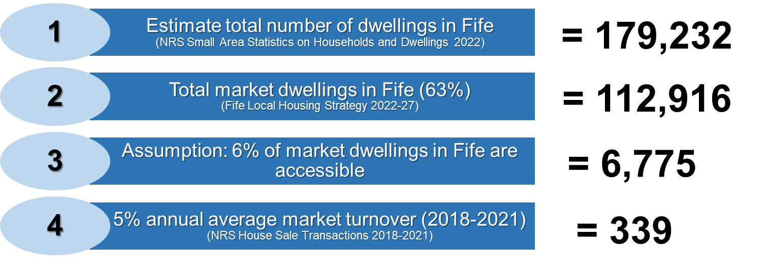
Of the estimated 179,232 dwellings, 63% are located in the owner occupied sector and could become available for sale in the Fife housing market each year (112,916 homes).
Of this number, it is estimated that 6% of all market homes are accessible; based on the proportion of social housing units which are either fully wheelchair accessible (1%) or partially accessible (5%). Whilst the proportion of accessible homes is likely to be higher in the social housing sector than in market housing, this assumption is based on credible evidence of the Fife stock profile. Applying this 6% equates to 6,775 accessible market homes across Fife.
Analysis of house sale transactions in Fife over the last 5 years, suggests that on average 5% of market homes are sold in the market each year. Applying this 5% turnover rate to accessible homes, estimates that 339 accessible properties which will be sold in the Fife housing market each year.
To translate this estimate into wheelchair and accessible housing, results from the 2022 household survey have been applied. Of the population of wheelchair user households living in adapted housing, 15% stated that their homes were fully wheelchair adapted. On this basis, it is assumed that 15% of the 339 accessible market homes are fully wheelchair accessible, with 85% partially accessible.
As there are no published statistics on the number of new homes built to accessible standards each year by private developers, market housing supply of wheelchair and accessible housing is estimated as follows:
 | Wheelchair housing | Accessible housing | Total
Stock Turnover Market Housing | 51 | 288 | 339
Annual New Build Supply
Total Annual Supply | 51 | 288 | 339
Table 8.8: Annual number of wheelchair and accessible market housing units available to meet need

Net Annual Wheelchair & Accessible Housing Estimates
Adjusting total annual need for wheelchair and accessible housing with annual housing supply creates the following estimates for wheelchair and accessible housing:
NET Wheelchair housing estimates | Market housing | Affordable housing | Total
Total NET Annual Requirement (5 years) | 26 | 28 | 54
Total NET Annual Requirement (7 years) | 10 | 9 | 19
Total NET Annual Requirement (10 years) | -2 | -5 | -7
Table 8.9: Annual number of wheelchair housing units required by tenure
NET Accessible housing estimates | Market housing | Affordable housing | Total
Total NET Annual Requirement (5 years) | 49 | -74 | -25
Total NET Annual Requirement (7 years) | -22 | -157 | -178
Total NET Annual Requirement (10 years) | -75 | -218 | -294
Table 8.10: Annual number of accessible housing units required by tenure
Assuming that a 5-year projections period is utilised to meet the need for wheelchair and accessible market housing, when benchmarked against average annual market completions in Fife (677); this estimate would account for 11% of all annual housing completions. When broken down by wheelchair and accessible housing per annum, the following outcomes are derived:
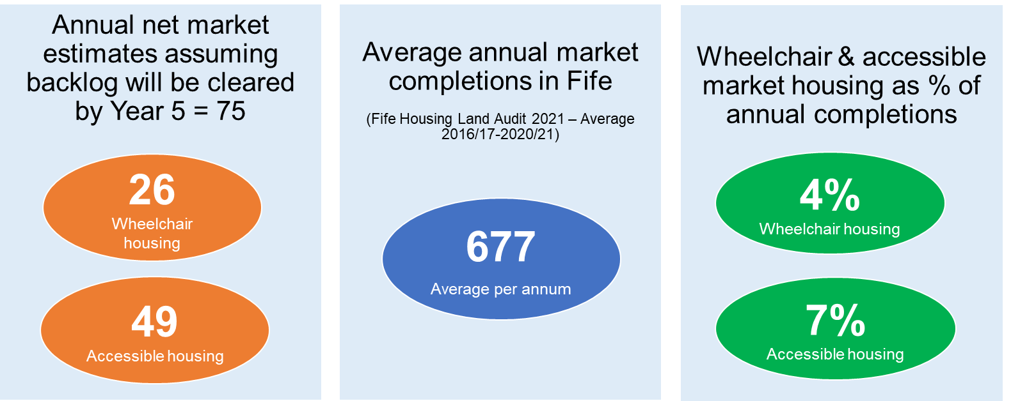
Assuming that a 5-year projections period is utilised to meet the need for wheelchair and accessible affordable housing, when benchmarked against projected annual SHIP completions in Fife (211), 46 more affordable homes than estimated will be delivered as follows:
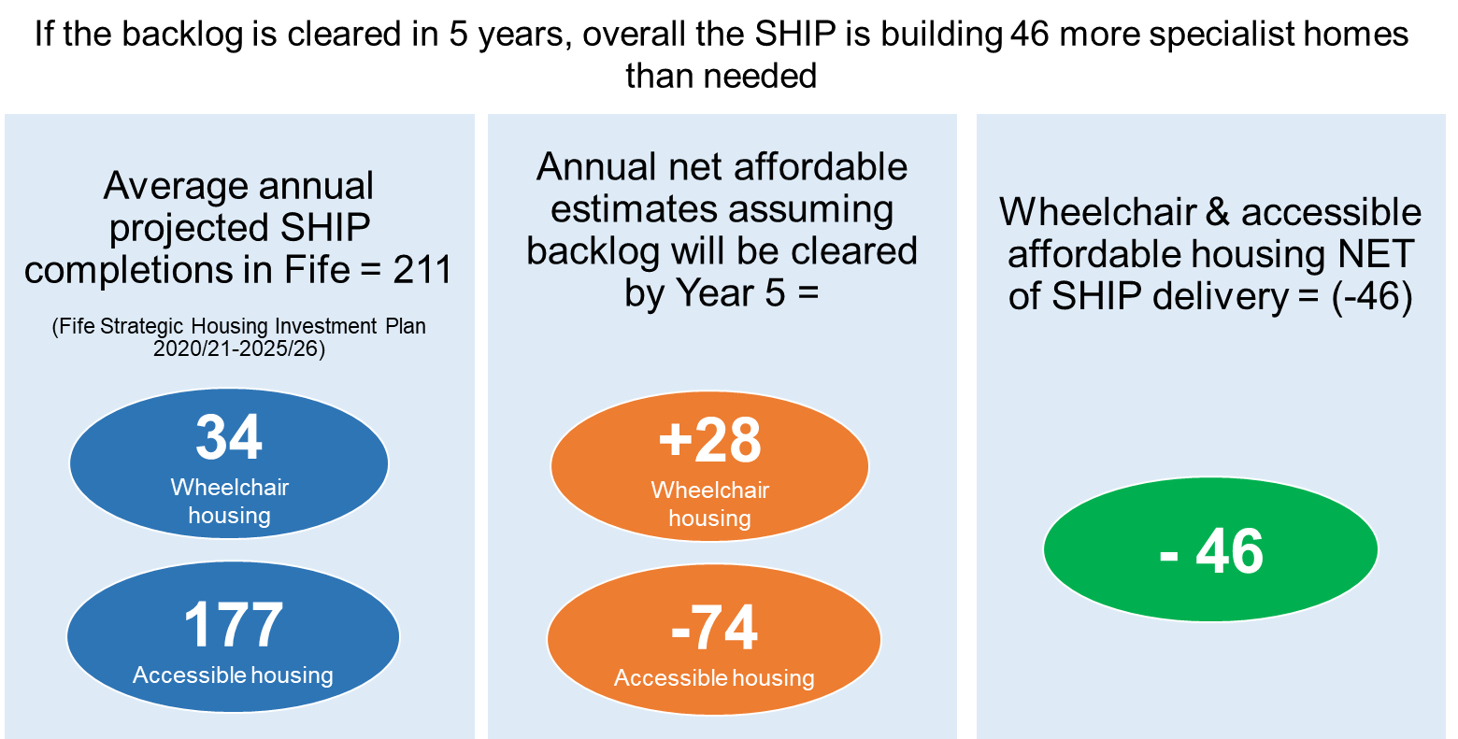

Key Findings: Annual Wheelchair & Accessible Housing Estimates
Steering Group discussion confirmed that the wheelchair and accessible housing calculation should assume that the backlog of households in unsuitable housing should be cleared over a 5 – 7 year projection period to minimise the length of time that households require to wait for alternative housing.
On this basis and taking into account potential supply arising from the Fife housing market; the maximum requirement for wheelchair and accessible to be delivered by private housing developers is estimated to be 75 units per annum, which accounts for 11% of average annual completions. This equates to 4% of market completions to be delivered as wheelchair accessible homes and 7% as accessible homes.
Taking into account the turnover of accessible homes arising from the Fife social housing sector; the requirement for wheelchair and accessible to be delivered by social housing developers is 165 units per annum. When projected annual delivery of the affordable homes through the SHIP is considered (211 homes per annum), affordable housing delivery exceed estimated requirements by 46 units per annum.

Key Findings and Recommendations
This research study has been successful in delivering a number of outcomes to support ongoing assessment of the extent and nature of wheelchair and specialist housing provision, unmet housing need and future requirements across Fife. It has provided:
- standard definitions of what is meant by wheelchair and accessible housing that partners can use to inform data collection, sharing and insight programmes
- analysis of the extent of data to determine existing wheelchair, accessible and specialist housing provision and highlighted gaps that could be addressed to improve this insight
- an opportunity to strengthen and/or build partnership working across services, organisations and sectors and the sharing of data and casework to improve outcomes for people with specialist housing needs
- insight on unmet needs for wheelchair, accessible and specialist housing across housing tenures via the primary research element of the project
- an opportunity for services users to influence research outcomes and policy interventions
- a basis to assess the requirements for wheelchair, which supports Fife Council to develop multi-tenure targets for inclusion within the new Local Housing Strategy and Strategic Housing Investment Programme.
Furthermore, the 2022 Fife Wheelchair & Specialist Housing Study has succeeded in delivering credible insights into the extent and nature of accessibility offered by the current Fife housing stock, as well as the circumstances, unmet needs and intentions of Fife households who require wheelchair, accessible or specialist housing. The following research findings synthesise desk-based, primary and lived experience research outcomes to present this insight.

Wheelchair & Accessible Housing Study Findings
Survey outcomes indicate that up to 40% of all dwellings in Fife are aged between 50-100 years old. Older properties are generally more challenging to repair, adapt or meet modern energy efficiency standards and may present accessibility challenges for households with progressing health conditions or disabilities. Despite this, 80% of survey respondents indicate that they do not have any problems with property condition or repairs, suggesting this not an overwhelming concern or major driver of housing unsuitability in Fife. However, just under a third of households could be experiencing problems with overcrowding which could further limit housing accessibility for households with health conditions or disabilities.
Around 65% of households in Fife live in low rise homes which provide a form of ground floor accommodation, offering at least some potential of achieving housing accessibility. However, more than 1 in 2 households (53%) indicate that they have internal stairs within their home, with a further 20% living in homes with both internal and external stairs. This means that three quarters of Fife households live in dwellings which present structural barriers to households with health conditions and physical disabilities. There is evidence to support this view, with survey feedback that ‘managing stairs at home’ is problematic to 46% of households with health and mobility issues.
Over and above this, around 30% of households live in flatted accommodation, with 54% living at height and without access to a lift. Such households are therefore currently living in dwellings that are likely to offer limited accessibility. This is borne out by survey results which show a majority of flat dwellers with health conditions and disabilities currently living in housing which does not meet the needs of their household, including 73% of those who live in high rise dwellings and 48% of those who live in other types of flats.
These accessibility barriers become further evident when considering the proportion of households who would not be able to accommodate a wheelchair user visiting their home. The vast majority of respondents (74%) indicate that someone using a wheelchair would have difficulty visiting their home, including accessing the property from street level and moving around inside without difficulty. Survey feedback also indicates that external environments and neighbourhoods are not wheelchair friendly, with 58% of households indicating that the location of their home was either not suitable or very unsuitable for someone using a wheelchair or with limited mobility. Lived experience research outcomes reinforce these findings, with the creation of accessible neighbourhoods, parking and quality outdoor space, a priority for those currently limited by their existing home.
Despite these barriers, the majority of households in Fife (71%) indicate that the amenity offered by their current home in no way limits the day to day activities of their household and can therefore be considered to be living in suitable accommodation. Furthermore, there are high levels of satisfaction with existing homes across Fife, with 9 out of 10 households (94%) indicating they are either very (68%) or fairly (26%) satisfied with their current housing and how it meets the needs of their household.
Pull factors into existing housing focus on location and proximity to family and support networks rather than the suitability or accessibility of a home. Just 2% of households moved into their current property because it was specifically designed or adapted to meet their needs. Whilst 9/10 households indicate that their home was suitable for the needs of the households when they first moved in, this drops to 70% when the household considers housing suitability at the present time. In total, 30% of households describe their current home as no longer suitable to meet the needs of their household. Despite this, only 12% households indicate that they need to move home, whilst 27% said they would like to move. For those households who indicate that they are planning to move in the next two years, 1 in 5 state they need to move to a level access property or require accessible housing to meet health or disability needs.
1 in 2 respondents (52%) identify someone in their household who has a long-term health condition or disability, with up to 40% indicating that their current housing does not meet the needs of their household. Of this group, high proportions of respondents are living in rented housing which does not meet the needs of their household including the PRS (52%) and social housing (51%). Almost 1 in 10 households in Fife (9%) contain a household member who requires to use a wheelchair, with just 1 in 5 living in a fully accessible wheelchair property.
Almost a quarter of respondents with health conditions and disabilities (23%) feel that someone in their household has an unmet need for specialist housing, with the most common requirements for accommodation without stairs (14%) followed by housing for older people (5%) and wheelchair housing (2%). To this end, 10% of all social housing units in Fife offer specialist housing options (3,902). Of the 3,900 specialist homes available, 5% are wheelchair accessible, 56% are accessible/amenity homes and 38% are homes for older people. There are clear pressures on the available supply of wheelchair housing with 15 housing applicants for every property that become available. Pressure ratios for accessible housing (5:1) and older people’s housing (9:1) are also considerably relative to expressed need. To address this, the delivery of the Strategic Housing Investment Plan in Fife over the next 5 years, will increase the supply of accessible homes in the social housing sector by over 50%. Over and above this, a further 215 units of wheelchair housing are scheduled for delivery (around the same numbers developed in the last 2 decades). This will more than double the number of wheelchair homes available in the social housing sector in Fife.
Aligned to this increase in accessible and wheelchair housing supply, lived experience outcomes suggest there is also a need to critically review the process for allocating homes to households who require specialist housing. The current allocations policy and process is seen as fragmented and described a ‘barrier’ by many households currently waiting for an offer of wheelchair or accessible housing. Furthermore, improvements in communication, person centred needs assessment and housing options information and advice is recommended by service users.
As there is no publicly available data on the accessibility of homes in private housing tenures or the number of accessible home delivered by private sector developers in Fife, it is difficult to gauge the extent to which households in owner occupation will be able to meet their needs in the Fife housing market. As a minimum, setting cross tenure targets for accessible and wheelchair homes and working with private developers to support and monitor delivery could improve the range of private sector accessible housing options. Delivering market housing options which are as affordable as possible also needs to be given careful consideration, with lived experience evidence suggesting that accessible market homes are out of reach for many households with a health condition or disability.
Whilst specialist housing is identified as a solution for 1 in 4 households, 31% of households with a health condition or disability identify a need for property adaptations to make their home more suitable, with the most common requirements including level access showers (11%) followed by handrails (9%). In 2020/21, over £2.3M was invested in property adaptations across Fife, supporting the installation of over 850 adaptations. The most common adaptations included bathroom/shower adaptations, safety rails and door widening. Further investment in property aids and adaptations is very likely to be required across all housing tenures, as the household population in Fife ages and mobility and frailty issues become more apparent. Furthermore, lived experience insight suggests a need to target the delivery of property adaptions to social housing applicants who are currently waiting for accessible or wheelchair homes for extended periods of time, in order to mitigate the deterioration of health and wellbeing.
In terms of forward planning to meet housing need, a third of all Fife households have never considered the future suitability of their current home and of those who have considered future needs, 40% have yet to explore alternative options or take any action. In that respect and given the significant changes to the age profile of Fife households, raising the profile of public debate around housing accessibility and available housing options in Fife, should perhaps be considered as a public health priority.

Wheelchair & Specialist Housing Study Conclusions
Research findings conclude that housing accessibility in Fife is particularly challenging given estimates that:
- three quarters of the existing housing stock in Fife would not be accessible to a wheelchair user
- a quarter of households with a long term health condition or disability do not feel their current home meet the needs of household members.
Key conclusions in relation to the accessibility of the Fife’s housing stock profile can be summarised as follows:
- 40% of homes in Fife were built before 1945 making them less likely to be accessible or adaptable
- 28% of all homes in Fife are flats and just 6% of households at height have access to a lift
- 73% of all homes (both flatted and low rise) have internal stairs
- 74% of households said a wheelchair user could not visit or access their property.
Triangulating this evidence suggests that just 1/4 of all homes across the Fife area have the potential to offer accessible housing opportunities.
Key conclusions on unmet requirements for wheelchair, accessible and specialist housing can be summarised as follows:
- 52% of households in Fife have a long-term health condition or disability
- 24% believe they have an unmet need for specialist housing including:
  - 2% who require wheelchair housing
  - 14% who require accessible housing (ground floor or without stairs)
  - 5% who require housing for older people
  - 1% who require supported housing
- when other survey measures of unmet housing need are assembled, estimates range from just under 7,000 (households who NEED to move to a wheelchair and accessible home in the next 2 years) to over 13,000 (households with an unmet need for specialist housing). Triangulating these findings suggests that roughly 10,000 households across Fife self-assess a need for wheelchair and accessible housing.
Estimates of the future requirements for wheelchair and accessible housing are defined as follows:
- there is currently a backlog of 3,301 homes across Fife: 612 wheelchair homes and 2,689 accessible homes
- every year, it is estimated that 234 new households will require specialist housing including 43 wheelchair homes and 190 accessible homes
- total estimates for specialist housing across Fife range from 564 per year to 894 (depending on whether the backlog cleared in 5 years – 10 years)
- it is estimated that 865 specialist homes become available in Fife each year including 526 affordable homes and 339 market homes
If the backlog need for specialist housing is cleared over 5 years:
- affordable housing developers will build 46 more specialist homes than needed
- market developers will require to deliver 75 specialist homes per annum, 11% of all market completions per year.

Wheelchair & Accessible Housing Study Recommendations
Throughout the course of this study a number of recommendations have been assembled that Fife Council and partners may wish to consider and take forward with partners to:
- enhance the provision of wheelchair and accessible homes in the market sector Fife
- build on the insight needed to understand better existing provision
- develop mechanisms to support the gathering of newly forming needs
- develop support services to meet the needs of individuals seeking specialist housing
- consider the roll of in-situ solutions in meeting need given the prevalence of existing supply.
These improvements/recommendations are scheduled by theme as follows:
Ref | Recommendation
1.0: New Supply
1.1 | Increase the supply of wheelchair housing in both affordable and market sectors, aligned to cross-tenure targets for new build wheelchair housing
1.2 | Consider the introduction of planning policies and design specifications which encourage delivery of accessible and wheelchair homes from market developers. The Housing for Varying Needs Review should address this issue at a national level; however, agreement at a local level through updated design guides/building standards should be considered
1.3 | Support proactive engagement with private developers to monitor the delivery of wheelchair and accessible homes
1.4 | Work with developers to better understand the barriers to developing accessible and wheelchair homes and define delivery models that support increases in supply
1.5 | Consider the role of MMR as an alternative to accessible social housing within the Strategic Housing Investment Plan
1.6 | Improve data collection and analysis of newly forming or pipeline need for wheelchair and accessible housing across housing, health and care professionals to ensure early planning and commissioning
2.0: Existing Supply
2.1 | Improve intelligence on the accessibility of existing housing across all tenures including property adaptations and accessibility features by considering the development of a property register
2.2 | Work with estate and letting agents to improve public information on housing accessibility for homes to let or for sale
2.3 | Consider a property acquisitions programme to target area shortfalls in wheelchair and accessible homes in the social housing sector
2.4 | Work with private landlords to improve property amenity information for PRS homes across Fife
2.5 | Review Fife Housing Register allocation policy and processes to address perceived barriers to wheelchair and accessible housing for households with health conditions or disabilities
2.6 | Encourage social landlords to invest in future proofing housing accessibility when properties are undergoing void repairs
3.0: Partnership Working
3.1 | Work collaboratively with partners including planning, HSCP and the third sector to review long term housing applications for specialist homes, assessing solutions jointly with service users, including the installation on interim property adaptations
3.2 | Engage with planning colleagues at early stages of new build developments to improve the accessibility of streets, parking, neighbourhoods and outdoor space for households with specialist housing needs
3.3 | Work collaboratively to promote the benefits, increase awareness and make better use of technology within a housing setting to enable independent living
3.4 | Develop a housing options approach to information and advice for households applying for wheelchair, accessible and specialist homes
3.5 | Create data sharing protocols which use the common definitions for wheelchair, accessible and specialist housing to guide data specification and capture
3.6 | Engage Registered Social Landlords across Fife in updating the data matrix developed for this study detailing wheelchair, accessible and specialist housing stock, turnover and demand
3.7 | Work with partners to resource a dedicated role which coordinates activity across occupational therapy, social care and housing services, supporting the delivery of person centred housing needs assessments and streamlining the housing allocation process
4.0 Support and Care Services
4.1 | Consider the provision of a one-stop shop for Fife residents to access advice and support on finding an accessible home or adapt their existing home
4.2 | Promote the provision of the Care and Repair scheme to homeowners who require property adaptations
4.3 | Improve the accessibility of the FHR application process including the development of a person centred advice model for households with specialist housing needs
4.4 | Consider a public health media campaign on the importance of making early decisions on meeting future housing accessibility needs
5.0 In-situ solutions
5.1 | Review adaptation processes with a view to streamlining applications and waiting times
5.2 | Review the Council’s Scheme of Assistance and funding available to homeowners for disabled adaptions
5.3 | Improve awareness on technology enabled care (TEC) through training and development of housing staff and partner agencies
5.4 | Review the resourcing of TEC from a budgetary and staffing perspective and explore the potential that this could offer
5.5 | Create a register of adapted homes
It is recommended that the Council’s Wheelchair and Specialist Housing Steering Group critically review these recommendations in detail for inclusion in the Local Housing Strategy, HSCP Strategic Commissioning Plan and Fife Local Development Plan.

The Steering Group comprised partners from Fife Council services including Planning, Housing Strategy, Affordable Housing & Regeneration, Occupational Therapy, Housing Adaptations and the Fife Housing Register; as well as partners from locally operating RSLs and the Disabled Persons Housing Service in Fife
Estimated completions include a 27.5% over provision to allow for slippage/ensure full AHSP grant expenditure
Estimated completions include a 27.5% over provision to allow for slippage/ensure full AHSP grant expenditure
For the purposes of the wheelchair and accessible housing calculation, estimated SHIP completions do NOT include a 27.5% over provision for slippage, to ensure that projected delivery is not overstated

