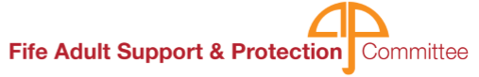
ADULT SUPPORT AND PROTECTION UPDATE

The Adult Support and Protection Committee had two surveys to find out what people thought.

The first survey was about Adult Protection. It could be filled out by anyone. 543 people did the survey.
This is what it found out.

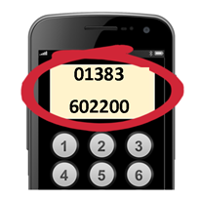
- Just over half (52%) of the people knew about the Adult Protection Phone Line.

- Most people would call the Adult Protection Phone Line or the Police if they wanted to report harm.


- Most people (68%) did not use Easy Read information.

    - Most people (76%) had not done the Adult Protection e-learning. This is training done on a computer.

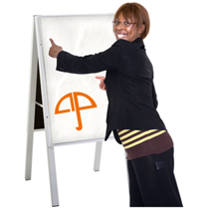
- Half of people who had a job (50%) had been given Adult Protection training by their employer.

People had lots of ideas about new Adult Protection information.

The second survey was about accessible information.
Accessible means in a way that you can understand it.
The survey was sent to staff who work in Health and Social Care services.

This is what it found out:

- Nearly everyone (93%) thought that accessible information is for everyone


- Easy Read, large print, and information translated into different languages were the kinds of accessible information that most people had used.
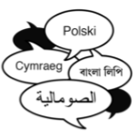

- Most people (64%) could either create Easy Read information, or would know who to ask about it.

- Most people (83%) had not used any Adult Protection Easy Read resources

- Many people (54%) do not have Easy Read resources in their part of their organisation.
- Many people (66%) would use an Easy Read service.
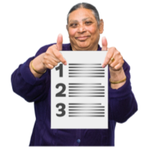

The Adult Support and Protection Committee have looked at all the survey results and have made a plan.


Thank you to everyone who took part in the survey.

