PUBLIC NOTICE
THE COMMUNITY EMPOWERMENT (SCOTLAND) ACT 2015
NOTICE OF CONSULTATION ON DISPOSAL OR CHANGE OF USE OF COMMON GOOD PROPERTY

Fife Council propose to change the use of a common good property: Tennis Court, Dunfermline Public Park, St Margaret’s Drive. Some time ago a Skate Park & Ball Court were developed on the eastern and central tennis courts with the western court retained. It is now proposed that the existing Skate Park be refurbished and extended into part of the Ball Court area. In time proposals will be brought forward for the redevelopment/refurbishment of the remainder of the Ball Court and the remaining Tennis Court. Before taking a decision, the Council requires to consult under Section 104 of the Community Empowerment (Scotland) Act 2015.

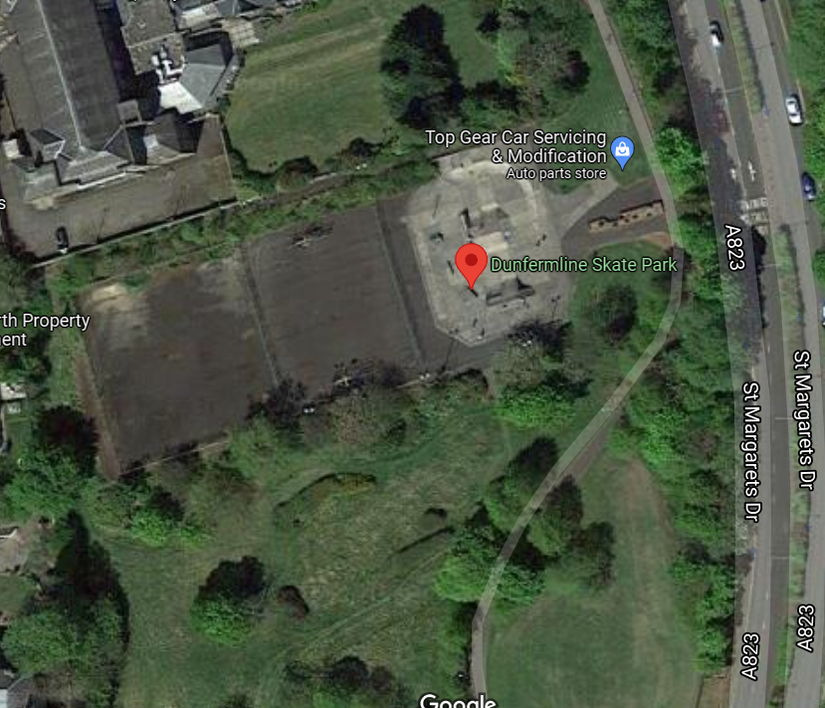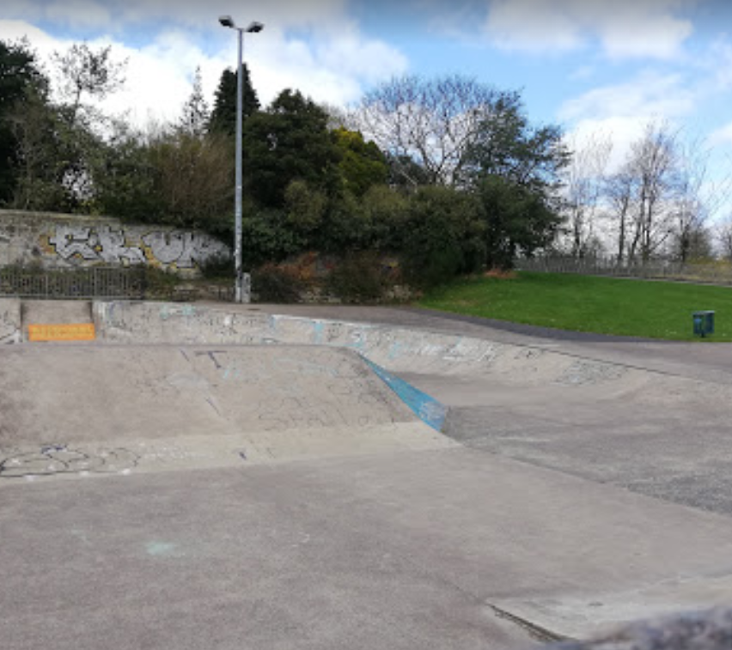
(Above photos) – Dunfermline Skate Park

Change of Use Request:

A local group, The Dunfermline Regeneration Trust, are raising funds to redevelop/improve the existing skate park facilities in Dunfermline Public Park. It is considered that the improvements to the skate park would encourage greater use of the facility and bring back skaters who travel to other areas of Fife and beyond in search of better facilities. Neither the Ball Court nor Tennis Court are used for the purpose intended and the area is attracting anti-social behaviour and has become a victim of vandalism. The new facilities will accommodate and attract a number of skate park users. The park will have no timeframe restrictions for users and will always be available and open for public use. Upon completion of the works the skate park will be maintained by Fife Councils Grounds Maintenance Service. The location plan for the skate park is available here. Location Plan-Skatepark, Dunfermline.pdf

This proposal would be subject to Full Planning Consent, and all other necessary statutory approvals and consents.

Representations:
Anyone may make representations about this request to Fife Council. Representations must be in writing and include the name and address of the person making it. All representations will be published at: www.fife.gov.uk/commongood

Representations must be received by Wednesday, 3rd August 2022. They should be sent to Zahida Ramzan, Policy Co-ordinator, Fife House, Glenrothes, KY7 5LT or to Zahida.ramzan@fife.gov.uk or to communityasset.transfer@fife.gov.uk.

Date of Notice: 7th June 2022

