
temporary raised Structures
CUSTOMER GUIDANCE
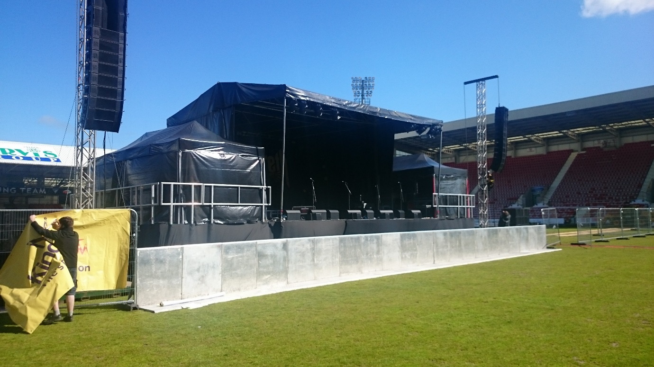
July 11, 2018
Fife Council
Public Safety Team

Temporary raised structures
Section 89 of Civic Government (Scotland) Act 1982 stipulates that temporary raised structures require local authority approval prior to use.
Fife Council consider that temporary raised structures where
- any part of the floor or platform level is 600mm or more above ground level and
- which persons have access onto
shall require approval.
Typical examples of temporary raised structures (where they meet conditions 1 & 2 above) generally include, but are not limited to; stages, grandstands, tents & marquees, other specialised raised platforms e.g. scaffolding for television towers.

PROCEDURE
- Applications must be submitted using our application form (appendix 2)
- The application form includes a list of the information that is to accompany the application and validation and assessment of the application will not commence without the associated fee being paid
- A Chartered Engineers third party check of the structure(s) will be required at either the design stage or the site stage or potentially both
- The application and accompanying information must be submitted to allow reasonable time for assessment. Any additional potential risks for untimely* or poorly detailed submissions may incur additional requirements and checks e.g. you may expect a Chartered Engineers site sign off to be insisted upon.
- The requirements and recommendations of this document must be adhered to and this aspect will be a condition of the Section 89 approval certificate
- The applicant is advised to ensure any constraints and client responsibilities noted on the structural drawings are addressed prior to submission of the section 89 application. Notes on drawings such as “client to ensure the ground supporting the proposed structure is suitable for the loads imposed by the structure as noted” should be considered as part of the application. Failure to do so may result in the insistence on Chartered engineers site sign off
*submitted days rather than ideally weeks before the event

Application design & assessment
The Officer undertaking the design and site assessment (once the structure is completed) and those submitting for a section 89 application and issue of consent must, in the course of undertaking these assessments or submission and in relation to the type of structure, make appropriate use and reference to;
- the ‘checklist for S89 assessment’ within this protocol
- document, ‘I StructE temporary demountable structures’
- document, ‘Guide to safety at sports grounds’ (green guide)
all of which can be found at the following central location, internally for Officers, or are also freely available on the world wide web for those making a submission;
P:\U00 Planning n Building Control\U01 Building Standards and Safety\U01.04 Public Safety\U01.04.05 Section 50 & 89 Consents\Section 89\Design Guidance
- and the non-domestic technical handbook
The finer details of requirements to those listed in the checklist for section 89 submission and assessment can be obtained from these referenced documents.

Checklist for Section 89 submission and assessment
The following table confirms the minimum checks required by Public Safety Team Officers and also the minimum information required to be submitted and site works undertaken by applicants for section 89 approval. The checks are not exhaustive and Officers and applicants still require to use their knowledge and experience to recognise & consider each event and structure independently for possible wider bespoke considerations and requirements to those general matters listed below. This includes where the structure type sits outwith the scope of the table, it would then be expected that the checklist is used to help formulate a relevant bespoke checklist. Note, the checklist requires to be read in conjunction with the following expanded explanatory notes and with the finer detail included within this report and with the reference documents also previously cited within this report. The checklist is a guide to helping ensure that salient Public safety matters are considered by both the Applicant and the assessing Officer(s).

I check required I type of structure I
DESIGN  (office based work) |  | Grandstand | Stage | Marquee/Tent | camera tower/leader boards/smaller/ltd access structures | TV studios
 |  | design shall consider ‘Green Guide’ | 1. guardrails required to side and rear (min. top and mid rail)  2. crowd segregation from stage ideally by barriers |  | barriers with top and mid rail can be considered acceptable to full protective barrier requirements | barriers with top and mid rail can be considered acceptable to full protective barrier requirements | satisfactory?  Yes No n/a
 | - = check applies to structure
 | structural drawings (plans, elevations and sections)
 | structural calculations or design certificate
 | maximum design wind speed and contingency planning
 | qualifications & experience of designer
 | public liability and professional indemnity insurance
 | independent check by chartered engineer
 | consideration given to type of spectators or users i.e. crowd dynamics e.g. golf versus music concert (re: natural frequencies for stability) |  | - (possible for dynamic bands) | _ | _ | _
 | ability to support suspended equipment e.g. for sound and lighting | not usually |  |  | not usually | not usually
 | allowance for site constraint on footing design i.e. slope and type of ground (verified or not, impact?)
 | allowance for possible vehicle impact
 | issue marquee standard conditions (appendix 1), if applicable | _ | _ |  | _ | _
 | consultation with fire authority | not usually | not usually |  | not usually | not usually
 | fall from height/protection against falling considered (barriers & handrails)
 | viewing for wheelchair users |  | _ | _ | _ | _
 | layout for means of escape adequate (e.g. evenly distributed exits, place of safety easily reached away from structure, escape routes uniform with no narrowing, outward opening doors (with push bars), travel distances met) |  |  |  | Usually restricted ladder access by trained staff with risk assessment | - (possible)
 | anchorage adequately detailed | - (if applicable) | - (if applicable)
 | wind loading adequately considered
 | flame retardant capacity of materials & linings ok | - (possible) | - (possible) |  | - (possible) | - (possible)
 | separation from other structures adequate (fire spread) | - (possible) | - (possible) |  | - (possible) | - (possible)
 | fire detection system adequate (if part of risk assessment requirement)? | _ | _ |  | _ | not usually but possible
 | proposed occupancy numbers ok for floor space factors/seating arrangements etc., use and mean of escape provisions |  |  |  | _ | - (possible)
 | maintained emergency lighting and signage ok | _ | _ |  | _ | - (possible)
 | means of audible fire warning or need to evacuate confirmed |  |  |  | _ | - (possible)
 | toilet provisions adequate | _ | _ |  | _ | _
 | wheelchair provisions ok |  | _ |  | _ | _
 | all ramp and step arrangements (handrails and balustrades also (types & heights)) ok
 | all protective balustrading to possible areas of fall from height (e.g. balcony area, stair landings) ok
 | consideration given to glazing manifestation | _ | _ |  | _ | - (possible)
 | decking, ailses, steps and ramps to be of non-slip materials
 | step nosings to be highlighted |  |  |  | - possible
 | stairs and ramps ok e.g. rise, going, landings, pitch etc. ok |  |  |  | - possible
 | low level glazing to BS6262 (safety glass) | possible | _ |  | _
 | glazing used as protective barrier to BSEN 1991-1-1/PD 6688-1-1 | possible | _ |  | _
 | flag poles adequately considered |  | not usual | - (possible) | not usual | not usual
ERECTION & USE  (site based work) |  | Grandstand | Stage | Marquee/Tent | camera tower etc. | TV studio
satisfactory?
Yes No n/a
 | evidence of check and sign off by competent person
 | evidence of check and sign off by chartered engineer | - (needed in most cases due to involvement of large numbers occupying these) | - (not required for smaller well managed stages) | - (only generally required where multi storey) | _ | - (if not at design stage- quite common)
 | sign off submitted by the client/event organiser (appendix 3) |  |  |  | _ | _
 | method of monitoring of wind speed & contingency provision in place
 | footings & ground levels as per design detail
 | anchorage/kentledge as per design detail | - (if applicable) | - (if applicable)
 | marquee conditions met, if applicable? | _ | _ |  | _ | _
 | allowance of weather conditions for time of event e.g. wind, heavy rain, snow
 | required joint visit with fire authority? | _ | _ |  | _ | _
 | fall from height provisions (barriers & handrails)
 | viewing for wheelchair user provision |  | _ | _ | _ | _
 | layout for means of escape adequate (e.g. evenly distributed exits, place of safety easily reached away from structure, escape routes uniform with no narrowing) |  |  |  | _ | - (possible)
 | flame retardant capacity of materials & linings ok | - (possible) | - (possible) |  | - (possible) | - (possible)
 | separation from other structures adequate (fire spread) | - (possible) | - (possible) |  | - (possible) | - (possible)
 | fire detection system adequate (if part of risk assessment requirement)? | _ | _ |  | _ | - (possible)
 | maintained emergency lighting and signage ok | _ | _ |  | _ | - (possible)
 | any loading hanging from tent not included in the design | not usually |  |  | not usually | not usually
 | snow loading considered, if applicable | not usually | not usually | - (critical since marquees not designed for this) | not usually | not usually
 | electrical works signed off | not usually | not usually |  | _ | - (possible)
 | all ramp and step arrangements (handrails and balustrades also) ok
 | toilet provisions adequate | _ | _ |  | _ | _
 | wheelchair provisions ok |  | _ |  | _ | _
 | all protective balustrading to possible areas of fall from height (e.g. balcony area, stair landings) ok
 | glazing manifestation ok | _ | _ |  | _ | - (possible)
 | decking, ailses, steps and ramps of non-slip materials
 | step nosings to be highlighted |  |  |  | _
 | stairs and ramps ok e.g. rise, going, landings, pitch etc. ok |  |  |  | _
 | no materials or other identifiable fire risk stored beneath the structure |  |  |  | _
 | low level glazing to BS6262 (safety glass) | possible | _ |  | _
 | glazing used as protective barrier to BSEN 1991-1-1/PD 6688-1-1 | possible | _ |  | _

Expanded explanatory notes for reference in use of the above checklist for submission/assessment
Design
- Design documentation: should include
- Structural drawings (plans, elevations and sections)
- Structural calculations or Design Certificate/statement
- Maximum wind speed that the structure is designed to withstand with appropriate contingency plan for high wind speed
- Evidence of competence: Qualification and experience of the designer to be evidenced. Also require evidence of public liability and professional indemnity insurance.
- Evidence of an independent check has been carried out by a chartered engineer (chartered structural or civil engineer, being a member of the institution of structural engineers or the institution of civil engineers, with appropriate experience in the context of temporary structures.

Erection & Use
- Evidence of an independent erection check has been carried out by
- a chartered engineer and/or
notes,
¹ this is required in addition to the competent person check where no independent design check has been undertaken
² it may be considered prudent for large scale or multi storey or complex structures and events to have this sign off in addition to both the competent person check and the design check
³ this is required in addition to the competent person check and any previous independent design check when on site deviations from the submitted and approved design are encountered
- a competent person (usually installer/supplier/erection team and submitted on their own completion/sign off paperwork)
- Section 89 standard sign off sheet (appendix 3) to be completed by
- the client (person or company procuring the raised structure – not always the same as the event organiser) and
- the checking engineer (if they do not complete on their own headed paper)
- Monitoring of wind speed must be carried out with contingency planning evidenced to safely respond should wind speeds approach the design limit i.e. how is wind going to be monitored and managed adequately – this should be a written statement to include who is responsible and who makes the decision to act or abort if needs be (this will need to be evidenced as someone with influence and authority during the event)
- Take account of vertical imposed loadings by lighting and sound equipment and note, depending on design details, heavy rain or snow should also be considered e.g. inflatable roofs may potentially become loaded by standing water in heavy rains
- check during the site works that all footings and ground levels as built match the design or design tolerances or assumptions
- check that all anchorage/kentledge is as designed e.g. not water ballast in place of ground spikes and vice versa.
Any noted differences between the design stage detailing and the site installation detailing means the design stage of this process should be redone to ensure a match and that the change made on site is indeed satisfactory.

Issue of consent
Once both the design and site assessment have been completed in accordance to the above procedure and to the authorised Public Safety Officer’s satisfaction then instruction can be given to issue the permission to erect and use certificate (appendix 4)

Enforcement
Any person who uses or permits usage of a temporary raised structure without local authority approval shall be guilty of an offence and liable, on summary conviction, to a fine.

Appendix 1
MARQUEES, STANDARD CONDITIONS

The following critical elements may affect public safety in marquees and tents and both assessing Public Safety Officers and those involved in the process of applying and obtaining section 89 consent (event organisers, clients, supplier, installers, engineers) shall consider and implement the following minimum, but not exhaustive, considerations;
- Anchorage

suppliers, installers and engineers require to consider and confirm as adequate for their respective signs-offs;

- type of ground,
- moisture content of ground,
- inclination of anchor,
- depth of anchor,
- type of anchor
- ballast weights (kentledge), if used in place of ground anchors

- Wind Loading

suppliers, installers and engineers require to consider and confirm as adequate for their respective signs-offs;

- the maximum design wind speed for the structure
- monitoring of weather forecasts prior and during period of use
- monitoring of actual site conditions, using on site anemometer(s)
- a clear contingency plan of actions to be taken versus on site wind speed measurements with identification of individuals with a position of influence to enact the contingency plan.

- Flame retardant capacity of materials
The membranes and fabrics of the marquee should be inherently flame retarded fabric or durably flame retarded fabric when tested to British Standard 7837 or 5438, tests 2A and 2B. Other linings should have a class 1 surface speed of flame to comply with British Standard 476, Part 7.

All unattached lining drape material should comply with type B performance of BS5867: Part 2.

- Quality of as built structure
After erection and before use, a tent or marquee should be thoroughly inspected and signed off by the contractor. The inspection should be based on a checklist and should include the following points which are recommended in the PTA code of practice.
- Anchorages should be suitable for the purpose and soil condition and are holding fast
- Bracing wires should be in place and properly tensioned
- All ropes, including wire ropes, are sound
- The fabric should be tensioned and not prone to ponding
- Exposed rope and staked adjacent to entrances and exits should be marked or fenced off
- All locking pins and bolts should be in place and secure
- Eaves connection joints should be securely locked home
- The fabric should not have any significant damage
- Flooring should be evenly laid, securely fixed, with no tripping points
- Timber uprights and ridges should be free from splits caused by damage that can lead to failure
- Walls should be securely pegged and/or secured
- Poled marquees should have a full complement of side uprights, anchor stakes, pulley blocks and gut ropes.
- The main upright should be independently guyed
- Emergency exits are in place and operational without obstruction
- Escape routes are clear of obstruction
- All structural supports are sound without cracks or significant dents and not overstressed
- Suspended weights are evenly distributed and do not overload the structure; no excessive weights suspended from roof beams, ridges etc.
- Flame retardant labelling is in place on every panel

- Fire & Emergency Exits
Note, whilst specific reference is made to the non-domestic handbook (NDH) it is possible that other reference guides and sources could demonstrate adequacy of the design but Public Safety Officers will initially default to the guidance of NDH
- The organiser or an appointed representative should carry out a Fire Risk Assessment which should assess:

- The fire risk from tents, stalls and other structures
- The provision of fire warning/detection
- The means of escape from fire
- access/egress doors and routes;
  - numbers and positioning e.g. more than 50 people, at least two exits distributed around the tent (table 2.12 NDH)
  - type and arrangement of exit points e.g. velcroed flap exits to be manned at all times or ‘normal’ door arrangements with push bar release, all doors to open outward in direction of escape
  - travel distances (table 2.11 NDH)
  - identify to a place of safety and/or assembly point
- occupancy numbers (table 2.10 NDH)
- maintained illuminated exit signs to BS5499 should be provided and sited above the exit openings.

- The provision of suitable, adequate fire fighting equipment and training in its use.
- Fire Authority to be consulted for advise and instruction but generally water based extinguishers at each exit with CO2 for possible electrical fire locations and trained staff as fire wardens where more than 250 occupants.
- The need for training stewards, stallholders, operators, etc, in their actions in the event of fire
- The maintenance of equipment, systems and training to ensure effective fire safety precautions.

In particular, the assessment should consider factors that may affect fire spread and effective fire fighting, such as:
- Site layout, particularly separation between structures and surrounding buildings
- Features within structures such as hidden voids, etc
- Prevailing wind and other environmental conditions
- Access for fire appliances and other emergency vehicles

- An audible means should be provided for giving warning in case of fire.

- All parts of the fabric structure and approaches thereto which the public have access and all external exit ways should, if intended for use in the absence of daylight, be provided with lighting capable of providing sufficient illumination of those parts for the public to leave the structure safely.

- Emergency lighting/signage shall be provided to all fire exit doors and escape routes and should be capable of operating independently of the central power source, to BS5266 Emergency Lighting.

- Electrics

- Electrical installations should be installed, tested and maintained in accordance with the provisions of the IEE Regulations for Electrical Installations. This should include as a minimum:
- Regular PAT test
- Visual inspection on each set up
- RCD in every circuit
All installations must be carried out by a competent person.
Where installations require anything other than connection through a 13A, 16A or 32A socket, a qualified electrician is required to sign off the installation and the Public Safety team may request a copy of this sign off prior to issue of section 89 consent.

- General
- Suitable and sufficient toilet facilities must be provided for males and females attending the venue and in addition a suitable and accessible toilet for use of a disabled person. Reference can be made to NDH, 3.12 Sanitary Facilities, particularly table 3.8, for general requirements
- Suitable and accessible provision for wheelchair users should be provided and located so that they do not obstruct means of passage for any other purpose.
- All entrance and exit steps & ramps shall not have ramp gradient of more than
1 in 12, with steps also in accordance with NDH and shall be surfaced with suitable non-slip material. Associated handrails and balustrades should for ramps and steps shall meet requirements of NDH.
- Glazing manifestation shall follow NDH guidance.
- Glazing used as protective barrier shall be to BSEN 1991-1-1/PD 6688-1-1
- Glazing shall be to BS6262

Appendix 2
FIFE COUNCIL
CIVIC GOVERNMENT (SCOTLAND) ACT 1982 SECTION 89

APPLICATION TO ERECT & USE PLATFORMS, STANDS, STAGING OR OTHER RAISED STRUCTURES

Name & Address of Applicant | Name & Address of Agent | Name & Address of Contractor  (If known)

Site Location:

Intended Use:

Date to be Erected:

Date to be Dismantled:

TYPE OF PLATFORMS/STAGING SYSTEM
This information must be accompanied by:-

1. | A block plan to a scale not less than 1/200 which should show:-
 | a) | the dimensions of the area to be occupied by the platforms, staging etc;
 | b) | the rows of seating and spacing between spacing;
 | c) | widths and locations of accesses/escape routes;
 | d) | the positions and widths of any adjacent roads and/or buildings.
2. | Where the site is not identifiable from the block plan referred to in (1), a location plan to a scale not less than  1:2500 showing the position of the site.
3. | In the case of a proprietary system, catalogue details of the platform/staging etc, in a non-proprietary system  a specification of the proposed construction.
4. | Certification from a Chartered Engineer that the proposed platform/staging etc is structurally adequate for the  intended use.
5. | £225.00 fee per type of structure made payable to Fife Council.

Note

It should be noted that an application under the Civic Government (Scotland) Act is required only if the raised structure is to be erected on a site for a period of not more than 28 days in any period of 12 months. Any raised structure erected for a period in excess of 28 days will require to be the subject of an application for Building Warrant under the Building (Scotland) Acts. Any permission granted in respect of this application does not exempt the application from any other statutory permissions e.g. under the Town and Country Planning (Scotland) Acts, which may be necessary.

Appendix 3
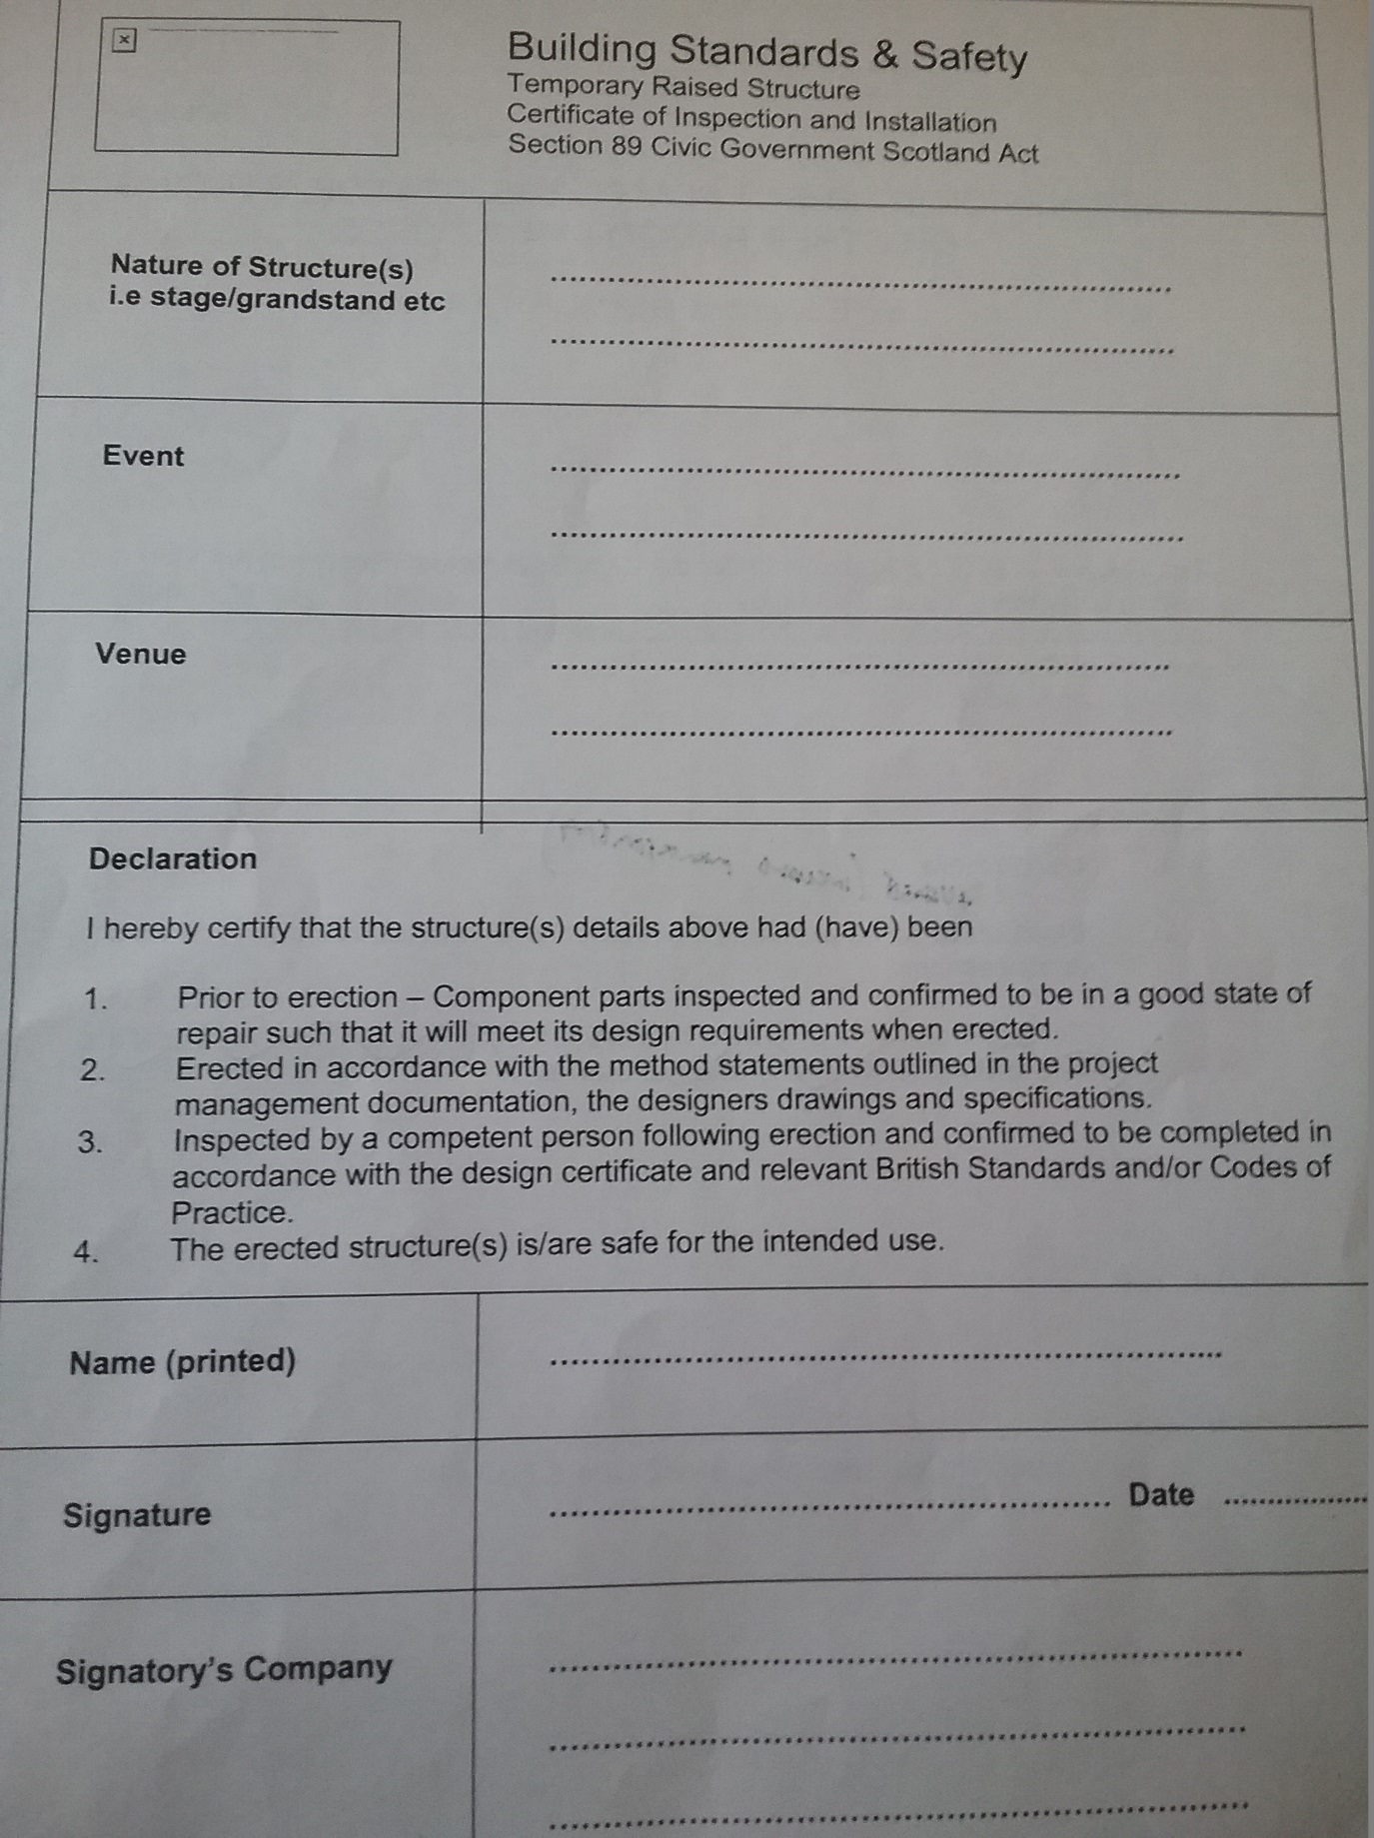

Appendix 4
PERMISSION TO ERECT & USE PLATFORMS, STANDS, STAGING OR OTHER RAISED STRUCTURES

Civic Government (Scotland) Act 1982
Section 89 Safety of platforms etc.

Fife Council as Local Authority under the Civic Government (Scotland) Act 1982, having considered the application by ………………………….. dated …………………… hereby grant permission under Section 89 of the Civic Government (Scotland) Act 1982 for the erection and use of ……………………………………..at …………………………………………….. subject to the following conditions:

- Usage from ………………………. to ………………………….

- Erection and usage (including the management) to be as per details provided with the application and amended as necessary and also with the requirements and recommendations of Fife Councils temporary raised structures’ customer guidance dated 11 July 2018

Date

Signed …………………………………………………..
The relevant authorising Officer (either Scott Y, Scott D or Jim F, currently)

