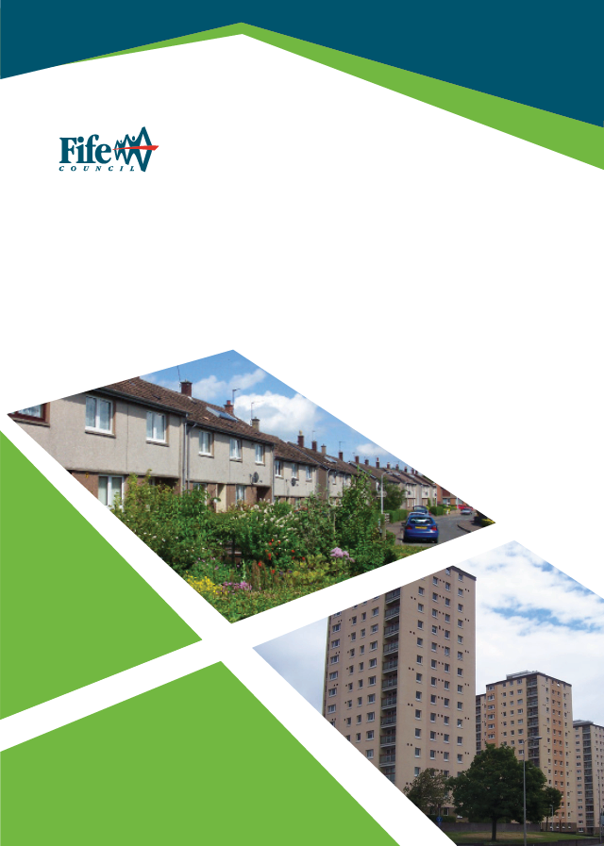

Domestic Property Acquisition Policy
(Revised September 2025)
Introduction

Housing Services recognises that under the Right to Buy Scheme which was active between 1980 – 2016 many council properties were sold; this policy seeks to purchase properties back in the areas of greatest demand to assist those in the greatest need of housing. The focus will be for these to be former Local Authority properties however, in certain circumstances properties that are not former Local Authority may be considered. The purchase of these properties will support the Affordable Housing programme (AHP), Fife’s Rapid Re-Housing Transition Plan (RRTP) and the Housing Emergency.

Aim

The aim of the Property Acquisition Policy is to increase the Council’s housing stock by purchasing properties from the open market and directly from owners.

All properties that are purchased will be improved to meet the Scottish Housing Quality Standard (SHQS). The costs of such work will be reflected in the offer price for the property.

Objectives

- • Targeting property acquisitions to meet demand in the areas of most need as reported in the Housing Needs and Demand Assessment (HNDA).
- • Targeting property acquisitions particularly where the Council is not building new Council housing.
- • Assist in the delivery of the AHP & the Fife Homelessness Strategy.
- • Identify properties on the open market or through speculative requests from owners.
- • Assist Fife in delivering the Affordable Housing programme.
- • Prioritise allocating properties to homeless applicants to support Fife’s Homelessness Strategy.
- • Raise the standard of housing in Fife by improving all properties to meet SHQS.
- • Work alongside Fife Council’s Private Sector Empty Homes team to identify potential properties to acquire to bring back into use.
Criteria

A property will be considered under the policy where it meets at least one of the following criteria:

- Resolve a Homeless Situation / Prevent Homelessness.
- To help meet housing need where there are significant pressures and limited opportunities to build new homes.
- To facilitate Estate Action or Regeneration Schemes.
- To facilitate New Build Schemes.
- To meet specific housing needs.
- To meet specific tenant’s’ housing needs for more appropriately sized or adapted properties by adopting a transfer-led approach to maximise housing opportunities.

- To Resolve a Homeless Situation / Prevent Homelessness

The Council may consider purchasing properties from the open market to resolve a homeless situation and/or prevent homelessness, the focus will be to purchase larger properties (3 bed and above) to reduce the time that families with children spend in temporary accommodation.
It is proposed that the Council may purchase properties to resolve / prevent homelessness where:

  - The Service has identified a suitably sized property on the open market, the properties will be purchased with vacant possession.
  - The application to the Scottish Government through mortgage to rent is successful (see www.mygov.scot/home-owners-support-fund/).
  - To prevent homelessness by purchasing the property directly from the owner with a sitting tenant where the tenant has high priority medical, specific needs or to prevent children coming into temporary accommodation
  - In view of the current very high demand for the provision of temporary accommodation to meet the Council’s statutory duty, property acquisitions can be made to boost the council’s pool of temporary accommodation available to homeless people.

- To meet specific tenant’s needs for more appropriately sized or adapted properties

It is recognised that there is a need to ensure that council tenants can up or downsize, or move to more suitably adapted or adaptable properties, particularly where the council new housing programme does not deliver in some areas the required number of housing options for our tenants.

It is proposed that the council seek to purchase properties to satisfy transfer needs following appropriate discussion with the Head of Housing Services.

- To help meet housing need where there are significant pressures and limited opportunities to build new homes

Significant Housing need will be determined by reference to the HNDA and cross referenced with the AHP. Typically, repurchase will take place where:

  - The AHP is likely to deliver less than 50% of the total HNDA requirement for affordable housing
  - The property is a former local authority property
  - The house size and type are under-represented in the local housing stock mix and demand exists
  - Demand will be demonstrated through the Fife Housing Register (FHR).

The property will be purchased with vacant possession.

- To facilitate Estate Action or Regeneration Schemes

It may be necessary to repurchase former Local Authority properties to ensure successful outcomes in terms of place-making and sustainable communities.

These will include:

  - Properties in blocks of flats where the owners are unable to meet the costs of improving the block. The property can be purchased with vacant possession, or the current owner-occupier may be offered a secure tenancy.
  - Properties in blocks of flats where purchasing the property would give Fife Council majority or sole ownership in the block. The property can be purchased with vacant possession or in exceptional circumstances the owner may be offered a secure tenancy.
  - Properties in schemes where the proposal is to demolish the existing properties and build new ones. The property will be purchased with vacant possession.

Properties will generally be former Local Authority properties but may include other properties if included in the boundaries of a formal Estate Action or Regeneration Scheme.

- To facilitate New Build Schemes

It may be necessary to purchase properties to gain appropriate site access or make satisfactory infrastructure works to a new build scheme.

Properties may or may not be former Local Authority properties. Normally, the property will be purchased with vacant possession for demolition. However, it may be that the site objectives can be achieved by using part of the garden ground, in which case Fife Council will only seek to purchase the land required.

- To meet specific needs

The Council may purchase properties to be used for specific needs applicants where no suitable Council property exists, taking account of the costs to provide adaptations or alterations. The Council may also purchase a private rented property which has been specifically substantially adapted in a major permanent way (i.e. does not have temporary adaptations for example stair lifts or ramps) where:

  - The property should normally be purchased with vacant possession
  - In exceptional circumstances where there is a sitting tenant who requires the adaptations in the property the Council may look to purchase the property and offer the tenant a secure tenancy. The tenant should have a live Fife Housing Register application and there is no suitable Council house to meet the needs of the sitting tenant locally (including consideration of the costs of adapting the property).

Financial and Value for Money (VFM) Guidelines

Purchase cost will be as assessed by an appropriately qualified surveying company or the District Valuer. The price paid by the Council will not exceed the valuation unless in exceptional circumstances. A pre-requisite for agreement to purchase will be that an estimate of repairs and improvements costs to meet the SHQS will be obtained through a condition survey.

The financial guidelines for the Property Acquisitions Team within Housing Services will be reviewed annually by the Executive Director (Finance & Corporate Services) and the Executive Director (Communities). The guideline will be based on 45-50% of the equivalent new build council property cost in that year. The SHQS upgrade costs will be limited to up to £20,000 per property. Exceptions can be dealt with on an individual business case submission to the Executive Directors.
Process

The full process is available on ISOMA process management on Fife Internet and will be publicised on the Council’s Website:

• The Property Acquisitions Team should complete the Property Acquisition request form and forward it to the Area Housing Manager to consult with the Area Team; this should be signed by the Area Housing Manager and returned to the Acquisitions Team.
• The property will be subject to an internal SQHS and external valuation and VFM assessment.
• In all cases the Service Manager (Housing Condition & Supply) and Elected Members for the Ward in which the property is located must be consulted.
• The final decision to purchase will be taken by the Executive Director (Communities) in accordance with the Fife Council Scheme of Delegation.
• Where a potential seller is a Fife Council employee or an Elected Member, it is important to protect the transaction from the perception of inappropriate influence being exercised. The Housing Service will require a Declaration of Interest form to be completed. The process will be used to evidence a process which is fair, open and transparent. That process will have at is heart the following principles:
  - The sellers must comply with the applicable codes of conduct and will not seek to use their position to gain an advantage.
  - The purchase will be conducted by Housing staff without fear or favour as an arm’s length transaction.
  - The commercial terms of the purchase will be based on an independent valuation of the property.”
Budget

The Head of Housing Services is responsible for the HRA Capital Budget to finance purchases of private properties. The budget for the Scheme is set as part of the HRA budget each financial year by Full Council. The Service Manager (Housing Condition & Supply and the Finance Business Partner will maintain a budget monitor.

Property Acquisitions are also supported by the Scottish Government through housing subsidy/grant as part of the Affordable Housing Programme.

Resources

Staff resources to support the Scheme will be drawn from Housing, Property (Estates), Legal, Finance and Building Services.

Equal Opportunities

We will ensure that no individual is discriminated against on grounds of gender or marital status, on racial grounds, or on grounds of disability, age, sexual orientation, language or social origin, or other personal attributes, including beliefs, or opinions, such as religious beliefs or political opinions. We will ensure the promotion of equal opportunities by translating information and documentation and providing other formats such as large print, CD and Braille, as required

Contact

Helen Wilkie
Service Manager - Housing Condition & Supply
3rd Floor Fife House
Glenrothes
KY7 5LT

Email: Helen.Wilkie@fife.gov.uk

How to make a comment or complaint

You can do this in any of the following ways:

  - Go online at Make a complaint | Fife Council
  - Phone our general enquiries line: 03451 55 00 00 (8am-8pm Monday to Friday)
  - • BT Text Direct for the Deaf: 18001 01592 55 11 91
  - Visit us at any Council office and speak to a member of staff
  - Write to us at: Freepost RTBZ-BBJT-BBYC, Comments and Complaints, Fife Council, Fife House, Glenrothes, KY7 5LT
  - If you are deaf and have registered for the Council’s SMS text service, please send your correspondence to the number given when you registered.

It is easier for us to resolve complaints if you make them quickly and directly to the service concerned. So please talk to Housing Services’ staff and they can try to resolve any problems on the spot.

If you are contacting us, tell us:
  - Your full name and address
  - As much detail as you can
  - What has gone wrong or right
  - If something has gone wrong, how you want us to resolve the matter.
Review

