ST3 - Version 2.05 (01.04.2026) Licence No.

FIFE COUNCIL
CIVIC GOVERNMENT (SCOTLAND) ACT 1982 - SECTION 39
APPLICATION FOR GRANT/RENEWAL OF A LICENCE TO ACT AS A STREET TRADER

CERTIFICATE OF COMPLIANCE ONLY

EACH QUESTION MUST BE ANSWERED
1. Full Name (Block Letters) | Surname |  | Maiden Name |  |  | First Name(s)
2. (a) Home Address  (incl. Postcode) |  |  |  | Telephone Numbers
2. (a) Home Address  (incl. Postcode) |  |  |  | Home:  Business:
2. (a) Home Address  (incl. Postcode) | e-mail:
(b) Previous addresses in past 5 years
3. Age, Date and Place of Birth | Age | Date of Birth |  |  | Place of Birth
4. (a) Are you the owner of the vehicle proposed for Street Trading? | YES / NO
(b) If not,  provide full details of the employer / company who is. | Name:  Address:  Place and Date of Birth (if applicable):  Business Hours Tel No:
5. State precise location including the postcode (if static) or area (if mobile) in which it is proposed to act as a Street Trader.
N.B. WRITTEN CONSENT OF THE LANDOWNER WILL BE REQUIRED IF YOUR SITE IS STATIC.

- 2 -

6. State the days and hours during which you propose to trade. | Hours: between a.m. and p.m.  on
7. State nature of goods/services in which it is proposed to trade.
DETAILS OF YOUR APPLICATION WILL BE FORWARDED TO ENVIRONMENTAL HEALTH.
8. State the address of the premises at which the goods will be stored when not being offered for sale.
9. Vehicle Details  (a) State the type of Vehicle or receptacle to be used in connection with Street Trading, (e.g. van, kiosk, trailer, moveable stall).  (b) Dimensions  (c) Registration Number | (a)  (b)  (c)
10. State the address at which the vehicle, kiosk etc will be kept when not in use.
11. Current / Previous Licence  (a) Have you previously held or do you currently hold a licence or permit for street trading?  IF YES,  (i) When was the licence/permit granted?  - When did/does it expire?  (iii) Which Authority granted the licence/permit?  (b) Have you ever applied for and been refused a licence/permit for street trading?  IF YES,  - When were you refused?  (ii) Which Authority refused you a licence/permit? |  | (a) YES / NO  (i)  (ii)  (iii)  (b) YES / NO  (i)  (ii)
12. Have you ever resided outwith the United Kingdom? |  | YES / NO  (IF THE ANSWER TO THIS QUESTION IS “YES” PLEASE SUBMIT ON A SEPARATE SHEET OF PAPER DETAILS AND DATES OF ALL OTHER COUNTRIES OF RESIDENCE).
- 3 -

How we use your information
The information provided by you on this form will be used by Fife Council in order to process your application. It will be shared with Police Scotland (Fife Division) and may be circulated to The Scottish Fire and Rescue Service as well as the relevant Council Services for their statutory interests. Information may also be obtained from those mentioned above. Further information on how your information is used, and why, can be found here: Miscellaneous Licence | Fife Council
The Council’s Data Protection Officer can be contacted on: dataprotection@fife.gov.uk

I declare that the particulars given by me on this form are true, and hereby make application to Fife Council for Grant/Renewal of the licence applied for. I have received, read and understood the conditions relating to this type of licence.

Date Signature of Applicant

N.B. Any person who in, or in connection with, the making of this application makes any statement which he knows to be false or recklessly makes any statement which is false in a material particular shall be guilty of an offence and liable, on summary conviction, to a fine not exceeding £2,500.

This application must be lodged by email at misc.licensing@fife.gov.uk together with the fee of £113 for the inspection & a £30 admin fee payable by credit or debit card.
The process for payment is attached.

Applications will not be processed until payment has been made.

To make a payment for your application click on Licences and permits under Make a Payment as seen below which is on the front page of our website www.fife.gov.uk

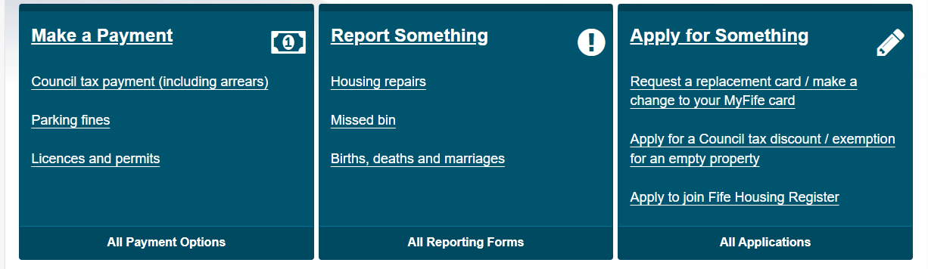

This will then take you to the page below where you click on Pay for a Licence Online

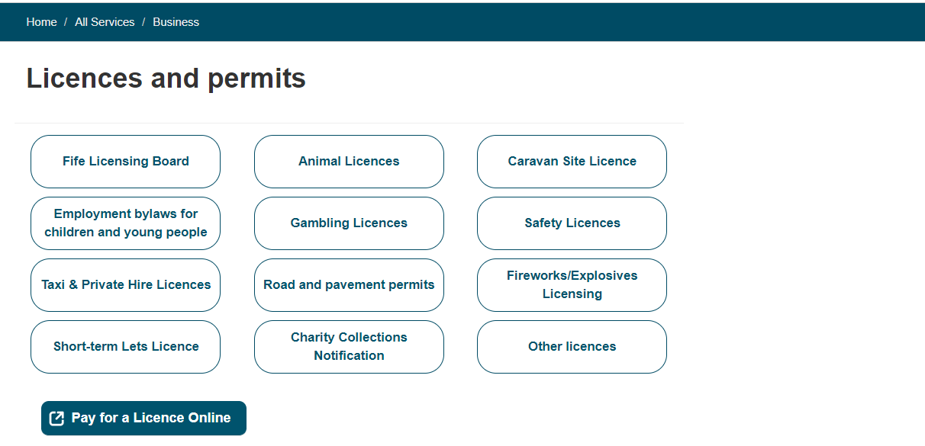

Click on the down arrow where it says Pay For below to go to the drop down menu and choose Environmental Health Fee then the reference should be ST then your surname. Enter £113.00 in the Amount to Pay then press add. Click on the down arrow where it says Pay For again and choose Miscellaneous Licence then the reference should be ST then your surname. Enter 30.00 in the Amount to Pay then press add.

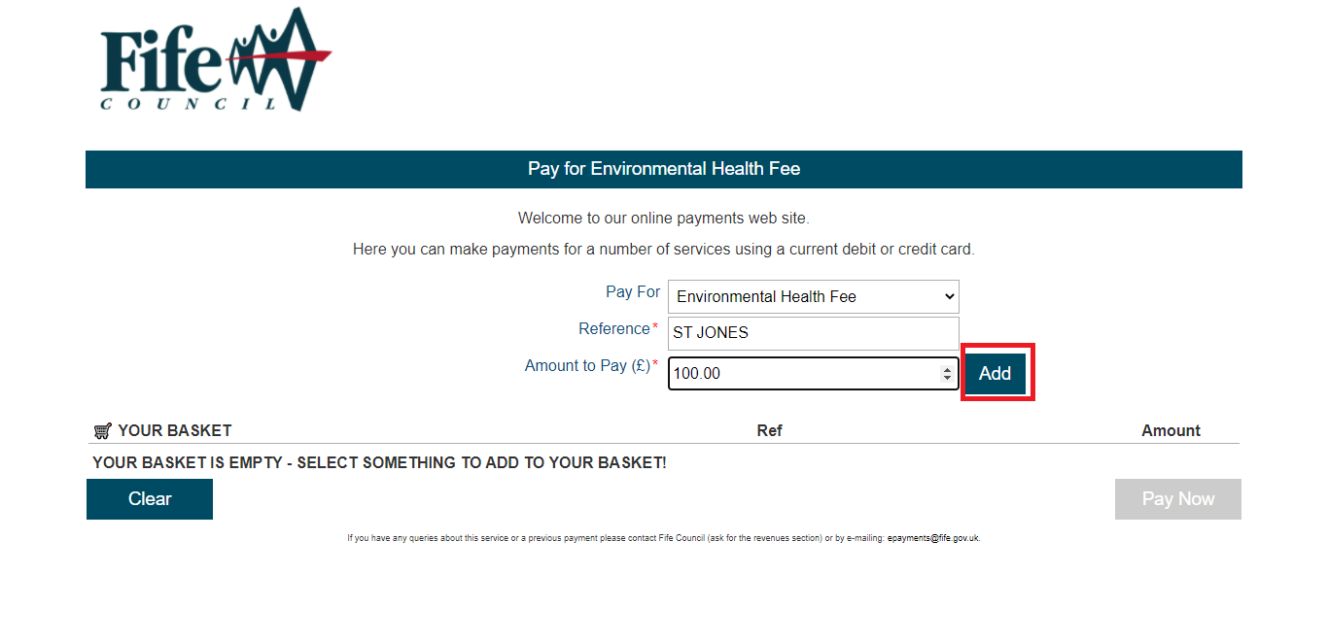

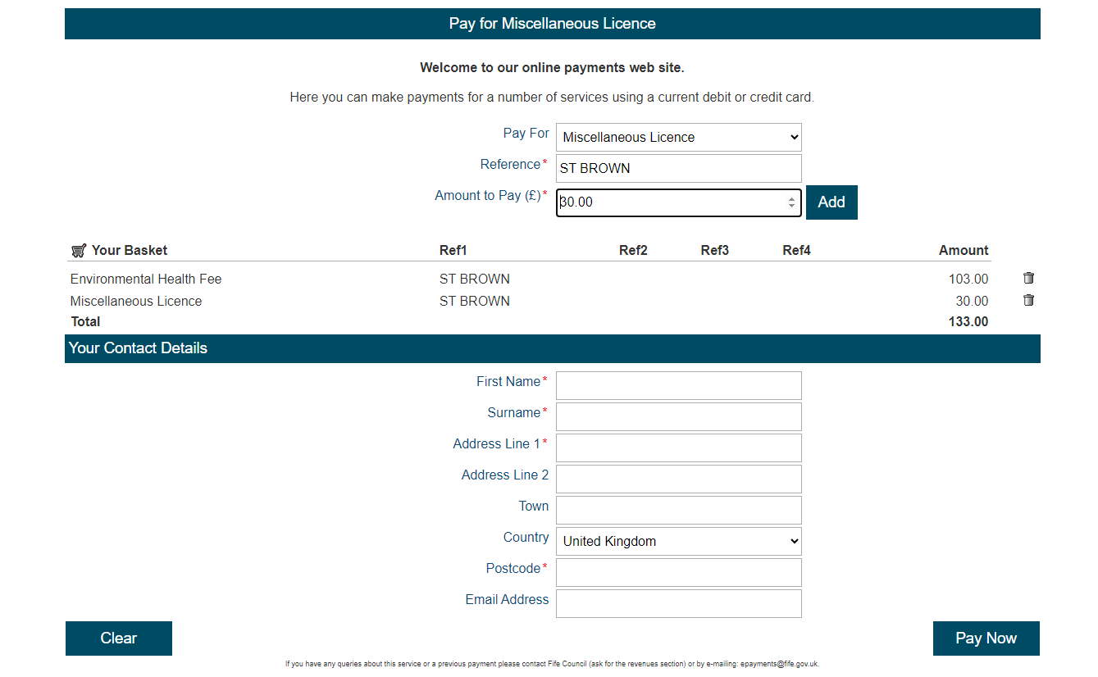

Complete your contact details then press Pay Now.

You will then be taken to the screen below where you will verify your details then press Continue

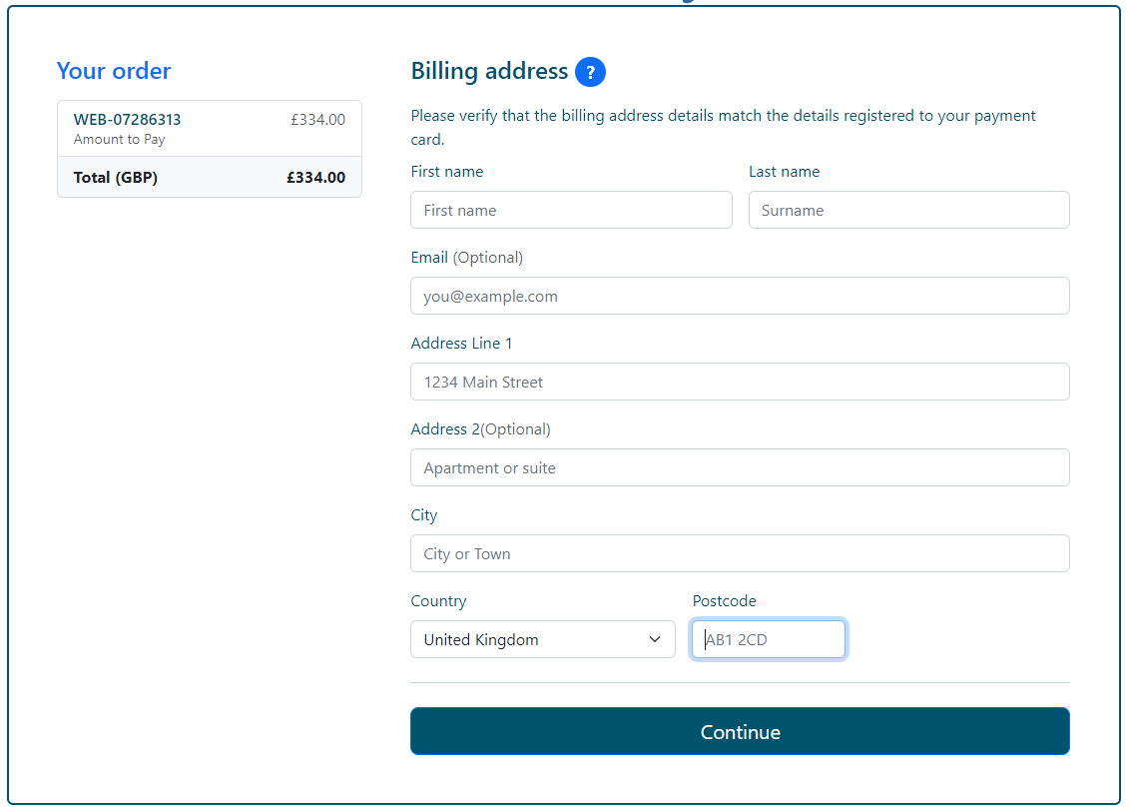

You will then be asked to add your payment details and then press Pay Now

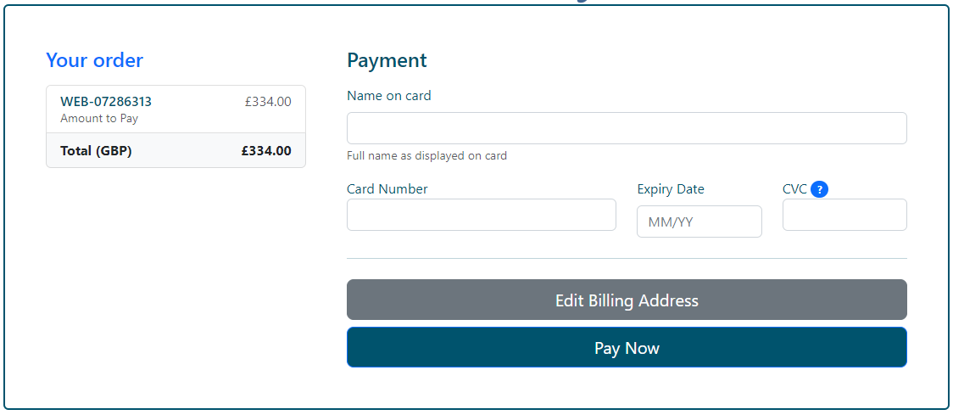

You will then be taken to the screen below which shows you an example of your payment details

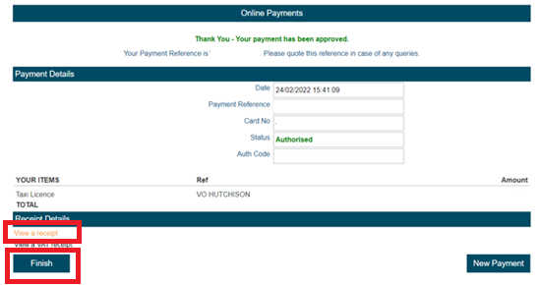

Click on View a receipt as on the above then click on finish and you will be taken to the page below

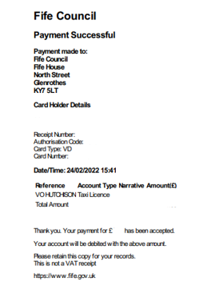
Save a copy of the above page then forward it to Misc.licensing@fife.gov.uk with your completed application.

